Name _____________________________________ Date ____________
AP Biology – Human Evolution Documentary Mr. Collea

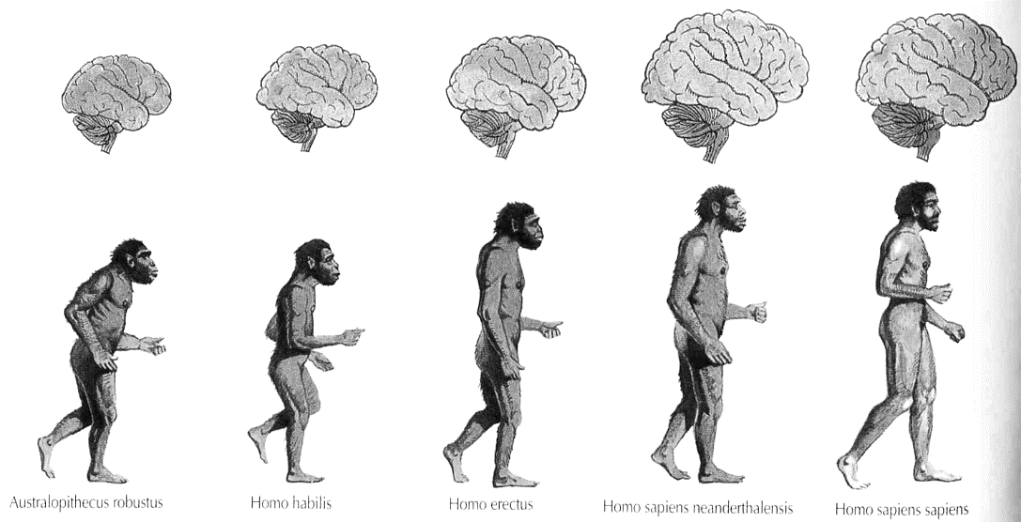
Ape to Man
Australopithecus afarensis Homo hablis Homo erectus Homo neanderthalensis Homo sapien

Where did we come from?
This is one of the central questions that has plagued human beings throughout the centuries, as people across cultural backgrounds and national boundaries have pondered the origins of the human species. Societies have framed this question in various ways, formulating diverse explanations for the sources of humankind. In the 19th century, scientists developed new theories of “evolution” which aimed to find evidence for the origins of humanity and to document the process of human development. This informative and compelling documentary, Ape to Man, chronicles the major anthropological and archaeological discoveries of the 19th and 20th centuries, revealing the ways scientific methods were first used to trace the path of humankind. The show covers the experiments of scientists like Charles Dawson, Raymond Dart and the Leakey’s, introducing viewers to their key theories and how they arrived at their findings. With accurate reenactments of the early human ancestors who roamed the earth, viewers gain insights into what life might have been like millions of years in the past. Ape to Man traces several key theories presented by evolutionary scientists, many of which were never fully accepted. From an elaborate scheme of scientific deception known as the “Piltman scandal” to the evolutionists quest for the “Missing Link” or humanity, this documentary traces the ways scientists have studied and defined the progression of humankind. Delving into the history of these scientists and their theories, Ape to Man helps viewers understand why theories that have been proven false today were considered valid in their 19th century context. This program offers a compelling historical framework for discussions of the origins of humanity. Rather than analyzing the current debate over evolution, this program recounts the scientific theories of evolution which emerged in the 19th century, and the ways these ideas have been reflected and reinterpreted since their inception.

Discussion Questions:

1. Why do you think so many people want to know where or how the human species originated?
Do you think this is a central question all societies ponder? Discuss.

2. Who was Neanderthal Man and what were some of his defining characteristics?

3. Why did so many Victorians have trouble with the proposition that they had descended from apes?
What does this reveal about the historical context in which they lived?

4. Why do you think anthropologists became focused on finding a “missing link” in order to explain human origins?

5. How was Charles Dawson able to convince the Royal Geographic Society and most of the world that his fossils were the “missing link” needed to explain human origins? What do you think fossils proved or suggested about human origins?

6. Why did Charles Darwin believe Africa was the cradle of humanity? What were the ramifications of this argument in Darwin’s era?

7. What was significant of the Taung fossil that Raymond Dart received and studied? Why were his findings disregarded in the anthropological world? Why do you think this was a significant event in the history of science?

8. What was the significance of Louis and Mary Leakey’s findings in the search for the “missing link”?
Why do you think they are regarded as pioneering scientists?

9. According to scientists highlighted in this documentary, walking upright is the main feature that put Lucy on the road to humanity. Why was this feature so important? What kind of cascading effects did the ability to walk have for humans according to the scientists in this program? How did Lucy get her name?

10. According to this documentary, how was it possible for Neanderthal Man and Homo Sapiens to evolve as separate species? Why is this distinction important?

11. Do you think that in the 21st century we have a satisfactory answer to where human beings came from, and when? Do you think it is possible for societies to arrive at consensus on this topic?

12. Complete the table located at the bottom of the next page using the phylogenic tree showing the relations between hominids and the sequence of the evolution of their traits.

Phylogenetic relations of hominids and the sequence of evolution of their traits.
Hominid evolution should not be read as a march to human-ness (even if it often appears that way from narratives of human evolution). Students should be aware that there is not a dichotomy between humans and apes. Humans are a kind of ape. In the table below, identify the presence of a derived trait with a “+” and the presence of an ancestral trait with a “O”
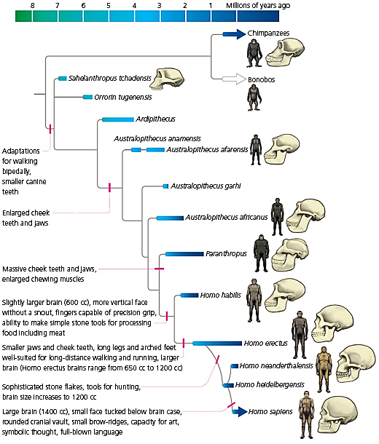

(1)

(2)

(3)

(4)

(5)

(6)

(7)
Species | Trait
 | 1 | 2 | 3 | 4 | 5 | 6 | 7
Australopithecus afarensis
Australopithecus garhi
Australopithecus africanus
Paranthropus
Homo habilis
Homo erectus
Homo neanderthalensis
Homo heidelbergensis
Homo sapien

