**Bozeman Biology: Water Potential**

**1.** Give the definition of water potential.

**2.** What does water potential allow us to figure out?

**3.** What is the “unit” for water potential?

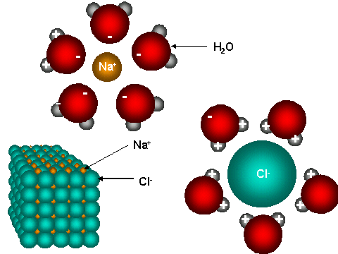

**4.** Use the diagram to the right to help you explain how

water (a polar molecule) orientation changes when NaCl

is added to it?

**5.** What is the water potential of pure water?

**6.** Which way does water move?

**7.** Summarize, using water potential, why salt causes water to leave a slug.

**8.** Label the diagram of the tree below and use it to explain why water moves from the roots to the tips of the treetops.

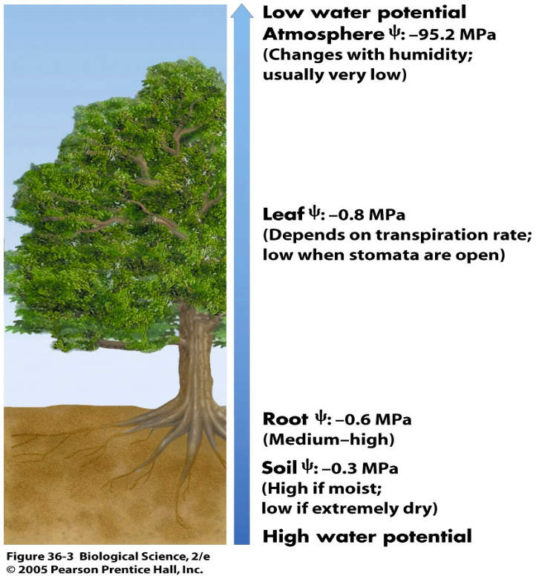

**9.** Write out and describe the water potential equation.

**10.** Solute potential is a factor of osmosis, what is pressure potential a factor of?

**11.** Why is pressure potential often a positive number?

**12.** Write out and explain each part of the solute potential equation:

**13.** Why is **i** (*the ionization constant*) a value of 2 for NaCl and a value of 1 for sucrose?

**14.** How does increasing temperature affect solute potential?

**15.** Show the steps (**E**quation – **S**ubstitute – **A**nswer) to work out his sample problem below.