AP Biology  Student  Interactive  Learning  Guide | North Salem University  MISSION: Engage students to continuously learn, question, define and solve problems through critical and creative thinking.  Fall 2018
Now that you know how photoautotrophs convert photons (light energy) into glyceraldehydes-3-phosphate or G3P (chemical energy) and then into C₆H₁₂O₆ / glucose. We’ll now take a look at how plant physiology (structure) allows them to accomplish this complex biochemical process (function) and transport the products (sugar) around to all the cells of the plant. Because what you do with glucose is the same thing plants do with glucose…ship it off to the mitochondria to create ATP.  Just remember the poem,  “Up the xylem, down and around the phloem…that’s the poem.”  (H₂O) (food/sugars)  If you have any problems – please sign up for extra help after school. |  | Chapters 36/35/37:  Plant Transport  Plant Physiology  Plant Nutrition

Chapter 36: Transport in Plants

OBJECTIVES:
An Overview of Transport Mechanisms in Plants
___1. List three levels in which transport occurs in plants.
___2. Define osmosis and water potential. Explain how water potential is measured.
___3. Explain how solutes and pressure affect water potential.
___4. Explain how the physical properties of plant cells are changed when the plant is placed into solutions that have higher, lower, or the same solute concentrations.
___5. Define flaccid, plasmolyze, turgor pressure, and turgid.
___6. Explain how aquaporins affect the rate of water transport across membranes.
___7. Describe the two routes available for lateral transport in plants.
___8. Define bulk flow and describe the different types of forces that generate pressure.

Absorption of Water and Minerals by Roots
___9. Explain how the structure of root hairs promotes their functions.
___10. Explain how the endodermis functions as a selective barrier between the root cortex and vascular tissue.

Transport of Xylem Sap
___11. Define root pressure, transpiration, and guttation.
___12. Explain how transpirational pull moves xylem sap up from the root tips to the leaves.

The Control of Transpiration
___13. Describe the role of guard cells in transpiration.
___14. Explain how transpiration changes the temperatures of leaves and why this is adaptive.
___15. Explain how and when stomata open and close.

Translocation of Phloem Sap
___16. Define and describe the process of translocation.
___17. Trace the path of phloem sap from the primary sugar source to common sugar sinks.

Chapter 35: Plants Physiology

OBJECTIVES:
Leaf Anatomy
___18. Describe how leaf structure enables it to carry out photosynthesis.

Chapter 37: Nutrition in Plants

OBJECTIVES:
Nutrition in Plants
___19. Define nitrogen fixation and write the overall equation representing the conversion of gaseous nitrogen to ammonia.
___20. Describe the important role of nitrogen-fixing bacteria.
___21. Recall the forms of nitrogen that plants can absorb and describe how they are used by plants.

Guided Reading: Chapter 36

Part I. An Overview of Transport Mechanisms in Plants

- List and describe the 3 levels of transport that takes place in plants.
(1)

(2)

(3)

- Label the diagram below and use it to describe the overall process of transport in a whole plant.

(4)
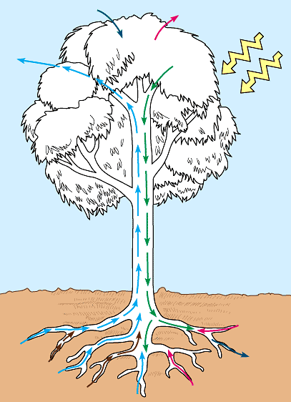
(5)

(3)

(6)

(2)

(7)
(1)

- Define each of the following words in terms of water potential.

(1) plasmolyze/plasmolysis -

(2) turgor/turgor pressure -

Part II. Absorption of Water and Minerals by Roots (Up the xylem…)

- What are root hairs and what function to they serve?

- Define each of the following internal parts of a root.

(1) Epidermis -

(2) Cortex -

(3) Endodermis -

(4) Casparian strip -

(5) Stele -

- Labeled diagram below and then use it to create a flowchart describing the pathway of water into and through the root of a plant. (Activity 36A)
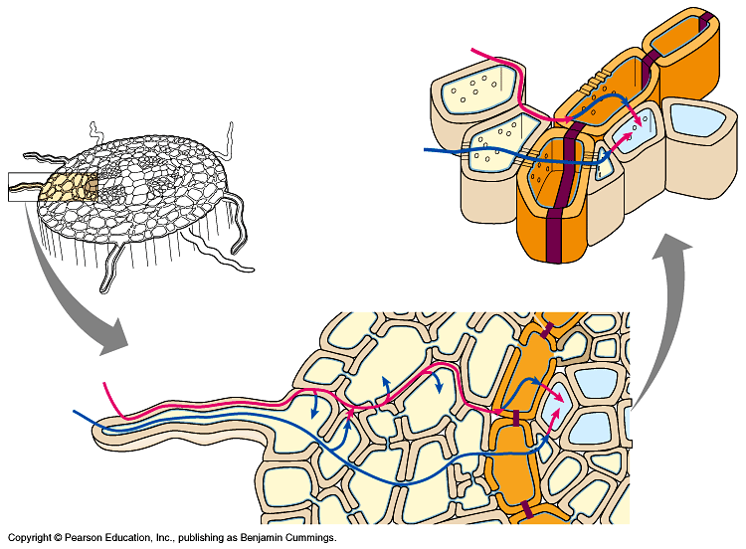

- What is transpiration?

- Is water PUSHED or PULLED up from the roots to the leaves? Explain.

- What is the difference between adhesion and cohesion?

- Label the diagram below and use it to describe the process of transpirational pull and the ascent of water in a tree. (Activity 36A)

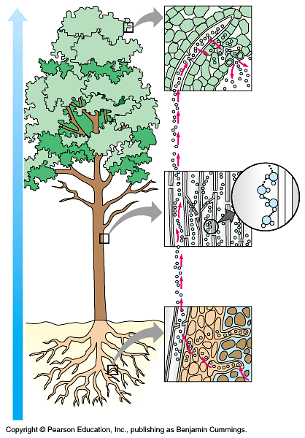

Part III. Control of Transpiration

- Label the diagrams below and use them to explain the mechanisms of stomata opening and closing (be sure to include the role of potassium ions/K+ in this process).

______________________________ ______________________________
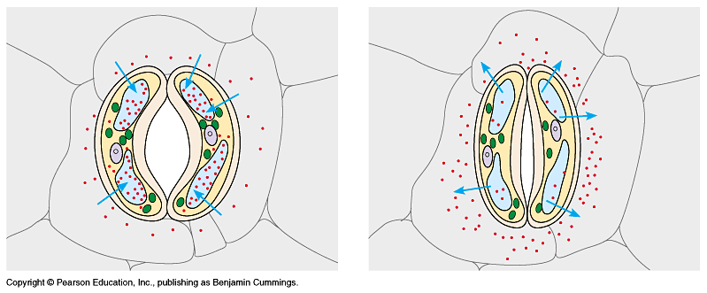

- Generally speaking, when are stomates usually open and closed. Why?

- List and briefly describe the three cues that contribute to stomates opening at dawn.

- List and briefly describe the environmental stresses that can cause stomates to close during the day.

Part IV. Translocation of Ploem Sap (down the phloem…)

- What is the difference between a sugar source and a sugar sink?

- Label the diagram below and use it to explain the source to sink transport of fluids in phloem vessel.
(Activity 36B)
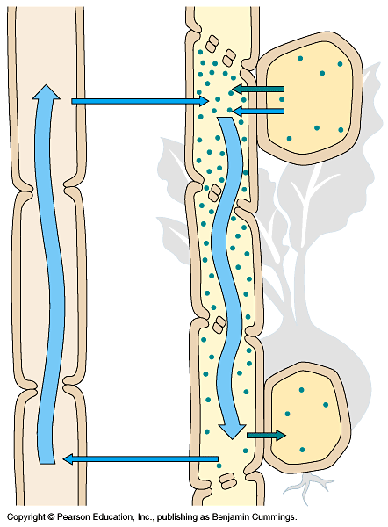

(1)

(2)

(3)

(4)

Chapter 35: Plants Physiology

Part V. Leaf Anatomy

- Label the diagram of the leaf below and use it to explain how the leaf structure is perfectly adapted for it function of carrying out photosynthesis.
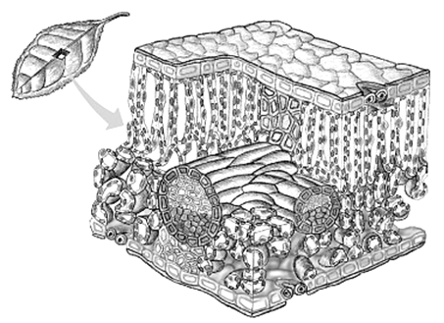

Part VI. Plant Nutrition

- Label the diagram below and use it to explain how plants obtain nitrogen from the soil. (Activity 37B)
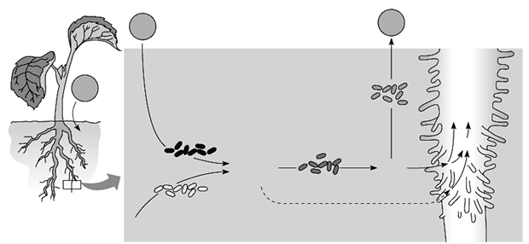

- What organic compounds do plants synthesize from this nitrogen?

Plant Transport – Review Questions

1) Which of the following structures is found in both plant and animal cells?
A) chloroplasts C) a large central vacuole containing fluid
B) mitochondria D) cell wall surrounding the plasma membrane

2) In an attempt to find out where a growing plant gets its mass, van Helmont planted a willow seedling in a pot of soil. After five years, the willow weighed 76.8 kg, and the soil had lost 0.06 kg of weight. Only water had been added to the pot. Which of the following conclusions should van Helmont have drawn?
A) Plants get their mass from water.
B) Plants get their mass from water and air.
C) Plants get their mass from water and atmospheric CO2.
D) Plants get all or almost all of their mass from a source other than soil.

3) Where do plants get most of their mass?
A) from nitrogen in the atmosphere C) from water, as van Helmont predicted
B) from carbon dioxide in the atmosphere D) from organic molecules taken up from the soil

4) What is the physical barrier in the root that regulates the flow of water to xylem via cell walls?
A) phloem C) Casparian strip
B) epidermis D) cortex

5) ________ increase the surface area of roots.
A) Plasmodesmata C) Casparian strips
B) Cell walls and endoplasmic reticulum D) Root hairs

6) Which of the following options correctly lists the sequence of structures through which water passes into a root?
A) guard cell, endodermis, cortex, xylem C) epidermis, cortex, endodermis, xylem
B) root hair, cortex, xylem, endodermis D) root hair, xylem, endodermis, phloem

7) Which of the following statements is false?
A) Stems and leaves depend on the water and minerals absorbed by the roots.
B) Roots depend upon sugars produced in photosynthetic organs such as leaves.
C) Plant root hairs help to absorb carbon dioxide from the soil.
D) The shoot system of a plant consists of the stems, leaves, and adaptations for reproduction.

8) How do mineral ions get into the xylem cells of a plant root by way of the intracellular route?
A) They percolate between root cells to the xylem and then enter a xylem vessel.
B) They are actively taken in to the xylem of root hairs.
C) They are taken up by root hair cells and transferred from cell to cell via plasmodesmata.
D) They move in solution through cell walls of the endodermis.

9) The loss of water from the leaves of plants is -
A) adhesion. C) transpiration.
B) cohesion. D) osmosis.

10) In the water relations of vascular plants, the cohesive property of water is most important in the -
A) epidermis. C) internal air spaces.
B) xylem. D) stomata.

11) What force is responsible for the cohesiveness of water?
A) osmosis C) negative pressure created by evaporation
B) hydrogen bonding between water molecules D) ionic bonding

12) Sieve-tube elements are plant cells that are part of a plant tissue called -
A) xylem. C) phloem.
B) tracheids. D) sclereids.

13) The two main forces that move water through a plant are -
A) transpiration and root pressure. C) transpiration and pressure flow.
B) root pressure and photosynthesis. D) active transport and cohesion.

14) A hot, dry summer will reduce crop yields in part because -
A) the stomata of the plants stay open to help cool the leaves.
B) carbon dioxide uptake is reduced by the stomata closing to prevent excessive water loss.
C) oxygen uptake is reduced by the stomata closing to prevent excessive water loss.
D) carbon dioxide release is reduced by the stomata closing to prevent excessive water loss.

15) Under which of the following weather conditions would transpiration be most rapid?
A) hot, humid weather C) hot, dry weather
B) cold, humid weather D) windy, wet weather

16) Which of the following options best describes the mechanism that causes a stoma to open?
A) K+ enters the guard cells and water follows passively, making the cells turgid.
B) K+ activates water pumps in the guard cell membrane that make them turgid.
C) K+ leaves the guard cells and water follows passively, making the cells flaccid.
D) Loss of K+ from guard cells creates positive pressure and expands the guard cells.

17) The pores that facilitate gas exchange in plant leaves are called -
A) stomata. C) lenticels.
B) guard cells. D) plasmodesmata.

18) Which of the following would be most likely to cause stomata to open?
A) Water molecules entering the stomatal pore. C) Sunrise on a clear morning.
B) Hot, dry weather, and strong winds. D) A cool night is setting in.

19) If a plant is kept in the dark, -
A) the stomata continue their daily rhythm of opening and closing.
B) the stomata will remain closed the entire time that the plant is in the dark.
C) the stomata will remain open the entire time that the plant is in the dark.
D) the guard cells will open as water is added.

20) Generally speaking, fluids in plants are -
A) pushed through phloem and pulled through xylem. C) pulled through both xylem and phloem.
B) pushed through xylem and pulled through phloem. D) actively pumped throughout the plant.

21) The sugar "sink" in roots is the result of -
A) active transport of mineral ions into xylem cells.
B) absorption of water from the soil through epidermal cells.
C) active transport of sugars from phloem to root cells.
D) pull of gravity on sugar molecules.

22) The existence of a hydrostatic pressure gradient in phloem tubes can be accounted for by -
A) the fact that the leaves are higher than the roots, which means that gravity creates pressure.
B) the diffusion of water from one sieve-tube cell to the next.
C) the loading of sugars into phloem at sources and removal of sugars at sinks.
D) the active transport of water from sugar sources to sugar sinks.

23) How do sugars move from one sieve-tube cell to the next?
A) by osmotic diffusion through the sieve plate
B) by flowing along with water through perforations in the sieve plate
C) by active transport across cell membranes at the sieve plate
D) by diffusion through a companion cell that spans the sieve plate

24) Which of the following essential macronutrient for plants is obtained directly from the air?
A) nitrogen C) hydrogen
B) magnesium D) carbon

25) Which of the following are important in breaking down organic material in fertile topsoil?
A) abrasive granite particles C) bacteria and fungi
B) humus and cations D) plant roots

26) Most plants can absorb and use which of the following forms of nitrogen directly?
A) nitrite and nitrate C) ammonium and nitrogen gas
B) nitrate only D) nitrate and ammonium

27) Nitrogen fixation consists of -
A) the conversion of ammonia to nitrate.
B) the production of ammonium from decomposing organic matter.
C) the conversion of N2 to ammonia.
D) the conversion of N2 to ammonia or nitrate.

28) The relationship between a plant and mycorrhizal fungi is best described as -
A) parasitic. C) mutualistic.
B) competitive. D) commensal.

29) Legumes, such as beans or peas, -
A) form mutualistic associations with nitrogen-fixing bacteria.
B) form mycorrhizal associations to increase nitrogen fixation in the soil.
C) form parasitic relationships with other photosynthetic plants.
D) fix N2 from the atmosphere in their leaves.
30) Legumes are frequently grown in rotation with primary field crops. What is the benefit in this?
A) A greater amount of the primary crop can be harvested each year.
B) Nitrogen is added to the soil because of the legumes' symbiotic nitrogen-fixing bacteria.
C) Soil erosion is reduced by frequent plowing.
D) Legumes decrease the amount of organic material in the soil.

31) Much research is being done to increase the nitrogen-fixing ability of plants with root nodules. Why is this an important goal for agricultural researchers?
A) Decreasing the size of nodules will allow plants to fix more nitrogen into their own molecules.
B) Nitrogen is an essential component of the amino acids used to form protein.
C) Increasing the nitrogen-fixing ability of plants will allow them to make better use of nitrogen fertilizers.
D) By removing the bacteria from the root nodules, more fixed nitrogen will be available to the plants.

32) Carnivorousness in plants is primarily an adaptation for -
A) growing in soil poor in organic material. C) obtaining supplemental carbon for photosynthesis.
B) growing in soil poor in usable nitrogen. D) discouraging herbivorous insects.

33) According to this figure, which of the following can directly use atmospheric N2?
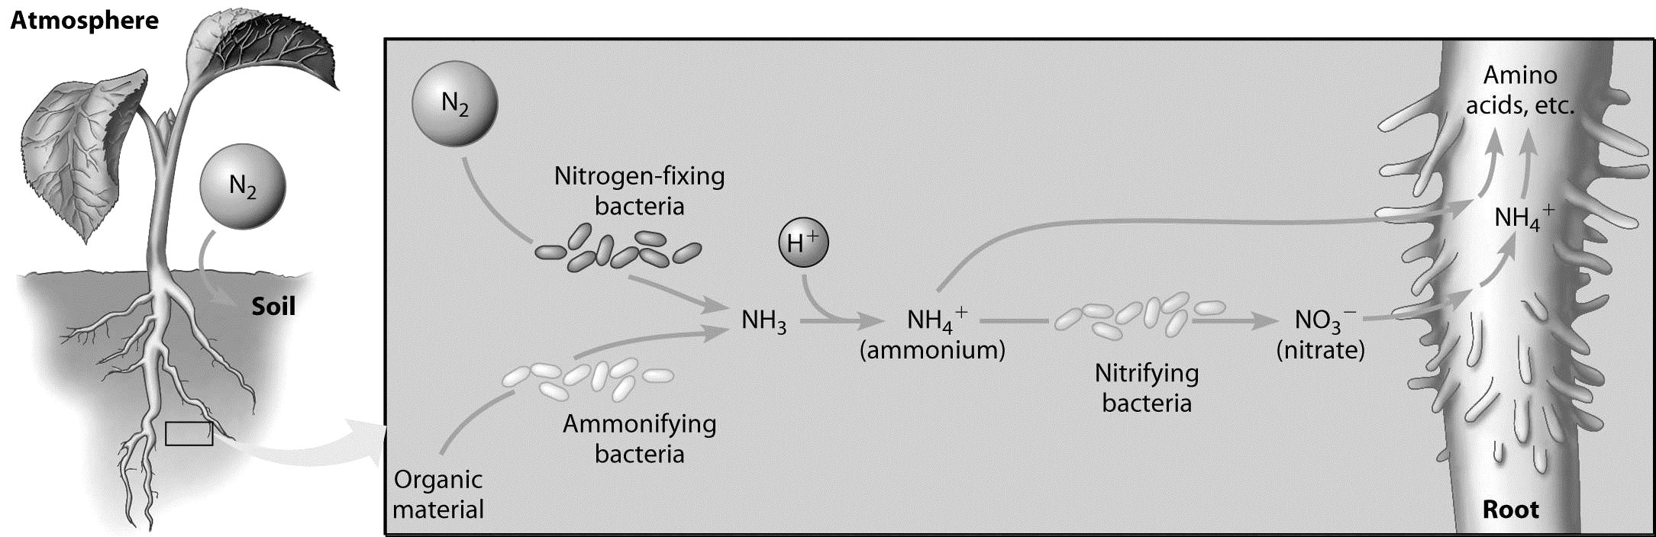

A) plant roots C) ammonifying bacteria
B) nitrogen-fixing bacteria D) nitrifying bacteria

