AP Biology  Interactive Student  Study  Guide | North Salem University  MISSION: Engage students to continuously learn, question, define and solve problems through critical and creative thinking.  Spring 2016
This chapter introduces the breadth of ecology and surveys some of the factors, both living (biotic) and nonliving (abiotic), that affect the distribution of organisms.  If you have any problems – please sign up for extra help after school. |  | Chapters : 50  Ecology and the Biosphere

Chapter 50: Ecology and the Biosphere

OBJECTIVES:

The Scope of Ecology
__1. Define ecology and identify the two features of organisms that ecologists try to explain.
__2. Distinguish between the abiotic and biotic components of the environment.
__3. Describe the relationship between ecology and evolutionary biology.
__4. Distinguish among organismal ecology, population ecology, community ecology, ecosystem
ecology, and landscape ecology.

Factors Affecting Distributions of Organisms
__5. Describe the problem of introduced species and the specific problems posed by the introduction of African bees and zebra mussels.

__6. Describe and illustrate biotic and abiotic factors that affect the distribution of organisms.
__7. Explain how climate affects the geographic distribution of organisms.
__8. Define and illustrate the concept of a microclimate.

Aquatic and Terrestrial Biomes
__9. Distinguish among the various zones found in aquatic biomes.
__10. Define and compare the many types of freshwater and marine biomes.
__11. Describe the characteristics of the major terrestrial biomes: tropical forest, savanna, desert, chaparral, temperate grassland, temperate forest, taiga, and tundra.

The Spatial Scale of Distributions
__12. Explain why the distribution of a species is often not easily accounted for.

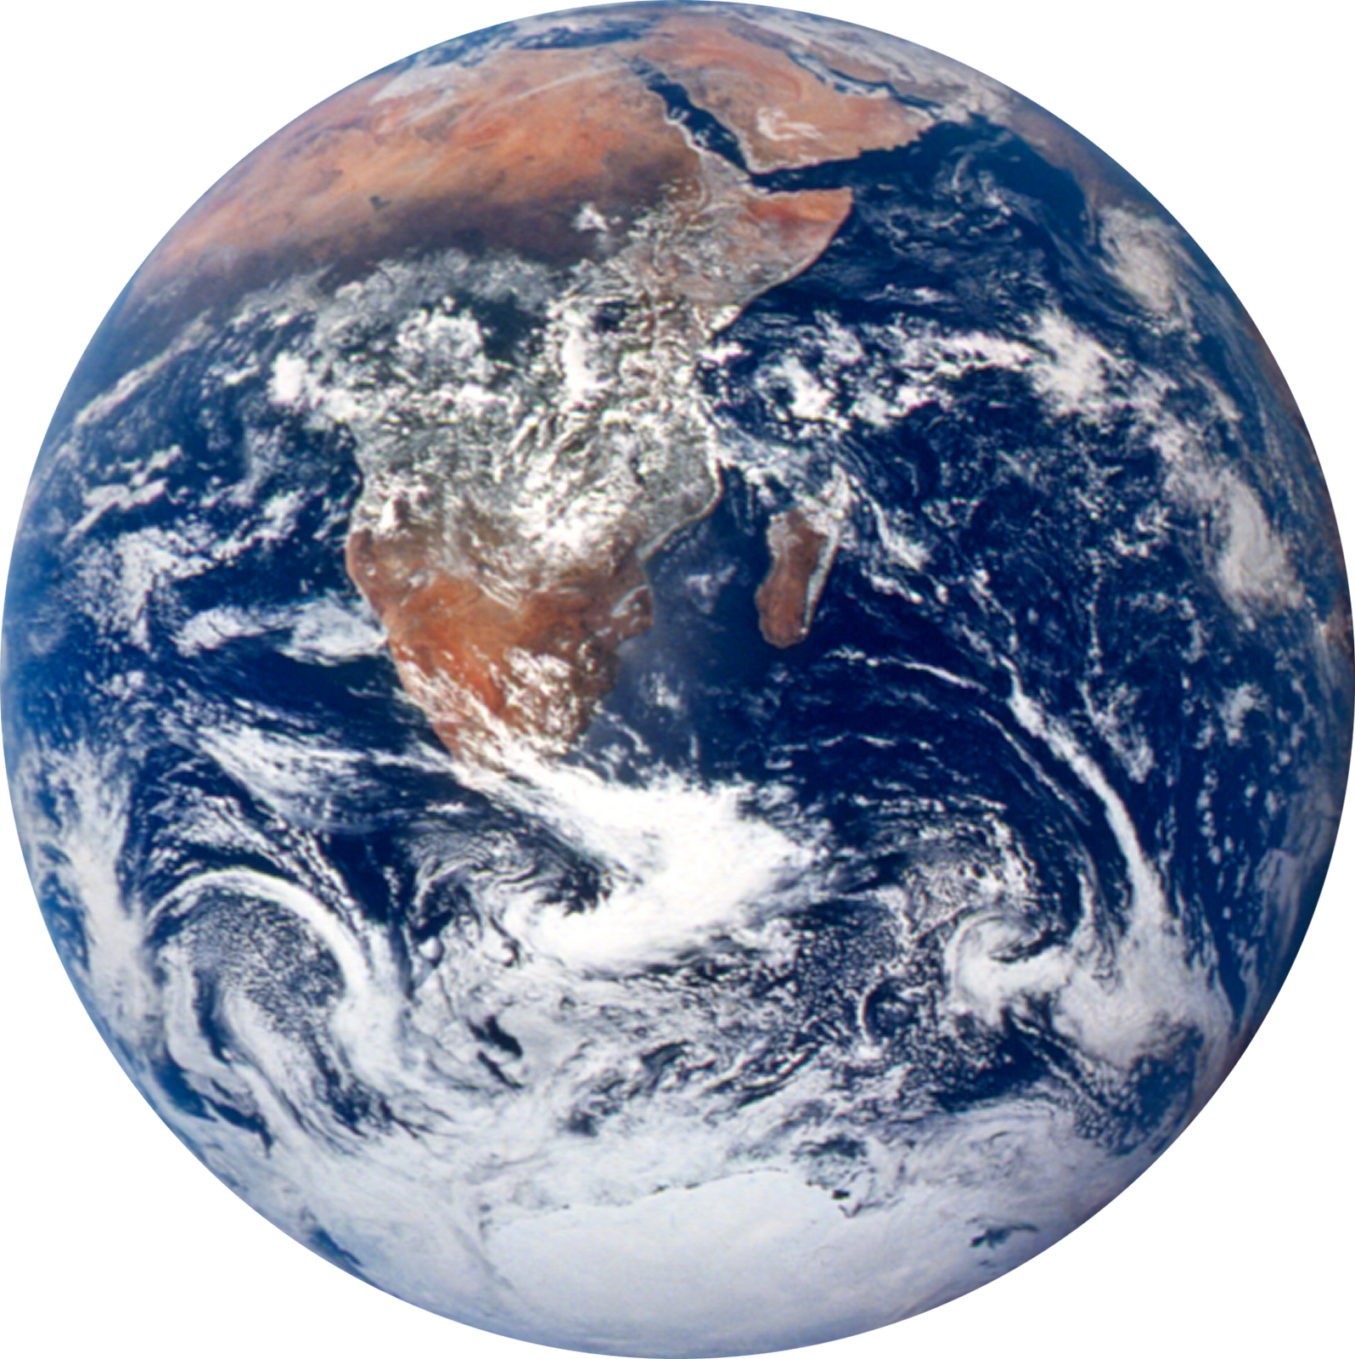

KEY TERMS:
abiotic components
biogeography biome biosphere biotic components
canopy climate community ecology community
coral reefs deep–sea hydrothermal vents detritus dispersal
ecosystem ecology estuary eutrophic
microclimate oligotrophic lake permafrost photic zone population ecology population turnover wetland

- - - - - - - - - - - - - - - - - - - - - - - - - - - - - - - - - - - - - - - - -

WORD ROOTS:
a- = without; bio- = life (abiotic components: nonliving chemical and physical factors in the environment)
abyss- = deep, bottomless (abyssal zone: the very deep benthic communities near the bottom of the ocean; this region is c haracterized by continuous cold, extremely high water pressure, low nutrients, and near or total absence of light)
estuar- = the sea (estuary: the area where a freshwater stream or river merges with the ocean)
eu- = good, well; troph- = food, nourishment (eutrophic: shallow lakes with high nutrient content in the water)
geo- = the Earth (biogeography: the study of the past and present distribution of species)
hydro- = water; therm- = heat (deep-sea hydrothermal vents: a dark, hot, oxygen-deficient environment associated with volcanic activity; the food producers are chemoautotrophic prokaryotes)
inter- = between (intertidal zone: the shallow zone of the ocean where land meets water)
meso- = middle (mesotrophic: lakes with moderate amounts of nutrients and phytoplankton productivity intermediate to oligotrophic and eutrophic systems)
micro- = small (microclimate: very fine scale variations of climate, such as the specific climatic conditions underneath a log)
perman- = remaining (permafrost: a permanently frozen stratum below the arctic tundra)
-photo = light (aphotic zone: the part of the ocean beneath the photic zone, where light does not penetrate sufficiently for photosynthesis to occur.
thermo- = heat; -clin = slope (thermocline: a narrow stratum of rapid temperature change in the ocean and in many temperate- zone lakes)

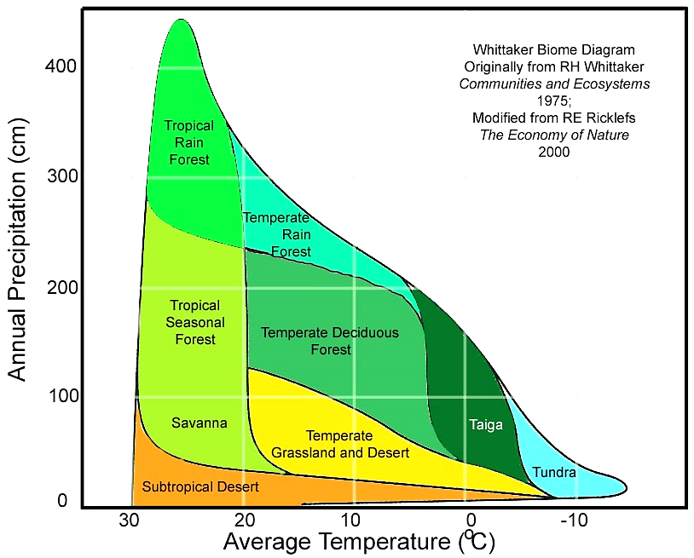

Guided Reading: Chapter 50

- Define the following terms:

  - Abiotic -

  - Biotic -
  - Give an example of the interactions of biotic and abiotic factors.

- What do the following subfields of ecology study?

  - Organismal Ecology -

  - Population Ecology -
(include the definition of ecology)

  - Community Ecology -
(include the definition of community)

  - Ecosystem Ecology -
(include the definition of ecosystem)

- Explain the factors that affect dispersal of organisms.

- Give two examples of the impact of each abiotic factor listed below has on the distribution of organism:

Abiotic Factor | Effect on Organism Distribution
Temperature
Water
Sunlight
Wind
Rocks and Soil

- What is the difference between macroclimate and microclimate?

- How does latitude affect sunlight intensity?

- What causes the seasons?

- Explain how mountains affect rainfall?

- How does seasonal turnover in lakes affect the oxygen level available to the aquatic organisms?

- How does temperature and precipitation impact the distribution of terrestrial biomes?

- Describe the following terrestrial biomes focusing on the major abiotic and biotic characteristics.

Terrestrial Biome | Abiotic Characteristics | Biotic Characteristics
Tropical Forest
Desert
Savanna
Chaparral
Grassland
Deciduous Forest
Coniferous Forest
Tundra

Chapter 50: Summary of Key Concepts

THE SCOPE OF ECOLOGY
- The interactions between organisms and their environments determine the distribution and abundance of organisms (p. 1093, FIGURE 50.1) The central questions of ecology are, Who lives where? How many are there? Ecologists use observations and experiments to test hypothetical explanations for the environmental limitations of distribution and abundance. The factors of the environment include both abiotic (nonliving) and biotic (living) components.
- Ecology and evolutionary biology are closely related sciences (p. 1093) Events that occur in ecological time affect life on the scale of evolutionary time.
- Ecological research ranges from the adaptations of individual organisms to the dynamics of the biosphere (pp. 1093-1095, FIGURE 50.2) Ecological research spans increasingly comprehensive levels of organization, from the individual organism through populations, communities, ecosystems, and landscapes to the biosphere (the global ecosystem).
- Ecology provides a scientific context for evaluating environmental issues (p. 1095, FIGURE 50.3) Most ecologists favor the precautionary principle of "Look before you leap."
Activity50A: Science, Technology, and Society: DDT

FACTORS AFFECTING THE DISTRIBUTION OF ORGANISMS
- Species dispersal contributes to the distribution of organisms (pp. 1096-1098, FIGURES 50.6-50.8) Transplanted species may disrupt the ecosystem at the new site, even causing the extinction of native species.
- Behavior and habitat selection contribute to the distribution of organisms (pp. 1098-1099) A species may use only a subset of the habitat in which it could survive.
- Biotic factors affect the distribution of organisms (p. 1099, FIGURE 50.9) Biotic factors involve interactions with other species, as in predation and competition.
- Abiotic factors affect the distribution of organisms (p. 1100) Among important abiotic factors are temperature, water, sunlight, wind, and rocks and soil.
Activity50B: Adaptations to Biotic and Abiotic Factors
- Temperature and water are the major climatic factors determining the distribution of organisms (pp. 1100-1106, FIGURES 50.10-50.16) Global patterns of distribution are set by climate and seasonality, which reflect the input of solar energy and Earth’s rotation around the sun.

AQUATIC AND TERRESTRIAL BIOMES
- Aquatic biomes occupy the largest part of the biosphere (pp. 1106-1112, FIGURES 50.17-50.23) Aquatic biomes are often stratified vertically with regard to light penetration, temperature, and community structure. Eutrophic lakes are high in nutrients and productivity; oligotrophic lakes are nutrient-poor. Rivers and streams contain freshwater communities that change significantly from the source to the final destination in an ocean or lake. An estuary is the zone where a river or stream enters the ocean; it is marked by fluctuations in salinity.
Oceanic zones include the intertidal zone, the neritic zone, and the oceanic zone. In the tropics, coral reefs are found in the warm, nutrient-rich waters of the neritic zone. The oceanic pelagic biome includes most of the open ocean. Photosynthetic plankton in the photic region of the pelagic zone are the primary food source for the rest of the community. Benthic, or bottom, communities subsist largely on detritus that rains down from the pelagic zone.
Activity50C: Aquatic Biomes
- The geographic distribution of terrestrial biomes is based mainly on regional variations in climate (pp. 1112-1117, FIGURES 50.24, 50.25) Near the equator, where photoperiod and temperature are nearly constant, the amount and pattern of rainfall determines biomes, including tropical rain forest and savanna. Deserts are inhabited by plants and animals adapted to extremely dry conditions. Chaparral is a dry scrubland found where winters are mild and rainy and summers are hot and dry. Temperate grasslands occur on nutrient-rich, deep soils where periodic fires and drought and the grazing of large mammals inhibit the growth of woody plants. Temperate deciduous forests occur in midlatitudes where there is sufficient moisture to support the growth of large, broadleaf deciduous trees. Coniferous forests include coastal temperate rain forests and the northern coniferous forest, or taiga. The largest terrestrial biome, taiga, is characterized by long, cold, snowy winters and short summers. Arctic tundra occurs at the northernmost limits of plant growth, where cold temperatures, wind, and permafrost limit plants to low shrubby or matlike forms. Alpine tundra occurs at high altitudes.
Activity50D: Terrestrial Biomes

Ch. 50 – Review Questions

__1) The primary source of energy for hydrothermal vent communities is -
A) the heat of the water emerging from the vents.
B) oxidation of petroleum compounds in the vent water.
C) oxidation of hydrogen sulfide in the vent water.
D) reduction of carbon dioxide in the vent water.

__2) All of Earth that is inhabited by life is called the -
A) stratosphere. C) biosphere.
B) lithosphere. D) hydrosphere.

__3) While on a walk through a forest, you notice birds in trees, earthworms in the soil, and fungi on plant litter on the forest floor. Based on your observations, you conclude that each of these organisms occupies a different -
A) habitat. C) biosphere.
B) ecosystem. D) abiome.

__4) The level of ecologic organization that incorporates abiotic factors is the -
A) community. C) population.
B) ecosystem. D) species.

__5) Rachel Carson's book, Silent Spring, deals with the -
A) destruction of polar habitats caused by global warming.
B) environmental effects of pesticides.
C) effects of lynx predation on snow hare populations.
D) fate of tropical rain forests.

__6) The immediate results of the widespread use of pesticides and fertilizers included ________, but long-term results included ________.
A) dramatic increases in crop yields . . . the evolution of pest resistance
B) the increased spread of malaria . . . delayed resistance to pesticides
C) terrible declines in agricultural productivity . . . worldwide distribution of DDT
D) global declines in undesirable pests, such as mice, rats, crows, and sharks . . . increases in these pests

__7) In many dense forests, plants living near the ground level engage in intense competition for -
A) oxygen. C) carbon dioxide.
B) water. D) sunlight.

__8) Which of the following environmental factors usually has the greatest direct effect on an organism's rate of water loss by evaporation?
A) soil type C) fires, hurricanes, and tornadoes
B) wind D) barometric pressure

__9) In terms of global air circulation, the tropics are a region where air -
A) descends and warms, dropping rain. C) rises and cools, creating an arid belt.
B) rises and warms, creating an arid belt. D) rises and cools, dropping rain.

__10) If you travel from west to east through Ecuador, you will pass through tundra, taiga, temperate forest, and tropical forest. Which of the following climatic factors remains constant on such a trip?
A) maximum temperature C) soil type
B) average rainfall D) day length
__11) Most of the world's deserts are located at latitudes where -
A) hot, dry air moving toward the equator rises. C) cold, dry air moving toward the poles descends.
B) hot, dry air moving toward the poles rises. D) cold, dry air moving toward the equator descends.

__12) Except near hydrothermal vents, the communities of the oceanic aphotic zone get their energy mainly from -
A) photosynthesis by local phytoplankton. C) oxidation of sulfur by sulfur bacteria.
B) photosynthesis by local zooplankton. D) organic matter sinking from the photic zone.

__13) Why is the runoff from fertilized agricultural fields, even if free of pesticides, often harmful to the ecosystems of temperate lakes?
A) Fertilizer compounds are toxic to fish.
B) The runoff causes heavy growth of algae, which eventually die and decompose, causing oxygen depletion.
C) Runoff water pools at the lake's bottom, where the fertilizer compounds react with materials in the sediment to form toxic substances.
D) The runoff is acid, and acidification kills key lake organisms.

__14) Which of the following statements about tropical forests is true?
A) Tropical forests occur in equatorial regions with very long 16- to 20-hour days.
B) The forest structure consists of distinct layers that provide many different habitats.
C) Once stripped, tropical rain forests regrow quickly, although with slightly less diversity.
D) The soils of tropical rain forests are typically rich in nutrients.

__15) The major reason for tropical deforestation is -
A) hurricane destruction of large regions. C) people clearing forests to open up land for agriculture.
B) governments clearing forests to build cities. D) natural succession as global warming occurs.

__16) The dominant herbivores in savannas are -
A) gophers. C) antelope.
B) insects. D) giraffes.

__17) Which of the following options correctly pairs a biome and its characteristics?
A) temperate broadleaf forestmild winters, moderate rainfall, predominantly dicot vegetation
B) chaparral=mild, rainy winters; long, hot, but wet summers
C) savanna=long, cold winters, vegetation dominated by conifers
D) tundra=very cold winters; only the upper layer of the soil thaws during summer

__18) Which of the following statements about deserts and the organisms that live there is true?
A) Air temperatures in cold deserts, such as those west of the Rocky Mountains, may never fall below 30 degrees C.
B) Growth and reproduction occur year-round in deserts.
C) Desert plants typically produce very few seeds.
D) Many desert animals are nocturnal.

__19) The factor(s) that help to perpetuate temperate grasslands, such as the American prairies, and prevent them from becoming woodlands include -
A) poor soil. C) large numbers of cacti.
B) periodic drought and fires. D) mild winters with very little rain.

__20) Which of the following statements about coniferous forests is true?
A) Coniferous forests are the smallest terrestrial biome.
B) Coniferous forests are characterized by long but mild winters and short, dry summers that are sometimes warm.
C) Coniferous forests usually have nutrient-rich soils.
D) Coniferous forests may experience considerable precipitation, but usually in the form of snow.

