AP Biology  Interactive  Student  Study  Guide | North Salem University  MISSION: Engage students to continuously learn, question, define and solve problems through critical and creative thinking.  Spring 2016
In our earlier study of biological populations (Ch.23) we emphasized the relationship between population genetics – the structure and dynamics of gene pools - and evolution. Evolution remains our central theme as we now view populations in an ecological context. Population ecology is concerned with measuring changes in population size and composition, and with identifying the ecological causes of these fluctuations with a focus on the human population.  If you have any problems – please sign up for extra help after school. |  | Chapter : 52  Population  Ecology

Chapter 52: Population Ecology

OBJECTIVES:

Characteristics of Populations
__1. Define the scope of population ecology
__2. Define and distinguish between density and dispersion.
__3. Explain how ecologists measure the density of a species.
__4. Describe conditions that may result in the clumped dispersion, uniform dispersion, and random dispersion of populations.
__5. Describe the characteristics of populations that exhibit Type I, Type II, and Type III survivorship curves.

Population Growth
__6. Compare the geometric model of population growth with the logistic model.
__7. Explain how an environment's carrying capacity affects the intrinsic rate of increase of a population.
__8. Distinguish between r-selected populations and K-selected populations.

Population-Limiting Factors
__9. Explain how density-dependent factors affect population growth.
__10. Explain how density-dependent and density-independent factors may work together to control a population's growth.
__11. Explain how predation can affect life history through natural selection.
__12. Describe several boom-and-bust population cycles, noting possible causes and consequences of the fluctuations.

Human Population Growth
__13. Describe the history of human population growth.
__14. Define the demographic transition.
__15. Compare the age structures of Italy, Kenya, and the United States. Describe the possible consequences for each country.
__16. Describe the problems associated with estimating Earth's carrying capacity.

KEY TERMS:
carrying capacity demography density dependent density independent
dispersion K-selection logistic population growth population
r-selection survivorship curve

- - - - - - - - - - - - - - - - - - - - - - - - - - - - - - - - - - - - - -

WORD ROOTS:
co- = together (cohort: a group of individuals of the same age, from birth until all are dead)
demo- = people; -graphy = writing (demography: the study of statistics relating to births and deaths in populations)
itero- = to repeat (iteroparity: a life history in which adults produce large numbers of offspring over many years; also known as iteroparity)
semel- = once; -parity = to beget (semelparity: a life history in which adults have but a single reproductive opportunity to produce large numbers of offspring, such as the life history of the Pacific salmon; also known as "big-bang reproduction")

Guided Reading: Chapter 52

- What is a population?

- Distinguish between population density and dispersion.

- Briefly describe the mark-recapture method used to estimate the size of any population.

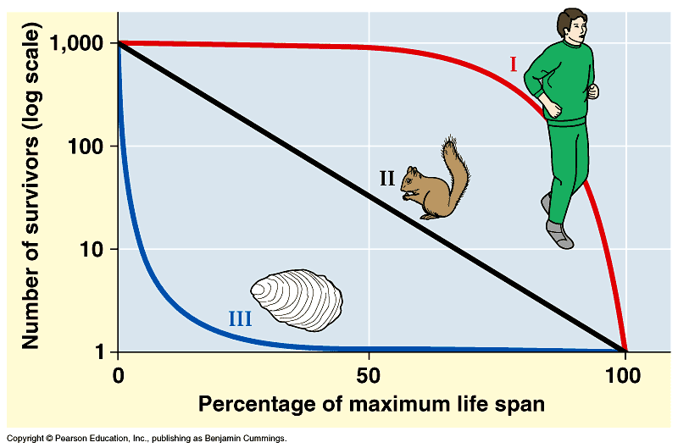
- Using the graph to the right to compare each of the following survivorship curves and give an example of each. (Activity 52B)

  - Type I

  - Type II

  - Type III

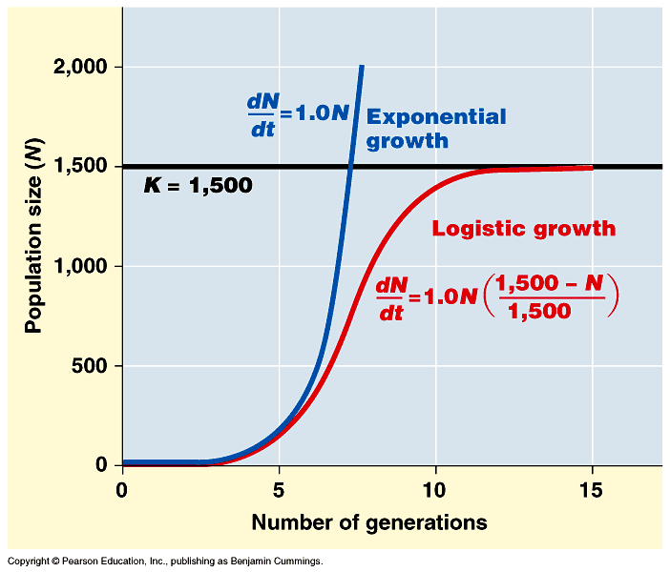
- Use the graph to the right to explain the differences, between exponential population growth and logistic population growth?

- Define carrying capacity.

- What happens to a population when the number of individuals approaches carrying capacity?

- Compare K-selected (density-dependent selection) to r-selected (density-independent selection) species. Give examples of each.

K-selected (density-dependent selection) | r-selected (density-independent selection)
Examples: | Examples:
- Identify factors that regulate population size.

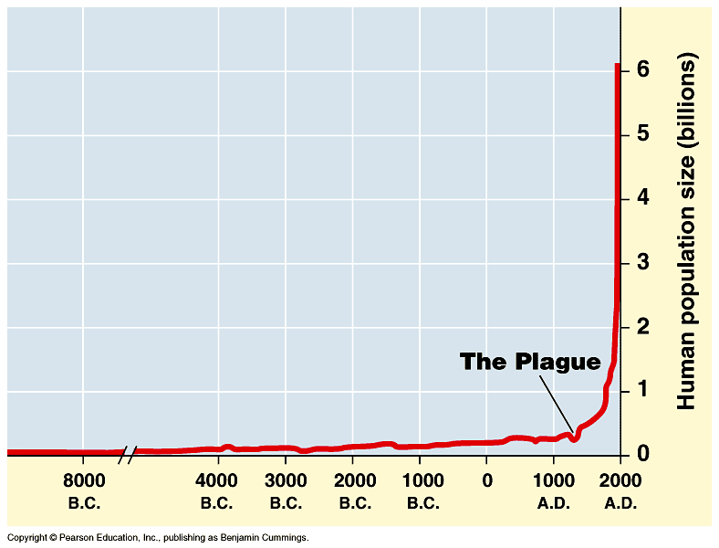
- Look at the growth curve of the human population. How does it compare to the growth curves mentioned earlier in this packet? (Activity 52C)

- Have humans reached K? What factors are significant when explaining our growth curve?

- Look at the age structure diagrams of different countries. Be prepared to discuss in class how each might influence various personal, governmental and economic policy? (Activity 52D)
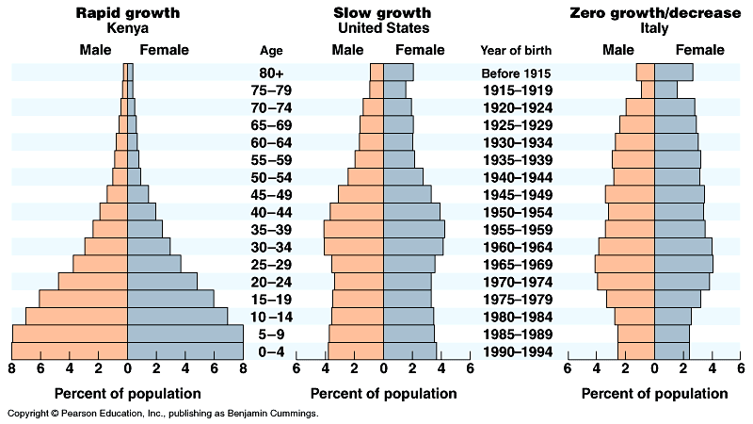

13.
Analyzing Age Structure Diagrams

Example: | Example: | Example:
Issues/Concerns: | Issues/Concerns:

Population Ecology Review Questions

___1) A group of individuals of a single species that occupy the same general area defines a -
A) population. C) community.
B) subspecies. D) clone.

___2) Which of the following is an example of a population?
A) all of the microorganisms on your skin
B) all of the students in your classroom
C) all students attending colleges and universities in your state
D) the various plants found in prairies in the western United States

___3) Assume that there are five alligators per acre in a swamp in northern Florida. This is a measure of the alligator population's -
A) dispersion. C) intrinsic rate of increase.
B) range. D) density.

___4) The pattern of distribution for a certain species of kelp is clumped. We would expect that the pattern of distribution for
a population of snails that live on the kelp would be -
A) clumped. C) homogeneous.
B) random. D) uniform.

___5) You drive through Iowa in the spring and notice that along a stretch of several kilometers, every third fence post has a male redwing blackbird perched on it defending its nesting territory. This is an example of -
A) clumped dispersion. C) random dispersion.
B) uniform dispersion. D) artificial dispersion.

___6) The density of Douglas firs in an old-growth forest is estimated by counting the Douglas firs in four sample plots of 1 hectare each. The number of fir trees in the plots is 10, 12, 7, and 11, respectively. What is the estimated density of
firs in the forest?
A) 5 trees per hectare C) 20 trees per hectare
B) 10 trees per hectare D) 25 trees per hectare

___7) A survivorship curve is a -
A) graph that plots an individual's likelihood of reproducing as a function of age.
B) graph that plots an individual's likelihood of being alive as a function of age.
C) graph that shows the effect of predation on a prey population.
D) model for population growth that incorporates the concept of carrying capacity.

___8) A Type I survivorship curve is associated with which of the following life history traits?
A) parents providing extended care for their young
B) large numbers of offspring being produced
C) infant mortality being much greater than adult mortality
D) a short life span for most individuals

___9) A survivorship curve that involves producing very few offspring, each of which has a high probability of surviving to adulthood, is typical of -
A) sea stars. C) oysters.
B) elephants. D) rodents.

___10) The maximum number of individuals a habitat can support is called its -
A) reproductive potential. C) community size.
B) carrying capacity. D) density-dependent factor.

___11) A newly mated queen ant establishes an ant nest in an unoccupied patch of suitable habitat. The population of the nest grows quickly at first, then levels off at carrying capacity. Which of the following types of equation will best describe
its population growth?
A) linear C) logistic
B) logarithmic D) exponential

___12) If an ecosystem has a carrying capacity of 1,000 individuals for a given species, and 2,000 individuals of that species
are present, we can predict that the population -
A) size will remain at equilibrium. C) will show a clumped dispersion pattern.
B) size will decrease. D) size will slowly increase.

___13) In terms of population dynamics, what is "boom-and-bust" cycling?
A) a situation in which a population moves back and forth between rapid growth and decline
B) a situation in which a growing population overshoots the carrying capacity of its environment and experiences a
crash before stabilizing
C) a situation in which the sex ratio in a population shows repeated oscillations
D) a situation in which the populations of a predator species and a prey species oscillate in unison

___14) An ecologist hypothesizes that predation by a particular owl species is the major factor controlling the population of a particular rabbit species. The first step in testing this hypothesis would be to determine -
A) whether populations of the rabbit that live outside the range of the owl have higher population densities.
B) whether the owls eat the rabbits.
C) to which diseases the rabbit population is subject.
D) what food the rabbits eat.

___15) An ecologist hypothesizes that predation by a particular owl species is the major factor controlling the population of a particular rabbit species. If this is the case, which of the following population effects could be expected in this pair?
A) A fall in the owl population should cause a fall in the rabbit population.
B) A fall in the rabbit population should cause an increase in the owl population.
C) An increase in the incidence of disease in the rabbit population should not change the owl population.
D) An increase in the owl population should cause a fall in the rabbit population.

___16) An r-selected species typically -
A) offers considerable parental care to offspring.
B) has an advantage in habitats that experience unpredictable disturbances.
C) is large-bodied and long-lived.
D) lives in stable climates.

___17) Which of the following organisms best illustrates K-selection?
A) the production of thousands of eggs every spring by frogs
B) mice that produce three litters of 10-15 babies in the course of a summer
C) a polar bear producing one or two cubs every three years
D) a species of weed that quickly spreads into a region of cleared trees

___18) Which of the following will likely decrease a population's size?
A) improving the quality of its habitat
B) increasing the size of its habitat
C) practicing sustainable resource management in its habitat
D) decreasing the food supply available to the population

___19) What is the age structure of a population?
A) the curve that results when the likelihood of dying is plotted as a function of age
B) the curve that results when the likelihood of being alive is plotted as a function of age
C) the proportion of individuals in different age groups
D) the difference in the age distribution of a population at two different points in time

___20) If most of the individuals of a human population are in their pre-reproductive years, you would expect the population
size to ________ after 20 years.
A) stay the same C) decrease
B) increase D) decrease and then stabilize

___21) The age structure of the United States in 2010 shows -
A) a broad base, suggesting a high birth rate.
B) a broad base, suggesting a low birth rate.
C) that a greater proportion of the population is elderly now than in earlier decades.
D) that the United States has not yet gone through a demographic transition.

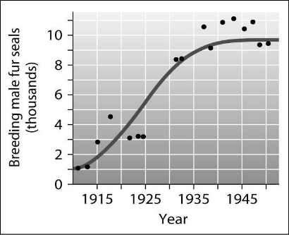
___22) According to this graph of the population growth of fur seals, in what year did the population first reach its carrying capacity?

A) 1925 B) 1930 C) 1940 D) 1950

Base your answers to questions 23 and 24 on the paragraph below

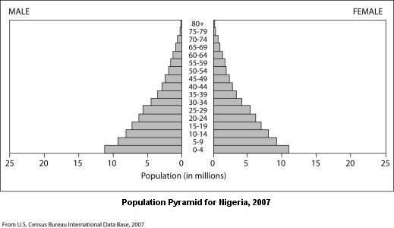
You're a member of an influential African family that's been displaced from your home by civil war. You're trying to select a new country in which to settle to gain better economic opportunities. You know that Nigeria is a large country with rich natural resources and are considering it for your new home. You've learned some basic principles of population growth and did some research on the Internet. Among the data you found was the following diagram of the current age structure of the country.

___23) The age structure data for Nigeria shows that the country has many more individuals under the age of 15 than over the
age of 40. What does this imply about the future population of Nigeria?
A) the population will probably remain stable C) the population will probably grow rapidly
B) the population will probably decrease D) the number of older people will probably increase rapidly

___24) Based on the age structure of the country, which of the following situations would be most likely over the next 20 years?
A) strong economic gains stimulated by population growth
B) an increased demand for resources based on population growth
C) a decreased demand for medical services due to the small number of elderly citizens
D) a decline in housing prices based on lack of demand
25)

Concerns for a Rapid Growing Population: Concerns for a Slow Growing Population:

26)
US Population Distribution (2015)

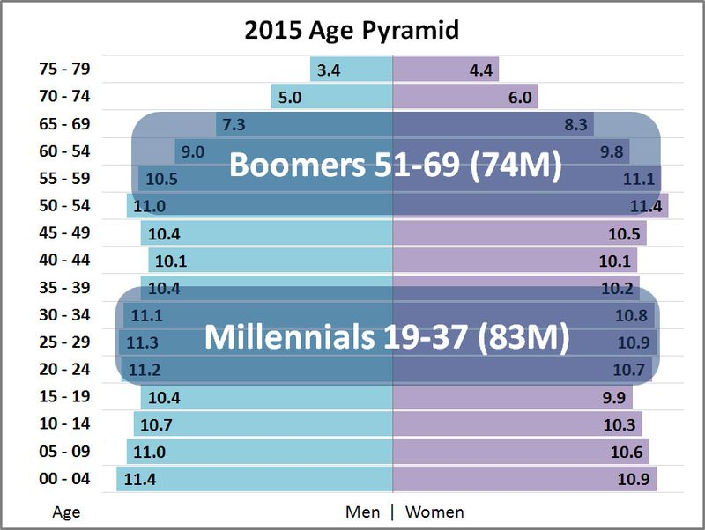

Issues / Concerns:

