|  |  |  |
| --- | --- | --- |
| AP Biology  **Interactive**  **Student**  **Study**  **Guide** | **North Salem University**  **MISSION**: *Engage students to continuously learn, question, define and solve problems through critical and creative thinking.*  Spring 2016 | |
| *Much of the information in this study guide was introduced to you in your Regents or Honors Biology class and regarded by the College Board as* ***prior knowledge****. Chapter 53 examines the different kinds of interactions among organism and addresses the central issue in community ecology: What factors are most significant in structuring a community? Chapter 54 describes the dynamics of energy flow and chemical cycling in ecosystems and considers some of the consequences of human intrusions into these processes. Chapter 55 takes a brief look at how man and science can counter the biodiversity crisis, the current rapid decrease in Earth’s great variety of life.*  ***If you have any problems – please sign up for extra help after school.*** | | **Chapters :**  **53-Community Ecology 54-Ecosystems**  **55-Conservation Biology** |

**Chapter 53: Community Ecology**

**OBJECTIVES:**

**Interspecific Interactions and Community Structure**

__1. Explain how interspecific competition may affect community structure.

__2. Describe the competitive exclusion principle and explain how competitive exclusion may affect community structure.

__3. Define an ecological niche and restate the competitive exclusion principle using the niche concept.

__4. Explain how resource partitioning can affect species diversity.

__5. Define and compare predation, herbivory, and parasitism.

__6. Relate some specific predatory adaptations to the properties of the prey.

__7. Describe the defense mechanisms that evolved in plants to reduce predation by herbivores.

__8. Explain how cryptic coloration and warning coloration aid an animal in avoiding predators.

__9. Distinguish between Batesian mimicry and Müllerian mimicry.

__10. Describe how predators use mimicry to obtain prey.

__11. Distinguish among parasitism, mutualism, and commensalism.

__12. Distinguish between a food chain and a food web.

__13. Describe the factors that transform food chains into food webs.

__14. Explain how dominant and keystone species exert strong control on community structure.

Give several examples of each.

__15. Describe and distinguish between primary and secondary succession.

**KEY TERMS:**

Batesian mimicry commensalism community competitive exclusion principle

cryptic coloration dominant species ecological niche ecological succession

food chain herbivory interspecific competition keystone species

Müllerian mimicry mutualism parasitism predation

primary succession resource partitioning secondary succession trophic level

trophic structure

- - - - - - - - - - - - - - - - - - - - - - - - - - - - - - - - - - - - - -

**WORD ROOTS:**

**crypto-** = hidden, concealed (*cryptic coloration*: a type of camouflage that makes potential prey difficult to spot against its background)

**ecto-** = outer (*ectoparasites*: parasites that feed on the external surface of a host)

**endo-** = inner (*endoparasites*: parasites that live within a host)

**herb-** = grass; **-vora** = eat (*herbivory*: the consumption of plant material by an herbivore)

**inter-** = between (*interspecific competition*: competition for resources between plants, between animals, or between decomposers when resources are in short supply)

**mutu-** = reciprocal (*mutualism*: a symbiotic relationship in which both the host and the symbiont benefit

**Guided Reading: Chapter 53**

1. What is the **competitive exclusion principle**?
2. [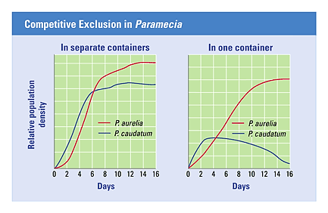](http://www.google.com/url?sa=i&rct=j&q=competitive%20exclusion%20principle%20example%20+gause&source=images&cd=&cad=rja&uact=8&docid=B3DYuuFudo1JKM&tbnid=tdr3E2bsiGGtRM:&ved=0CAUQjRw&url=http://biologytb.net23.net/text/chapter35/concept35.4.html&ei=aQ5HU72yNZe0sATb0oH4BQ&bvm=bv.64507335,d.dmQ&psig=AFQjCNHigf3qwCa7nawktlnmxqHqr5hPwA&ust=1397252032000236)Use the graph to the right to help you describe Gause’s experiment with Paramecia.
3. Use the diagram to the below to help you explain **resource partitioning**.

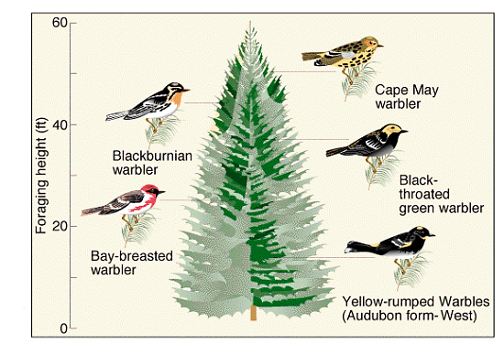

1. Describe several defense mechanisms to predation in plants.

*(Refer to your What Plants Talk About video sheet.)*

1. Define and give an example of the following animal defenses:
   1. **Cryptic coloration** -
   2. **Batesian mimicry** -
   3. **Mullerian mimicry** -

1. Define and give 2 examples of **mutualism**. ***(Activity 53A)***
2. Define and give 2 examples of **commensalism**. ***(Activity 53A)***
3. What is meant by the “**trophic structure**” of a community?

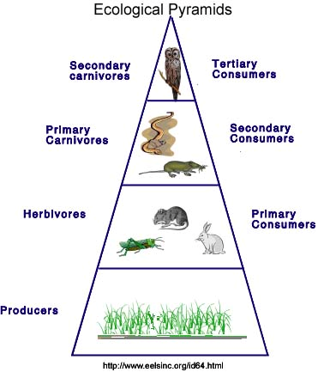

1. Explain why is the Ecological Pyramid located to the

right is shaped like a pyramid.

1. What does a **food web** show that isn’t indicated by a **food chain**? ***(Activity 53B)***
2. What limits the length of any food chain?
3. Define a **keystone species** and why are they so important to a community?
4. 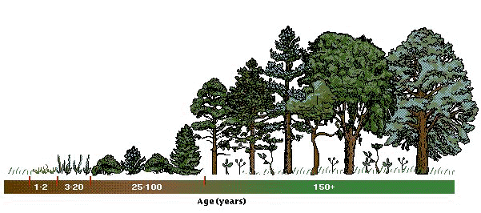 Use the diagram to the right to help you define **ecological succession**.
5. What is the difference between **primary** and **secondary succession**?

**Chapter 53: Summary of Key Concepts**

**INTERSPECIFIC INTERACTIONS AND COMMUNITY STRUCTURE**

* Populations may be linked by competition, predation, mutualism, and commensalism (pp. 1176-1181, TABLE 53.1, FIGURES 53.2-53.9) The ecological niche is the sum total of the organism’s use of the biotic and abiotic resources in its environment. The competitive exclusion principle states that two species cannot coexist in the same community if their niches are identical. Predation includes herbivory and parasitism. Predation has led to diverse adaptations in predators and prey, including mimicry. Mutualism refers to symbiotic interactions in which both species benefit. Commensalism refers to symbiotic interactions in which one species benefits and the other is not affected; there are few if any cases of pure commensalism.

*Activity53A:*[*Interspecific Interactions*](javascript:bcPopActivity('53A'))

* Trophic structure is a key factor in community dynamics (pp. 1181-1183, FIGURES 53.10-53.13) Food chains link the trophic levels from producers to top carnivores. Branching food chains form food webs. A community’s total energy input limits the length of its food chains.

*Activity53B:*[*Food Webs*](javascript:bcPopActivity('53B'))

* Dominant species and keystone species exert strong controls on community structure (pp. 1183-1185,  FIGURES 53.14, 53.15) Dominant species are the most abundant species in a community, and dominance is achieved by having high competitive ability. Keystone species are relatively rare species that exert a disproportionate influence on community structure. They are often top predators in a community.

**DISTURBANCE AND COMMUNITY STRUCTURE**

* Humans are the most widespread agents of disturbance (p. 1188) Among all animals, humans create the greatest disturbances in communities, usually reducing species diversity. Humans also prevent some naturally occurring disturbances such as fire, which can be important to community structure.
* Ecological succession is the sequence of community changes after a disturbance (pp. 1189-1191, FIGURES 53.19, 53.20) Primary succession occurs where no soil exists when succession begins; secondary succession begins in an area where soil remains after a disturbance.

*Activity53C:*[*Primary Succession*](javascript:bcPopActivity('53C'))

**Chapter 54: Ecosystems**

**OBJECTIVES:**

**What Is the Ecosystem Approach to Ecology?**

__1. Describe the relationship between autotrophs and heterotrophs in an ecosystem.

__2. Explain how decomposition connects all trophic levels in an ecosystem.

__3. Explain how the first and second laws of thermodynamics apply to ecosystems.

**Primary Production in Ecosystems**

__4. Explain why the amount of energy used in photosynthesis is so much less than the amount of solar energy that reaches Earth.

__5. Define and compare gross primary production and net primary production.

__6. Compare primary productivity in marine, freshwater, and terrestrial ecosystems.

**Secondary Production in Ecosystems**

__7. Explain why energy is said to flow rather than cycle within ecosystems.

__8. Distinguish between energy pyramids and biomass pyramids. Explain why both relationships are in the form of pyramids. Explain the special circumstances of inverted biomass pyramids.

__9. Explain why food pyramids usually have only four or five trophic levels

__10. Define the pyramid of numbers.

__11. Explain why worldwide agriculture could feed more people if all humans consumed only plant material.

**The Cycling of Chemical Elements in Ecosystems**

__12. Describe the hydrologic water cycle.

__13. Describe the nitrogen cycle and explain the importance of nitrogen fixation to all living organisms.

__14. Explain how decomposition affects the rate of nutrient cycling in ecosystems.

**Human Impact on the Chemical Dynamics of the Biosphere**

__15. Describe how agricultural practices can interfere with nitrogen cycling.

__16. Describe the causes and consequences of acid precipitation.

__17. Explain why toxic compounds usually have the greatest effect on top-level carnivores.

__18. Describe how increased atmospheric concentrations of carbon dioxide could affect Earth.

__19. Describe how human interference might alter the biosphere.

**KEY TERMS:**

acid precipitation autotrophs biogeochemical cycles biological magnification

biomass detritus ecosystem greenhouse effect

heterotrophs gross primary productivity net primary productivity nitrogen fixation

trophic level

- - - - - - - - - - - - - - - - - - - - - - - - - - - - - - - - - - - - - -

**WORD ROOTS:**

**auto-** = self;

**troph-** = food, nourishment (*autotroph*: an organism that obtains organic food molecules without eating other organisms)

**bio-** = life;

**geo-** = the Earth (*biogeochemical cycles*: the various nutrient circuits which involve both biotic and abiotic components of

ecosystems)

**de-** = from, down, out (*denitrification*: the process of converting nitrate back to nitrogen)

**Guided Reading: Chapter 54**

1. What is needed to maintain a **self-sustaining ecosystem**?
2. Label the diagram below representing an **overview of ecosystem dynamics**. *(Activity 54B)*

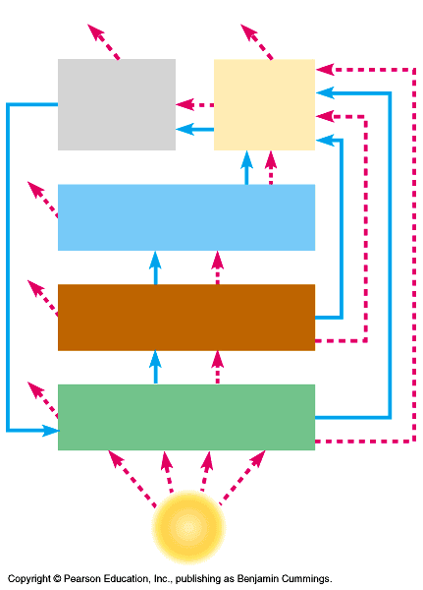

1. What are **detritivores** and what is their major function?
2. Define the following energy budget terms:

**a.** **Primary productivity** –

**b.** **Gross primary productivity** –

**c.** **Net primary productivity** -

1. Which ecosystems have the **HIGHEST productivity** per unit area?
2. What factors do you think contribute to such high productivity?
3. Which ecosystems have the **LOWEST** **productivity** per unit area?
4. Why is the open ocean so low in productivity?
5. What is **secondary productivity**?
6. What happens to the size each level in the idealized **pyramid as energy** is transferred through the trophic levels?
7. Explain what happens to the **ENERGY** and **BIOMASS** as it is passed through the trophic levels?
8. Why is it essential that elements move through **biogeochemical cycles** in the ecosystem?
9. Label the diagram of the **Water Cycle** below. Is this mainly a PHYSICAL or CHEMICAL process?

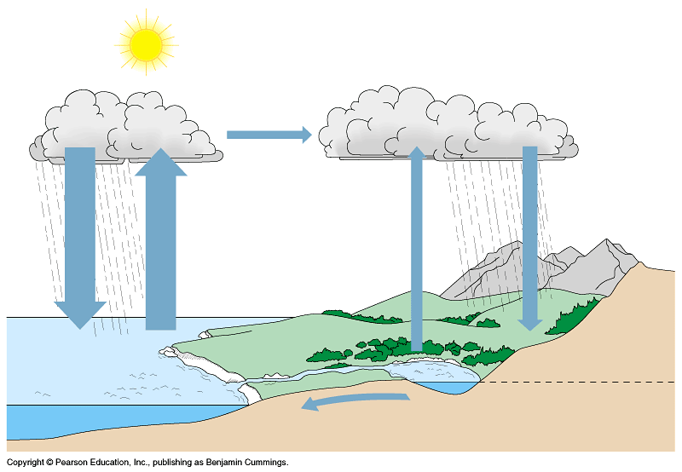

**The Water Cycle**

**(*Activity 54E* / Fig. 54.16)**

1. What is the source of **acid rain** and why is it a problem?
2. What percentage of the Earth’s atmosphere is composed of nitrogen?
3. What important organic compounds are composed of nitrogen?
4. Label the diagram of the **Nitrogen Cycle** below and identify the role each chemical process plays in the cycle.

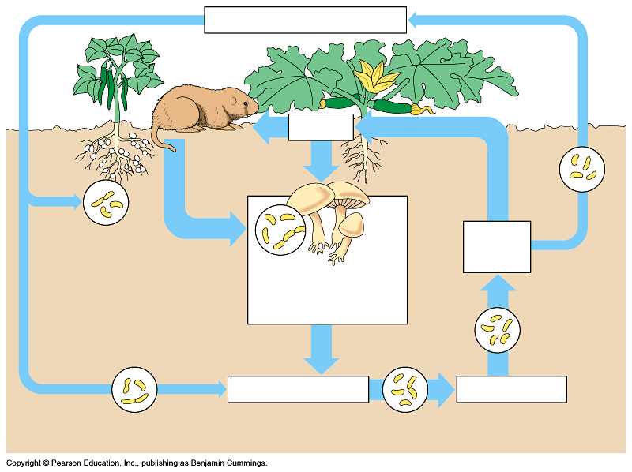

**The Nitrogen Cycle** - ***(Activity 54 D / Fig.54.18)***

**a.** **Nitrogen fixation** -

**b.** **Ammonification** -

**c.** **Nitrification** -

**d.** **Denitrification** -

**e.** **Assimilation** -

1. Label the diagram of the Carbon Cycle below and identify the role each chemical process plays in the movement of carbon through the ecosystem.

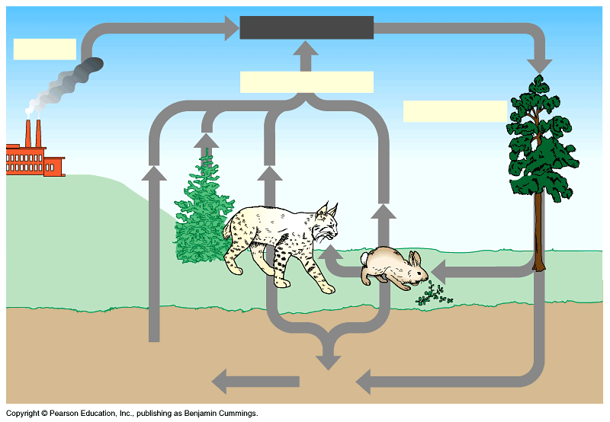

**The Carbon Cycle**

***(Activity 54B/C and Fig. 54.17)***

**a.** **Combustion** -

**b.** **Photosynthesis** -

**c.** **Cellular Respiration** -

1. Why is human population growth at the root of environmental issues?
2. Label the diagram of the **Biological Magnification of DDT in the Food Chain** below and use it to explain what happens in the process of biological magnification. *(Fig. 54.25)*

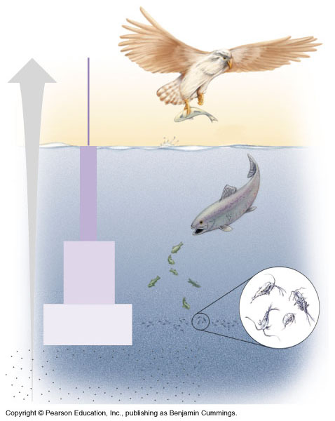

1. What are some of the properties of molecules that could be candidates for **biological magnification**?
2. 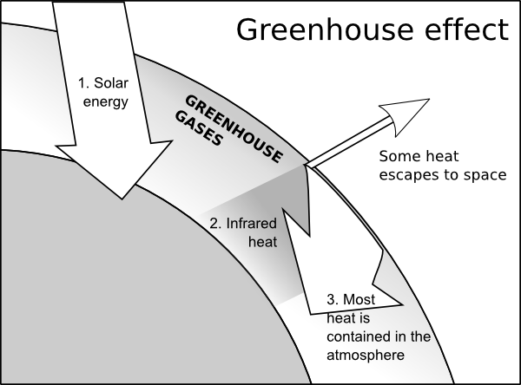Use the diagram to the right to help you explain the greenhouse effect.

1. Is the greenhouse effect a **GOOD** or **BAD** thing? Explain.
2. What are possible reasons for **global warming** (*greenhouse effect*)? (*Activity 54F*)
3. What is the function of the ozone layer?
4. List three sources of chlorofluorocarbons (CFC’s) ___________________________

___________________________

___________________________

1. Is **depletion of the ozone layer** a possible reason for global warming? YES or NO
2. List three possible consequencies of continued ozone depletion.

**a)** _________________________________________________________________________

**b)** _________________________________________________________________________

**c)** _________________________________________________________________________

**Chapter 55: Conservation Biology**

**OBJECTIVES:**

**The Biodiversity Crisis**

**__1.** Describe the three levels of biodiversity.

**__2.** Explain why biodiversity at all levels is vital to human welfare.

**__3.** List the four major threats to biodiversity and give an example of each.

**Conservation at the Community, Ecosystem, and Landscape Levels**

**__4.** Explain why natural reserves must be functional parts of landscapes.

**__5.** Define restoration ecology and describe its goals. Explain the importance of bioremediation and the augmentation of ecosystem processes in restoration efforts.

**__6.** Describe the concept of sustainable development.

**__7.** Explain the goals of the Sustainable Biosphere Initiative.

**__8.** Define biophilia and explain why the concept gives some biologists hope.



**Guided Reading: Chapter 55**

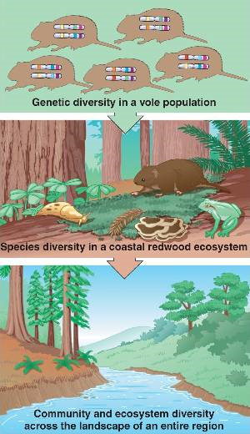

1. Use the diagram to the right to help you

describe the three levels of biodiversity.

1. Explain why biodiversity at all levels is vital to human welfare.
2. In the table below, list the four major threats to biodiversity and give an example of each.

|  |  |  |
| --- | --- | --- |
|  | **Biodiversity** | |
|  | **Threat** | **Example** |
| **1** |  |  |
| **2** |  |  |
| **3** |  |  |
| **4** |  |  |

*(Remember:* ***H I P P O*** *from Honors Biology?)*

1. Define restoration ecology and describe its goals.

1. Explain the importance of bioremediation and the augmentation of ecosystem processes in restoration

efforts.

1. Describe the concept of sustainable development.
2. Explain the goals of the Sustainable Biosphere Initiative.
3. Define biophilia and explain why the concept gives some biologists hope.

**Review Questions**

___1) A community is composed of -

A) potentially interacting populations of different kinds of organisms.

B) one species of organism living in a specific environment on Earth.

C) living organisms and their nonliving environment.

D) the factors that constitute an organism's niche.

___2) One reason it is important to understand community ecology is -

A) to understand the life cycle of fish, such as cichlids.

B) for identification of stomach microbes.

C) to aid in conservation of endangered species.

D) to provide an enriched habitat for humans.

___3) An owl and a hawk both eat mice. Which of these describes the relationship between a hawk and an owl?

A) predation C) mutualism

B) competition D) parasitism

___4) When two different populations in a community benefit from their relationship with each other, the result is called -

A) benefism. C) parasitism.

B) mutualism. D) competition.

___5) Which of the following is an example of predation?

A) a lizard's camouflage

B) a hawk swooping down quickly to capture, kill, and eat a prairie king snake

C) a goldfinch feeding on the seeds of a thistle plant

D) the vivid colors of the poison-arrow frog in Costa Rica

___6) The sum total of a population's use of the biotic and abiotic resources of its habitat constitutes its -

A) environment. C) range.

B) evolution. D) niche.

___7) In an ecosystem, you would expect to find interspecific competition between -

A) males and females of a species in which both sexes occupy the same niche.

B) populations of two species that occupy the same niche.

C) a prey species and its predator.

D) two wasp species that mimic each other's appearance.

___8) Camouflage typically evolves as a result of -

A) predation. C) mutualism

B) interspecific competition. D) herbivory.

___9) Most plants have a variety of chemicals, spines, and thorns because the plants -

A) cannot run away from herbivores. C) are camouflaged into their surroundings.

B) feed on the organisms that try to eat them. D) are relying upon Batesian mimicry.

___10) Within an ecosystem, a tree is a -

A) secondary consumer. C) primary consumer.

B) detritivore. D) producer.

___11) On Earth, most organic molecules are produced by -

A) photosynthesis. C) hydrolysis

B) glycolysis. D) cellular respiration.

___12) In a hypothetical food chain consisting of grass, grasshoppers, sparrows, and hawks, the grasshoppers are -

A) primary consumers. C) secondary consumers.

B) primary producers. D) secondary producers.

___13) In a food chain consisting of phytoplankton → zooplankton → fish → fishermen, the fishermen are -

A) secondary consumers. C) quaternary consumers

B) tertiary consumers. D) secondary producers.

___14) Organisms that digest molecules in organic material and convert them into inorganic forms are -

A) primary consumers. C) primary producers

B) decomposers. D) detritivores.

___15) In a certain ecosystem, field mice are preyed on by snakes and hawks. The entry of wild dogs into the system adds another predator of the mice. Of the following, the most likely short-term result of this addition is -

A) an increase in snake population. C) a reduction in numbers of mice.

B) a tendency for hawks to prey on the dogs. D) migration of the hawks to another ecosystem.

­­___16) Which of the following statements regarding food webs is *true*?

A) A consumer eats only one type of producer.

B) Detritivores consume dead organic matter from a specific trophic level.

C) Several species of primary consumers may feed on the same species of producer.

D) Nutrient transfer moves from producer to consumer and back.

___17) We expect that a keystone species that is a predator will -

A) maintain the species diversity in a community. C) help many of its prey reproduce.

B) harvest prey species down to extinction. D) reduce the diversity of the community.

___18) When a New England farm is abandoned, its formerly plowed fields first become weedy meadows, then shrubby areas, and finally forest. This sequence of plant communities is an example of -

A) evolution. C) secondary succession.

B) a trophic chain. D) primary succession

___19) Non-native species that are introduced in new environments, spread far beyond the original point of introduction, and cause damage are called -

A) destructive species. C) invasive species.

B) enemy species. D) proprietary species.

___20) Biological control is defined as -

A) the use of chemicals, such as pesticides, to control pests.

B) the intentional release of a natural enemy of a pest population.

C) the exploitation of coevolutionary principles to produce pesticides.

D) an intentional attempt to increase the numbers of specific prey populations.

___21) The flow of ________ into ecosystems occurs in one direction only, while ________ are recycled within the ecosystem itself.

A) minerals . . . energy compounds C) organic compounds . . . minerals

B) genetic information . . . genotypes D) energy . . . chemicals

___22) The amount of solar energy converted to chemical energy in organic compounds is called -

A) primary succession. C) primary production.

B) secondary succession. D) secondary production.

___23) Given that CO2 is produced by cellular respiration, why does the amount of CO2 in the atmosphere remain relatively constant? (*When answering this question, exclude the impact of human activities on atmospheric CO2*).

A) CO2 is converted in photosynthesis to carbohydrates.

B) CO2 is split apart during photosynthesis.

C) CO2 mostly forms carbonate rocks.

D) CO2 is trapped in dead organisms' bodies.

___24) Carbon mainly cycles between the biotic and abiotic worlds through the processes of -

A) cellular respiration and transpiration. C) evaporation and photosynthesis.

B) transpiration and photosynthesis. D) cellular respiration and photosynthesis.

___25) Which of the following statements about the nitrogen cycle is *true*?

A) The nitrogen cycle requires different types of bacteria.

B) Nitrogen gas is converted to nitrates in plant leaves.

C) Nitrogen cannot be cycled through living organisms.

D) When plants and animals die, nitrogen is removed from the nitrogen cycle.

___26) Which of the following represents a step in the nitrogen cycle?

A) nitrogen-fixing bacteria convert atmospheric nitrogen to nitrates

B) nitrites bind to soil particles

C) nitrogen-fixing bacteria convert atmospheric nitrogen to ammonium

D) denitrifiers convert ammonium to atmospheric nitrogen

___27) Denitrifying bacteria convert ________ to ________.

A) ammonium . . . nitrates C) nitrogen gas . . . nitrates

B) nitrates . . . nitrogen gas D) nitrogen gas . . . nitrites

___28) Which of the following ecological problems might result from fertilizing a golf course with phosphorus-rich fertilizer?

A) poisoning of the grass caused by excess phosphorus

B) heavy growth of algae and cyanobacteria in lakes and rivers caused by phosphorus runoff

C) accumulation of toxic levels of phosphorus in animals in the vicinity, especially those higher on the food chain

D) a slowdown in the weathering of rock that releases phosphates into the soil under natural conditions

___29) Eutrophication of a lake could occur if -

A) phosphate-rich detergents were dumped into the lake.

B) fertilizers were applied in an insoluble form.

C) runoff from over fertilized lawns was prevented from reaching the lake.

D) fish were removed.

___30) One of the most worrisome results of the large-scale clearing and cultivation of land is -

A) erosion and soil degradation. C) the inability fo supply enough food for growing populations.

B) the inability to supply fresh water. D) hurricanes.

***Base your answers to questions 31 – 36 on the diagram of a terrestrial food chain below.***

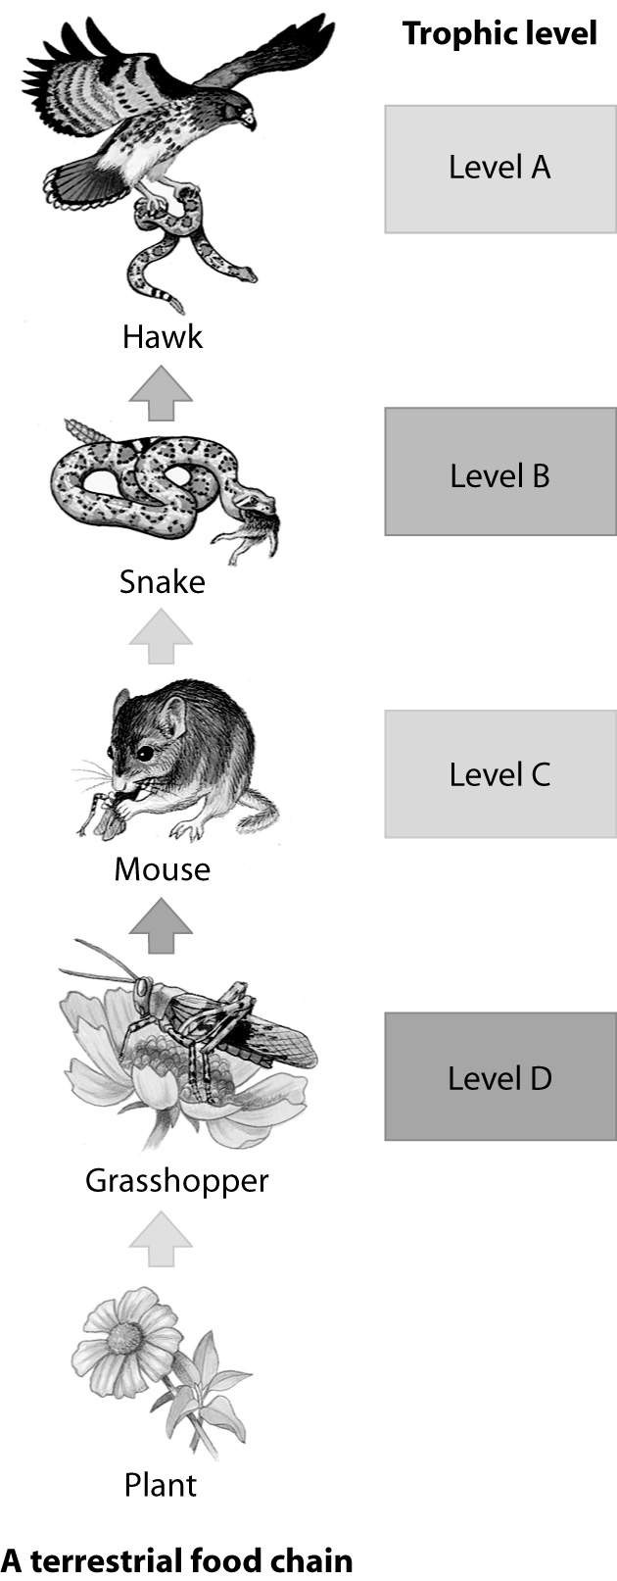

___31) Which trophic level in this food chain

represents the primary consumer?

___32) Which trophic level in this food chain

represents the secondary consumer?

___33) Which trophic level in this food chain

represents the tertiary consumer?

___34) Which trophic level in this food chain

contains an herbiviore?

___35) Which trophic level in this food chain

contains the greatest biomass?

___36) Which trophic level in this food chain

contains the least biomass?

***Base your answers to questions 37 – 40 on the diagram of the carbon cycle below.***

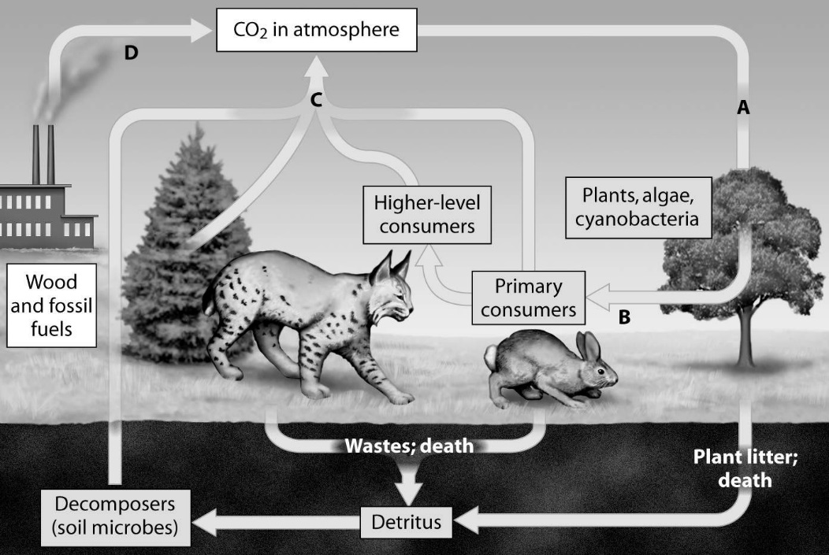

___37) Which arrow shows CO2 released as a product of cellular respiration?

___38) Which arrow shows CO2 released as a product of burning and combustion?

___39) Which arrow shows CO2 being removed during photosynthesis?

___40) Which arrow shows Carbon entering the food chain?

***Base your answers to questions 41 – 44 on the diagram of the nitrogen cycle below.***

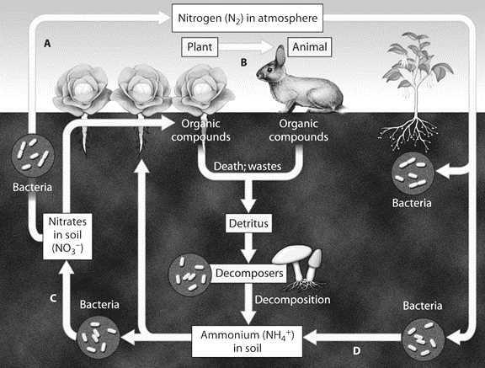

___41) Which arrow shows nitrogen fixation?

___42) Which arrow shows the products of denitrifying bacteria.

___43) Which arrow shows nitrification?

___44) Which arrow shows nitrogen entering the food chain?

___45) The primary goal of conservation biology is to -

A) estimate the total number of species that exist. C) maximize the land set aside for wildlife.

B) integrate human culture back into nature. D) counter the loss of biodiversity.

___46) Biodiversity considers -

A) the genetic diversity within and between populations of a species.

B) the fate of water in the ecosystem.

C) commensal relationships between species.

D) the relationships of individuals to a food chain.

___47) Currently, the single greatest threat to biodiversity is -

A) global warming. C) habitat destruction due to humans.

B) the introduction of exotic species. D) overexploitation of populations for food.

___48) You arrive back in the United States after having visited a foreign country located on another continent. The customs agent stops the person in front of you and confiscates the fruit basket this person is bringing home. Being the knowledgeable person you are, you calmly explain to your enraged fellow traveler that the reason for the detainment is that the fruit basket may be -

A) carrying endangered fruit.

B) carrying an exotic species that could damage North American ecosystems.

C) contaminated with CFCs that will damage the ozone layer above North America.

D) contaminated with sufficient DDT to cause serious harm to anyone who eats the fruit.

___49) The three greatest current threats to biodiversity, in order starting with the greatest, are -

A) habitat loss, overharvesting, and invasive species. C) habitat loss, invasive species, and overharvesting.

B) invasive species, habitat loss, and overharvesting. D) invasive species, overharvesting, and habitat loss.

___50) DDT and mercury -

A) were once used as an energy source. C) contribute to acid precipitation.

B) accumulate in the tissues of organisms. D) deplete the ozone layer.

___51) Which of the following is a likely consequence of the thinning of the ozone layer?

A) increases in skin cancer C) increases in escape of heat from Earth

B) global warming D) decreases in flying insect populations

___52) You spray your lawn with a pesticide. The concentration of the pesticide in the tissues of the grass on your lawn is

10-6 parts per million (ppm). Grasshoppers eat the grass and are in turn eaten by rats, which are then eaten by owls.

At each successive trophic level, the concentration of pesticides increases. The term for this process is -

A) biological extirpation. C) biological magnification.

B) trophic concentration. D) bioconcentration.

___53) Global warming is the result of -

A) rises in ocean levels. C) rising concentration of greenhouse gases.

B) increased solar activity. D) pollution.

___54) Greenhouse gases include -

A) nitrous oxide and oxygen. C) nitrogen and oxygen.

B) carbon dioxide and nitrogen. D) carbon dioxide and methane.

___55) CO2 in the atmosphere is absorbed by ________ and converted into biomass.

A) the ozone layer C) other atmosphere gases

B) photosynthetic organisms D) large land masses

___56) Scientists worry that global warming will result in the oceans -

A) becoming more acidic. C) becoming more basic.

B) containing less dissolved oxygen. D) containing less dissolved carbon dioxide.

___57) One way in which populations and species have been responding to climate change is by -

A) changing their coat color. C) shifting their distribution.

B) changing their metabolism. D) evolving a flexible mode of reproduction.

___58) Some populations, especially those with high genetic variability and short life spans, may avoid extinction as the climate changes through -

A) genetic shift. C) feedback inhibition.

B) distribution of populations. D) evolutionary adaptation.

___59) Captive breeding -

A) has allowed for the re-introduction of many species to areas from which they had disappeared.

B) has advanced to the point where biologists believe it can be used to save most endangered species.

C) can work for animals, but is generally not used for endangered plants.

D) is the main conservation technique used to try to save endangered species from extinction.

___60) If wolves were now removed from Yellowstone National Park, we would expect that -

A) elk populations would increase.

B) deer populations would decrease.

C) the vegetation would remain unchanged.

D) vegetation would increase, providing shelter for smaller animals.

___61) The aspect of conservation ecology concerned with returning degraded ecosystems (as nearly as possible) to their natural state is -

A) bioremediation. C) sustainable development.

B) restoration ecology. D) landscape ecology.

___62) Using living organisms to clean up polluted ecosystems is known as -

A) biological demagnification. C) PVA.

B) bioremediation. D) landscaping.