|  |  |  |
| --- | --- | --- |
| ­­­ AP Biology  **Student**  **Interactive**  **Learning**  **Guide** | **North Salem University**  **MISSION**: *Engage students to continuously learn, question, define and solve problems through critical and creative thinking.*  Fall 2018 | |
| Now you know how photoautotrophs tap into the ultimate source of energy for our planet…the sun, and convert and store this energy in the chemical bonds of glucose. You also know how organisms convert these organic molecules (*glucose*) into another USABLE form of chemical energy called Adenosine Tri-Phosphate (*ATP*). We’ll now take a look at how human physiology (*structure*) allows us to accomplish this complex biochemical process (*function*) by ***obtaining***,  ***transporting*** *and* ***regulating*** the reactants (*glucose and oxygen*) around **TO** all the cells of the body and getting rid of the by-products (*carbon dioxide and water*) **FROM** all the cells of the body.  ***If you have any problems – please sign up for extra help after school.*** | | **Chapters 11/41/42:**  **Cell Communication Carbohydrate Digestion**  **Blood Sugar Regulation**  **Gas Exchange** |

**Chapter 11: Cell Communication**

___1. Describe how hormones function in long distance cell communication.

___2. Describe the two basic methods of direct contact communication between cells.

___3. Describe the three main stages of cell signaling.

___4. Compare and contrast the signaling mechanisms between peptide and steroid hormones.

**Chapter 41: Animal Nutrition**

___1. Describe the steps involved in the regulation of blood sugar in animals.

___2. What are essential amino acids and essential fatty acids?  
___3. Contrast vitamins and minerals.  
___4. Define the following terms: Ingestion -Digestion -Enzymatic hydrolysis -Absorption - Elimination  
___5. Contrast intracellular and extracellular digestion.

___6. Label a diagram of the Human Digestive System and explain the role each plays in the mechanical and chemical breakdown of carbohydrates.

___7. Explain how the structure of the small intestine allows it to perform its main function of absorption.

___8. Explain role(s) the liver and pancreas play in glucose metabolism?

**Chapter 42: Circulation and Gas Exchange**

___1. Relate the structures of capillaries, arteries, and veins to their functions.

___2. Define gas exchange.

___3. Describe the general requirements for a respiratory surface.

___4. Label a diagram of the human respiratory system.

___5. Describe the movement of air through air passageways to the alveolus, listing the structures that air must pass through on its journey.

___6. Compare positive and negative pressure breathing. Explain how respiratory movements in humans ventilate the lungs.

___7. Explain how breathing is controlled.

___8. Describe how carbon dioxide is picked up at the tissues and deposited in the lungs.

**Guided Reading: Chapter 11**

1. What is a signal transduction pathway?
2. Label the diagram below and use it to help you describe the long distance cell communication that takes place in animals?

**Hormonal Signaling**

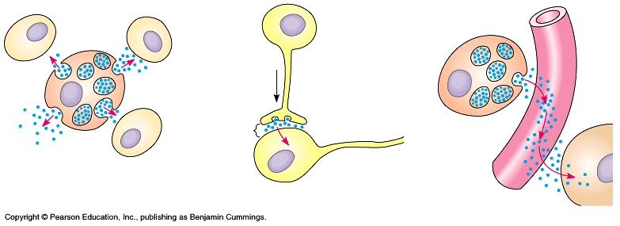

1. Label the diagrams below and use them to help you describe the 2 basic methods of communication by direct contact between cells.

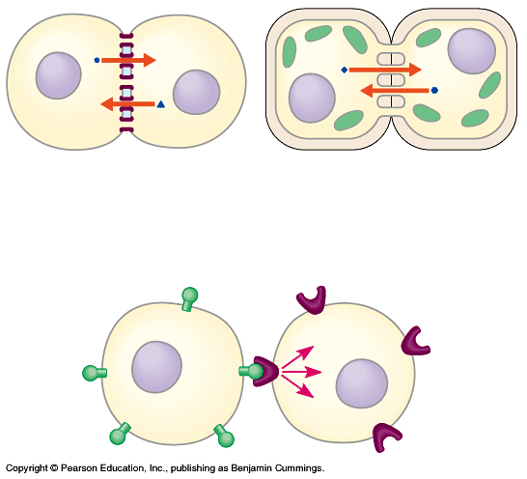 **Cell Junctions Cell-Cell Recognition**



1. A signal transduction pathway has three stages. Use **Figure 11.5** to label the missing parts of the preview figure below, and then briefly explain each step.

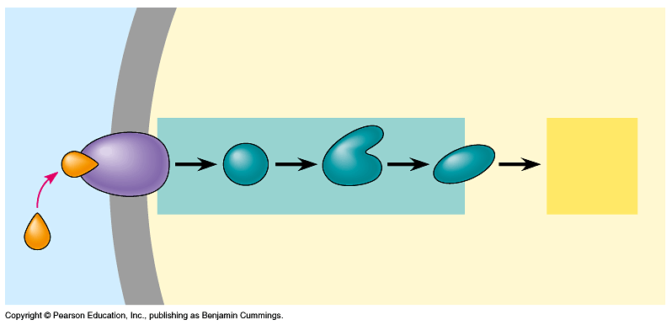**Reception -**

**Transduction -**

**Response -**

**5.** Use Figure **45.3** to help describe the differences between the two main mechanisms of chemical signaling depending on the chemical nature (*peptide/steroid*) of the hormone.

**Peptide Hormones: Receptor in plasma membrane**

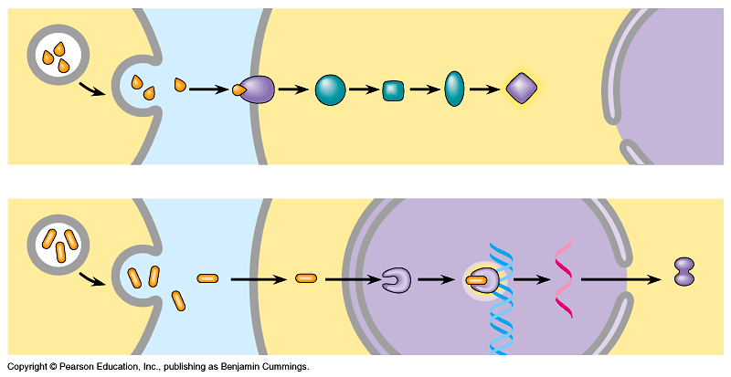

**Steroid Hormones: Receptor in cell nucleus**



**Guided Reading: Chapter 41**

1. Complete the diagram below concerning animal homeostasis and blood sugar regulation.

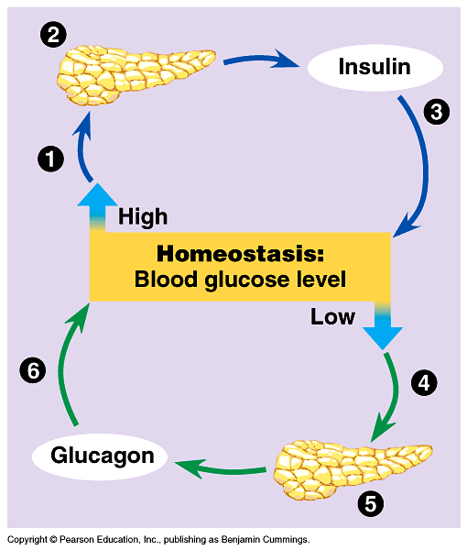

**(1)**

**(2)**

**(3)**

**(4)**

**(5)**

**(6)**

1. What are essential amino acids and essential fatty acids?
2. Contrast vitamins and minerals.

1. Define the following terms:
   1. **Ingestion** -
   2. **Digestion** -
   3. **Enzymatic hydrolysis** -
   4. **Absorption** -
   5. **Elimination** -
2. Contrast intracellular and extracellular digestion.

1. 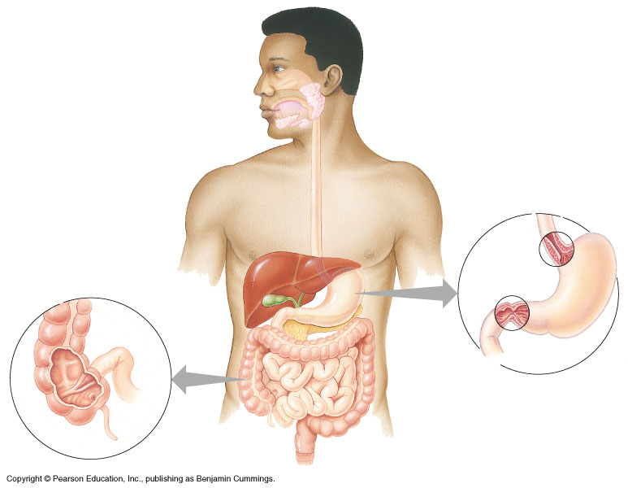Label the diagram below of the human digestive system.
2. What are the accessory glands of the digestive system and why are they called “accessory” – are they part of the digestive tract?

1. Why is the advantage of secreting some enzymes in their inactive form?
2. Label the diagram of the first part of the small intestine – what activities are occurring here?

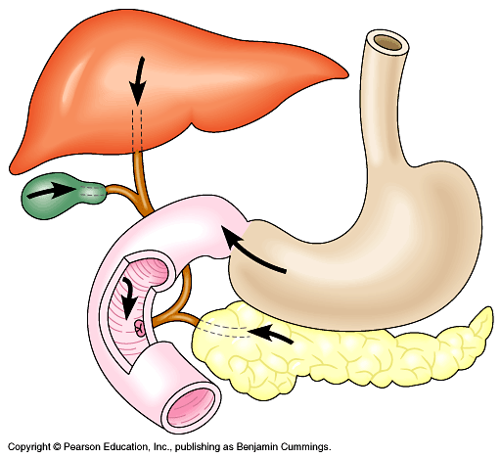

1. How is the small intestine adapted for nutrient absorption?

**11.** What role does the liver and pancreas play in glucose metabolism?

**Chapter 42: Guided Reading**

1. What are the limits to diffusion as a means of transport for living organisms?

1. 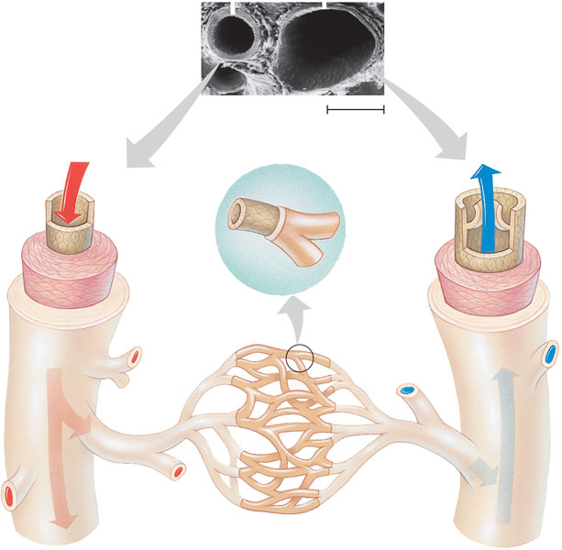Label the diagram below concerning the **structure** of blood vessels and use it to describe the major **functions** of the major types of blood vessels:

**a. Arteries –**

**b. Veins –**

**c. Capillaries -**

1. Why is gas exchange necessary to all living organisms?
2. Considering the rate of diffusion, why is it essential for respiratory surfaces to maximize surface area?
3. Why do organisms with lungs require a circulatory system?

1. Label the diagram of the human respiratory system.

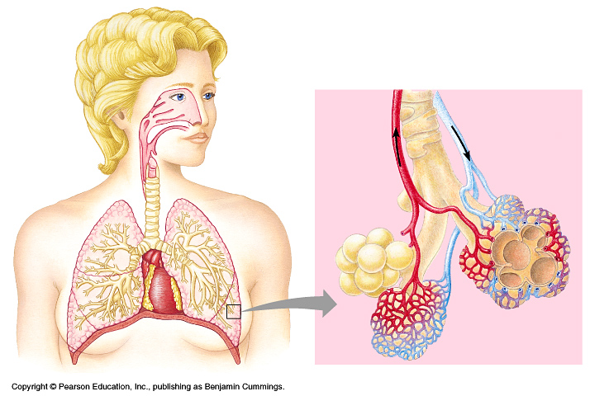

1. What are the characteristics of a respiratory surface.

**a)**

**b)**

**c)**

**d)**

1. Label the diagram below and use it to describe the process of inhalation and exhalation with regard to the contraction of the diaphragm. Which is an active process and which is passive?

*Be sure to discuss the relationship between pressure and volume (Boyle’s Law) in your answer.*

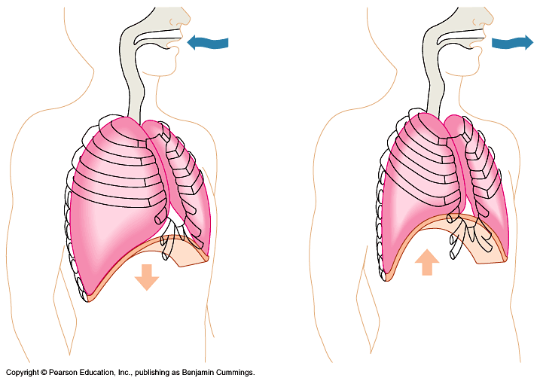

1. Label the diagram below concerning the automatic control of breathing in humans.

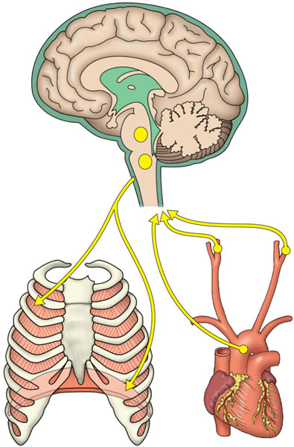  
 **a)** List the 3 ways CO2 is transported in the blood.

**(1)**

**(2)**

**(3)**

**b)** What [gas] does the medulla regulate and what does it detect in order to do this?

**Review Questions**

1) All animals must obtain ________ from outside sources.

A) preformed ATP C) enzymes

B) fuel to power body activities D) chyme

2) Digestion is the -

A) absorption of nutrients suspended in water.

B) conversion of glycogen to glucose.

C) breaking down of food into molecules small enough for the body to absorb.

D) churning of food in the stomach and intestine.

3) What happens to nutrient macromolecules in an animal's digestive tract?

A) They are absorbed whole and are broken down into monomers in cells that ultimately use them.

B) Proteins and nucleic acids are digested into monomers before absorption; energy-storage macromolecules (starch and fat) are absorbed whole.

C) The digestive breakdown of macromolecules is keyed to the body's need for monomers; only the monomers that are immediately needed are produced.

D) Nutrient macromolecules are digested into monomers before absorption.

4) Through digestion, polysaccharides are broken down into -

A) fatty acids. C) glycerols.

B) monosaccharides. D) amino acids.

5) Through digestion, nucleic acids are broken down into -

A) fatty acids. C) nucleotides.

B) glycerols. D) amino acids.

6) Which of the following correctly lists the order of the parts of the human digestive system, from first to last contact with food matter?

A) pharynx, oral cavity, esophagus, stomach, large intestine

B) oral cavity, pharynx, esophagus, stomach, small intestine, large intestine

C) esophagus, pharynx, stomach, small intestine, large intestine

D) oral cavity, esophagus, stomach, large intestine, small intestine

7) Smooth muscle propels food through the alimentary canal by a process called -

A) circular contractions. C) active transport.

B) diffusion. D) peristalsis.

8) The chemical digestion of carbohydrate/starch begins in the -

A) tongue. C) esophagus.

B) oral cavity D) stomach.

9) What is the name given to the starch-digesting enzyme secreted by salivary glands?

A) toothpickase C) protease

B) lipase D) amylase

10) In the digestive system, most nutrient absorption occurs in the -

A) stomach. C) small intestine.

B) pancreas. D) large intestine.

11) Epithelial cells lining the intestine have surface projections that increase nutrient absorption.

These projections are called -

A) villi. C) microvilli.

B) cilia. D) rugae.

12) What is the main digestive function of the pancreas?

A) to produce digestive enzymes and bile salts

B) to produce digestive enzymes and an alkaline solution

C) to produce bicarbonate-containing mucus

D) to aid in the control of cholesterol

13) Nutrients absorbed by the intestines move directly to the liver, which -

A) converts the nutrients into monomers.

B) converts excess glucose to glycogen.

C) manages the amount of glucose that is converted to polysaccharides.

D) converts glucose to alcohol.

14) Which arrow shows the release of digestive enzymes by the pancreas?

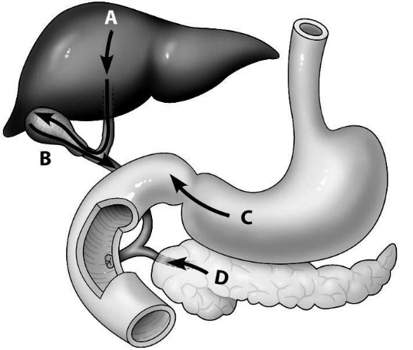

A) arrow A B) arrow B C) arrow C D) arrow D

15) How are hormones distributed to tissues, and what determines which cells hormones will affect?

A) They are carried throughout the body in the bloodstream, and each hormone affects target cells that have receptors for it.

B) They are carried to specific organs by lymphatic vessels and affect the cells in those organs.

C) They are delivered by neurosecretory cells to specific tissues and cells, which are affected.

D) They are distributed locally in the interstitial fluid and affect nearby responsive target cells.

16) The two main classes of molecules that function as hormones are steroid hormones and hormones that are derived from -

A) amino acids. C) nucleic acids.

B) cholesterol. D) long-chain fatty acids.

17) Which of the following options lists the sequence of events in the cell-signaling process in the correct order?

A) reception, response, signal transduction C) signal transduction, response, reception

B) signal transduction, reception, response D) reception, signal transduction, response

18) Why do some hormones bind to membrane receptors on a target cell's surface in order to activate it?

A) for activation by ATP

B) because they are not water-soluble

C) because they cannot cross cell membranes

D) to stimulate endocytosis to internalize the hormone

19) The result of binding a signal molecule to its receptor is -

A) production of a protein by the target cell, followed by death.

B) cell division.

C) signal transduction.

D) partitioning of the nucleus within the target cell.

20) Steroid hormones are lipids made from -

A) amino acids. C) nucleic acids.

B) cholesterol. D) carbohydrates and amino acids.

21) Which gland exerts primary control over the concentration of sugar in the blood?

A) liver C) pancreas

B) pineal D) parathyroid

22) Which of the following statements best describes the relationship of insulin to glucagon?

A) They work together to prepare the body to deal with stress.

B) Insulin stimulates the pancreas to secrete glucagon.

C) They are antagonistic hormones.

D) Insulin is a steroid hormone; glucagon is a protein hormone.

23) When the concentration of glucose in the blood rises following digestion of a meal, what is the hormonal response?

A) Levels of both glucagon and insulin increase. C) More insulin is released.

B) More glucagon is released. D) Neither glucagon nor insulin is released.

24) Which of the following hormones causes glucose release and, consequently, a rise in the concentration of sugar in the blood?

A) insulin C) estrogen

B) glucagon D) testosterone

25) Which molecule in this figure portraying 26) Which step in this figure portraying

water-soluble hormone action is the receptor lipid-soluble hormone action shows

protein? transcription in response to the bound

A) molecule A hormone-receptor complex?

B) molecule B A) step 1

C) molecule C B) step 2

D) molecule D C) step 3

D) step 4

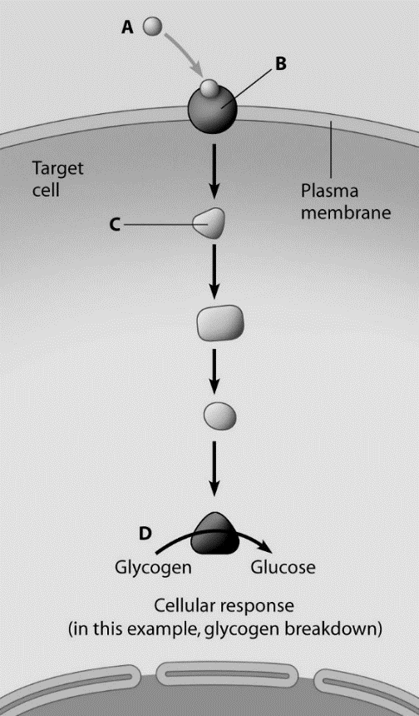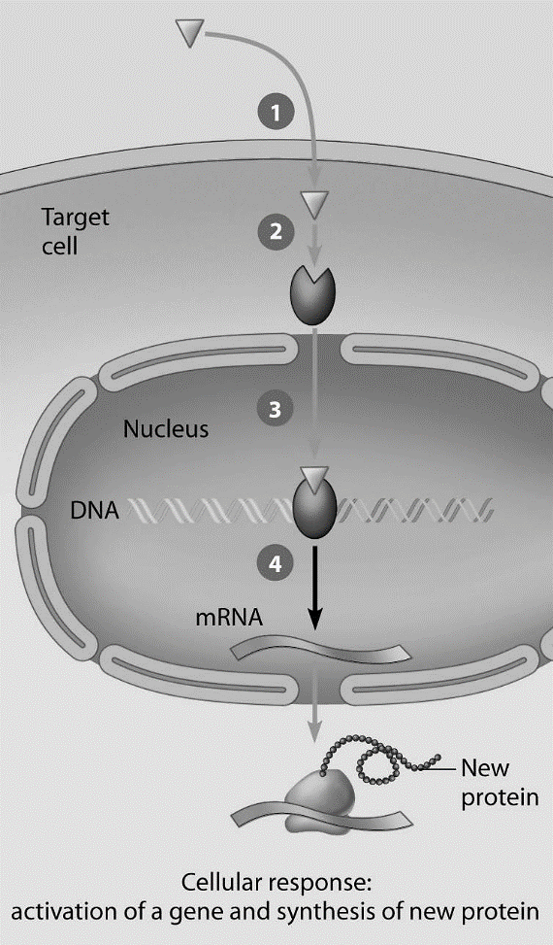

27) The reason animals need a continuous supply of oxygen is to -

A) make carbon dioxide. C) carry out glycolysis.

B) dispose of carbon dioxide. D) obtain energy from their food.

28) A waste product of cellular respiration is -

A) electrons. C) carbon dioxide.

B) hydrogen peroxide. D) glucose.

29) When you exhale, you -

A) exchange CO2 for O2.

B) take up oxygen and release carbon dioxide to the blood.

C) take up carbon dioxide and release oxygen.

D) remove CO2 from the body.

30) During gas exchange, body cells -

A) take up CO2 from red blood cells. C) increase in size to accommodate the reuptake of O2.

B) release O2 to red blood cells. D) release CO2 and take up O2.

31) The body structure where gas exchange occurs is called the -

A) integumentary surface. C) exchange network.

B) respiratory surface. D) capillary network.

32) Which of the following options correctly lists the direction of carbon dioxide travel as it leaves the body?

A) alveoli, bronchioles, bronchi, trachea, pharynx, larynx

B) alveoli, bronchi, bronchioles, trachea, larynx, pharynx

C) alveoli, bronchioles, bronchi, trachea, larynx, pharynx

D) alveoli, bronchi, bronchioles, trachea, pharynx, larynx

33) Which of the following is a function of the nasal cavities in humans?

A) secreting enzymes for digestion C) secreting excess carbon dioxide into exhaled air

B) warming inhaled air D) determining O2 content in inhaled air

34) What name is given to the sheet of muscle that helps move air in and out of the lungs?

A) trachea C) diaphragm

B) alveolus D) bronchus

35) Within the lungs, gas exchange occurs across -

A) alveoli. C) diaphragms.

B) bronchioles. D) bronchi.

36) The ________ is a passageway shared by both food and air.

A) trachea C) larynx

B) pharynx D) nasal cavity

37) Inhalation in humans is achieved by -

A) contraction of muscles in the lungs.

B) contraction of the diaphragm.

C) relaxation of the diaphragm and chest muscles.

D) contraction of the diaphragm and chest muscles.

38) When you are breathing normally, exhalation results mainly from -

A) the contraction of muscles in the chest.

B) the contraction of the diaphragm.

C) the relaxation of the chest muscles and diaphragm.

D) low pressure in the lungs.

39) Air leaving human lungs during exhalation contains -

A) no oxygen.

B) no carbon dioxide.

C) mostly carbon dioxide and carbon monoxide.

D) carbon dioxide and unused oxygen.

40) When you hold your breath, which of the following blood gas changes leads initially to the urge to breathe again?

A) rising oxygen concentration C) falling oxygen concentration

B) rising carbon dioxide concentration D) falling carbon dioxide concentration

41) What part of the human brain contains the primary breathing control center?

A) neocortex C) medulla oblongata

B) cerebellum D) thalamus

42) Medullary breathing centers directly sense and respond to -

A) blood pH and CO2 concentration. C) alveolar O2 concentration.

B) blood O2 concentration. D) blood pH and O2 concentration.

43) In a mammal, blood leaving the lungs goes to -

A) the heart. C) the liver.

B) the limbs. D) the brain.

44) Oxygen is mostly transported through the body in which of the following ways?

A) dissolved in the blood C) bound to hemoglobin

B) dissolved in red blood cells D) bound to dissolved iron

45) The oxygen-carrying component in red blood cells is -

A) hemoglobin. C) iron.

B) bicarbonate ions. D) the cell membrane.

46) Most CO2 is transported to the lungs in which of the following ways?

A) dissolved in the plasma C) as carboxyl

B) as carbonic anhydrase D) attached to hemoglobin or as bicarbonate ion

47) Label the diagram of the alveoli?

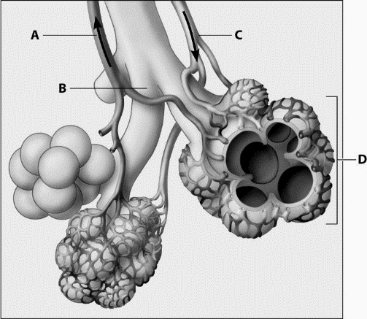

A. __________________________________

B. __________________________________

C. __________________________________

D. __________________________________

48) Explain how the alveoli fulfills all of the requirements of a respiratory surface.

_________________________________________________________________________________

*_________________________________________________________________________________*

_________________________________________________________________________________

_________________________________________________________________________________

*_________________________________________________________________________________*

_________________________________________________________________________________

*_________________________________________________________________________________*

_________________________________________________________________________________