|  |  |  |
| --- | --- | --- |
| AP Biology  **Interactive**  **Student**  **Study**  **Guide** | **North Salem University**  **MISSION**: *Engage students to continuously learn, question, define and solve problems through critical and creative thinking.*  Fall  2014 | |
| The last chapter examined how we make cells. This chapter will examine on how we make the cells to make a baby (*meiosis*) with a focus on the events that produce genetically different (*unique*) sex cells (*gametes*) essential to sexual reproduction and evolution.  ***If you have any problems – please sign up for extra help after school.*** | | **Reproduction:**  **Ch.13 – Sexual Life Cycles**  **Meiosis** |

**Chapter 13: Meiosis**

**OBJECTIVES:**

**An Introduction to Heredity**

**__**1. Explain why organisms reproduce only their own kind and why offspring more closely resemble their parents.

__2. Explain what makes heredity possible.

__3. Distinguish between asexual and sexual reproduction.

**The Role of Meiosis in Sexual Life Cycles**

__4. Diagram the human life cycle and indicate where in the human body mitosis and meiosis occur.

__5. Distinguish among the life cycle patterns of animals, fungi, and plants.

__6. List the phases of meiosis I and meiosis II and describe the events characteristic of each phase.

__7. Recognize the phases of meiosis from diagrams or micrographs.

__8. Describe the process of synapsis during prophase I and explain how genetic recombination occurs.

__9. Describe the key differences between mitosis and meiosis.

**Origins of Genetic Variation**

__10. Explain how independent assortment, crossing over, and random fertilization contribute to genetic variation in sexually reproducing organisms.

__11. Explain why inheritable variation was crucial to Darwin's theory of evolution.

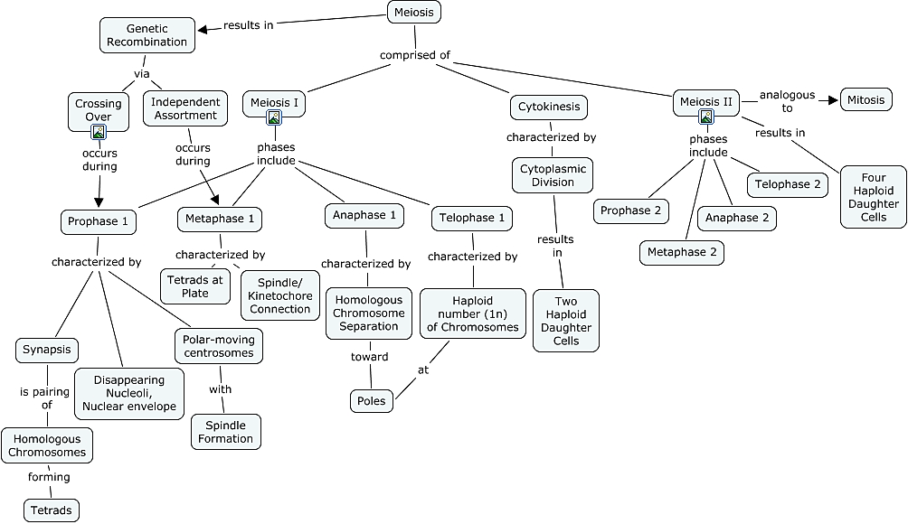

**Guided Reading: Chapter 13**

**Keep in Mind – This process makes the cells that make babies.**

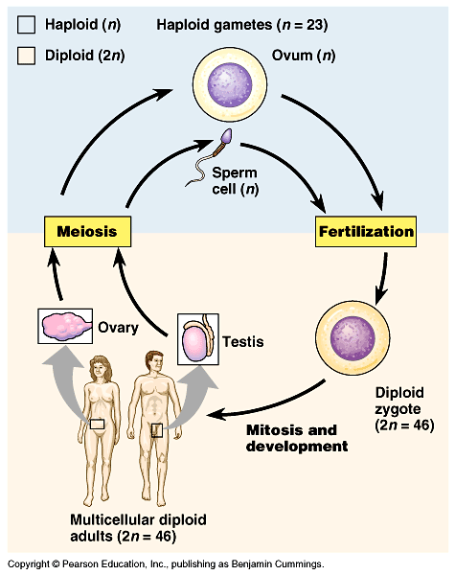

**An Introduction to Heredity**

1. Let’s begin with a review of several terms that you may already know. If not…look them up in the

chapter.

**a) gene -**

**b) locus –**

**c) gamete –**

**d) male gamete –**

**e) female gamete -**

1. Use the picture below to help you describe how does a hydra reproduce?

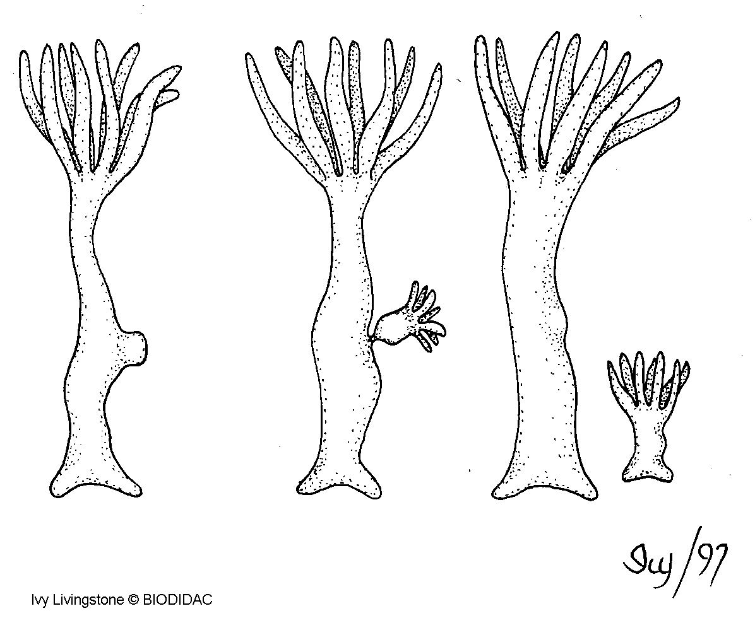

1. How many chromosomes are in human cells?
2. What *is* a chromosome?
3. Which type of reproduction will result in genetically identical offspring?
4. Complete the Venn diagram below about asexual reproduction and sexual reproduction. Feel free to add to it after each lecture.

**Asexual Reproduction Sexual Reproduction**

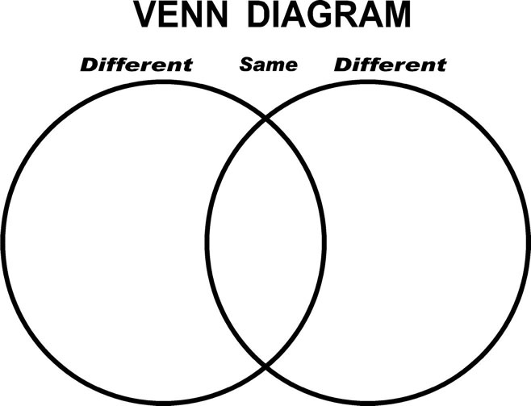

1. What is a somatic cell? Give examples of two human somatic cell types.
2. How does a somatic cell compare to a gamete in terms of chromosome number?
3. Distinguish between sex chromosomes and autosomes. How many of each are found in human cells?
4. Explain what is meant by homologous chromosomes.
5. Use the diagram below to help you explain what is a karyotype? How is it prepared? What are three things that can be determined from a karyotype?

**Preparation of a Human Karyotype**

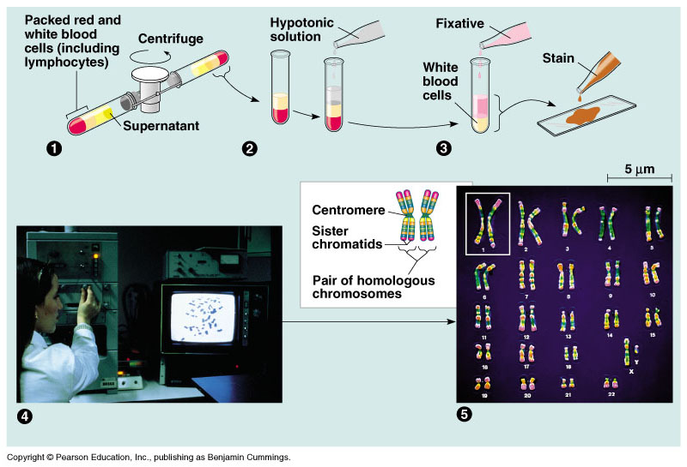

**(1)**

**(2)**

**(3)**

**(4)**

**(5)**

1. Cells that have only one of each homologous pair are said to be haploid or monoploid, a condition that is represented by *n*. Cells that have two of each homologous pair are said to be diploid or *2n*. For each of the following, is the cell haploid or diploid?

liver cell ____________________________ gamete ________________________________

egg _________________________________ zygote ________________________________

skin cell _____________________________ sperm ________________________________

somatic cell __________________________ sex cell _______________________________

1. The muscle cells of a dog have **78** chromosomes. Fill in the correct chromosome number in a:

**bone cell_______ sperm_______ haploid cell_______ somatic cell_______ zygote_______**

1. In the cell below, the chromosomes are shaded in two colors to represent the parent of origin. On this sketch, label the following structures and then answer the following questions

**a) sister chromatids c) homologous chromosomes e) centromere**

**b) replicated chromosome d) maternal chromosomes f) paternal chromosomes**



How many chromosomes does the cell above have? __________

How many homologous pairs? __________

How many chromatids? __________

Is this cell haploid or diploid? __________

1. Where are the gametes of an animal produced? Male _______________ / Female _______________
2. By what process are gametes produced? ____________________
3. What is another term for a fertilized egg? __________________
4. What is the chromosome number of the fertilized egg? ­­­____________________

*(Answer this in general terms, haploid, n, or diploid, 2n.)*

1. What is the purpose of meiosis?

1. What are *alleles*? Give an example.
2. Why is meiosis often called “reduction division”?
3. In meiosis, the DNA is replicateted during interphase, followed by two divisions. The first division is

meiosis I. Study the events of *prophase I* as they are significant. Explain each of these events:

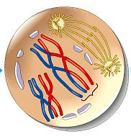

**synapsis -**

**crossing over -**

**chiasmata -**

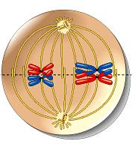

1. The figure at the right shows *metaphase I*.

How is the arrangement of chromosomes different from

metaphase of mitosis?

1. There will be two divisions in meiosis. What will separate in the first division in meiosis I?
2.  Now study the chromosomes in *anaphase I* and *telophase I* carefully.

How many chromosomes are in each cell at the end of the first meiotic division?

Are the chromosomes single or double-stranded?

Are the resultant daughter cells haploid,

or diploid?

1. From this figure, you should see that chromosome number is reduced in meiosis I and that the daughter cells at the end of meiosis I are haploid. Remember this!

During meiosis I, homologous chromosomes separate. What separates during meiosis II?

*(Use the diagram below help you answer this question.*

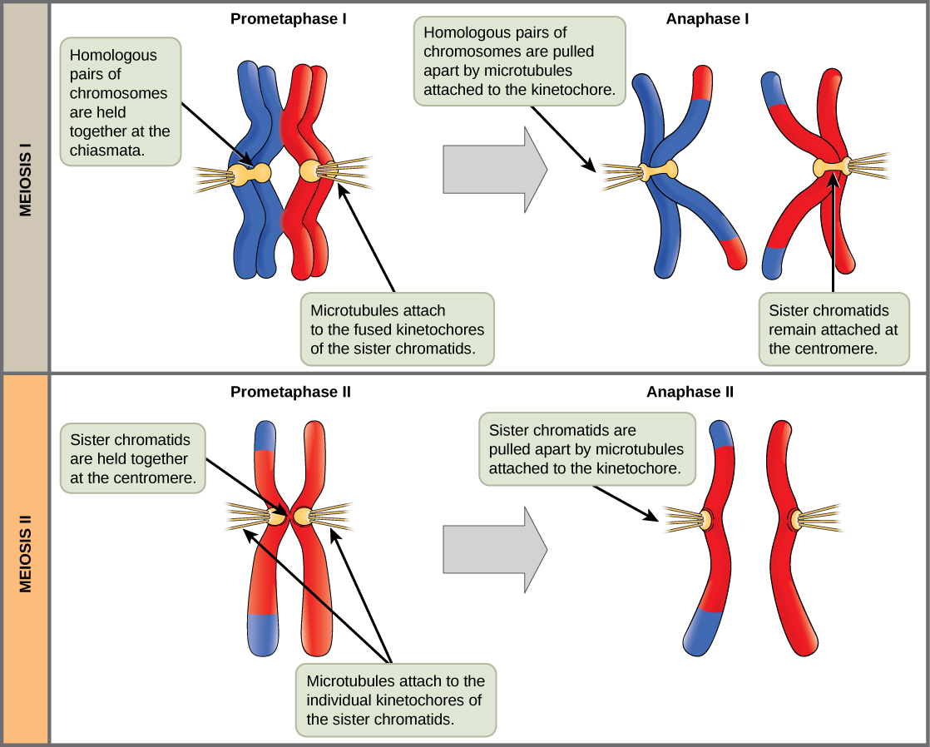

1. To check that you have the BIG PICTURE, here are some quick review questions.

**a.** What happens to chromosome number in meiosis?

**b.** During which division is the chromosome number reduced?

**c.** What is the purpose of meiosis?

**d.** How many times does the cell divide in meiosis?

**e.** How many times do the chromosomes duplicate?

**f.** How many daughter cells are formed?

**g.** What is the chromosome number?

**h.**What are homologs (homologous chromosomes)?

**i.** What occurs in synapsis?

j. What is crossing over?

1. Students often get confused about the differences between mitosis and meiosis. To help with this, work through the following chart:

|  |  |  |
| --- | --- | --- |
|  | **Mitosis** | **Meiosis** |
| **Role in the body** |  |  |
| **Number of DNA replications** |  |  |
| **Number of divisions** |  |  |
| **Number of daughter cells** |  |  |
| **Chromosome number in daughter cells** |  |  |

1. Now use the information from questions 27 and 28 to complete the Venn diagram comparing and contrasting mitosis and meiosis.

** Mitosis Meiosis**

1. An important idea for you to understand is that new alleles arise by changes in the DNA or mutation, but genetic diversity occurs when the deck that is dealt is simply reshuffled. So, there are three ways that sexually reproducing organisms “shuffle the deck.” They are listed below. Explain what occurs in each, and how this increases diversity.

**independent assortment of chromosomes –**

**crossing over –**

**random fertilization –**

1. Here is a fun exercise to drive this point home. Pull out your calculator, and try your hand at this: When you were conceived, what were the odds that of the many possibilities, your parents would come up with you?

**a.** The number of different gametes that can be formed because of independent assortment is

2n, where n = the number of homologous pairs

Therefore, since humans have 46 chromosomes or 23 homologous pairs, what is the number of possible gametes that can be formed due to independent assortment of chromosomes?

**b.** Now, this is the number of unique gametes your mom could have made. Your father could have made the same number. To see the effect of random fertilization, multiply the number of gametes one parent could make by the number of unique gametes the other parent could make.

Your answer should be in the trillions, and all of this is without crossing over and random mutations.

See how unique and special you are?



**Chapter 13: Summary of Key Concepts**

**AN INTRODUCTION TO HEREDITY**

Offspring acquire genes from parents by inheriting chromosomes (pp. 234-235) Genetics is the study of heredity and gene-based variation. Each gene in an organism’s DNA has a specific locus on a certain chromosome.

Like begets like, more or less: a comparison of asexual and sexual reproduction (p. 235, FIGURE 13.2) In asexual reproduction, one parent produces genetically identical offspring by mitosis. Sexual reproduction combines genes from two different parents to form genetically diverse offspring.

***Activity13A: Asexual and Sexual Life Cycles***

**THE ROLE OF MEIOSIS IN SEXUAL LIFE CYCLES**

Fertilization and meiosis alternate in sexual life cycles (pp. 236-239, FIGURE 13.5) Normal human somatic cells have 46 chromosomes, half from each parent. Each of the 22 maternal autosomes has a homologous paternal chromosome. The 23rd pair, the sex chromosomes, determines whether the person is female (XX) or male (XY). Single, haploid (n ) sets of chromosomes in ovum and sperm unite during fertilization to form a diploid (2n ) single-celled zygote, which develops into a multicellular organism by mitosis. At sexual maturity, ovaries and testes (the gonads) produce haploid gametes by meiosis. Sexual life cycles differ in the timing of meiosis in relation to fertilization. Multicellular organisms may be diploid (as in animals), or haploid (as in most fungi), or may alternate between haploid and diploid generations (as in plants).

Meiosis reduces chromosome number from diploid to haploid: a closer look (pp. 239-243, FIGURES 13.6-13.8) The two cell divisions of meiosis, meiosis I and meiosis II, produce four haploid daughter cells. Meiosis is distinguished from mitosis by the events of meiosis I. In prophase I, replicated homologous chromosomes, each chromosome with two chromatids, undergo synapsis. Nonsister chromatids cross over, exchanging segments (the crossover sites appear as chiasmata). The paired chromosomes (tetrads) align on the metaphase plate, and at anaphase I, the two chromosomes of each homologous pair (not the sister chromatids) move to separate poles. The cell divides, with half the chromosomes going to each daughter cell. Meiosis II separates the sister chromatids, yielding four haploid daughter cells.

***Activity13B: Meiosis Animation***

**ORIGINS OF GENETIC VARIATION**

Sexual life cycles produce genetic variation among offspring (pp. 243-245, FIGURES 13.9, 13.10) The events of sexual reproduction that contribute to genetic variation in a population are independent assortment of chromosomes during meiosis I, crossing over between homologous chromosomes during meiosis I, and random fertilization of ova by sperm.

***Activity13C: Origins of Genetic Variation***

Evolutionary adaptation depends on a population’s genetic variation (p. 245) Genetic variation among a population’s members is the raw material for evolution by natural selection. Sexual reproduction and mutations generate this variation.

**Chapter 13 - Review Questions**

__1) Sister chromatids are -

A) found right after a cell divides. C) made only of DNA.

B) joined together at a centromere. D) unique to prokaryotes.

__2) Two chromosomes in a nucleus that carry genes controlling the same inherited characteristics are -

A) homologous chromosomes. C) complementary chromosomes.

B) heterologous chromosomes. D) parallel chromosomes.

__3) A pair of sex chromosomes found in a human male is most like -

A) a pair of blue jeans. C) a knife, fork, and spoon.

B) a bride and groom. D) identical twins.

__4) Which of the following statements regarding mitosis and meiosis is *false*?

A) Meiosis only occurs in the ovaries and testes.

B) All sexual life cycles involve an alternation of diploid and haploid stages.

C) Mitosis produces daughter cells with half the number of chromosomes as the parent cell.

D) A normal human zygote has 46 chromosomes.

__5) Which of the following statements is *false*?

A) Gametes are haploid cells. C) An X chromosome is an autosome.

B) Two haploid cells fuse during fertilization. D) A zygote is a fertilized egg.

__6) During which stage of meiosis do synapsis and crossing over occur?

A) interphase I B) prophase I C) prophase II D) metaphase I

__7) Which of the following options correctly describes the behavior of a tetrad during anaphase I of meiosis?

A) It goes intact to one pole of the dividing cell.

B) It splits into two pairs of sister chromatids, and one pair goes to each pole of the dividing cell.

C) It splits into two pairs of homologous, nonsister chromatids, and one pair goes to each pole of the dividing cell.

D) It splits into four chromosomes, which distribute in random pairs to the two poles of the dividing cell.

__8) Which of the following statements regarding the differences between mitosis and meiosis is *false*?

A) In meiosis four daughter cells are produced, whereas in mitosis two daughter cells are produced.

B) Cells produced by mitosis are diploid, whereas cells produced by meiosis are haploid.

C) In mitosis cytokinesis occurs once, whereas in meiosis cytokinesis occurs twice.

D) Crossing over is a phenomenon that creates genetic diversity during mitosis.

__9) Which of the following statements regarding mitosis and meiosis is *false*?

A) Mitosis provides for growth and tissue repair.

B) Meiosis provides for asexual reproduction.

C) In mitosis, the chromosomes replicate only once in the preceding interphase.

D) All the events unique to meiosis occur during meiosis I.

__10) Both mitosis and meiosis are preceded by -

A) metaphase. B) interphase. C) prophase. D) telophase.

__11) Independent orientation of chromosomes at metaphase I and random fertilization are most like-

A) shuffling cards and dealing out hands of poker.

B) cutting up a pie into eight even-sized slices.

C) alphabetizing files in a filing cabinet.

D) pairing up similar socks after washing your clothes.

__12) Independent orientation of chromosomes at metaphase I results in an increase in the number of -

A) gametes. C) possible combinations of characteristics

B) homologous chromosomes. D) sex chromosomes.

__13) Which of the following statements regarding genetic diversity is *false*?

A) Genetic diversity is enhanced by random fertilization.

B) Genetic diversity is enhanced by independent orientation of chromosomes at metaphase I.

C) Genetic diversity is enhanced by mitosis.

D) Genetic diversity is enhanced by crossing over during meiosis.

__14) At a chiasma, two ________ are attached to each other.

A) homologous or non-sister chromatids C) non-homologous chromosomes

B) homologous or sister chromatids D) daughter cells

__15) Without crossing over -

A) cells could not complete meiosis.

B) meiosis could not produce haploid gametes.

C) only a small number of unique gametes could be produced by a single individual.

D) genetic recombination could not occur.

__16) Karyotyping -

A) shows chromosomes as they appear in metaphase of meiosis II.

B) can reveal alterations in chromosome number.

C) examines points of crossing over.

D) reveals the presence of cancerous genes.

__17) A karyotype is most like -

A) a map showing the hidden location of buried treasure.

B) a movie showing the stages of the reproductive cycle of a beetle.

C) photographs of every couple at a high school prom.

D) the answer key to a multiple-choice exam.

__18) Which of the following statements regarding Down syndrome is *false*?

A) Trisomy 21 is the cause of Down syndrome.

B) Down syndrome is the most common serious birth defect in the United States.

C) People with Down syndrome usually have a shorter life span than normal.

D) Down syndrome is least likely to be seen in the infants of mothers over 40.

__19) Nondisjunction occurs when -

A) a portion of a chromosome breaks off and is lost.

B) two chromosomes fuse into one.

C) members of a chromosome pair fail to separate.

D) an entire pair of chromosomes is lost during meiosis I.

__20) With the exception of identical twins, siblings who have the same two biological parents are likely to look similar, but not identical, to each other because they have -

A) identical chromosomes, but different genes. C) the same combination of traits, but different genes.

B) identical genes but different chromosomes. D) a similar but not identical combination of genes.