AP Biology  Interactive  Student  Study  Guide | North Salem University  MISSION: Engage students to continuously learn, question, define and solve problems through critical and creative thinking.  Spring 2015
The AP Biology exam has reached into this chapter for essay questions on a regular basis over the past 15 years. Student responses show that biotechnology is a difficult topic. This chapter requires a strong conceptual understanding of the technological processes and the underlying biochemistry that guides the procedure. With a little careful work, this chapter will give you insights into the incredible advancements already made and a basis for understanding the new marvels yet to be discovered in biotechnology.  If you have any problems – please sign up for extra help after school. |  | Chapter 20:  DNA Technology  and Genomics

Chapter 20: DNA Technology and Genomics

OBJECTIVES
DNA Cloning
__1. Explain how advances in recombinant DNA technology have helped scientists study the eukaryotic genome.
__2. Describe the natural function of restriction enzymes.
__3. Explain how the creation of sticky ends by restriction enzymes is useful in producing a recombinant DNA molecule.
__4. Outline the procedures for cloning a eukaryotic gene in a bacterial plasmid.
__5. Describe the role of an expression vector.
__6. Describe two techniques to introduce recombinant DNA into eukaryotic cells.
__7. Define and distinguish between genomic libraries using plasmids, phages, and cDNA.
__8. Describe the polymerase chain reaction (PCR) and explain the advantages and limitations of this procedure.

DNA Analysis and Genomics
__9. Explain how gel electrophoresis is used to analyze nucleic acids and proteins and to distinguish between two alleles of a gene.
__10. Describe the process of nucleic acid hybridization.
__11. Describe the Southern blotting procedure and explain how it can be used to detect and analyze instances of
restriction fragment length polymorphism (RFLP).
__12. Explain how RFLP analysis facilitated the process of genomic mapping.
__13. List the goals of the Human Genome Project.
__14. Explain how linkage mapping, physical mapping, and DNA sequencing each contributed to the genome
mapping project.
__15. Describe the alternate approach to whole-genome sequencing pursued by J. Craig Venter and the Celera Genomics company. Describe the advantages and disadvantages of public and private efforts.
__16. Describe the surprising results of the human genome project.
__17. Explain how the vertebrate genome, including that of humans, generates greater diversity than the genomes
of invertebrate organisms.
__18. Describe what we have learned by comparing the human genome to that of other organisms.
__19. Explain how in vitro mutagenesis and RNA interference help to discover the functions of some genes.
__20. Define and compare the fields of proteomics and genomics.
__21. Explain the significance of single nucleotide polymorphisms in the study of the human genome.

Practical Applications of DNA Technology
__22. Describe how DNA technology can have medical applications in such areas as the diagnosis of genetic
disease, the development of gene therapy, vaccine production, and the development of pharmaceutical
products.
__23. Explain how DNA technology is used in the forensic sciences.
__24. Describe how gene manipulation has practical applications for environmental and agricultural work.
__25 Explain how DNA technology can be used to improve the nutritional value of crops and to develop plants
that can produce pharmaceutical products.
__26. Describe the safety and ethical questions related to recombinant DNA studies and the biotechnology industry
__27. Describe the general process by which the ewe Dolly and the first mice were cloned.
__28. Describe the two important properties of stem cells. Explain their significance to medicine.

KEY TERMS:
bacterial artificial chromosome (BAC) biotechnology
cDNA library chromosome walking complementary DNA (cDNA) cloning vector
DNA fingerprint DNA microarray assays
DNA ligase expression vector
gel electrophoresis gene cloning
genetically modified organisms (GMOs) gene therapy
genetic engineering genomic library
Human Genome Project genomics
in vitro mutagenesis nucleic acid hybridization
recombinant DNA polymerase chain reaction (PCR) restriction enzyme restriction site
restriction fragment length polymorphisms (RFLPs) southern blotting
single nucleotide polymorphisms (SNPs) sticky end
stem cells (embryonic/adult) stem cells (totipotent/pluripotent)
- - - - - - - - - - - - - - - - - - - - - - - - - - - - - - - - - - - - - - - - - - - - - - - - - - - - - - - - - - - -

WORD ROOTS:

liga- = bound, tied (DNA ligase: a linking enzyme essential for DNA replication)

electro- = electricity (electroporation: a technique to introduce recombinant DNA into cells by applying a brief electrical pulse to a solution containing cells)

muta- = change; -genesis = origin, birth (in vitro mutagenesis: a technique to discover the function of a gene by introducing specific changes into the sequence of a cloned gene, reinserting the mutated gene into a cell, and studying the phenotype of the mutant)

poly- = many; morph- = form (Single nucleotide polymorphisms: one-base-pair variations in the genome sequence)

John Craig Venter
October 14, 1946

Guided Reading: Chapter 20

- It is important to understand the meaning of the three terms in below to start this chapter.

(a) recombinant DNA –

(b) genetic engineering –

(c) biotechnology -

- Plasmids are important in biotechnology. Give a full and complete definition of plasmid.

- The production of multiple copies of a single gene is called ____________________________.

- Using Figure 20.1, label and explain the five steps in this preview of gene cloning.
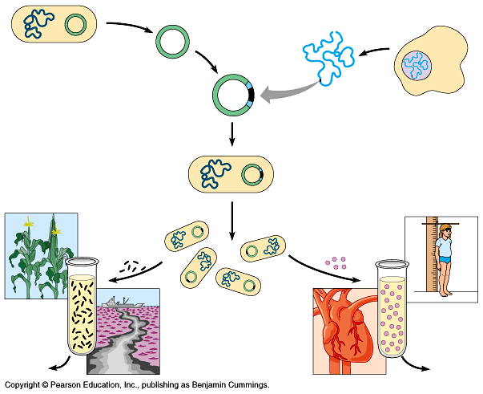
(1)

(2)

(3)

(4)

(5)

- Read the description of restriction enzymes on page 377 carefully. Then, using Figure 20.2 as a guide, label and explain each step in the diagram below.

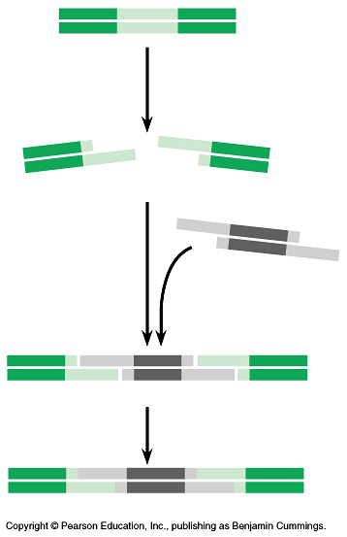

- When were restriction enzymes discovered and what function do they serve in nature?

- What is a cloning vector?

- Figure 20.3 is a more detailed discussion of the gene cloning procedure shown in Figure 20.1.
Explain the following key points.

(a) Explain why the plasmid is engineered with ampR and lacZ.

(b) After transformation has occurred, why are some colonies blue?

(c) Why are some colonies white? Why is this important?

- Once the DNA is cloned, we have the problem of finding the piece of DNA that holds our gene of interest. Explain how nucleic acid hybridization will accomplish this task.

- Describe how a radioactively labeled nucleic acid probe can locate the gene of interest.
(Use Figure 20.4 to guide your response.)

- The cloning procedure described in question 8 and Figure 20.3 will produce many different fragments of DNA. These fragments may be stored in a genomic library. What is the purpose of a genomic library?

- The polymerase chain reaction (PCR) is a Nobel Prize–winning idea that
is used by scientists to amplify DNA, particularly when the quantity of
DNA is very small or contaminated. Label the diagram to the right and
use it to name and briefly explain the three initial steps that occur in PCR.

(a)

(b)

(c)

- How many molecules will be produced by four PCR cycles?

The next section begins with a discussion of gel electrophoresis, a technique that will be covered in lab.
(It is important to understand the principles of gel electrophoresis.)

- ______________________________ is a technique used to separate nucleic acids or proteins that differ in size or electrical charge.

- Why is the DNA sample to be separated by gel electrophoresis always loaded at the cathode or negative end of the power source?

- Why is DNA treated with restriction enzymes before analyzed via gel electrophoresis.

- What are restriction fragment length polymorphisms (RFLP’s)?

- Explain why shorter DNA fragments or RFLP’s travel farther down the gel than larger molecules.

- Label the diagram below and use it to explain the process of cell electrophoresis.
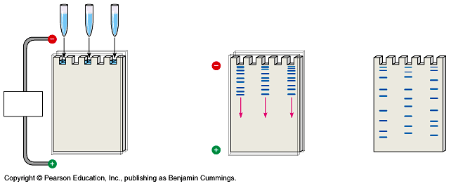
(1) (2) (3)

- What is the purpose of a Southern blot?

- Label the diagram below and use it to explain how restriction fragments are analyzed via the Southern blotting technique.
(1) (2) (3)

(5) (6)

- What is the Human Genome Project?

- What was one surprising result of the Human Genome Project?

- So what makes human - and vertebrate animals in general - more complex than flies or worms?

- What is proteomics?

- The amount of DNA variations in humans is small compared to other species. Why is this?

- Most of the variations in our DNA seems to be in the form of single nucleotide polymorphisms (SNP’s). What are single nucleotide polymorphisms (SNP’s)?

- How has DNA technology helped in the diagnosis and treatment of human genetic diseases?

- What is gene therapy?

- Label the diagram below and use it to describe one type gene therapy.

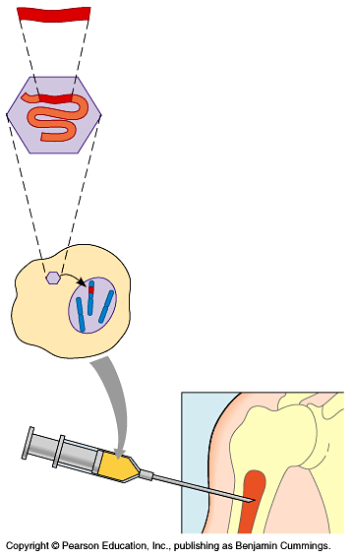
(1)

(2)

(3)

(4)

- Why hasn’t gene therapy proven to be very effective at correcting genetic defects in human somatic cells?

- If not for correcting genetic defects, then what are researcher’s currently using gene therapy for?

- What was one of the first practical applications of gene splicing in the pharmaceutical industry?

- How do Forensic Scientists use RFLP analysis by Southern blotting to solve murder cases?

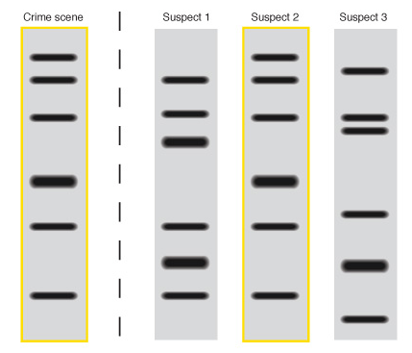
- Based upon the DNA fingerprint to the right, which suspect’s DNA matches the DNA found at the crime scene? Explain your answer. (Murder Mystery Review)

- How is genetic engineering/DNA technology being applied to environmental work?

- How is genetic engineering/DNA technology being used in agriculture, specifically animal husbandry?

- How is genetic engineering/DNA technology being used in agriculture, specifically crop production?

- What are Genetically Modified Organisms (GMO’s)?

- What are some of the major safety concerns relating to DNA technology?

- What are some of the major ethical concerns relating to DNA technology?

Guided Reading: Chapter 21

- Label the diagram below and use it to describe the process of cloning in mammals.
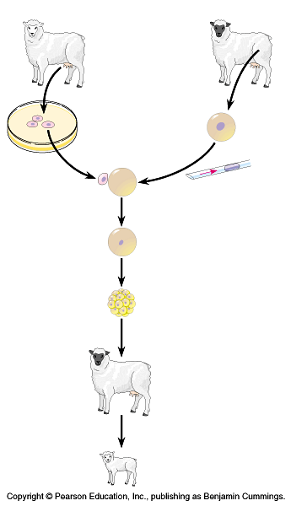

- In most cases, only a tiny percentage of cloned embryos develop normally. Why is this?

- Embryonic development involves cell division (mitosis + cytokinesis), cell differentiation and morphogenesis. Define cell differentiation and morphogenesis.

- What is a totipotent cell?

- What are stem cells?

- Label the diagram below and use it to describe the benefits of stem cell research.

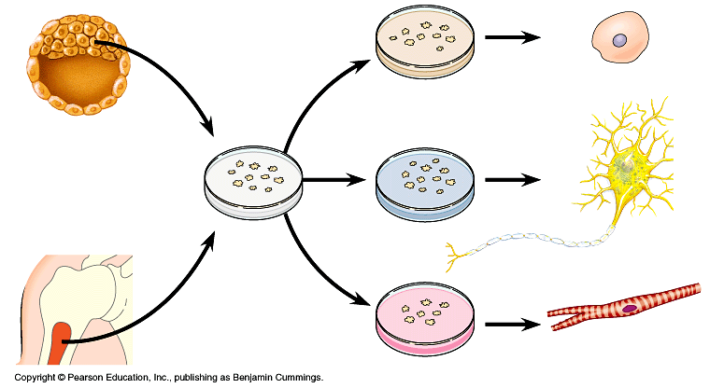

- What are pluripotent stem cells?

- What is the major difference between embryonic stem cells and adult stem cells?

- Why does embryonic stem cell research raise a number of ethical and political concerns?

Chapter 20: Summary of Key Concepts

DNA CLONING
- DNA technology makes it possible to clone genes for basic research and commercial applications: an overview (pp. 376-377, FIGURE 20.1) DNA technology is a powerful set of techniques that enables biologists to manipulate and analyze DNA. It can help make useful new products and organisms.
Activity20A: Applications of DNA Technology
- Restriction enzymes are used to make recombinant DNA (pp. 377-378, FIGURE 20.2) A variety of bacterial restriction enzymes recognize short, specific nucleotide sequences in DNA and cut the sequences at specific points on both strands to yield a set of double-stranded DNA fragments with single-stranded sticky ends. The sticky ends readily form base pairs with complementary single-stranded segments on other DNA molecules. The enzyme DNA ligase can seal the strands to produce recombinant DNA molecules.
Activity20B: Restriction Enzymes
- Genes can be cloned in recombinant DNA vectors: a closer look (pp. 378-381, FIGURES 20.3-20.5) Plasmids can serve as vectors (carriers) to introduce foreign genes into host bacteria. Recombinant DNA is made by inserting restriction fragments from DNA containing a gene of interest into the vector DNA, which has been cut open by the same enzyme. Gene cloning results when the foreign genes replicate inside the host bacterial cell as part of the recombinant vector. Eukaryotic cells can also serve as host cells for gene cloning. Cell clones carrying the gene of interest can be identified with a radioactively labeled nucleic acid probe, which has a sequence complementary to the gene.
Activity20C: Cloning a Gene in Bacteria
- Cloned genes are stored in DNA libraries (pp. 381-382, FIGURE 20.6) When the starting material for DNA (gene) cloning is an entire genome, the resulting collection of recombinant vector clones is called a genomic library. Alternatively, a cDNA (complementary DNA) library can be made by cloning DNA made in vitro by reverse transcription of all the mRNA produced by a particular kind of cell. Libraries of cDNA are especially useful for working with eukaryotic genes (whose introns are not present in the cDNA versions) and for studying gene expression.
- The polymerase chain reaction (PCR) clones DNA entirely in vitro (pp. 382-383, FIGURE 20.7) For quickly making many copies of a particular segment of DNA, this method uses primers that bracket the desired sequence and a heat-resistant DNA polymerase.

DNA ANALYSIS AND GENOMICS
- Restriction fragment analysis detects DNA differences that affect restriction sites (pp. 383-386, FIGURES 20.8-20.10) Gel electro-phoresis makes it possible to separate and isolate DNA restriction fragments of different lengths. Restriction fragment length polymorphisms (RFLPs) are differences in DNA sequence on homologous chromosomes that result in different patterns of restriction fragment lengths. These patterns are visualized as bands on gel electrophoresis. Specific fragments can be identified by Southern blotting, using labeled probes that hybridize to the DNA stuck to a "blot" of the gel. RFLPs are prevalent genetic markers, present throughout eukaryotic noncoding DNA. RFLP analysis has many applications, including genetic mapping and diagnosis of genetic disorders.
Activity20D: Gel Electrophoresis of DNA
Activity20E: Analyzing DNA Fragments Using Gel Electrophoresis
- Entire genomes can be mapped at the DNA level (pp. 386-389, FIGURES 20.11-20.13) An international research effort, the Human Genome Project involves linkage mapping, physical mapping, and DNA sequencing of the human genome and the genomes of other organisms. An alternative approach starts with sequencing of random DNA fragments, relying especially heavily on computer power to assemble the sequences. The human genome is thought to have 30,000 to 40,000 genes, fewer than once thought.
Activity20F: The Human Genome Project: Genes on Human Chromosome 17
- Genome sequences provide clues to important biological questions (pp. 389-393, FIGURE 20.14) Genome sequences are helping researchers find new genes, probe details of gene organization and control, and answer questions about evolution. DNA microarrays allow researchers to compare patterns of gene expression in different tissues and under different conditions. Genomics is the systematic study of entire genomes; proteomics is the systematic study of all the proteins encoded by a genome. Single nucleotide polymorphisms (SNPs) provide useful markers for studying human genetic variation.

PRACTICAL APPLICATIONS OF DNA TECHNOLOGY
- DNA technology is reshaping medicine and the pharmaceutical industry (pp. 393-395; FIGURES 20.15, 20.16) Medical applications of DNA technology include diagnostic tests for genetic and other diseases; safer, more effective vaccines; the large-scale production of many new, and some previously scarce, pharmaceutical products; and the prospect of treating or even curing certain genetic disorders.
- DNA technology offers forensic, environmental, and agricultural applications (pp. 395-399; FIGURES 20.17-20.20) DNA "fingerprints" obtained from RFLP or STR analysis of tissue found at the scenes of violent crimes provide evidence in trials; such fingerprints are also useful in parenthood disputes. Genetic engineering can modify the metabolism of microorganisms so that they can be used to extract minerals from the environment or degrade waste materials. In agriculture, transgenic plants and animals are being designed to improve food productivity and quality.
Activity20G: DNA Fingerprinting
- DNA technology raises important safety and ethical questions (p. 399) Several U.S. government agencies are responsible for setting policies about and regulating recombinant DNA technology. The potential benefits of genetic engineering must be carefully weighed against the potential hazards of creating products or developing procedures that are harmful to humans or the environment.
Activity20H: Making Decisions About DNA Technology: Golden Rice

Chapter 21: Summary of Key Concepts

FROM SINGLE CELL TO MULTICELLULAR ORGANISM
- Embryonic development involves cell division, cell differentiation, and morphogenesis (p. 403) In addition to mitosis, embryonic cells undergo differentiation, becoming specialized in structure and function. Morphogenesis encompasses the processes that give shape to the organism and its various parts.
Activity 21A: C. elegans Development Video
- Researchers study development in model organisms to identify general principles (pp. 403-406,FIGURE 21.3) Organisms used to study the genetic basis of development include the fruit fly Drosophila melanogaster , the nematode Caenorhabditis elegans , the mouse Mus musculus , the zebrafish Danio rerio , and the common wall cress Arabidopsis thaliana .
Activity 21B: Adult C. elegans Video

DIFFERENTIAL GENE EXPRESSION
- Different types of cells in an organism have the same DNA (pp. 406-410;FIGURES 21.5,21.6) Cells differ in structure and function not because they contain different genes, but because they express different portions of a common genome; they have genomic equivalence. Differentiated cells from mature plants are often totipotent, capable of generating a complete new plant. The nucleus from a differentiated animal cell can sometimes give rise to a new animal if transplanted to an enucleated egg cell. Pluripotent stem cells from animal embryos or adult tissues can reproduce and differentiate in vitro as well as in vivo, offering hope for medical use.

Chapter 20 - Review Questions

__1) Biotechnology -
A) is a modern scientific discipline that has existed for only a few decades.
B) is strictly concerned with the manipulation of DNA.
C) has been around since the dawn of civilization.
D) is generally considered more harmful than valuable to society.

__2) When DNA from two sources is combined into one single piece of DNA, it is known as -
A) cloned DNA. C) a vector.
B) recombinant DNA. D) a plasmid.

__3) The production of multiple identical copies of gene-sized pieces of DNA defines -
A) gene cloning. C) clonal selection.
B) plasmid transformation. D) tissue culturing.

__4) In the process of human gene cloning using plasmids, the bacterial plasmid -
A) functions as a vector.
B) is the source of the gene to be cloned.
C) is cultured inside the human cell, which contains the gene to be cloned.
D) is used to insert the human gene into the bacterial chromosome.

__5) DNA ligase binds -
A) exons together. C) nucleotides together.
B) polymerase to the promotor. D) an intron to an exon.

__6) Restriction enzymes -
A) edit proteins. C) stop transcription.
B) cut DNA at specific sites. D) bind together strands of DNA.

__7) Restriction enzymes specifically recognize and cut short sequences of DNA called -
A) promoter sequences. C) sticky ends.
B) short terminal repeats. D) restriction sites.

__8) "Sticky ends" are -
A) produced by the action of DNA ligase.
B) produced by PCR.
C) always long sequences of a single nucleotide.
D) DNA fragments with exposed single-stranded ends.

__9) The feature of "sticky ends" that makes them especially useful in DNA recombination is their ability to -
A) bind to DNA and thereby activate transcription.
B) bind to ribosomes and thereby activate translation.
C) form hydrogen-bonded base pairs with complementary single-stranded stretches of DNA.
D) allow plasmids to attach to the main bacterial chromosome.

__10) A collection of DNA fragments obtained from the genome of one organism, inserted by recombinant DNA techniques into the genome of a host organism (one fragment per host genome), and maintained there is called a -
A) DNA collection. C) DNA file.
B) genomic library. D) gene bank.

__11) The enzyme that converts information stored in their RNA to information stored in DNA is -
A) DNA ligase. C) a restriction enzyme.
B) reverse transcriptase. D) RNA polymerase.

__12) A nucleic acid probe is -
A) a virus that transfers DNA to a recipient cell.
B) a piece of radioactively labeled DNA that is used to locate a specific gene.
C) an enzyme that locates a specific restriction site on RNA.
D) a plasmid that recognizes a specific DNA sequence.

__13) Which of the following statements about nucleic acid probes is false?
A) A nucleic acid probe is a double-stranded section of DNA.
B) A nucleic acid probe can be used to find a specific gene.
C) A nucleic acid probe binds to a complementary sequence in the gene of interest.
D) A nucleic acid probe is usually labeled with a radioactive isotope or fluorescent tag to help identify its location.

__14) The advantage of being able to clone the gene for human insulin is that -
A) there are too few cows, pigs, and horses to provide an adequate supply of their insulin.
B) human insulin is less likely to cause harmful side effects than cow, pig, or horse insulin.
C) cow, pig, or horse insulin cannot keep a diabetic alive for more than three months.
D) using human insulin increases the probability that, in the future, the person suffering from diabetes can be weaned from a dependence on insulin.

__15) Golden rice is golden in color because it is rich in -
A) vitamin A. C) beta-carotene.
B) vitamin C. D) chromium picolinate.

__16) A transgenic animal is -
A) an animal that is the first of its kind to bear a particular allele.
B) an animal in which a genetic defect has been corrected using recombinant DNA therapy.
C) an animal containing a gene from another organism, typically of another species.
D) an animal containing genes from three or more species.

__17) In order for gene therapy to be permanent, -
A) the defective gene must first be removed from all somatic cells.
B) the normal gene must be added to the germ line cells.
C) the normal gene must first be treated with UV radiation to ensure noninfectivity.
D) the normal gene must be transferred to somatic cells that can continuously multiply.

__18) If you commit a crime, you need to make sure that you do not leave even the smallest speck of blood, hair, or other organic matter from your body. If you do, the DNA in this material can be amplified by ________, subjected to genetic analysis, and used to identify you as the perpetrator of the crime.
A) PCR C) RFLP
B) blotting D) reverse transcriptase

__19) The polymerase chain reaction relies upon unusual, heat-resistant ________ that were isolated from bacteria living in hot springs.
A) DNA polymerase molecules C) restriction enzymes
B) phages D) plasmids

__20) Gel electrophoresis sorts DNA molecules on the basis of their -
A) nucleotide sequence. C) solubility in the gel.
B) ability to bind to mRNA. D) size.

__21) During the process of electrophoresis, the ________ functions like a molecular sieve, separating the samples according to their size.
A) sample mixture C) negatively charged electrode
B) positively charged electrode D) gel

__22) Segments of eukaryotic DNA that can move or be copied from one site to another in the genome are called -
A) exons. C) transposable elements.
B) plasmids. D) vectors.

__23) Which of the following statements regarding proteomics is correct?
A) Proteomics is the study of protein interaction within a cell.
B) Proteomics involves the complete analysis of the prokaryotes.
C) Proteomics is the systematic study of the full set of proteins encoded by a genome.
D) Proteomics and genomics allow scientists to study life in an ever-increasing reductive approach.

__24) Approximately what percentage of the human genome is identical to that of a chimpanzee?
A) 50.0% B) 62.3% C) 92. 0% D) 98.8%

