Name ________________________________ Date __________
AP Biology Mr. Collea
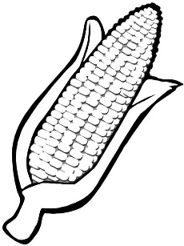
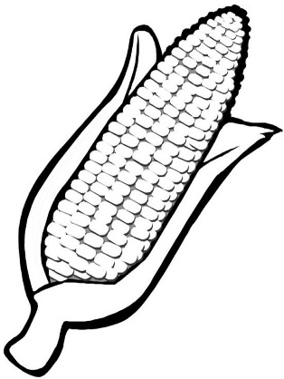
Corn Genetics Lab

PreLab: Go to Collea’s Corner to watch the Bozeman Science Chi-Square Video and answer each of the questions that follow.
www.bozemanscience.com/chi-squared-test

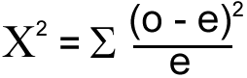
1. Label what each element represents in the
Chi-square formula to the right.

2. Why do you use the Chi-Square Test?

__________________________________________________________________________________

__________________________________________________________________________________

__________________________________________________________________________________

3. Define the Null Hypothesis.

__________________________________________________________________________________

__________________________________________________________________________________

__________________________________________________________________________________

4. What is the whole point or cool thing about Chi-Square?

__________________________________________________________________________________

__________________________________________________________________________________

__________________________________________________________________________________

5. What is the whole point of a Chi-Square test?

__________________________________________________________________________________

__________________________________________________________________________________

6. What is the definition of and how do you calculate the “Degrees of Freedom”?

__________________________________________________________________________________

__________________________________________________________________________________

__________________________________________________________________________________

7. What is the probability (p) we will most likely use in this class (AP Biology at NSU)? __________

8. What does a probability (p) of .05 actually mean?

__________________________________________________________________________________

__________________________________________________________________________________

__________________________________________________________________________________

9. What happens if you get a Chi-Square HIGHER than your critical value?

__________________________________________________________________________________

__________________________________________________________________________________

10. What happens if you get a Chi-Square LOWER than your critical value?

__________________________________________________________________________________

__________________________________________________________________________________

11. Complete the Chi-square question Paul Andersen uses as an example involving coin flipping.

(a) State your null hypothesis (Ho) for this problem:

__________________________________________________________________________________

__________________________________________________________________________________

__________________________________________________________________________________

 | Heads | Tails
Expected
Observed
(b) Fill in the data table to the right with the sample
data Mr. Andersen give you and then solve.

Please SHOW ALL WORK in the space below.
(Equation – Substitute – Answer = ESA)

(c) What is the probability (p) we will use in this problem and MOST problems at NSU? __________

(d) What is your critical value for this problem? __________

(e) What is your degrees of freedom for this problem? __________

(f) What is the Chi-square value you calculated? __________

(g) Is your Chi-square HIGHER or LOWER than the critical value from the table? ______________

(h) Do you ACCEPT or REJECT your null hypothesis? ____________________

What EXACTLY does this mean: ____________________________________________________

________________________________________________________________________________

________________________________________________________________________________

________________________________________________________________________________

12. Complete the 2nd Chi-square question Paul Andersen uses as an example involving dice.

(a) State your null hypothesis (Ho) for this problem:

__________________________________________________________________________________

__________________________________________________________________________________

__________________________________________________________________________________

(b) Fill in the data table below with the sample data Mr. Andersen give you and then solve.
 | 1 | 2 | 3 | 4 | 5 | 6
Expected
Observed

Please SHOW ALL WORK in the space below.
(Equation – Substitute – Answer = ESA)

(c) What is the probability (p) we will use in this problem and ALL problems at NSU? __________

(d) What is your critical value for this problem? __________

(e) What is your degrees of freedom for this problem? __________

(f) What is the Chi-square value you calculated? __________

(g) Is your Chi-square HIGHER or LOWER than the critical value from the table? ______________

(h) Do you ACCEPT or REJECT your null hypothesis? ____________________

What EXACTLY does this mean: ____________________________________________________

________________________________________________________________________________

________________________________________________________________________________

________________________________________________________________________________
13. Complete the 3rd Chi-square question Paul Andersen uses as an example involving pill bugs.

(a) State your null hypothesis (Ho) for this problem:

__________________________________________________________________________________

__________________________________________________________________________________

__________________________________________________________________________________

 | Wet | Dry
Expected
Observed
(b) Fill in the data table to the right with the sample
data Mr. Andersen give you and then solve.

Please SHOW ALL WORK in the space below.
(Equation – Substitute – Answer = ESA)

(c) What is the probability (p) we will use in this problem and ALL problems at NSU? __________

(d) What is your critical value for this problem? __________

(e) What is your degrees of freedom for this problem? __________

(f) What is the Chi-square value you calculated? __________

(g) Is your Chi-square HIGHER or LOWER than the critical value from the table? ______________

(h) Do you ACCEPT or REJECT your null hypothesis? ____________________

What EXACTLY does this mean: ____________________________________________________

________________________________________________________________________________

________________________________________________________________________________

________________________________________________________________________________

Corn Genetics Lab

Background Information:

A gene is a unit of heredity on a chromosome and can have alternate forms called alleles. In sexually reproducing organisms each parent contributes one allele to their offspring that may or may not be like the other parent's allele. Alleles for a particular gene occur in pairs. Alleles that mask expression of other alleles of a particular gene, but are themselves expressed are dominant, and are usually designated by a capital letter of that dominant allele (for example, "B"). Alleles whose expression is masked by dominant alleles are recessive, and are designated by a lower case letter (for example, "b"). The genotype (genetic makeup) of an organism includes all the alleles present in the cell, whether they are dominant or recessive. The biochemical manifestation of the trait is called the phenotype (physical makeup).

Why are fruit flies (Drosophila melanogaster) and corn (Zea maze) excellent choices for introducing Mendelian inheritance? (1) Fruit flies and corn have numerous contrasting phenotypes (easily observable traits). (2) Fruit flies and corn produce many offspring and seeds giving us an ample supply of data to work with. (3) Corn is a very important food crop and its genetics have been extensively investigated and modified (genetically modified organism / GMO) for better or worse.

Figure 1: Examples of Phenotypes in Fruit Flies (Drosophila melanogaster)
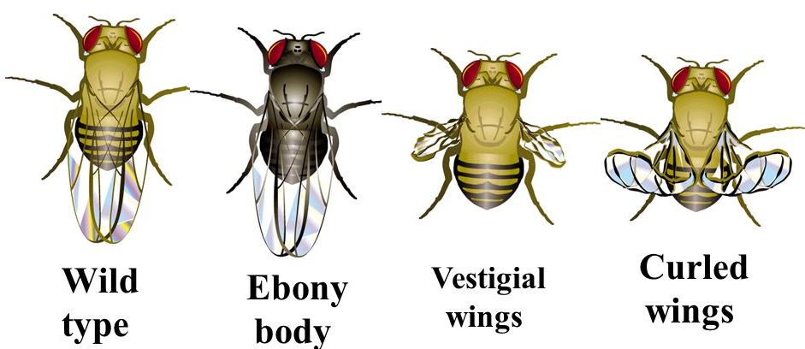

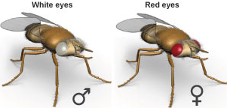

______ ______ ______ ______ __________ __________

Morgan's conventions on notation
1. Genes symbol based on 1st mutant observed (non wild-type)
2. If mutant recessive, 1st letter lowercase (w = white eye)
3. If mutant dominant, 1st letter uppercase: Cy = curled wings
4. Wild-type designated by superscript + over symbol for trait:
w+ = flies with normal red eyes
vg+ = normal sized wings not vestigial in shape
Cy+ = allele for normal or straight wings not curl
The corn phenotypes studied in this activity Figure 2: Cross Section of a Corn Seed
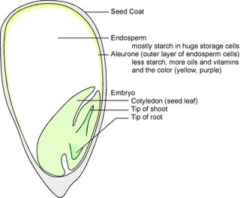
are kernel color and endosperm characteristics
(starchy and sweet). The two forms of kernel color
you will look at are Colored Aleurone (R) which
appears purple and Coloredless Aleurone (r) which
appears yellow. Normal corn endosperm is high in
starch or starchy (Su) and is dominant over the
recessive sweet (su) trait. As corn dries, its sugary
endosperm loses water, its kernels wrinkle and it tastes
sweet.

Part I. Chi-Square Analysis of a Monohybrid Cross of Corn (Color)

This monohybrid cross begins with the cross pollination of two corn plants that are homozygous (pure) for different forms of the kernel color trait. The offspring (F1) are then allowed to cross pollinate and the F2 offspring (seeds) are counted and analyzed.

P1: RR x rr F1: Rr x Rr

F1
F2

_______________
_______________

_______________

Use a Chi-square test on the F2 generation data to analyze your prediction that the parental genotypes of the F1 were, in fact, heterozygous or hybrid.
 | obs | exp | obs - exp | (obs - exp)² | (obs - exp)² exp
Colored
(purple)
Colorless
(yellow)
Degrees of Freedom = |  |  |  | X² Total

Does the observed data fit the expected/predicted phenotypic ratio?

Part II. Chi-Square Analysis of a Dihybrid Testcross of Corn

This dihybrid testcross begins with the cross pollination of two corn plants, one that is heterozygous or hybrid for both traits (kernel color/Rr and endosperm characteristics/Susu) and the other that is homozygous (pure) recessive for the same traits /rr susu. The offspring (F1) are then allowed to cross pollinate and the F2 offspring (seeds) are counted and analyzed. The results of such a cross can help you determine if the genes for any two traits are linked (found on the same chromosome) or not.

________________ X _______________
Dihybrid Organism Testcross Organism
Colored / Starchy Colorless / Sweet
purple / inflated yellow / wrinkled

Results:

______: Colored / Starchy
purple / inflated

______: Colored / Sweet
purple / wrinkled

______: Colorless / Starchy
yellow / inflated

______: Colorless / Sweet
yellow / wrinkled

* Offspring/seeds that have a phenotype different from the parents are called RECOMBINANTS.*

If the genes are on different chromosomes (unlinked), independent assortment will produce a 1:1:1:1 ratio of gametes, which in turn will produce a 1:1:1:1 phenotypic ratio in the seeds or offspring.

Use a Chi-square test to analyze your prediction that these two traits are, in fact, unlinked.
 | obs | exp
Colored / Starchy
purple / inflated

Colored / Sweet
purple / wrinkled

Colorless / Starchy
yellow / inflated

Colorless / Sweet
yellow / wrinkled

Degrees of Freedom =

Does the observed data fit the expected/predicted phenotypic ratio and are these two genes unlinked?
Part III. Crossover/Recombination Frequencies & Gene Mapping

In Part II of this activity you determined that the two genes for kernel color and endosperm characteristics were in fact UNLINKED and located on different chromosomes because the 1:1:1:1 phenotypical ratio that resulted in the offspring. The first step in genetic mapping is to determine that the two genes in question are in fact LINKED and located on the same chromosome. Once this is determined, you can then MAP them.

Let’s use the data below (instead of the data from Part II) to determine if two genes are UNLINKED

________________ X _______________
Dihybrid Organism Testcross Organism
Colored / Starchy Colorless / Sweet
purple / inflated yellow / wrinkled

 | obs | exp
Colored / Starchy  purple / inflated | 72 | 40
Colored / Sweet  purple / wrinkled | 8 | 40
Colorless / Starchy  yellow / inflated | 13 | 40
Colorless / Sweet  yellow / wrinkled | 67 | 40
Degrees of Freedom =

Does the observed data fit the expected/predicted phenotypic ratio and are these two genes unlinked?

Now that we have established that two genes in question are indeed linked (because the observed results were SIGNIFICANTLY different from the expected results AND most of the organisms resemble the parental phenotypes) the next question is:

WHAT ARE THEIR RELATIVE POSITIONS (loci) on the chromosome?
or
HOW FAR APART ARE THEY on the chromosome?
(map unit = centimorgans)

Doing some simple arithmetic by calculating the crossover / recombination frequency
can answer this question and provide us with the first step in GENE MAPPING.

Crossover/Recombination Frequency = Number of Recombinants
Total Number of Offspring

a) Using the formula below, determine how far apart the genes for kernal color (purple/yellow) and endosperm characteristics (inflated/wrinkle) are in corn?
Crossover/Recombination Frequencies & Gene Mapping Questions

1. In guinea pigs, black fur is dominant over brown fur and solid color is dominant over spotted color.
Determine the ratio of expected phenotypes in a dihybrid testcross between a heterozygous black, solid-colored guinea pigs and a homozygous recessive brown, spotted guinea pig.

P1: ____________ X ____________
(dihybrid) (homozygous recessive)

Results:
______: black / solid

______: black / spotted

______: brown / solid

______: brown / spotted

2. So based upon your results from above, how many of each type of guinea pig would you expect in a litter of 40 guinea pigs?

black/solid = ___ black/spotted = ___ brown/solid = ___ brown/spotted = ___

But let’s say when you actually breed the guinea pigs you observe and record the following results:

black/solid = 17 black/spotted = 1 brown/solid = 3 brown/spotted = 19

What do these observed results indicate: ______________________________________________________

If linked genes are usually inherited together, then what explains the guinea pigs that have phenotypes different from their parents?
______________________________________________________

Recombination Frequency = Number of Recombinants
Total Number of Offspring

a) Using the formula above, how are far apart are the genes for coat color (black/brown) and coat pattern (solid/spotted) in guinea pigs?
__________
3. By analyzing the results of many dihybrid test crosses (to see if the genes are linked) and calculating the recombination frequencies for these genes (to see how far apart they are), one can begin creating a map of where linked genes are located on chromosomes.

a) The following recombination frequencies were calculated after performing 4 dihybrid testcrosses. Determine the position of these genes (a, b, c and d) on the chromosome.

a, c = 10% a, d = 30% b, c = 24% b, d = 16%

