Mutations: Helpful or Harmful?
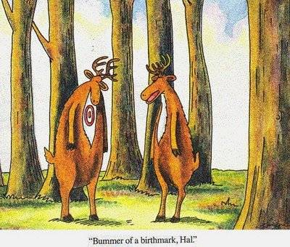
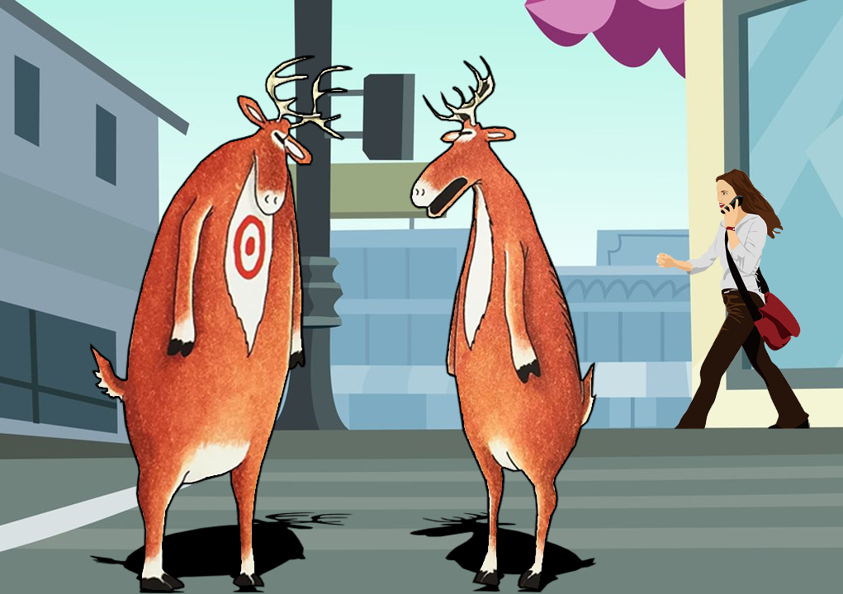
How can a mutation be helpful in one environment and harmful in another?
A city where hunting is illegal. The forest where hunting is legal.

