Name _____________________________________

Regents  Biology  Off Site  Learning Packet  Assignment #1: _____  Assignment #2: _____  Assignment #3: _____  Assignment #4: _____  Assignment #5: _____  Assignment #6: _____  Assignment #7: _____  Assignment #8: _____  Crossword Puzzle: _____ | North Salem High School  MISSION: Engage students to continuously learn, question, define and solve problems through critical and creative thinking.  Life Functions  and  Cytology  (cells) (study of)  (pp.77 - 90)
If you have any problems – please sign up for extra help after school. |  | Collea / Oliver  Room W-19

Assignment #1

"Substituted Sammy": An Exercise in Defining Life

[1] Sammy was a normal, healthy boy. There was nothing in his life to indicate that he was any different from anyone else. After he completed high school in North Salem, he obtained a job in a factory operating a printing press. On this job he had an accident and lost his hand. It was replaced with an artificial hand that looked and operated almost like a real one.

[2] Soon afterward, Sammy’s friends dared him to the hot chip challenge which ended up permanently burning his entire digestive tract. The entire digestive tract had to be surgically removed and replaced with an elastic silicone tube. Sammy was fed through this tube for the rest of his life.

[3] Everything looked good for Sammy until he was involved in a serious car accident on his way to the Danbury Mall. Both of his legs and his good arm were crushed and had to be amputated. His ear ring got stuck in the tire and so he lost his right ear. Artificial legs enabled Sammy to walk again, and an artificial arm replaced the real arm. Plastic surgery and the use of silicone polymers enabled doctors to rebuild the ear.

[4] Over the next several years Sammy was plagued with internal disorders. First, his girlfriend broke his heart (literally). Luckily for Sammy, a donor heart was available for a heart transplant. Then, he developed a kidney malfunction, and the only way he could survive was to use a kidney dialysis machine as no donor could be found to give him a kidney transplant.

[5] It was now obvious that Sammy had become a medical phenomenon. He had artificial limbs. Nourishment was supplied to him through his feeding tube. All metabolic wastes material were removed by the kidney dialysis machine. The transplanted heart that pumped his blood to carry oxygen and food to his cells began to fail. He was immediately placed on a heart-lung machine. This supplied oxygen and removed carbon dioxide from his blood and circulated it throughout his body.

[6] The doctors consulted bioengineers at Fordham University about Sammy. Because almost all of his life-sustaining functions were being carried on by machines, it might be possible to compress all of these machines into one mobile unit, which could be controlled by electrical impulses from the brain. This unit would be equipped with mechanical arms to enable him to perform basic tasks. A mechanism to create a flow of air over his vocal cords enabled him to speak. To do all this, they would have to amputate at the neck and attach his head to the machine, which would then supply all nutrients to his brain. Sammy consented, and the operation was successfully performed.

[7] Sammy functioned well for a few years. However, slow deterioration of his brain cells was observed and was diagnosed as terminal. So the medical team that worked with Sammy began to program his brain. A miniature computer was developed and housed in a machine that was humanlike in appearance, movement, and mannerisms. Sammy was once again able to leave the hospital with complete assurance that he would not return with biologic illnesses.

1. By the end of this story does Sammy still have the necessary characteristics to be considered a living organism? Explain your answer.

____________________________________________________________________________________
____________________________________________________________________________________
____________________________________________________________________________________
____________________________________________________________________________________

2. At what point in the story ([1] - [7]) do you consider Sammy to have ceased living a life that we could recognize as a human life? Cite specific examples in the story and use the characteristics of life to help explain your answer.

____________________________________________________________________________________
____________________________________________________________________________________
____________________________________________________________________________________
____________________________________________________________________________________
____________________________________________________________________________________
____________________________________________________________________________________

3. List and briefly describe at least 5 of the characteristics of life that Sammy lost.

a.______________________________________________________________________
b. _____________________________________________________________________
c. ______________________________________________________________________
d. _____________________________________________________________________
e. ______________________________________________________________________

Assignment #2

Directions: Go to Collea’s Corner to watch the below mentioned Ted-Ed video and then answers the questions below.

The Wacky History of the Cell Theory
- Lauren Royal-Woods

Background Information:
Scientific discovery isn't as simple as one good experiment. The weird and wonderful history of the cell theory illuminates the twists and turns that came together to build the foundations of cell biology.

1. Scientists can only make discoveries in a laboratory with white lab coats and science gizmos that go beep.
(A) True (B) False

2. There are three parts to the cell theory. Which is NOT one of those parts?
(a) All organisms are composed of one or more cells.
(b) The cell is the basic unit of structure and organization in organisms.
(c) Cells spontaneously arise from carbon and nutrients carried in the bloodstream.
(d) All cells come from pre-existing cells.

3. Anton van Leeuwenhoek made his own version of the microscope and discovered something very odd when he looked at the gunk on his teeth. What did he discover?
(a) Cells (b) Bacteria (c) Cavities (d) Influenza

4. Who named the cell?
(a) Robert Hooke (c) Mr. Collea
(b) Theodor Schwann (d) Ms. Oliver

5. Which scientist realized that, by studying samples under a microscope, all animals are made up of cells?
(a) Rudolf Virchow (c) Anton van Leeuwenhoek
(b) Theodor Schwann (d) Isaac Newton

6. Why do you think there were so many heated debates around the development of the cell theory?

____________________________________________________________________________________

____________________________________________________________________________________

____________________________________________________________________________________

____________________________________________________________________________________

7. If you could invent one "science gizmo," what would it be? Do you think your invention would lead to any discoveries that would change our understanding of science?

____________________________________________________________________________________

____________________________________________________________________________________

____________________________________________________________________________________

____________________________________________________________________________________

____________________________________________________________________________________

____________________________________________________________________________________

8. Can you describe a time when collaboration (working with others as a team) worked well for you?

____________________________________________________________________________________

____________________________________________________________________________________

____________________________________________________________________________________

____________________________________________________________________________________

____________________________________________________________________________________

____________________________________________________________________________________

Assignment #3

Directions: Go to Collea’s Corner to watch the below mentioned Ted-Ed video and
then answers the questions below.

At What Moment Are You Dead
- Randall Hayes

Background Information:
For as far back as we can trace our existence, humans have been fascinated with death and resurrection. But is resurrection really possible? And what is the actual difference between a living creature and a dead body anyway? Randall Hayes delves into the scientific theories that seek to answer these age-old questions.

1. Dead bodies are cold. Would heating them up restore them to life?
(a) Yes, because it would restore movement to the molecules inside the body.
(b) Yes, because bodies need energy, and heat is a form of energy.
(c) No, this would probably make them rot faster (and smell worse!)
(d) No, because heat is a waste product and does nothing useful.

2. How does a defibrillator work?
(a) It recharges the heart like a battery.
(b) It ignites the fuel inside the heart muscle cells like a spark plug.
(c) The electrical pulse turns on the muscle cells like a switch so they start beating.
(d) It synchronizes the still beating heart cells so they work together.

3. What sort of energy do cells run on?
(a) Light energy (c) Electrical energy
(b) Chemical energy (ATP) (d) Kinetic energy

4. Atoms and molecules diffuse -
(a) from high to low concentration. (c) from high energy to low energy.
(b) from low to high concentration. (d) from low energy to high energy.

5. What is Cryonics? (Google it!)

____________________________________________________________________________________
____________________________________________________________________________________
Assignment #4

Directions: Go to Collea’s Corner to watch the below mentioned Ted-Ed video and
then answers the questions below.

Cell vs.Virus
- Shannon Stiles

Background Information:
All living things are made of cells. In the human body, these highly efficient units are protected by layer upon layer of defense against icky invaders like the cold virus. Shannon Stiles takes a journey into the cell, introducing the microscopic arsenal of weapons and warriors that play a role in the battle for your health.

1. Every living on Earth is made of _______________.

2. Each cell in your body is surrounded by a ______________________________.

3. Cell membranes are made up of _______________________________________.

4. The job of the cell membrane is to ___________________________________________.

5. Cell membranes are ___________________________ which means it lets some things and out but blocks others.

6. Cell membranes are covered with tiny projections called _______________________.

Ex: Neurotransmitters binding to receptors on an adjacent nerve cell membrane.
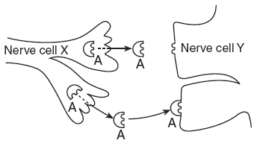

7. Only plant cells have a ____________________.

8. Antibodies are __________________________________________________________.

9. The nucleus of the cell contains an important molecule found in all cells.
This molecule is “the blueprint of life” and is called -
(a) sugar. (b) protein. (c) ATP. (d) DNA.

10. Proteins, like antibodies, are made inside of the cell. Proteins are made by the cell’s -
(a) golgi apparatus. (b) ribosomes. (c) nucleus. (d) DNA.

11. Once a protein is made, it needs to be able to leave the cell. The structure that packages the protein in a vesicle and directs it to the cell membrane is known as the -
(a) golgi apparatus. (b) ribosome. (c) mitochondria. (d) nucleus.

12. Cells need energy to perform all of their functions. Where in the cell is energy made?
(a) golgi apparatus (b) nucleus (c) mitochondria (d) nucleus

13. The mitochondria creates a high energy molecule called __________.

14. In the space below, write the complete chemical equation for cellular respiration. NOTES

Raw Materials
Products

15. Plant cells have ________________________ that allow to make energy a different way.

16. Sugar is a form of ____________________ energy.

17. In the space below, write the complete chemical equation for photosynthesis. NOTES

Products
Raw Materials

Assignment #5

Directions: Answer each of the following questions as completely and as accurately as
possible

___1. Which are the four most abundant elements in living cells?
(a) carbon, oxygen, nitrogen, sulfur (c) carbon, hydrogen, oxygen, nitrogen
(b) carbon, oxygen, sulfur, phosphorus (d) carbon, sulfur, hydrogen, magnesium

___2. Which formula represents an organic compound?
(a) Mg(OH)₂ (b) NaCl (c) C₁₂H₂₂O₁₁ (d) NH₃

___3. An organelle differs from an organ in that an organelle -
(a) is a substructure/part of a cell. (c) contains one specific type of tissue.
(b) is larger than an organ. (d) cannot be stained

___4. The absorption of fluids by various cells of the human body is part of the life function known as -
(a) excretion. (c) transport.
(b) respiration. (d) growth.

___5. The life function of transport directly involves those activities used to -
(a) absorb and distribute materials. (c) obtain and hydrolyze materials.
(b) release energy from food. (d) produce cellular waste products.

___6. Nutrition involves those activities by which organisms -
(a) remove cellular waste products
(b) obtain and process materials needed for other activities
(c) exchange gases with their environment
(d) absorb and circulate materials

___7. Which life process is classified as autotrophic in some organisms and heterotrophic
in other organisms?
(a) hormonal regulation (c) nutrition
(b) anaerobic respiration (d) transport

___8. Respiration is best described as a process by which -
(a) necessary nutrients are circulated
(b) hydrogen is used to synthesize glucose
(c) metabolic wastes are absorbed
(d) chemical energy is converted into a usable form

___9. Which term is defined as all the chemical reactions that are required to sustain life?
(a) metabolism (c) nutrition
(b) regulation (d) synthesis

___10. One characteristic of all living things is that they -
(a) develop organ systems. (c) produce identical offspring.
(b) maintain internal stability. (d) synthesize only inorganic matter.

___11. Which process includes the other three?
(a) synthesis (c) metabolism
(b) excretion (d) nutrition

___12. In which process are simple materials chemically combined to form more complex materials?
(a) synthesis (c) metabolism
(b) excretion (d) nutrition

___13. Which activity is an example of the life process known as synthesis?
(a) An organic compound is broken down and energy is released.
(b) Starch is formed by the chemical bonding of glucose molecules.
(c) A large molecule is broken down into smaller molecules.
(d) Oxygen moves into a cell through the cell membrane.

___14. The diagram below represents an activity that occurs in the human body.

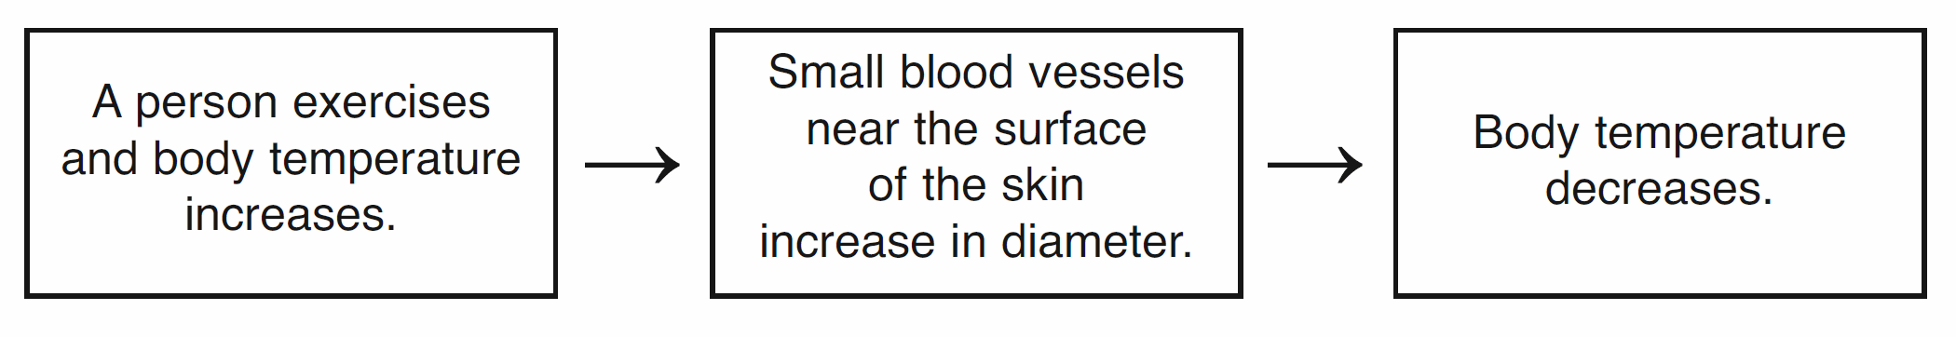
This diagram best illustrates -
(a) metabolism. (c) nutrition.
(b) homeostasis. (d) synthesis.

Assignment #6

Directions: Answer each of the following questions as completely and as accurately as
possible

___1. According to the cell theory, which statement is correct?
(a) Viruses are true cells.
(b) Cells are basically unlike in structure.
(c) Mitochondria are found only in plant cells.
(d) Cells come from preexisting cells.

___2. Which statement describes an exception to the cell theory?
(a) Mitochondria and chloroplasts are self-reproducing structures.
(b) All cells must come from preexisting cells.
(c) Cells are the basic unit of structure in living things.
(d) Cells are the basic unit of function in living things.

___3. Viruses are exceptions to the cell theory, but they have some characteristics of living things. What is one of these characteristics?
(a) They are made up of many specialized cells.
(b) They contain genetic material.
(c) They reproduce by mitosis.
(d) They contain chlorophyll.

___4. Which cell organelles are considered the sites of aerobic respiration in both plant and animal cells?
(a) mitochondria (c) centrosomes
(b) chloroplasts (d) nuclei

___5. Intracellular transport of materials is most closely associated with which cell
organelle?
(a) cell membrane (c) cell wall
(b) ribosome (d) endoplasmic reticulum

___6. The ribosome is an organelle that functions in the process of -
(a) excretion (c) photosynthesis
(b) protein synthesis (d) cellular respiration

___7. Which organelle is present in the cells of a mouse but not present in the cells of a bean plant?
(a) cell wall (c) chloroplast
(b) cell membrane (d) nucleus

___8. The mitochondria is to the cell as -
(a) the motor is to a car (c) the windshield is to a car
(b) the door is to a car (d) the seatbelt is to a car

___9. What is the main function of a vacuole in a cell?
(a) storage (c) coordination
(b) synthesis of molecules (d) release of energy

___10. Which diagram best represents the locations of the structures in the list below?

A - cell
B - tissue
C - organ
D - organelle

(a) (b) (c) (d)
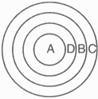
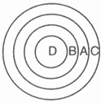
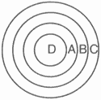
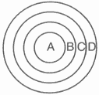

___11. Muscle cells in athletes often have more mitochondria than muscle cells in
non-athletes. Based on this observation, it can be inferred that the muscle cells in
athletes -
(a) have a smaller demand for cell proteins than the muscle cells of non-athletes.
(b) reproduce less frequently than the muscle cells of non-athletes.
(c) have nuclei containing more DNA than nuclei in the muscle cells of non-athletes.
(d) have a greater demand for energy than the muscle cells of non-athletes.

___12. Within a cell, where is the DNA chiefly found?
(a) cell wall (c) plasma membrane
(b) ribosomes (d) nucleus

___13. Unlike animal cells, ________ and ________ are found only in plant cells.
(a) chloroplasts . . . cell walls (c) cell membranes. . . chloroplasts
(b) chloroplasts . . . mitochondria (d) nucleus. . . cell walls
___14. The function of chloroplasts is to carry out the process of -
(a) cellular respiration. (c) lipid synthesis.
(b) photosynthesis. (d) intracellular digestion.
___15. Which structure is a boundary between the living cell and its environment?
(a) ribosome (c) mitochondria
(b) cell membrane (d) vacuole

___16. Which structure carries out a similar function in both plant and animal cells?
(a) cell wall (b) chloroplast (c) plasma membrane

___17. Which are the main structural components of a cell membrane?
(a) proteins and carbohydrates (c) lipids and cellulose
(b) amino acids and proteins (d) proteins and lipids

___18. What is the main structural components of a cell wall?
(a) proteins (c) cellulose
(b) amino acids (d) glucose

___19. The diagram below represents an incomplete sequence of levels of organization.

organelles tissues organs organ systems organism

This sequence can be completed correctly by inserting
(a) "cells " between organelles and tissues
(b) "proteins " between tissues and organs
(c) "populations " between organs and organ systems
(d) "molecules " between organ systems and organisms

___20. A brick is to house as a cell is to -
(a) an organ system. (c) an organ.
(b) a tissue. (d) an organism.

Assignment #7

In a cell, a variety of structures perform specific functions and interact to maintain a stable internal environment or homeostasis. The diagram below represents a typical cell with three cell structures labeled 1, 2, and 3.
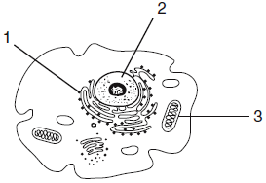
1. Select one cell structure labeled in the
diagram and write its number and name
in the space below.

_____ = ________________________

2. Explain how the cell structure you selected helps maintain homeostasis in a cell.
In your answer, be sure to:
- state one function of this cell structure
- identify one substance that is often associated with the cell structure you selected and state how that substance is associated with the cell structure
- identify one other cell structure and explain how it interacts with the cell structure you selected to maintain homeostasis in the cell

____________________________________________________________________________________

____________________________________________________________________________________

____________________________________________________________________________________

____________________________________________________________________________________

____________________________________________________________________________________

____________________________________________________________________________________

____________________________________________________________________________________

____________________________________________________________________________________

____________________________________________________________________________________

____________________________________________________________________________________

____________________________________________________________________________________

____________________________________________________________________________________

Assignment #8

All the cells in the human body
By ThoughtCo.com, adapted by Newsela staff
Cells in the human body number in the trillions and come in all shapes and sizes. These tiny
structures are the basic unit of living organisms. Cells make up tissues, and tissues make up
organs. Organs form organ systems, and organ systems work together to keep an organism
alive.
There are hundreds of different types of cells in the body and the structure of a cell is perfectly
suited for the role it performs. Cells of the digestive system, for instance, have a different
function from cells of the skeletal system.
No matter the differences, cells of the body depend on one another, either directly or indirectly,
to keep the body functioning as one unit. The following are examples of different types of cells
in the human body.
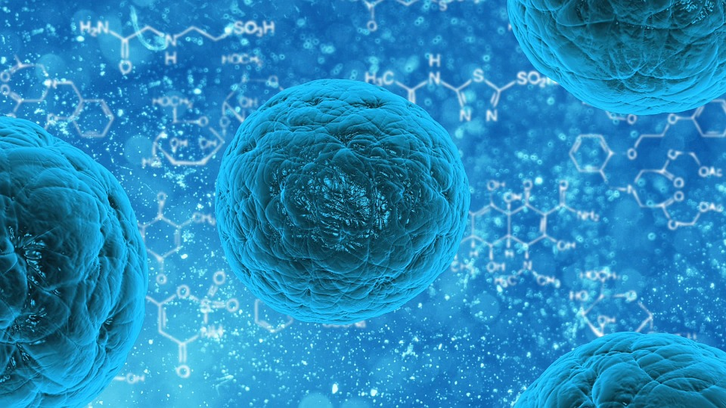
Stem Cells
Stem cells are unique cells of the body in that they are not specialized for any particular role. However, they have the ability to develop into specialized cells for specific organs or tissues when the need arises.
Stem cells are able to divide and replicate many times in order to renew and repair tissue. Scientists are researching ways to take advantage of the renewal properties of stem cells. They use these cells to repair damaged tissue, for organ transplantation and for the treatment of disease.

Blood Cells
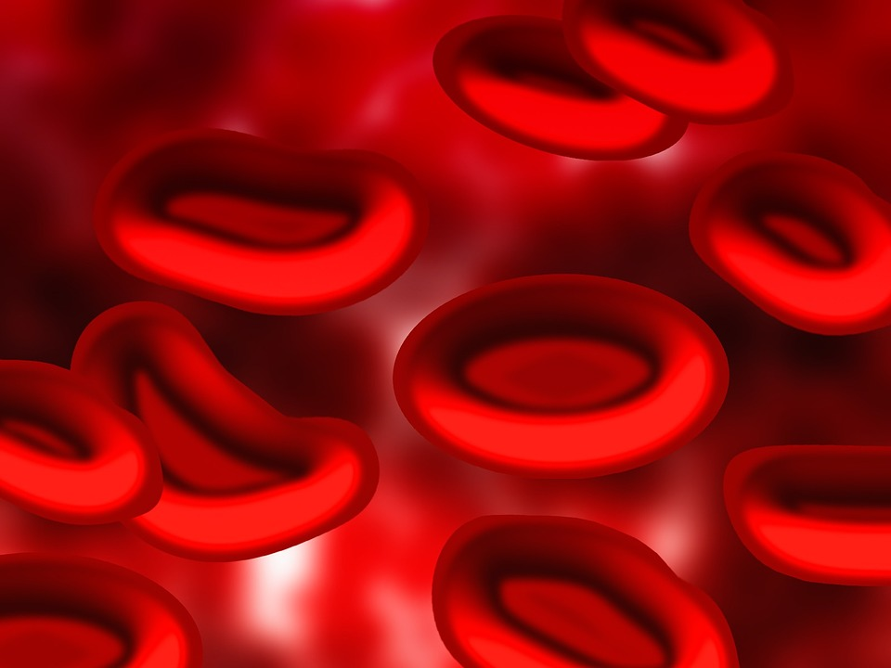
From transporting oxygen throughout the body to fighting infection, cells of the blood are vital to life. The three major types of cells in the blood are red blood cells, white blood cells and platelets.
Red blood cells determine blood type and are also responsible for transporting oxygen to other cells. White blood cells are immune system cells that destroy pathogens, or disease-causing organisms, and provide protection. When blood vessels break, platelets, which are produced by bone marrow, help to clot the blood and prevent too much blood loss.
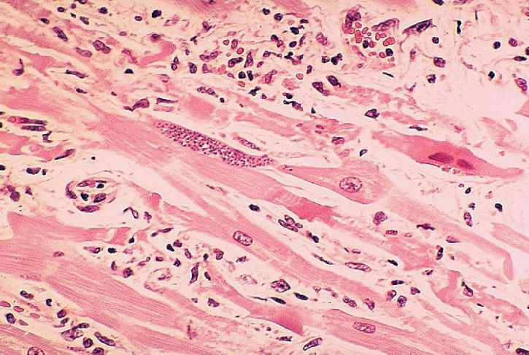
Muscle Cells
Muscle cells form muscle tissue, which is important for moving the body. Skeletal muscle tissue, like a tendon, attaches to bones and allows us to move as we please.
Cardiac muscle cells form the muscles in the heart, which help the heart contract as it pumps blood. These muscles are involuntary, which means that they move without us telling them to do so.
Smooth muscle is also involuntary. It is a type of muscle that forms the walls of many organs, including kidneys, intestines, blood vessels and lung airways.

Nerve Cells
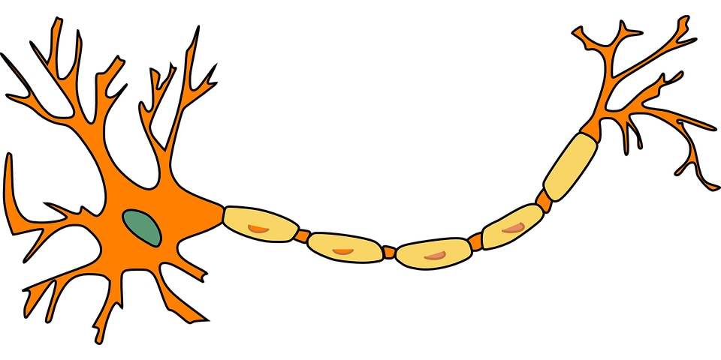
Nerve cells, or neurons, are the basic units of the nervous system. Nerves send signals between the brain, the spinal cord and the various body organs through nerve impulses.
A neuron consists of two major parts, a cell body and nerve processes. The central cell body contains the neuron's nucleus, associated cytoplasm and organelles. Nerve processes, called axons and dendrites, extend from the cell body and are able to create and send signals elsewhere.

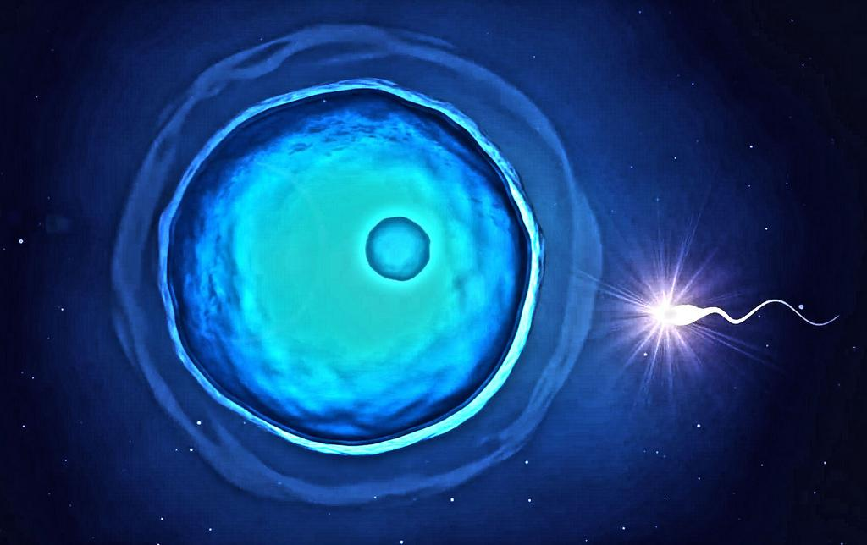
Sex Cells
Sex cells, or gametes, are reproductive cells, which combine during fertilization in order to create new life. Male sex cells, or sperm, can move by using a long tail called a flagellum to propel themselves forward. Female sex cells, or eggs (ova), do not move and are relatively large in comparison to the male gamete.

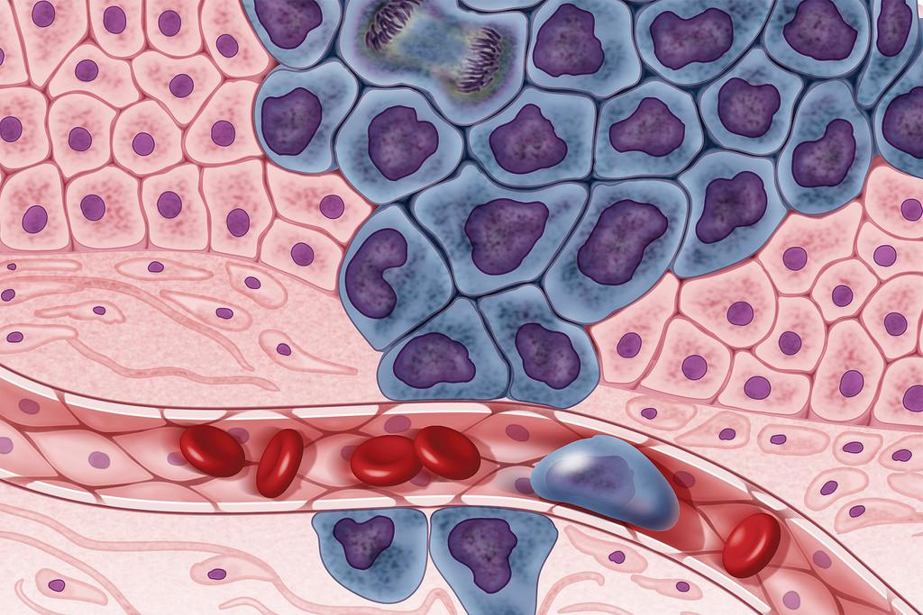
Cancer Cells
Cancer is caused when normal cells develop abnormal properties, such as not being able to go through apoptosis or cell death. Without apoptosis, which is the cell's self-destruct mechanism, these cells can divide uncontrollably by mitosis and spread to other locations.
Cancer cell development can be caused by mutations. These mutations may form because of exposure to chemicals, radiation or viral infection.

1. According to the article, different types of cells work together to ensure that the human body works properly.
Which paragraph BEST supports the idea outlined above?
(A) Stem cells are unique cells of the body in that they are not specialized for any
particular role. However, they have the ability to develop into specialized cells for specific organs or tissues when the need arises.
(B) There are three primary types of bone cells in the body. Osteoclasts are large
cells that decompose bone so it can be absorbed into the body. Osteoblasts regulate bone mineralization and produce the substance osteoid, which mineralizes, or hardens, in order to form bone. Osteoblasts mature to form osteocytes, which aid in the formation of bone and help maintain calcium balance.
(C) Muscle cells form muscle tissue, which is important for moving the body.
Skeletal muscle tissue, like a tendon, attaches to bones and allows us to move
as we please.
(D) A neuron consists of two major parts, a cell body and nerve processes. The
central cell body contains the neuron's nucleus, associated cytoplasm and
organelles. Nerve processes, called axons and dendrites, extend from the cell
body and are able to create and send signals elsewhere.

2. Read these sentences from the article.
1. No matter the differences, cells of the body depend on one another, either directly or indirectly, to keep the body functioning as one unit.
2. Stem cells are able to divide and replicate many times in order to renew and repair tissue.
3. White blood cells are immune system cells that destroy pathogens, or disease-causing organisms, and provide protection.
Which two sentences taken together provide the BEST evidence to support the idea that cells
protect the body?
(A) 1 and 2 (B) 1 and 3 (C) 2 and 3

3. Read the sentence from the section "Stem Cells."
Stem cells are unique cells of the body in that they are not specialized for any particular role.

Which of the following words from the article provides context clues to the meaning of the word "specialized"?
(A) particular and specific
(B) develop and repair
(C) ability and replicate
(D) unique and renew

4. Read the sentence from the section "Cancer Cells."

Cancer is caused when normal cells develop abnormal properties, such as not being able to go through apoptosis.
The author uses the word "abnormal" to mean:
(A) ordinary
(B) standard
(C) traditional
(D) exceptional

5. Even though each body cell in an individual contains the same DNA, the functions of
muscle cells and liver cells are not the same because -
(A) mutations usually occur in genes when muscle cells divide
(B) liver tissue develops before muscle tissue
(C) liver cells produce more oxygen than muscle cells
(D) liver cells use different genes than muscle cells

6. The function of a cell depends primarily
on its -
(A) life span
(B) color
(C) structure
(D) movement

7. Stem cells are cells that do not have a specific function. What must happen to these cells for them to become specialized cells like heart muscle cells?
(A) Certain genes in the cell have to become activated to cause special enzymes to form.
(B) The nucleus in the stem cell must become bigger and more DNA has to be produced.
(C) The cells must begin to divide by mitosis.
Good test question....

Base your answer to the following question on " Some human body cells are shown in the diagrams below.

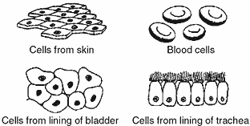
These groups of cells represent different

A) tissues in which similar cells function together B) organs that help to carry out a specific life activity C) systems that are responsible for a specific life activity D) organelles that carry out different functions

Crossword Puzzle

