Name _______________________________ Date __________
Regents Biology

DNA Extraction

INTRODUCTION:

Many students find studying DNA difficult because it is so small that the concepts are quite abstract. This lab enables students to work with DNA concretely by easily isolating chromosomal DNA using the same basic tools and methods that scientists use.

DNA can be extracted from many types of cells in four easy steps. These steps include:
1. To lyse or split open the cell. This can be done by grinding a piece of tissue in a blender.
2. After the cells have split open, a salt and detergents solution is added to break down and emulsify the lipids and proteins that make up a nuclear and cell membrane.
3. Meat tenderizer (enzyme) is used to separate the DNA from the histones (proteins) in the chromosomes.
4. Finally, ethyl alcohol (ethanol) is added because DNA is soluble in water. The alcohol causes DNA to precipitate, or settle out of the solution, leaving behind all the cellular components that
aren't soluble in alcohol. The DNA can be spooled (wound) on a stirring rod and pulled from the solution at this point.
Remember: Detergent, eNzymes then Alcohol = DNA

Since DNA is the blueprint for life, everything living contains DNA. DNA extraction and isolation is one of the most basic and essential techniques in the study of DNA. The extraction of DNA from cells and its purification are of primary importance to the field of biotechnology and forensics. Extraction and purification of DNA are the first steps in the analysis and manipulation of DNA that allow scientists to detect genetic disorders, produce DNA fingerprints of individuals, and even create genetically engineered organisms that can produce beneficial proteins such as insulin, antibodies, and hormones.

Organization of Genetic Material
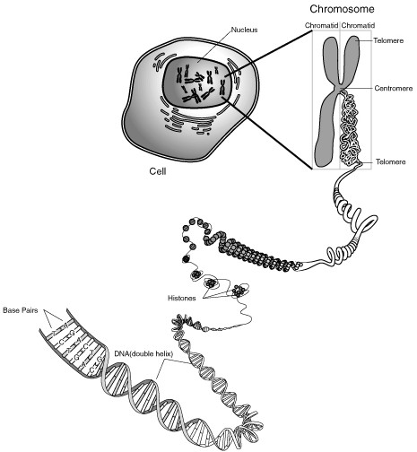

METHODS

Materials
DNA source (strawberries) graduated cylinders (10mL-25mL-100mL) 2 test tubes 250mL / 400 mL beaker strainer/cheese cloth salt
glass stirring rod Dawn detergent distilled water ice cold 95% ethanol zip-lock bag digital scale

Procedure

- Use a 100mL graduated cylinder to measure 90 mL of distilled water and then pour it into a 250 mL beaker.

- Use a 10 mL graduated cylinder to measure 9 mL of Dawn dish detergent and then pour into the 250 mL beaker with the 90 mL of distilled water. This may have already been done for you.

- Use the digital scale to measure 1.5g of salt and then it to the 250 mL beaker with detergent and distilled water
.
- Use a glass stirring rod to mix the ingredients together- try not to make a lot of bubbles during this step. This is your extraction solution.

- Place 5 strawberries into a plastic zip-lock bag and then carefully smush the strawberries with your fingers.

- Once smushed, pour the extraction solution into the zip-lock bag with the 5 strawberries.

- Before sealing the bag, remove as much air as possible.

- Once the bag is sealed, use your fingers to continue to mix and smush the contents of the bag until there are no chunks remaining.

The detergent disrupts and captures the proteins & lipids of the cell and nuclear membranes.
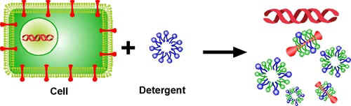

- Slowly pour the contents of the bag through a piece of cheesecloth secured to a 400 mL beaker with a rubber band to filter the strawberry solution and remove the big chunks of strawberry. The solution in the beaker is called the filtrate.

- Add a pinch of meat tenderizer to your 400 mL beaker and GENTLY stir with your stirring rod.
Be careful! If you stir too hard, you'll break up the DNA, making it harder to see.

The DNA in the nucleus of the cell is molded, folded, and protected by proteins.
The meat tenderizer contains the enzyme protease that cuts the proteins away from the DNA.
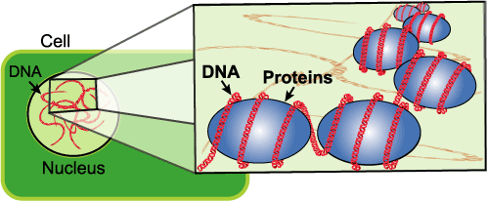

- Carefully pour the filtrate into a test tube until it is about 1/3 full.

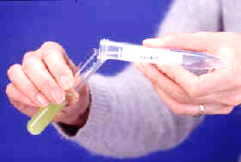
- Obtain 20 mL of ice cold ethanol from Mr. Collea. TILT your test tube and SLOWLY pour the ice cold ethanol into the test tube down the side so that it forms a layer on top of the solution. Pour until you have about the same amount of alcohol in the tube as filtrate.

Alcohol is less dense than water, so it floats
on top forming two separate layers. All of
the lipids and the protein that you broke up
in the first two steps move to the bottom,
watery layer.

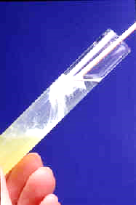
- Let the test tube sit for 5 minutes and observe what happens.
Take a picture of the DNA and send it to Mr. Collea.

- The negatively charged DNA is attracted to the ethanol and should rise into the alcohol layer from the filtrate solution. You can use a bent plastic stick to draw the DNA into the alcohol. SLOWLY turning the stick will spool (wrap) the DNA around the stick so it can be removed from the test tube. Behold…DNA!

- Place a small amount of you DNA on a clean slide prepared with Methylene Blue stain and observe under a microscope.
Draw what you see on the next page.

DNA stained with Methylene Blue

Magnification __________

Good Luck in your quest for the

Rosalind Franklin Award for Excellence in DNA Extraction

