Phylogeny and Earth Origins:
Possible Free-Response Questions

1. Construct and Interpret Phylogenic Trees using biochemical and physical data.

2. Scientists recently have proposed a reorganization of the phylogenetic system of classification to include the Domain, a new taxonomic category higher (more inclusive) than the Kingdom category, as shown in the diagram below.

Universal Ancestor
Domain Bacteria Domain Archaea Domain Eukarya
(Eubacteria) (Archaebacteria) (Eukaryotes)
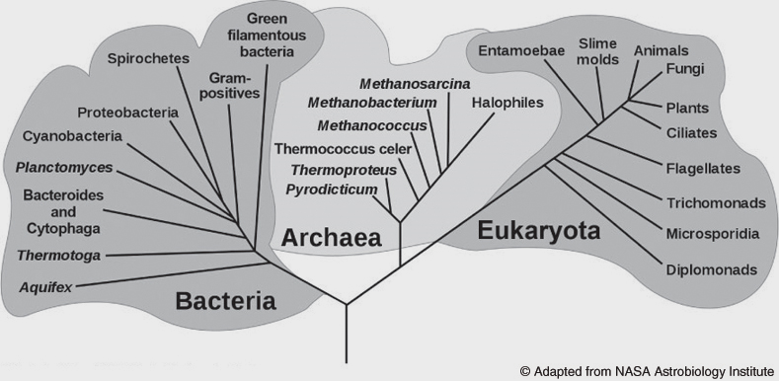

Universal Ancestor

(a) Compare and contrast the old five-kingdom classification scheme with the newer three-domain / four-kingdom scheme and describe how this classification scheme presents different conclusions about the relationships among living organisms than those presented by the older system.
(b) Describe three kinds of evidence that were used to develop the taxonomic scheme above, and
explain how this evidence was used.
(The evidence may be structural, physiological, molecular, and/or genetic.)

3. (a) Explain the endosymbiotic theory and discuss (in detail) three observations that support it.
(b) Relate this theory to Darwin’s phrase, “descent with modification.”

4. (a) List and briefly describe the conditions on early Earth that made the origin on life possible.
(b) Describe the contributions that A. I. Oparin, J. B. S. Haldane, and Stanley Miller made toward
developing a model for the abiotic synthesis of organic molecules.

