|  |  |  |
| --- | --- | --- |
| **AP Biology**  Interactive Student  Study  Guide | **North Salem University**  **MISSION**: *Engage students to continuously learn, question, define and solve problems through critical and creative thinking.*  Spring  2018 | |
| *Ecology is the branch of biology which studies the interactions among organisms and their environment. Objects of study include interactions of organisms with each other and with abiotic components of their environment. This unit will also take a closer look at the populations of organisms, as well as cooperation and competition within and between species. Ecosystem processes, such as primary production, nutrient cycling and the regulate the flow energy and matter through an environment will also be discussed*  ***If you have any problems – please sign up for extra help after school.*** | | **Ecology**  Ch.50-55 |

**Organization of Life**

*(Prior Knowledge)*

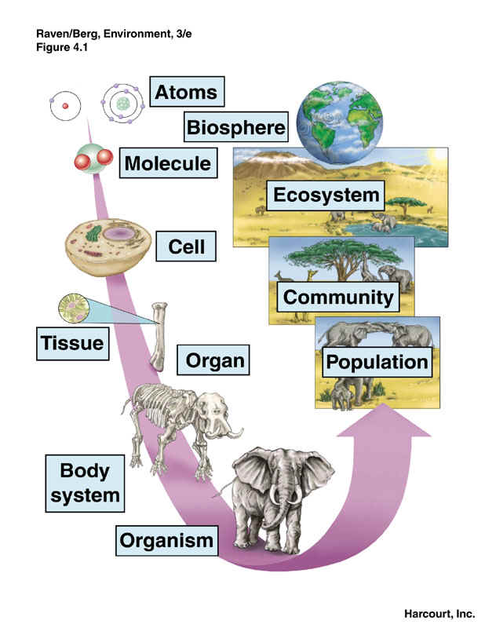

**Chapter 50: Ecology and the Biosphere**

**OBJECTIVES:**

**The Scope of Ecology**

__2. Distinguish between the abiotic and biotic components of the environment.

__3. Describe the relationship between ecology and evolutionary biology.

__4. Distinguish among population ecology, community ecology, and ecosystem ecology

**Factors Affecting Distributions of Organisms**

__5. Describe the problem of introduced species and the specific problems posed by the introduction of zebra mussels.

__6. Describe and illustrate biotic and abiotic factors that affect the distribution of organisms.

__7. Explain how climate affects the geographic distribution of organisms.

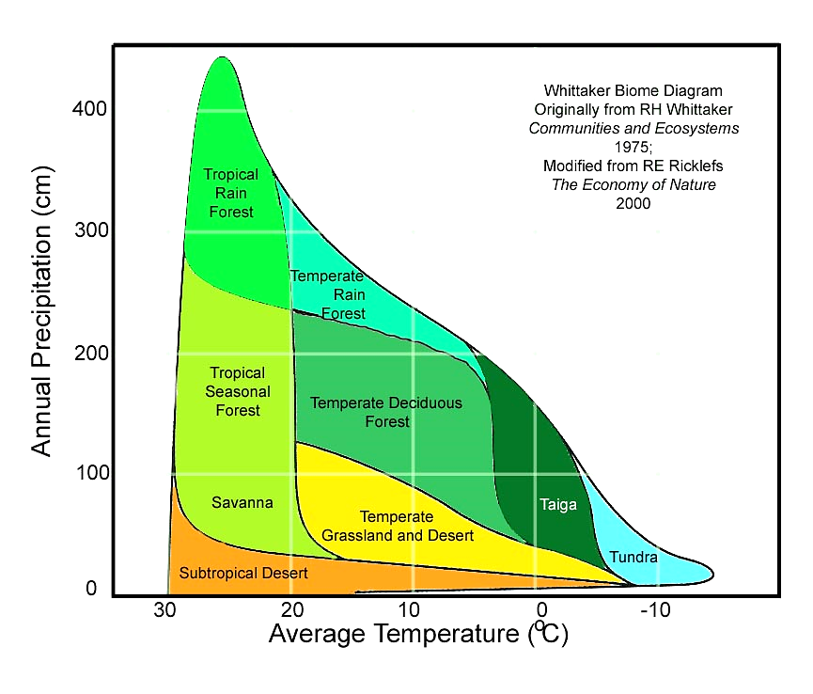

The Whittaker Biome Diagram above is a simple way to organize biomes is by their climate (*temperature and precipitation*).

A scientist by the name of Robert Harding Whittaker was the first to propose the scheme pictured above.

**Guided Reading: Chapter 50**

1. Define the following terms:
   1. **Abiotic** –
   2. **Biotic** –

* 1. Give an example of the interactions of biotic and abiotic factors.

1. What do the following subfields of ecology study?
   1. **Population Ecology** -

(include the definition of ecology)

* 1. **Community Ecology** -

(include the definition of community)

* 1. **Ecosystem Ecology** -

(include the definition of ecosystem)

1. List the factors that affect dispersal of organisms.
2. Use the **Figure 50.8** to help you describe the expansion of the zebra mussel across the US since its discovery in Detroit in 1988.
3. Define **Biomass**.
4. Describe and explain the effects zebra mussels had on the biomass of each of the following

organisms found in the Hudson River:

**(a)** phytoplankton -

**(b)** zooplankton -

**(c)** native mollusks -

1. Construct a food chain for the organisms affected by the introduction of zebra mussels in the Hudson River.

**Chapter 52: Population Ecology**

**OBJECTIVES:**

**Characteristics of Populations**

__1. Define the scope of population ecology

__2. Define and distinguish between density and dispersion.

__3. Explain how ecologists measure the density of a species.

__4. Describe conditions that may result in the clumped dispersion, uniform dispersion, and random dispersion of populations.

__5. Describe the characteristics of populations that exhibit Type I, Type II, and Type III survivorship curves.

**Population Growth**

__6. Compare the geometric model of population growth with the logistic model.

__7. Explain how an environment's carrying capacity affects the intrinsic rate of increase of a population.

__8. Distinguish between r-selected populations and K-selected populations.

**Population-Limiting Factors**

__9. Explain how density-dependent factors affect population growth.

__10. Explain how density-dependent and density-independent factors may work together to control a population's growth.

__11. Explain how predation can affect life history through natural selection.

__12. Describe several boom-and-bust population cycles, noting possible causes and consequences of the fluctuations.

**Human Population Growth**

__13. Describe the history of human population growth.

__14. Define the demographic transition.

__15. Compare the age structures of Italy, Kenya, and the United States. Describe the possible consequences for each country.

__16. Describe the problems associated with estimating Earth's carrying capacity.

**KEY TERMS:**

carrying capacity demography density dependent density independent

dispersion K-selection logistic population growth population

r-selection survivorship curve

- - - - - - - - - - - - - - - - - - - - - - - - - - - - - - - - - - - - - -

**WORD ROOTS:**

**co-** = together (*cohort*: a group of individuals of the same age, from birth until all are dead)

**demo-** = people; **-graphy** = writing (*demography*: the study of statistics relating to births and deaths in populations)

**itero-** = to repeat *(iteroparity*: a life history in which adults produce large numbers of offspring over many years; also known as iteroparity)

**semel-** = once; **-parity** = to beget (*semelparity*: a life history in which adults have but a single reproductive opportunity to produce large numbers of offspring, such as the life history of the Pacific salmon; also known as "big-bang reproduction")

**Guided Reading: Chapter 52**

1. What is a **population**?
2. 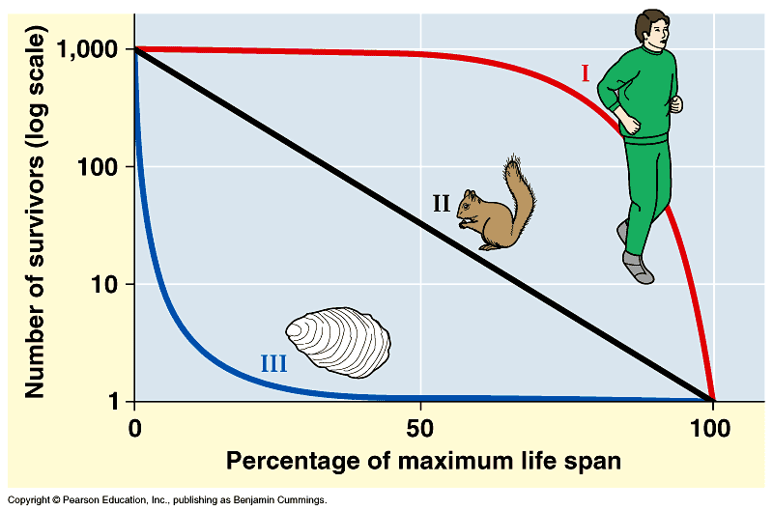Using the graph to the right to describe and compare each of the following survivorship curves and give a few examples of each. ***(Activity 52B)***

* 1. **Type I**
  2. **Type II**
  3. **Type III**

1. 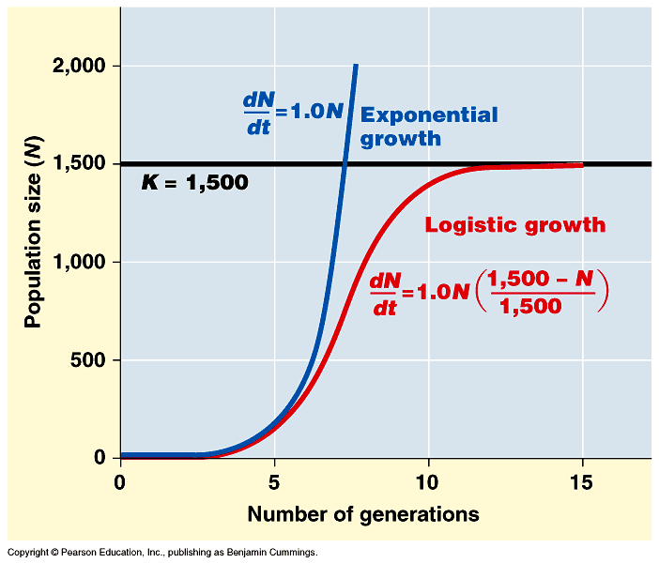Use the graph to the right to explain the differences, between **exponential population growth** and **logistic population growth**?

1. Define **carrying capacity**.
2. What happens to a population when the number of individuals approaches **carrying capacity**?
3. Compare **K-selected** (*density-dependent selection*) to **r-selected** (*density-independent selection*) species. Give examples of each.

|  |  |
| --- | --- |
| **K-selected**  (*density-dependent selection*) | **r-selected** (*density-independent selection*) |
|  |  |
| **Examples:** | **Examples:** |

1. Identify factors that regulate population size.

1. 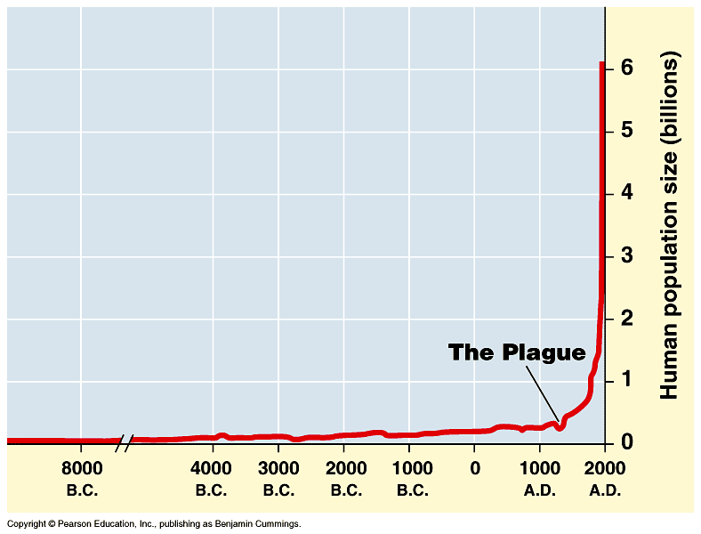Look at the growth curve of the human population. How does it compare to the growth curves mentioned earlier in this packet? ***(Activity 52C)***

1. Have humans reached **K**? What factors are significant when explaining our growth curve?
2. Look at the age structure diagrams of different countries. Be prepared to discuss in class how each might influence various personal, governmental and economic policy? ***(Activity 52D)***

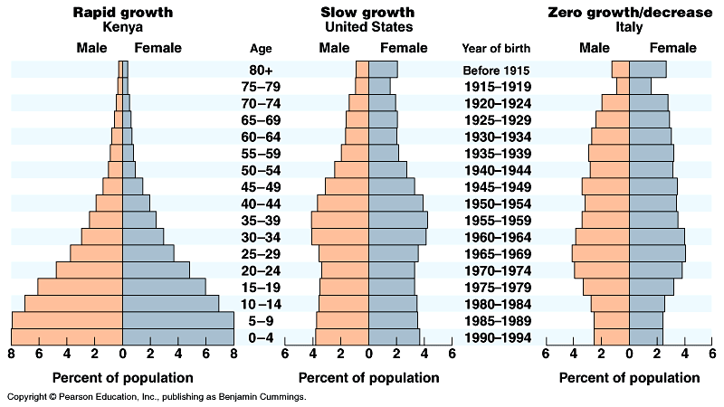

**18. Analyzing Age Structure Diagrams**



|  |  |  |
| --- | --- | --- |
|  |  |  |
| **Examples:** | **Examples:** | **Examples:** |
| **Issues/Concerns:** | **Issues/Concerns:** | **Issues/Concerns:** |

**Population Growth**

**Formulas:**

**Rate Population Growth Exponential Growth Logistic Growth**

dY/dt dN/dt = B – D  

**dY** = amount of change **N** = population size

**t** = time **K** = carrying capacity

**B** = birth rate **rmax** = maximum per capita growth rate of population

**D** = death rate

 =  =  = **population growth rate**

Population growth rate **dN/dt** is the *change in the population size* (**N**) over some *time* (**t**) interval.

**Population Growth Rate (dN/dt) = birth rate (B) – death rate (D)**

**Birth rate** (**B**) is the proportion of individuals born in a population (*over a period of time*).

**Example**: if there are 5 births among 10 individuals,

B = 5/10 = **0.5**

**Death rate (D)** is the proportion of individuals dying in a population (*over a period of time*).

**Example**: if 4 of 10 individuals die,

D = 4/10 = **0.4**

Thus, **dN/dt = B – D**

**dN/dt = 0.5 – 0.4**

**dN/dt =** **0.1**

Change in population can be calculated by multiplying the growth rate (**dN/dt**) by the original population size (**N**)

**Change in Population =** (**dN/dt**) **N**

In this example, change in population = (**dN/dt**) **N**  = **0.1(10)** = 1,

so the population has increased by one individual in that time period.

To determine the *size of the population at the end of the time period*,

add the population size (**N**) to the change in the population

= **N +** (**dN/dt**) **N**

= 10 + (0.1)10

= 10 + 1

= **11**

**19.** There are **252** deer in a population. There is no net immigration or emigration. If **47** deer die and **32** deer are born in one month, what is the population size at the end of the month?

*Round your answer to the nearest whole number.*

**20.** In a population of **600** squirrels, the *birth rate* **(B)** in a particular period is .**06** and the *death rate* **(D)** is **0.12**.

**a)** What is the *growth rate* of the population (B – D)? *Round your answer to the nearest hundredth.*

**b)** What is the actual number of squirrels that were born during this particular period?

*Round your answer to the nearest whole number.*

**c)** What is the actual number of squirrels that died during this period?

*Round your answer to the nearest whole number.*

**21.** In a population of **750** fish, **25** die on a particular day while **12** were born.

**a)** What is the *death rate* **(D)** for the day? *Round your answer to the nearest hundredth.*

**b)** What is the *birth rate* **(B)** for the day? *Round your answer to the nearest hundredth.*

**c)** What is the *growth rate* of the population (B – D)? *Round your answer to the nearest hundredth.*

**22.** In a population of **125** foxes, **10** die on a particular day and **22** were born on that day.

**a)** What is the *death rate* **(D)** for the day? *Round your answer to the nearest hundredth.*

**b)** What is the *birth rate* **(B)** for the day? *Round your answer to the nearest hundredth.*

**c)** What is the *growth rate* of the population (B – D)? *Round your answer to the nearest hundredth.*

**23.** The doubling time of a population of plants is **12** years. Assuming that the initial population is **300** and that the rate of increase remains constant, how large will the population be in **36** years?

*Round your answer to the nearest whole number.*

**24.** If **300** robins are found in a 20 hectare plot, what’s the density in robins/hectare in that plot?

*Round your answer to the nearest whole number.*

**25.** If **3400** maple trees are counted on a 3km x 4km rectangular piece of land, what is the density of the maple trees per square kilometer (km)? *Round your answer to the nearest tenth.*

**26.** You and your friends have monitored two populations of wild lupine for one entire reproductive cycle (June – Year 1 to June – Year 2). By carefully mapping, tagging and taking a census of the plants throughout this period, you obtain the data listed in the table below.

|  |  |  |
| --- | --- | --- |
| **Parameter** | **Population A** | **Population B** |
| **Initial # of plants** | 500 | 300 |
| **# of new seedlings established** | 100 | 30 |
| **# of initial plants that die** | 20 | 100 |

**(a)** Calculate the following parameters for each population. *Round your answer to the nearest hundredth.*

|  |  |  |
| --- | --- | --- |
| **Parameter** | **Population A** | **Population B** |
| Birth Rate **(B)** |  |  |
| Death Rate **(D)** |  |  |
| Population Growth Rate **(B - D)** |  |  |

(**b)** Given the intitial population size of population A and assuming that the population is experiencing growth at the growth rate [*calculated above*], what will the number of plants be in each of the next 3 years. (Use the intial population size as time 0.) *Round your answer to the nearest whole number.*

|  |  |  |
| --- | --- | --- |
| **Time (year)** | **Population** | **Work Space** |
| 0 | 500 |  |
| 1 |  |  |
| 2 |  |  |
| 3 |  |  |

**(c)** Given the intitial population size of population B and assuming that the population is experiencing growth at the growth rate [*calculated above*], what will the number of plants be in each of the next 3 years. (Use the intial population size as time 0.) *Round your answer to the nearest whole number.*

|  |  |  |
| --- | --- | --- |
| **Time (year)** | **Population** | **Work Space** |
| 0 | 300 |  |
| 1 |  |  |
| 2 |  |  |
| 3 |  |  |

**27.** In a population of **600** squirrels, the *birth rate* **(B)** in a particular period is .**06** and the *death rate* **(D)** is **0.12**.

**a)** What is the *growth rate* of the population (B – D)? *Round your answer to the nearest hundredth.*

**b)** What is the actual number of squirrels that were born during this particular period?

*Round your answer to the nearest whole number.*

**c)** What is the actual number of squirrels that died during this period?

*Round your answer to the nearest whole number.*

**28.** In a population of **750** fish, **25** die on a particular day while **12** were born.

**a)** What is the *death rate* **(D)** for the day? *Round your answer to the nearest hundredth.*

**b)** What is the *birth rate* **(B)** for the day? *Round your answer to the nearest hundredth.*

**c)** What is the *growth rate* of the population (B – D)? *Round your answer to the nearest hundredth.*

**29.** In a population of **125** foxes, **10** die on a particular day and **22** were born on that day.

**a)** What is the *death rate* **(D)** for the day? *Round your answer to the nearest hundredth.*

**b)** What is the *birth rate* **(B)** for the day? *Round your answer to the nearest hundredth.*

**c)** What is the *growth rate* of the population (B – D)? *Round your answer to the nearest hundredth.*

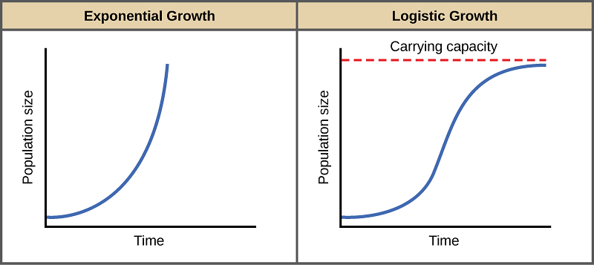**Exponential growth** is continuous population growth in an environment where resources are unlimited; it is **density-independent growth**.

Most density-independent factors are **abiotic**, or nonliving, and include:

_________________________ _________________________

_________________________ _________________________



**Formula**:

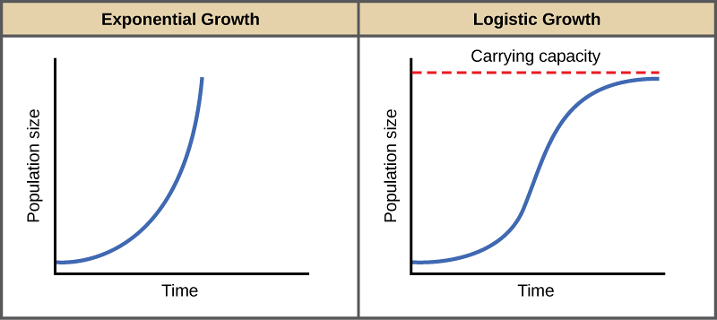

**Logistic growth** is continuous population growth in an environment

where resources are limited; it is **density-dependent growth.**

Most density-dependent factors(*a limiting factor that depends on*

*population size*) are mainly **biotic**, or living, and include:

_________________________ _________________________

_________________________ _________________________

 **Formula**:

**Exponential vs Logistic Growth**

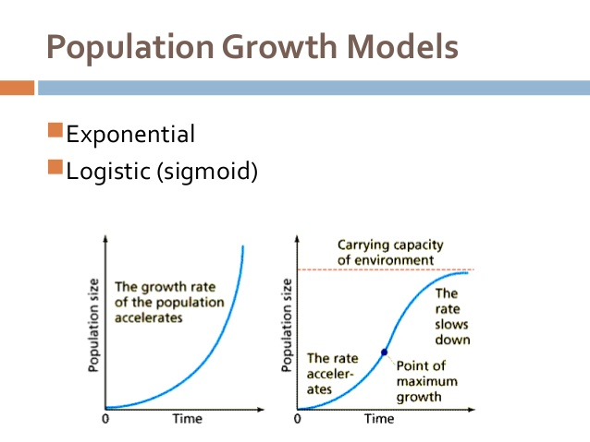

**30.** A certain population **A** is experiencing **exponential growth**.

Population size = **50**

Births = **10**

Death = **4**

**a)** Calculate the individual growth rate (rmax). This is also known as *the maximum per capita growth rate of a population rate*.

**b)** Calculate the population growth rate.

**31.** A certain population **B** is experiencing **logistic growth**.

Population size = **50**

Use the same growth rate as in the previous question.

rmax = _______

Carrying capacity (**K**) = **400**

**a)** Calculate the population growth rate.

**b)** Given that the individual growth rates (rmax) of the populations above were equal, explain why

the population growth rates were different between population A and B.

**32.** The following population, C, has no limits on food resources or space.

Population size = **500**

Births = **240**

Deaths = **170**

**a)** Calculate the growth rate (rmax).

**b)** How many individuals will be in the population at the start of the second generation?

**c)** How many individuals will be in the population at the start of the third generation?

**33.** Now consider population D, in which food resources are limited.

Population size = **500**

Use the same growth rate as in the previous question.

rmax = _____

Carrying Capacity **(K)** = 1,000

**a)** How many individuals will be in the population at the start of the second generation?

**b)** How many individuals will be in the population at the start of the third generation?

**34.** There are **300** falcons living in a certain forest at the beginning of 2013.

The population is under carrying capacity. If the maximum per capita

growth rate **(rmax) = 0.1** falcons/year, predict the population size of the

falcon population each year for the next four years.

*Round your answer to the nearest whole number.*

|  |  |  |  |
| --- | --- | --- | --- |
| **2014** | **2015** | **2016** | **2017** |
|  |  |  |  |

 **(a)** Using the information from above, fill in the table below and construct the graph.

|  |  |
| --- | --- |
| **Year** | **Population Size** |
| **2013** | **300** |
| **2014** |  |
| **2015** |  |
| **2016** |  |
| **2017** |  |

**(b)** Find the **average rate of change** *(slope)* for the falcon population from 2013 to 2018.

*Round your answer to the nearest tenth.*

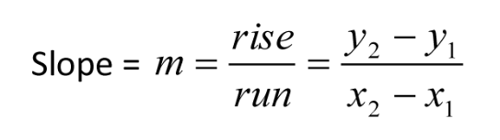

**35.** Utica, NY had a population of **49,000** in the year 2013. The infrastructure of the city allows for a carrying capacity of **60,000** people. rmax = **0.9** for Utica.

**(a)** Is the current population above or below the carrying capacity? _________________________

**(b)** Will the population increase or decrease in the next year? _________________________

**(c)** What will be the population growthfor 2013?

*Round your answer to the nearest whole number.*



**Formula:**

**(d)** What will the population size be at the start of 2014?

|  |  |  |
| --- | --- | --- |
| **Year** | **Population size** | **Population growth** |
| **2013** |  |  |
| **2014** |  |  |
| **2015** |  |  |
| **2016** |  |  |
| **2017** |  |  |

 **(e)** Fill in the data table and construct a graph.

**(f)** What happened to the population size over the years? _________________________

**(g)** What happened to the population growth over the years? _________________________

**(h)** Explain your answer from f and g using what you know about carrying capacity.

__________________________________________________________________________________

__________________________________________________________________________________

__________________________________________________________________________________

**36.** Fill in the following chart to calculate the population growth rates for a population of rats in an urban area. The starting population is **450** individuals and the rmax is equal to **0.15**. The population has reached its carrying capacity of **1000** rats and is experiencing logistic growth.

|  |  |  |  |  |  |
| --- | --- | --- | --- | --- | --- |
| **Generation** | **N** | **rmax** | **rmax N** | **(K-N)/K** | **final dN/dt** |
| **1** | **450** | **0.15** |  |  |  |
| **2** |  | **0.15** |  |  |  |
| **3** |  | **0.15** |  |  |  |
| **4** |  | **0.15** |  |  |  |
| **5** |  | **0.15** |  |  |  |

**(a)** In which of the generations (1-5) does the birth rate exceed the death rate? ___________

**(b)** Does this population reach zero growth rate at any point in generations 1-5? (Y, N) ________

**(c)** Explain why the growth rate begins to decrease after generation 3.

_______________________________________________________________________________________

_______________________________________________________________________________________

_______________________________________________________________________________________

_______________________________________________________________________________________

_______________________________________________________________________________________

****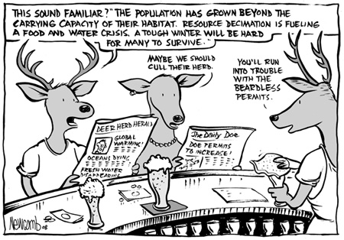**37.** Base your answers to the following questions on the graph and cartoon below.

**(a)** What type of growth curve is exhibited by the deer? _____________________________

**(b)** What type of organism (*r or K selected*) is displayed in the graph above? _________________________

**(c)** After reaching carrying capacity, in which year was the deer population the lowest? __________

**(d)** Give two possible reasons for this population decrease after it had reached its carrying capacity.

___________________________________________________________________________________

**(e)** In approximately which year did the deer population exceed its carrying capacity? ________

**(f)** Give two possible reasons why the population exceeded its carrying capacity.

__________________________________________________________________________________

**38.** Use the graph to the right to calculate the **lag time** (*in* *months*) between the change

in the densities of prey and

the predator populations

_______________________

**Chapter 53: Community Ecology**

**OBJECTIVES:**

**Interspecific Interactions and Community Structure**

__1. Explain how interspecific competition may affect community structure.

__2. Describe the competitive exclusion principle and explain how competitive exclusion may affect community structure.

__3. Define an ecological niche and restate the competitive exclusion principle using the niche concept.

__4. Explain how resource partitioning can affect species diversity.

__5. Define and compare predation, herbivory, and parasitism.

__6. Relate some specific predatory adaptations to the properties of the prey.

__7. Describe the defense mechanisms that evolved in plants to reduce predation by herbivores.

__8. Explain how cryptic coloration and warning coloration aid an animal in avoiding predators.

__9. Distinguish between Batesian mimicry and Müllerian mimicry.

__10. Describe how predators use mimicry to obtain prey.

__11. Distinguish among parasitism, mutualism, and commensalism.

__12. Distinguish between a food chain and a food web.

__13. Describe the factors that transform food chains into food webs.

__14. Explain how dominant and keystone species exert strong control on community structure.

Give several examples of each.

__15. Describe and distinguish between primary and secondary succession.

**KEY TERMS:**

Batesian mimicry commensalism community competitive exclusion principle

cryptic coloration dominant species ecological niche ecological succession

food chain herbivory keystone species interspecific competition

Müllerian mimicry mutualism parasitism predation

primary succession resource partitioning secondary succession trophic level

- - - - - - - - - - - - - - - - - - - - - - - - - - - - - - - - - - - - - -

**WORD ROOTS:**

**crypto-** = hidden, concealed (*cryptic coloration*: a type of camouflage that makes potential prey difficult to spot against its background)

**ecto-** = outer (*ectoparasites*: parasites that feed on the external surface of a host)

**endo-** = inner (*endoparasites*: parasites that live within a host)

**herb-** = grass; **-vora** = eat (*herbivory*: the consumption of plant material by an herbivore)

**inter-** = between (*interspecific competition*: competition for resources between plants, between animals, or between decomposers when resources are in short supply)

**mutu-** = reciprocal (*mutualism*: a symbiotic relationship in which both the host and the symbiont benefit

**Guided Reading: Chapter 53**

1. What is the **competitive exclusion principle**?
2. [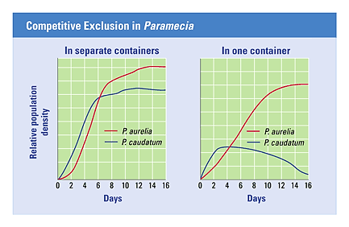](http://www.google.com/url?sa=i&rct=j&q=competitive%20exclusion%20principle%20example%20+gause&source=images&cd=&cad=rja&uact=8&docid=B3DYuuFudo1JKM&tbnid=tdr3E2bsiGGtRM:&ved=0CAUQjRw&url=http://biologytb.net23.net/text/chapter35/concept35.4.html&ei=aQ5HU72yNZe0sATb0oH4BQ&bvm=bv.64507335,d.dmQ&psig=AFQjCNHigf3qwCa7nawktlnmxqHqr5hPwA&ust=1397252032000236)Use the graph to the right to help you describe Gause’s experiment with Paramecia.
3. Describe several defense mechanisms to predation in plants.

*(Refer to your What Plants Talk About video sheet.)*

1. Define and give an example of the following animal defenses:
   1. **Cryptic coloration** -
   2. **Batesian mimicry** -
   3. **Mullerian mimicry** -

1. Define and give 2 examples of **mutualism**. ***(Activity 53A)***
2. Define and give 2 examples of **commensalism**. ***(Activity 53A)***
3. What is meant by the “**trophic structure**” of a community?
4. 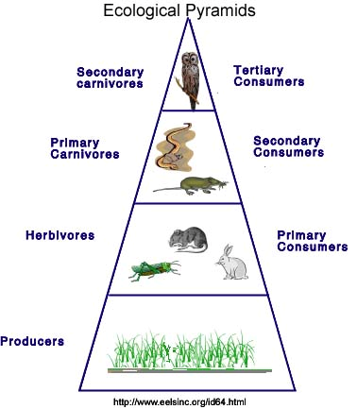Explain why is the Ecological Pyramid located to the

right is shaped like a pyramid.

1. What does a **food web** show that isn’t indicated by a **food chain**? ***(Activity 53B)***
2. What limits the length of any food chain?
3. Define a **keystone species** and why are they so important to a community?
4. Use the diagram below to help you define **ecological succession**.

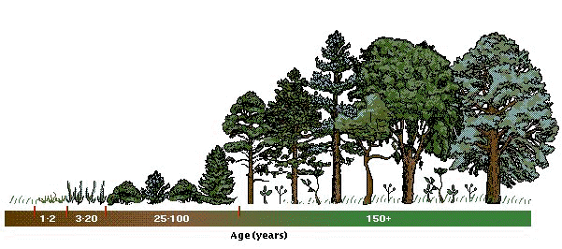

1. What is the difference between **primary** and **secondary succession**?

**Chapter 54: Ecosystems**

**OBJECTIVES:**

**What Is the Ecosystem Approach to Ecology?**

__1. Describe the relationship between autotrophs and heterotrophs in an ecosystem.

__2. Explain how decomposition connects all trophic levels in an ecosystem.

__3. Explain how the first and second laws of thermodynamics apply to ecosystems.

**Primary Production in Ecosystems**

__4. Explain why the amount of energy used in photosynthesis is so much less than the amount of solar energy that reaches Earth.

__5. Define and compare gross primary production and net primary production.

__6. Compare primary productivity in marine, freshwater, and terrestrial ecosystems.

**Secondary Production in Ecosystems**

__7. Explain why energy is said to flow rather than cycle within ecosystems.

__8. Distinguish between energy pyramids and biomass pyramids. Explain why both relationships are in the form of pyramids. Explain the special circumstances of inverted biomass pyramids.

__9. Explain why food pyramids usually have only four or five trophic levels

__10. Define the pyramid of numbers.

__11. Explain why worldwide agriculture could feed more people if all humans consumed only plant material.

**The Cycling of Chemical Elements in Ecosystems**

__12. Describe the hydrologic water cycle.

__13. Describe the nitrogen cycle and explain the importance of nitrogen fixation to all living organisms.

__14. Explain how decomposition affects the rate of nutrient cycling in ecosystems.

**Human Impact on the Chemical Dynamics of the Biosphere**

__15. Describe how agricultural practices can interfere with nitrogen cycling.

__16. Describe the causes and consequences of acid precipitation.

__17. Explain why toxic compounds usually have the greatest effect on top-level carnivores.

__18. Describe how increased atmospheric concentrations of carbon dioxide could affect Earth.

__19. Describe how human interference might alter the biosphere.

**KEY TERMS:**

acid precipitation autotrophs biogeochemical cycles biological magnification

biomass detritus ecosystem greenhouse effect

heterotrophs gross primary productivity net primary productivity nitrogen fixation

trophic level

- - - - - - - - - - - - - - - - - - - - - - - - - - - - - - - - - - - - - -

**WORD ROOTS:**

**auto-** = self;

**troph-** = food, nourishment (*autotroph*: an organism that obtains organic food molecules without eating other organisms)

**bio-** = life;

**geo-** = the Earth (*biogeochemical cycles*: the various nutrient circuits which involve both biotic and abiotic components of

ecosystems)

**de-** = from, down, out (*denitrification*: the process of converting nitrate back to nitrogen)

**Guided Reading: Chapter 54**

1. What is needed to maintain a **self-sustaining ecosystem**?
2. Label the diagram below representing an **overview of ecosystem dynamics**. *(Activity 54B)*

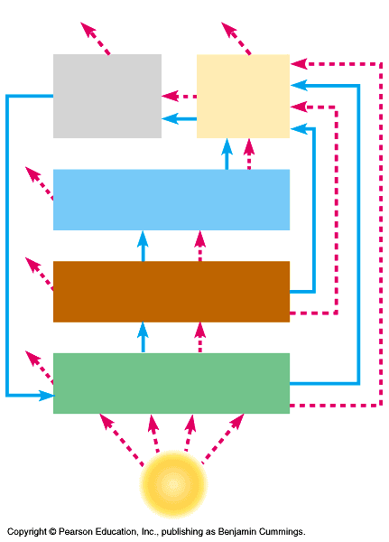

1. What are **detritivores** (decomposers) and what is their major function?
2. Define the following energy budget terms:

**a.** **Primary productivity** –

**b.** **Gross primary productivity** –

**c.** **Net primary productivity** -

1. Which ecosystems have the **HIGHEST productivity** per unit area?
2. What factors do you think contribute to such high productivity?
3. Which ecosystems have the **LOWEST** **productivity** per unit area?
4. Why is the open ocean so low in productivity?
5. What is **secondary productivity**?
6. What happens to the size each level in the idealized **pyramid as energy** is transferred through the trophic levels?
7. Explain what happens to the **ENERGY** and **BIOMASS** as it is passed through the trophic levels?
8. Label the diagram of the **Water Cycle** below. Is this mainly a PHYSICAL or CHEMICAL process?

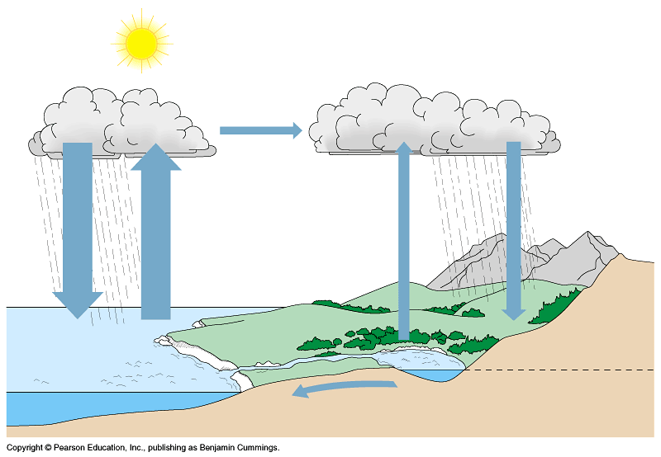

**The Water Cycle**

**(*Activity 54E* / Fig. 54.16)**

1. What is the source of **acid rain** and why is it a problem?
2. What percentage of the Earth’s atmosphere is composed of nitrogen?
3. What important organic compounds are composed of nitrogen?
4. Label the diagram of the **Nitrogen Cycle** below and identify the role each chemical process plays in the cycle.

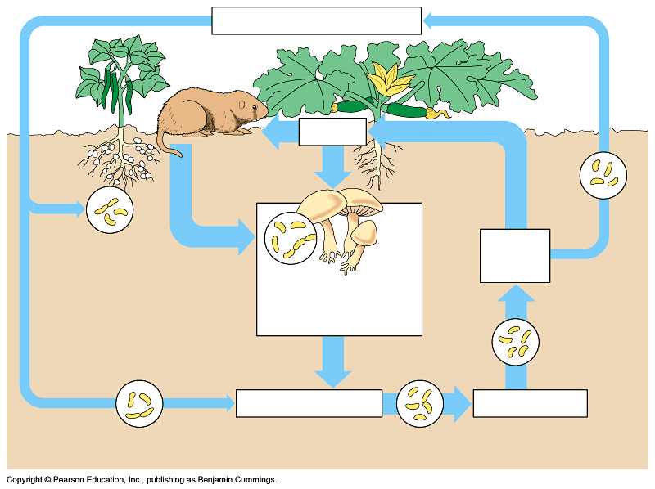

**The Nitrogen Cycle** - ***(Activity 54 D / Fig.54.18)***

**a.** **Nitrogen fixation** -

**b.** **Ammonification** -

**c.** **Nitrification** -

**d.** **Denitrification** -

**e.** **Assimilation** -

1. Label the diagram of the Carbon Cycle below and identify the role each chemical process plays in the movement of carbon through the ecosystem.

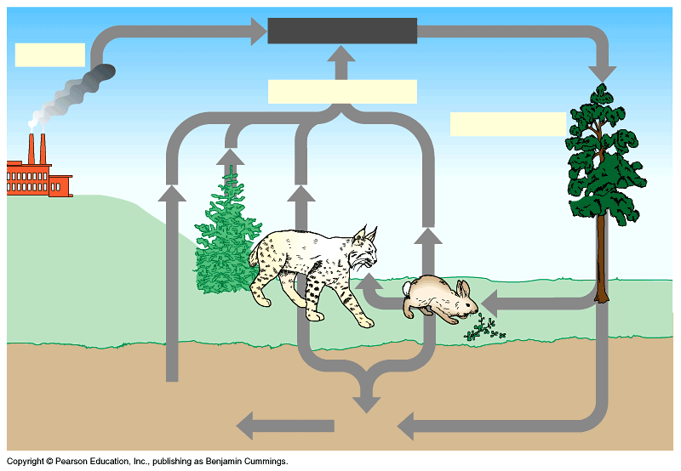

**The Carbon Cycle**

***(Activity 54B/C and Fig. 54.17)***

**a.** **Combustion** -

**b.** **Photosynthesis** -

**c.** **Cellular Respiration** -

1. Why is human population growth at the root of environmental issues?
2. Label the diagram of the **Biological Magnification of DDT in the Food Chain** below and use it to explain what happens in the process of biological magnification. *(Fig. 54.25)*

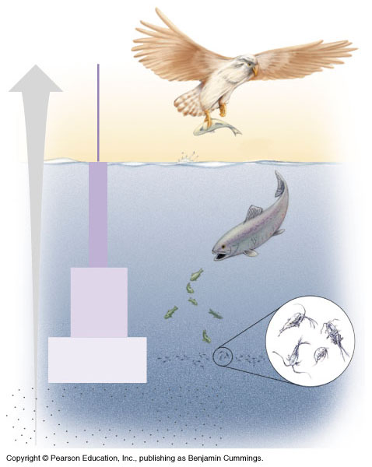

1. What are some of the properties of molecules that could be candidates for **biological magnification**?
2. 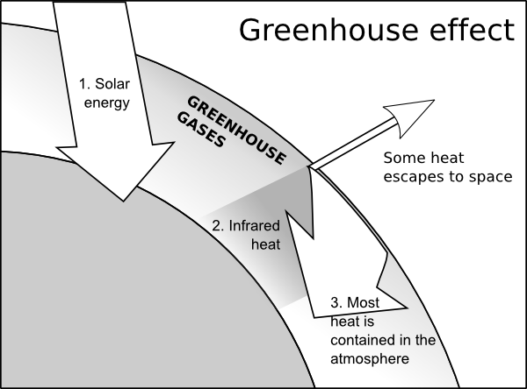Use the diagram to the right to help you explain the greenhouse effect.

1. Is the greenhouse effect a **GOOD** or **BAD** thing? Explain.
2. What are possible reasons for **global warming** (*greenhouse effect*)? (*Activity 54F*)
3. What is the function of the ozone layer?
4. List three sources of chlorofluorocarbons (CFC’s) ________________________________

________________________________

________________________________

1. Is **depletion of the ozone layer** a possible reason for global warming? YES or NO
2. List three possible consequencies of continued ozone depletion.

**a)** _________________________________________________________________________

**b)** _________________________________________________________________________

**c)** _________________________________________________________________________

**Chapter 55: Conservation Biology**

**OBJECTIVES:**

**The Biodiversity Crisis**

**__1.** Describe the three levels of biodiversity.

**__2.** Explain why biodiversity at all levels is vital to human welfare.

**__3.** List the four major threats to biodiversity and give an example of each.

**Conservation at the Community, Ecosystem, and Landscape Levels**

**__4.** Explain why natural reserves must be functional parts of landscapes.

**__5.** Define restoration ecology and describe its goals. Explain the importance of bioremediation and the augmentation of ecosystem processes in restoration efforts.

**__6.** Describe the concept of sustainable development.

**__7.** Explain the goals of the Sustainable Biosphere Initiative.

**__8.** Define biophilia and explain why the concept gives some biologists hope.



**Guided Reading: Chapter 55**

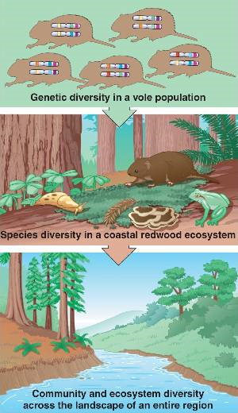

1. Use the diagram to the right to help you

describe the three levels of biodiversity.

1. Explain why biodiversity at all levels is vital to human welfare.
2. In the table below, list the four major threats to biodiversity and give an example of each.

|  |  |  |
| --- | --- | --- |
|  | **Biodiversity** | |
|  | **Threat** | **Example** |
| **1** |  |  |
| **2** |  |  |
| **3** |  |  |
| **4** |  |  |

*(Remember:* ***H I P P O*** *from Honors Biology?)*

1. Define restoration ecology and describe its goals.

1. Explain the importance of bioremediation and the augmentation of ecosystem processes in restoration

efforts.

1. Describe the concept of sustainable development.
2. Explain the goals of the Sustainable Biosphere Initiative.
3. Define biophilia and explain why the concept gives some biologists hope.

**Review Questions**

1) All of Earth that is inhabited by life is called the -

A) stratosphere. C) biosphere.

B) lithosphere. D) hydrosphere.

2) The level of ecologic organization that incorporates abiotic factors is the -

A) community. C) population.

B) ecosystem. D) species.

3) Rachel Carson's book, *Silent Spring,* deals with the -

A) destruction of polar habitats caused by global warming.

B) environmental effects of pesticides.

C) effects of lynx predation on snow hare populations.

D) fate of tropical rain forests.

4) The immediate results of the widespread use of pesticides and fertilizers included ___, but long-term results included ___.

A) dramatic increases in crop yields . . . the evolution of pest resistance

B) the increased spread of malaria . . . delayed resistance to pesticides

C) terrible declines in agricultural productivity . . . worldwide distribution of DDT

D) global declines in undesirable pests, such as mice, rats, crows, and sharks . . . increases in these pests

5) In many dense forests, plants living near the ground level engage in intense competition for -

A) oxygen. C) carbon dioxide.

B) water. D) sunlight.

6) Which of the following environmental factors usually has the greatest direct effect on an organism's rate of water loss by evaporation?

A) soil type C) fires, hurricanes, and tornadoes

B) wind D) barometric pressure

7) Except near hydrothermal vents, the communities of the oceanic aphotic zone get their energy mainly from -

A) photosynthesis by local phytoplankton. C) oxidation of sulfur by sulfur bacteria.

B) photosynthesis by local zooplankton. D) organic matter sinking from the photic zone.

8) A group of individuals of a single species that occupy the same general area defines a -

A) population. C) community.

B) subspecies. D) clone.

9) Which of the following is an example of a population?

A) all of the microorganisms on your skin

B) all of the students in your classroom

C) all students attending colleges and universities in your state

D) the various plants found in prairies in the western United States

10) Assume that there are five alligators per acre in a swamp in northern Florida. This is a measure of the alligator population's -

A) dispersion. C) intrinsic rate of increase.

B) range. D) density.

11) The pattern of distribution for a certain species of kelp is clumped. We would expect that the pattern of distribution for

a population of snails that live on the kelp would be -

A) clumped. C) homogeneous.

B) random. D) uniform.

12) You drive through Iowa in the spring and notice that along a stretch of several kilometers, every third fence post has a male redwing blackbird perched on it defending its nesting territory. This is an example of -

A) clumped dispersion. C) random dispersion.

B) uniform dispersion. D) artificial dispersion.

13) The density of Douglas firs in an old-growth forest is estimated by counting the Douglas firs in four sample plots of 1 hectare each. The number of fir trees in the plots is 10, 12, 7, and 11, respectively. What is the estimated density of

firs in the forest?

A) 5 trees per hectare C) 20 trees per hectare

B) 10 trees per hectare D) 25 trees per hectare

14) A survivorship curve is a -

A) graph that plots an individual's likelihood of reproducing as a function of age.

B) graph that plots an individual's likelihood of being alive as a function of age.

C) graph that shows the effect of predation on a prey population.

D) model for population growth that incorporates the concept of carrying capacity.

15) A Type I survivorship curve is associated with which of the following life history traits?

A) parents providing extended care for their young

B) large numbers of offspring being produced

C) infant mortality being much greater than adult mortality

D) a short life span for most individuals

16) A survivorship curve that involves producing very few offspring, each of which has a high probability of surviving to adulthood, is typical of -

A) sea stars. C) oysters.

B) elephants. D) rodents.

17) The maximum number of individuals a habitat can support is called its -

A) reproductive potential. C) community size.

B) carrying capacity. D) density-dependent factor.

18) A newly mated queen ant establishes an ant nest in an unoccupied patch of suitable habitat. The population of the nest grows quickly at first, then levels off at carrying capacity. Which of the following types of equation will best describe

its population growth?

A) linear C) logistic

B) logarithmic D) exponential

19) If an ecosystem has a carrying capacity of 1,000 individuals for a given species, and 2,000 individuals of that species

are present, we can predict that the population -

A) size will remain at equilibrium. C) will show a clumped dispersion pattern.

B) size will decrease. D) size will slowly increase.

20) In terms of population dynamics, what is "boom-and-bust" cycling?

A) a situation in which a population moves back and forth between rapid growth and decline

B) a situation in which a growing population overshoots the carrying capacity of its environment and experiences a

crash before stabilizing

C) a situation in which the sex ratio in a population shows repeated oscillations

D) a situation in which the populations of a predator species and a prey species oscillate in unison

21) An ecologist hypothesizes that predation by a particular owl species is the major factor controlling the population of a particular rabbit species. The first step in testing this hypothesis would be to determine -

A) whether populations of the rabbit that live outside the range of the owl have higher population densities.

B) whether the owls eat the rabbits.

C) to which diseases the rabbit population is subject.

D) what food the rabbits eat.

22) An ecologist hypothesizes that predation by a particular owl species is the major factor controlling the population of a particular rabbit species. If this is the case, which of the following population effects could be expected in this pair?

A) A fall in the owl population should cause a fall in the rabbit population.

B) A fall in the rabbit population should cause an increase in the owl population.

C) An increase in the incidence of disease in the rabbit population should not change the owl population.

D) An increase in the owl population should cause a fall in the rabbit population.

23) An *r*-selected species typically -

A) offers considerable parental care to offspring.

B) has an advantage in habitats that experience unpredictable disturbances.

C) is large-bodied and long-lived.

D) lives in stable climates.

24) Which of the following organisms best illustrates *K-*selection*?*

A) the production of thousands of eggs every spring by frogs

B) mice that produce three litters of 10-15 babies in the course of a summer

C) a polar bear producing one or two cubs every three years

D) a species of weed that quickly spreads into a region of cleared trees

25) Which of the following will likely decrease a population's size?

A) improving the quality of its habitat

B) increasing the size of its habitat

C) practicing sustainable resource management in its habitat

D) decreasing the food supply available to the population

26) What is the age structure of a population?

A) the curve that results when the likelihood of dying is plotted as a function of age

B) the curve that results when the likelihood of being alive is plotted as a function of age

C) the proportion of individuals in different age groups

D) the difference in the age distribution of a population at two different points in time

27) If most of the individuals in Africa in 2010 are in their pre-reproductive years, you would expect the population size to ________ after 20 years.

A) stay the same C) decrease

B) increase D) decrease and then stabilize

28) The age structure of Africa in 2010 shows -

A) a broad base, suggesting a high birth rate.

B) a broad base, suggesting a low birth rate.

C) that a greater proportion of the population is elderly now than in earlier decades.

D) that the United States has not yet gone through a demographic transition.

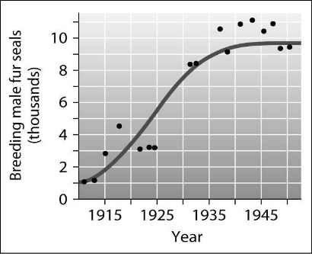29) According to this graph of the population growth of fur seals,

in what year did the population first reach its carrying capacity?

A) 1925

B) 1930

C) 1940

D) 1950

***Base your answers to questions 30 and 31 on the paragraph below***

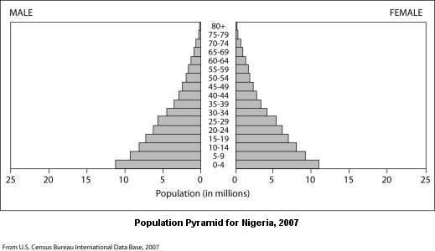You're a member of an influential African family that's been displaced from your home by civil war. You're trying to select a new country in which to settle to gain better economic opportunities. You know that Nigeria is a large country with rich natural resources and are considering it for your new home. You've learned some basic principles of population growth and did some research on the Internet. Among the data you found was the following diagram of the current age structure of the country.

30) The age structure data for Nigeria shows that the country has many more individuals under the age of 15 than over the

age of 40. What does this imply about the future population of Nigeria?

A) the population will probably remain stable C) the population will probably grow rapidly

B) the population will probably decrease D) the number of older people will probably increase rapidly

31) Based on the age structure of the country, which of the following situations would be most likely over the next 20 years?

A) strong economic gains stimulated by population growth

B) an increased demand for resources based on population growth

C) a decreased demand for medical services due to the small number of elderly citizens

D) a decline in housing prices based on lack of demand

32) A community is composed of -

A) potentially interacting populations of different kinds of organisms.

B) one species of organism living in a specific environment on Earth.

C) living organisms and their nonliving environment.

D) the factors that constitute an organism's niche.

33) One reason it is important to understand community ecology is -

A) to understand the life cycle of fish, such as cichlids.

B) for identification of stomach microbes.

C) to aid in conservation of endangered species.

D) to provide an enriched habitat for humans.

34) An owl and a hawk both eat mice. Which of these describes the relationship between a hawk and an owl?

A) predation C) mutualism

B) competition D) parasitism

35) When two different populations in a community benefit from their relationship with each other, the result is called -

A) benefism. C) parasitism.

B) mutualism. D) competition.

36) Which of the following is an example of predation?

A) a lizard's camouflage

B) a hawk swooping down quickly to capture, kill, and eat a prairie king snake

C) a goldfinch feeding on the seeds of a thistle plant

D) the vivid colors of the poison-arrow frog in Costa Rica

37) The sum total of a population's use of the biotic and abiotic resources of its habitat constitutes its -

A) environment. C) range.

B) evolution. D) niche.

38) In an ecosystem, you would expect to find interspecific competition between -

A) males and females of a species in which both sexes occupy the same niche.

B) populations of two species that occupy the same niche.

C) a prey species and its predator.

D) two wasp species that mimic each other's appearance.

39) Camouflage typically evolves as a result of -

A) predation. C) mutualism

B) interspecific competition. D) herbivory.

40) Most plants have a variety of chemicals, spines, and thorns because the plants -

A) cannot run away from herbivores. C) are camouflaged into their surroundings.

B) feed on the organisms that try to eat them. D) are relying upon Batesian mimicry.

41) Within an ecosystem, a tree is a -

A) secondary consumer. C) primary consumer.

B) detritivore. D) producer.

42) On Earth, most organic molecules are produced by -

A) photosynthesis. C) hydrolysis

B) glycolysis. D) cellular respiration.

43) In a hypothetical food chain consisting of grass, grasshoppers, sparrows, and hawks, the grasshoppers are -

A) primary consumers. C) secondary consumers.

B) primary producers. D) secondary producers.

44) In a food chain consisting of phytoplankton → zooplankton → fish → fishermen, the fishermen are -

A) secondary consumers. C) quaternary consumers

B) tertiary consumers. D) secondary producers.

45) Organisms that digest molecules in organic material and convert them into inorganic forms are -

A) primary consumers. C) primary producers

B) secondary consumers. D) detritivores.

46) In a certain ecosystem, field mice are preyed on by snakes and hawks. The entry of wild dogs into the system adds another

predator of the mice. Of the following, the most likely short-term result of this addition is -

A) an increase in snake population. C) a reduction in numbers of mice.

B) a tendency for hawks to prey on the dogs. D) migration of the hawks to another ecosystem.

­­47) Which of the following statements regarding food webs is *true*?

A) A consumer eats only one type of producer.

B) Detritivores consume dead organic matter from a specific trophic level.

C) Several species of primary consumers may feed on the same species of producer.

D) Nutrient transfer moves from producer to consumer and back.

48) We expect that a keystone species that is a predator will -

A) maintain the species diversity in a community. C) help many of its prey reproduce.

B) harvest prey species down to extinction. D) reduce the diversity of the community.

49) When a New England farm is abandoned, its formerly plowed fields first become weedy meadows, then shrubby areas, and finally forest. This sequence of plant communities is an example of -

A) evolution. C) secondary succession.

B) a trophic chain. D) primary succession

50) Non-native species that are introduced in new environments, spread far beyond the original point of introduction, and cause damage are called -

A) destructive species. C) invasive species.

B) enemy species. D) proprietary species.

51) Biological control is defined as -

A) the use of chemicals, such as pesticides, to control pests.

B) the intentional release of a natural enemy of a pest population.

C) the exploitation of coevolutionary principles to produce pesticides.

D) an intentional attempt to increase the numbers of specific prey populations.

52) The flow of ________ into ecosystems occurs in one direction only, while ________ are recycled within the ecosystem itself.

A) minerals . . . energy compounds C) organic compounds . . . minerals

B) genetic information . . . genotypes D) energy . . . chemicals

53) The amount of solar energy converted to chemical energy in organic compounds is called -

A) primary succession. C) primary production.

B) secondary succession. D) secondary production.

54) Given that CO2 is produced by cellular respiration, why does the amount of CO2 in the atmosphere remain relatively constant? (*When answering this question, exclude the impact of human activities on atmospheric CO2*).

A) CO2 is converted in photosynthesis to carbohydrates.

B) CO2 is split apart during photosynthesis.

C) CO2 mostly forms carbonate rocks.

D) CO2 is trapped in dead organisms' bodies.

55) Carbon mainly cycles between the biotic and abiotic worlds through the processes of -

A) cellular respiration and transpiration. C) evaporation and photosynthesis.

B) transpiration and photosynthesis. D) cellular respiration and photosynthesis.

56) Which of the following statements about the nitrogen cycle is *true*?

A) The nitrogen cycle requires different types of bacteria.

B) Nitrogen gas is converted to nitrates in plant leaves.

C) Nitrogen cannot be cycled through living organisms.

D) When plants and animals die, nitrogen is removed from the nitrogen cycle.

57) Which of the following represents a step in the nitrogen cycle?

A) nitrogen-fixing bacteria convert atmospheric nitrogen to nitrates

B) nitrites bind to soil particles

C) nitrogen-fixing bacteria convert atmospheric nitrogen to ammonium

D) denitrifiers convert ammonium to atmospheric nitrogen

58) Denitrifying bacteria convert ________ to ________.

A) ammonium . . . nitrates C) nitrogen gas . . . nitrates

B) nitrates . . . nitrogen gas D) nitrogen gas . . . nitrites

59) Which of the following ecological problems might result from fertilizing a golf course with phosphorus-rich fertilizer?

A) poisoning of the grass caused by excess phosphorus

B) heavy growth of algae and cyanobacteria in lakes and rivers caused by phosphorus runoff

C) accumulation of toxic levels of phosphorus in animals in the vicinity, especially those higher on the food chain

D) a slowdown in the weathering of rock that releases phosphates into the soil under natural conditions

60) Eutrophication of a lake could occur if -

A) phosphate-rich detergents were dumped into the lake.

B) fertilizers were applied in an insoluble form.

C) runoff from over fertilized lawns was prevented from reaching the lake.

D) fish were removed.

61) One of the most worrisome results of the large-scale clearing and cultivation of land is -

A) erosion and soil degradation. C) the inability fo supply enough food for growing populations.

B) the inability to supply fresh water. D) hurricanes.

***Base your answers to questions 62 – 67 on the diagram of a terrestrial food chain below.***

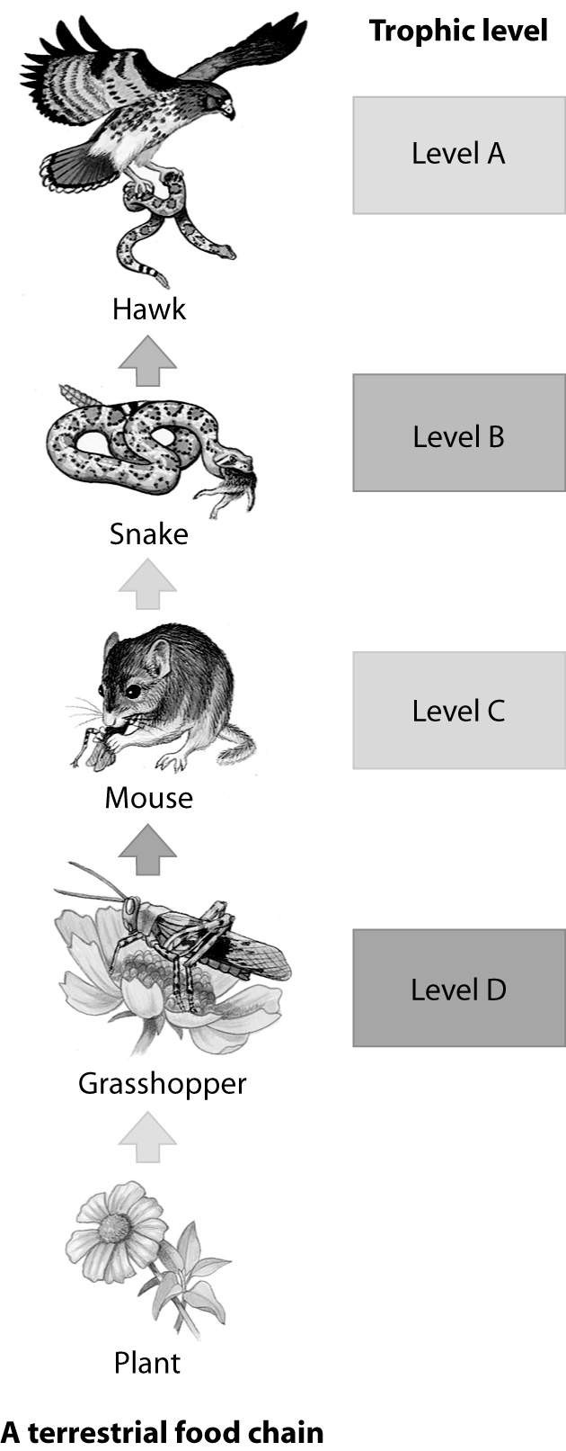

62) Which trophic level in this food chain

represents the primary consumer?

63) Which trophic level in this food chain

represents the secondary consumer?

64) Which trophic level in this food chain

represents the tertiary consumer?

65) Which trophic level in this food chain

contains an herbiviore?

66) Which trophic level in this food chain

contains the greatest biomass?

67) Which trophic level in this food chain

contains the least biomass?

***Base your answers to questions 68 – 71 on the diagram of the carbon cycle below.***

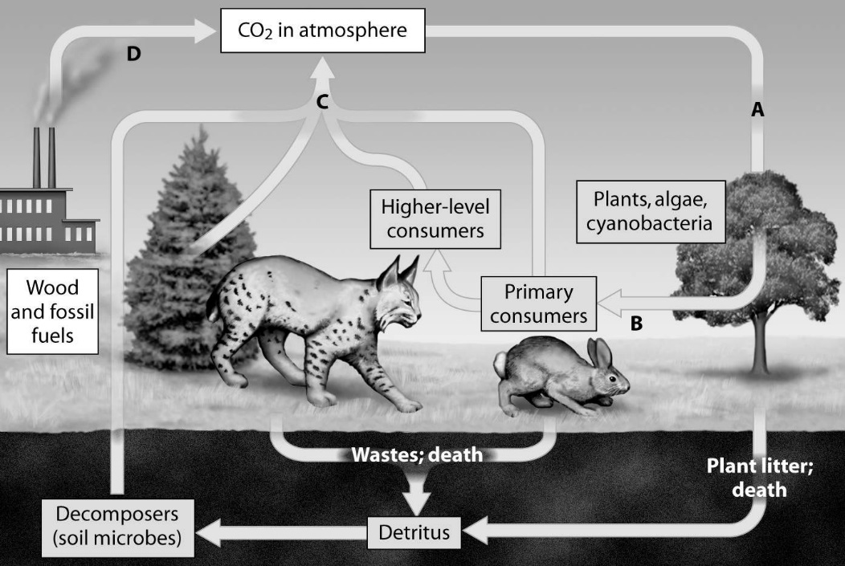

68) Which arrow shows CO2 released as a product of cellular respiration?

69) Which arrow shows CO2 released as a product of burning and combustion?

70) Which arrow shows CO2 being removed during photosynthesis?

71) Which arrow shows Carbon entering the food chain?

***Base your answers to questions 72 – 75 on the diagram of the nitrogen cycle below.***

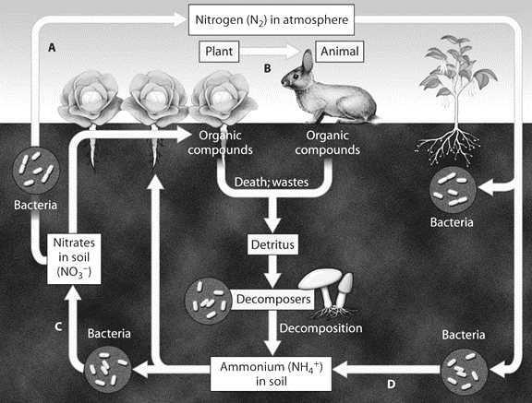

72) Which arrow shows nitrogen fixation?

73) Which arrow shows the products of

denitrifying bacteria.

74) Which arrow shows nitrification?

75) Which arrow shows nitrogen entering

the food chain?

76) The primary goal of conservation biology is to -

A) estimate the total number of species that exist. C) maximize the land set aside for wildlife.

B) integrate human culture back into nature. D) counter the loss of biodiversity.

77) Biodiversity considers -

A) the genetic diversity within and between populations of a species.

B) the fate of water in the ecosystem.

C) commensal relationships between species.

D) the relationships of individuals to a food chain.

78) Currently, the single greatest threat to biodiversity is -

A) global warming. C) habitat destruction due to humans.

B) the introduction of exotic species. D) overexploitation of populations for food.

79) You arrive back in the United States after having visited a foreign country located on another continent. The customs agent stops the person in front of you and confiscates the fruit basket this person is bringing home. Being the knowledgeable person you are, you calmly explain to your enraged fellow traveler that the reason for the detainment is that the fruit basket may be -

A) carrying endangered fruit.

B) carrying an exotic species that could damage North American ecosystems.

C) contaminated with CFCs that will damage the ozone layer above North America.

D) contaminated with sufficient DDT to cause serious harm to anyone who eats the fruit.

80) The three greatest current threats to biodiversity, in order starting with the greatest, are -

A) habitat loss, overharvesting, and invasive species. C) habitat loss, invasive species, and overharvesting.

B) invasive species, habitat loss, and overharvesting. D) invasive species, overharvesting, and habitat loss.

81) DDT and mercury -

A) were once used as an energy source. C) contribute to acid precipitation.

B) accumulate in the tissues of organisms. D) deplete the ozone layer.

82) Which of the following is a likely consequence of the thinning of the ozone layer?

A) increases in skin cancer C) increases in escape of heat from Earth

B) global warming D) decreases in flying insect populations

83) You spray your lawn with a pesticide. The concentration of the pesticide in the tissues of the grass on your lawn is

10-6 parts per million (ppm). Grasshoppers eat the grass and are in turn eaten by rats, which are then eaten by owls.

At each successive trophic level, the concentration of pesticides increases. The term for this process is -

A) biological extirpation. C) biological magnification.

B) trophic concentration. D) bioconcentration.

84) Global warming is the result of -

A) rises in ocean levels. C) rising concentration of greenhouse gases.

B) increased solar activity. D) pollution.

85) Greenhouse gases include -

A) nitrous oxide and oxygen. C) nitrogen and oxygen.

B) carbon dioxide and nitrogen. D) carbon dioxide and methane.

86) CO2 in the atmosphere is absorbed by ________ and converted into biomass.

A) the ozone layer C) other atmosphere gases

B) photosynthetic organisms D) large land masses

87) Scientists worry that global warming will result in the oceans -

A) becoming more acidic. C) becoming more basic.

B) containing less dissolved oxygen. D) containing less dissolved carbon dioxide.

88) One way in which populations and species have been responding to climate change is by -

A) changing their coat color. C) shifting their distribution.

B) changing their metabolism. D) evolving a flexible mode of reproduction.

89) Some populations, especially those with high genetic variability and short life spans, may avoid extinction as the climate changes through -

A) genetic shift. C) feedback inhibition.

B) distribution of populations. D) evolutionary adaptation.

90) Captive breeding -

A) has allowed for the re-introduction of many species to areas from which they had disappeared.

B) has advanced to the point where biologists believe it can be used to save most endangered species.

C) can work for animals, but is generally not used for endangered plants.

D) is the main conservation technique used to try to save endangered species from extinction.

91) If wolves were now removed from Yellowstone National Park, we would expect that -

A) elk populations would increase.

B) deer populations would decrease.

C) the vegetation would remain unchanged.

D) vegetation would increase, providing shelter for smaller animals.

92) The aspect of conservation ecology concerned with returning degraded ecosystems (as nearly as possible) to their natural

state is -

A) bioremediation. C) sustainable development.

B) restoration ecology. D) landscape ecology.

93) Using living organisms to clean up polluted ecosystems is known as -

A) biological demagnification. C) PVA.

B) bioremediation. D) landscaping.