|  |  |  |
| --- | --- | --- |
| AP Biology  **Final**  **Exam**  **Review** | **North Salem University**  **MISSION**: *Engage students to continuously learn, question, define and solve problems through critical and creative thinking.*  Spring  2015 | |
| *This packet is designed to familiarize yourself with the location and proper use of the AP Biology equations and formulas you may encounter on the Grid-In Section of your AP exam.*  ***If you have any problems – please sign up for extra help after school.*** | | **Equations and**  **Formulas** |

**I. FREE ENERGY**

**A.** The energy transformations of life are subject to **two laws of thermodynamics**:

**1.** The first, conservation of energy, states that energy cannot be created or destroyed.

**2.** The second states that when energy changes form, entropy (S), or the disorder of the universe, increases. Matter can become more ordered only if the surroundings become more disordered.

**B.** Organisms live at the expense of free energy.

**1.** A living system’s free energy is energy that can do work under cellular conditions.

Free energy (G) is related directly to total energy (H) and to entropy (S): ∆G = ∆H - T ∆S .

**(a)** ***Spontaneous*** changes involve a ***decrease*** in free energy (-∆G). In an exergonic (***spontaneous***) chemical reaction, the products have ***less*** free energy than the reactants (-∆G).

**(b)** ***Nonspontaneous*** changes require an input of energy (+∆G). In an endergonic ***(non- spontaneous***) reaction, the products have ***more*** free energy than the reactants. (+∆G)

*In cellular metabolism, exergonic reactions power endergonic reactions* ***(energy coupling****).*

*___________________________________ _______________________________*

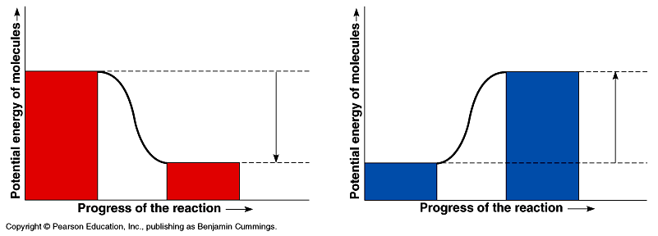

**1)** __________________________________ **1)** __________________________________

**2)** __________________________________ **2)** __________________________________

**Example**: ____________________________ **Example**: ____________________________

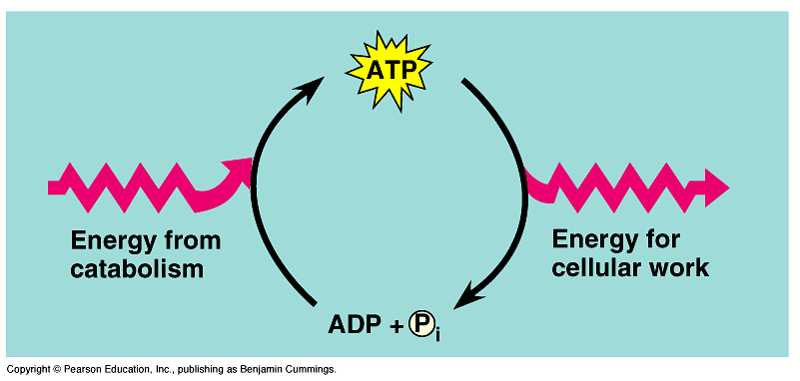**C. ATP powers cellular work by coupling exergonic reactions to endergonic reactions**

**1.** ATP is the cell’s energy shuttle. Release of its terminal phosphate group produces ADP, inorganic phosphate, and free energy.

**2.** ATP drives endergonic reactions by transfer of the phosphate to specific reactants, making them more reactive. In this way, cells can carry out work, such as movement and anabolism. Catabolic pathways drive the regeneration of ATP from ADP and phosphate.

**D. Catalyzed vs. Uncatalyzed Reactions**

1. **E**______________ are **C**________________ that **L**__________ the **A**__________________ energy

of a chemical reaction allowing them to proceed at a **T**__________ and **R**________ conducive for life.

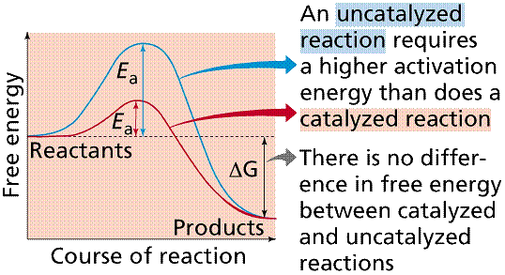

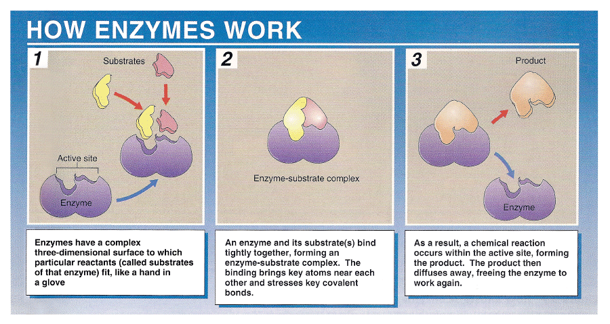**E. How Enzymes Work**

**F. Gibbs Free Energy Practice Problems**

**Temperature Conversions: K = °C + 273**

**http://images-mediawiki-sites.thefullwiki.org/03/3/7/0/1932191290094424.png Formula:**

**1**. Calculate the Gibbs *free energy change* (**ΔG**) for the following chemical reaction:

**ATP ADP + Pi**

The reaction occurs at **20 °C**, the *change in heat* (**ΔH**) = **19,070 cal**, and the *change in entropy*

(**ΔS**) = **90 cal/K.** *Give your answer to the nearest tenth.*

**2**. Calculate the *Gibbs free energy change* (**ΔG**) for the following chemical reaction:

**glutamate + NH3 glutamine + H2O**

The reaction occurs at **22 °C**, the *change in heat* (**ΔH**) = **4103 cal**, and the *change in entropy*

(**ΔS**) = **2.4 cal/K.** *Give your answer to the nearest tenth.*

**3.** Would either of the reactions above occur **spontaneously**? If so, which one(s) and why?

**4.** Are either of the above reactions **endergonic**? If so, which one(s) and why?

**5.** How does the Gibbs free energy in each of the two reactions change if the temperature were raised to normal body temperature (**98.6 °F = 37.0°C**)? *Give your answers to the nearest tenth.*

**Reaction #1** **Reaction #2**

The reaction occurs at **_____ °C**, the *change in heat* The reaction occurs at _____ **°C**, the *change in heat*

(**ΔH**) = **19,070 cal**, and the *change in entropy* (**ΔH**) = **4103 cal**, and the *change in entropy*

(**ΔS**) = **90 cal/K.** (**ΔS**) = **2.4 cal/K.**

**6.** Does an increase in reaction temperature make each of these reactions more or less likely to occur spontaneously? Explain your answer.

**II. BASIC STATISTICS**

**Mean** = sum of all data points divided by the number of data points

**Median** = middle value that separates the greater and lesser halves of a data set

**Mode** = value that occurs most frequently in a data set

**Range** = value obtained by subtracting the smallest observation (sample minimum) from the greatest (sample maximum)

**Standard Deviation** =  where = mean and n = size of the sample

- measures the average of the deviation between each measurement in the sample and the sample mean.

**Sample Problems:**

**(1)** Your lab group collected the following data for the heights (***cm***) of their Wisconsin Fast Plants: **5.4 7.2 4.9 9.3 7.2 8.1 8.5 5.4 7.8 10.2**

**a)** Find the mean, median, mode and range for the data above. *Give your answer to the nearest whole number.*

**Mean**: __________ **Median: __________** **Mode**: __________ **Range**: __________

**b)** Find the standard deviation by filling in the following table. **Standard Deviation:**

|  |  |  |  |  |  |
| --- | --- | --- | --- | --- | --- |
| **Heights (x)** | **Mean ()** |  |  |  |  |
| **5.4** |  |  |  |  |  |
| **7.2** |  |  |  |  |  |
| **4.9** |  |  |  |  |  |
| **9.3** |  |  |  |  |  |
| **7.2** |  |  |  |  |  |
| **8.1** |  |  |  | **What does this mean?** |  |
| **8.5** |  |  |  |  |  |
| **5.4** |  |  |  |  |  |
| **7.8** |  |  |  |  |  |
| **10.2** |  |  |  |  |  |
|  |  | 🡪 |  |  |  |

**(2)** Your lab group collected data relating to the time (***sec***) it took 13 mice to locate food in a maze:

**31 33 163 33 28 29 33 27 27 34 35 28 32**

**a)** Find the mean, median, mode and range for the data above. *Give your answer to the nearest whole number.*

**Mean**: __________ **Median: __________** **Mode**: __________ **Range**: __________

**b)** Find the standard deviation by filling in the following table. **Standard Deviation:**

|  |  |  |  |  |  |
| --- | --- | --- | --- | --- | --- |
| **Time (x)** | **Mean ()** |  |  |  |  |
| **31** |  |  |  |  |  |
| **33** |  |  |  |  |  |
| **163** |  |  |  |  |  |
| **33** |  |  |  |  |  |
| **28** |  |  |  |  |  |
| **29** |  |  |  |  |  |
| **33** |  |  |  |  |  |
| **27** |  |  |  | **What does this mean?** |  |
| **27** |  |  |  |  |  |
| **34** |  |  |  |  |  |
| **35** |  |  |  |  |  |
| **28** |  |  |  |  |  |
| **32** |  |  |  |  |  |
|  |  | 🡪 |  |  |  |

**Standard Normal Distribution or “The Bell Curve”**

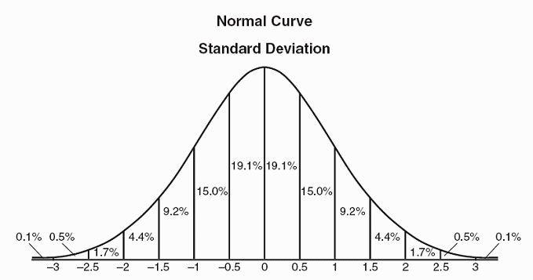For normally distributed data,

______ of data points lie between **±1** standard deviation of the mean, _____ of data points lie between **±2** standard deviations of the mean and **_____** of data points lie between **±3** standard deviation of the mean.

***Standard Deviations***

**III. WATER POTENTIAL**

**A.** Water potential is the free energy of water, water will always move from an area of higher water potential to an area of lower water potential (high free energy to low free energy).

**B.** Water/Osmotic Potential is dependent on **pressure potential (P)** and **solute concentration (S)**.

## Water Potential = Pressure Potential + Solute Potential

** = P + S**

**Water basically moves from a higher water potential to a lower water potential.**

*(high free energy) (low free energy)*

**Sample Problems:**

**(1)** The initial concentration of Side A and Side B are indicated on either side of the U-tube.

The membrane shown is permeable to sucrose and NaCl but NOT starch.

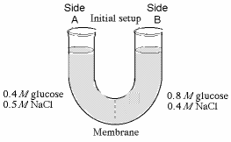

0.6M sucrose

1.2M starch

1.6M NaCl

1.5M sucrose

0.8M starch

0.4M NaCl

**a)** Initially, which side is hypertonic? _______ **b)** Initially, which side is hypotonic? _______

**c)** Please use the correct letters to fill in the blanks below. In order to reach equilibrium:

sucrose will move from side ______ to side ______.

starch will move from side ______ to side ______.

NaCl will move from side ______ to side ______.

**d)** After this system reaches equilibrium: what is the molarity of each side? **A** = _______ **B** = _______

Which side will lose water? _______. How will you know?

**(2)** Calculate the water potential of a solution of **0.15M** sucrose. **Work Space:**

*Give your answer to the nearest hundredths.*

**i** = 1 (ionization constant for sucrose)

**C** = osmolarity

**R** = 0.0831 L bars/mole degree K (pressure constant)

**T** = temperature in Kelvin (295oK)

**(3)** If a cell’s **P = 3 bars** and it’s **S= -4.5 bars,** what is the resulting **** **Work Space:**

*Give your answer to the nearest tenth.*

**(4)** If the cell from the previous question is placed into a beaker **Work Space:**

of sugar water with **S= -4.5 bars.**

In which direction will the net flow of water be and WHY?

**\*(5)** If the original cell from question #4 is placed into a beaker of sugar **Work Space:**

water with **S= -0.15 MPa** (*megapascals / 1 MPa = 10 bars*), in which

direction will the net flow of water be?

**\*(6)** At **20oC**, a cell with **P = 3 bars** is in equilibrium with the **Work Space:**

surrounding **0.4M** solution of sucrose in an open container.

What is the molar concentration **(C)** of sucrose in the cell?

*Give your answer to the nearest hundredth.*

**IV. SURFACE AREA AND VOULME**

**(1)** What is the SA/V for the cell to the right?

*Give your answer to the nearest hundredth.*

**(2)** Is it better for a cell to have a **HIGH** or **LOW** SA/V ratio? Explain.

**V. GENETICS / PROBABILITY**

## A. Rule of Addition

The rule of addition applies to the following situation. We have two events, and we want to know the probability that **either** event occurs.

**Example**: The chance of rolling a 1 or 2 on a six-sided [die](http://en.wikipedia.org/wiki/Dice) is ____________________.

**(1)** A card is drawn randomly from a deck of ordinary playing cards. You win $10 if the card is a spade or an ace. What is the probability that you will win the game?

*Give your answer to the nearest hundredth.*

## B. Rule of Multiplication

The rule of multiplication applies to the situation when we want to know the probability of the intersection of two events; that is, we want to know the probability that two events (Event A and Event B) **both** occur.

**Example**: If two coins are flipped the chance of both being heads is ____________________.

**(2)** An urn contains 6 red marbles and 4 black marbles. Two marbles are drawn *without replacement* from the urn. What is the probability that both of the marbles are black?

*Give your answer to the nearest hundredth.*

**(3)** An urn contains 6 red marbles and 4 black marbles. Two marbles are drawn *with replacement* from the urn. What is the probability that both of the marbles are black?

*Give your answer to the nearest hundredth.*

**(4)** What is the probability the parents shown below would create the genotypic offspring listed?

*Give your answer to the nearest hundredth.*

HhOoDdAaYy x HhooDdAayy

**a)** HhOoDdAaYy = **b)** hhooDdAayy =

**VI. GENETICS / CHI-SQUARE**

Collected/Observed (O) data rarely conform exactly to prediction, so it is important to determine if the deviation (difference) between the expected (E) values (*based upon the hypothesis*) and the observed results is **SIGNIFICANT** enough to discredit the original hypothesis. This need has led to the development of a variety of statistical devices designed to challenge the collected data.

**Chi-Square Formula: Chi-Square Table**

|  |  |  |  |  |  |  |  |  |
| --- | --- | --- | --- | --- | --- | --- | --- | --- |
|  | **Degrees of Freedom** | | | | | | | |
| **p** | **1** | **2** | **3** | **4** | **5** | **6** | **7** | **8** |
| **0.05** | 3.84 | 5.99 | 7.82 | 9.49 | 11.07 | 12.59 | 14.07 | 15.51 |
| 0.01 | 6.64 | 9.32 | 11.34 | 13.28 | 15.09 | 16.81 | 18.48 | 20.09 |

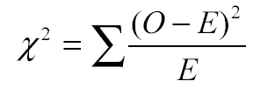

**Sample Problems:**

**(1)** In corn (*Zea mays*), purple kernels (R) are dominant to yellow kernels (r). Cobs from the offspring of a cross between a purple plant and yellow plant were used in a lab. A student counts **329** purple and **299** yellow kernels on one cob.

Calculate the chi-squared value for the null hypothesis that the purple parent was heterozygous for purple kernels*. Give your answer to the nearest tenth.*

**Expected Results:**

|  |  |
| --- | --- |
|  |  |
|  |  |

**(2)** In snapdragons (*Antirrhinum*), the phenotype for flower

color is governed by two alleles – red (R) and white (W).

Heterozygous individuals have pink flowers. Two pink

individuals are crossed to produce 465 offspring.

Calculate how many of these offspring are expected to have

the red phenotype. *Round your response to the nearest whole number.*

**(3)** In a dog breed known as the Mexican Hairless, the “hairless”

phenotype is a result of a mutation displaying an autosomal

dominant pattern of inheritance. Homozygous recessive individuals

(hh) display a “coated” phenotype. Inheriting two copies of the

mutation (HH) is lethal during embryonic development.

In a cross between two dogs with the hairless phenotype, what

proportion of puppies born is expected to be hairless?

*Give your answer in the form of a fraction*.

**(4)** Wild-type fruit flies have red eyes (+). The “white-eyed” phenotype (w)

is recessive and results from a mutation on the X chromosome. During a

lab, students cross a white-eyed male with a homozygous red-eyed female.

A red-eyed female and a red-eyed male from the F1 generation are

then bred to produce 573 offspring.

How many of the offspring are predicted to be white-eyed males?

*Round your response to the nearest whole number.*

**(5)** A plant geneticist is investing the inheritance of genes for bitter taste (Su) and explosive rind (e) in watermelon (*Citrullus lanatus*). Explosive rind is recessive and causes watermelons to burst when cut. Non-bitter watermelons are a result of the recessive genotype (susu). The geneticist wishes to determine if the genes assort independently. She performs a testcross between a bitter/nonexplosive hybrid and a plant homozygous recessive for both traits. The following offspring are produced:

|  |  |  |  |  |  |
| --- | --- | --- | --- | --- | --- |
| **Phenotype** | **observed** | **expected** | **obs-exp** | **(obs-exp)2** | **(obs-exp)2/exp** |
| bitter/non-explosive | 88 |  |  |  |  |
| bitter/explosive | 68 |  |  |  |  |
| non-bitter/non-explosive | 62 |  |  |  |  |
| non-bitter/explosive | 81 |  |  |  |  |
|  |  |  |  |  | X2 = |

Calculate the chi-squared value for the null hypothesis that the two genes assort independently.

*Give your answer to the nearest hundredth.*

**(6)** In *Drosophila*, “bow-legged” is a mutation that is hypothesized to be X-linked recessive. A homozygous wild-type female was crossed with a bow-legged male. The F1 generation contained equal numbers of wild-type males and wild-type females. The F2 generation contained 30 wild-type males, 40 bow-legged males, 75 wild-type females, and 0 bow-legged females.

Calculate the chi-squared value for the null hypothesis that the “bow-legged” mutation is X-linked recessive.

*Give your answer to the nearest tenth.*



|  |  |  |  |  |  |  |  |  |
| --- | --- | --- | --- | --- | --- | --- | --- | --- |
|  | **Degrees of Freedom** | | | | | | | |
| **p** | **1** | **2** | **3** | **4** | **5** | **6** | **7** | **8** |
| **0.05** | 3.84 | 5.99 | 7.82 | 9.49 | 11.07 | 12.59 | 14.07 | 15.51 |
| **0.01** | 6.64 | 9.32 | 11.34 | 13.28 | 15.09 | 16.81 | 18.48 | 20.09 |

**Work Space:**

**VII. RECOMBINATION/CROSS-OVER FREQUENCY**

[*Cross-over frequency = map distance (centimorgans / cM*)]

**A.** Recombinant offspring, which exhibit new combinations of traits inherited from two parents, result from events of **meiosis** and **random fertilization**. These events include **crossing over** and **independent assortment** of chromosomes during the first meiotic division.

**B.** Geneticists can use recombination data to map a chromosome’s genetic loci.

*(The farther apart genes are on a chromosome, the more likely they are to be separated during crossing over.)*

**(1)** **Crossing-over in Sordaria**

Determine the cross-over frequency (*map distance*) for the fungus *Sordaria.* 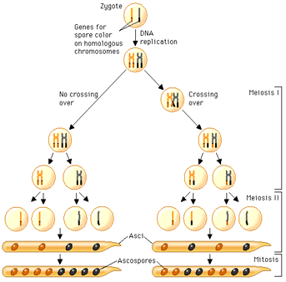

**The arrangement of ascospores corresponds directly with the process of crossing-over!**

|  |  |  |  |  |  |
| --- | --- | --- | --- | --- | --- |
| *Sordaria* Phenotype Crossed | Number of 4:4 Asci (*non-crossover events*) | Number of Asci Showing Crossover | Total Asci | % Asci Showing Crossover *(Recombination Frequency*) | Calculated Gene to Centromere Distance (cM) |
| **Wild x Tan** |  |  |  |  |  |

**VIII. HARDY WEINBERG:**

*Population Genetics p2 + 2pq + q2 = 1*Hardy Weinberg Strategies:

**p =** frequency of the **dominant** allele in the population **1.** Figure out what you are given:  **q =** frequency of the **recessive** allele in the population allele **p/q** OR genotype: **p2 q2 2pq**

**(p + q = 1) 2.** Figure out what you are solving for.

**p2 =** percentage of **homozygous dominant** individuals **3.** Manipulate formulas to go from given to solving  
**q2 =** percentage of **homozygous recessive** individuals  **2pq =** percentage of **heterozygous** individuals

Hardy and Weinberg also argues that if five conditions are met, the population’s allele and genotype frequencies will remain constant from generation to generation. These conditions are as follows:

**1. The breeding population is large.** *The effect of chance on changes in allele frequencies is greatly reduced.*

**2. Mating is random.** *Individuals show no mating preference for a particular phenotype.*

**3. There is no mutation of the alleles.** *No alteration in the DNA sequences of alleles.*

**4. No differential migration occurs.** *No immigration or emigration.*

**5. There is no selection.** *All genotypes have an equal chance of surviving and reproducing.*

**Sample Problems:**

**(1)** In Mr. Collea’s AP Biology class at North Salem High School , _____ members of the class have a straight hairline. A straight hairline is controlled by a recessive allele (w). The dominant allele (W) for this trait produces a widow’s peak hairline (*one that comes to a point*). Determine the allelic frequencies (**p and q**) along with the number of individuals you would expect to have each of the possible three genotypes for this hairline trait?

|  |  |  |  |  |  |  |
| --- | --- | --- | --- | --- | --- | --- |
|  | **Phenotypes** | | | | **Allele Frequency Based**  **on the H-W Equation** | |
| **Widow’s Peak Hairline**  (p2 + 2pq) | | **Straight Hairline**  (q2) | | **p** | **q** |
| **Class Population** | # | % | # | % |  |  |
|  |  |  |  |
| **North American Population** | 0.45 | | 0.55 | |  |  |

**a)** The frequency of the recessive allele **(q)** = __________. *Give your answer to the nearest hundredth.*

**b)** The frequency of the dominant allele **(p)** = __________. *Give your answer to the nearest hundredth.*

**c)** The frequency of homozygous dominant individuals **(p2)** = __________*. Give your answer as a percent.*

**d)** The frequency of heterozygous individuals **(2pq)** = __________. *Give your answer as a percent.*

**e)** The frequency of homozygous recessive individuals **(q2)** = __________. *Give your answer as a percent.*

**(2)** In 1986 the Utica Free Academy High School student body was made up of 90% right handed students.

Being right handed (**R**) is the dominant trait over being left handed (**r**).

**a)** What is *p* and *q* for the population of Utica Free Academy High School students in 1986?

*Give your answer to the nearest hundredth.*

**b)** Find the percent of the student body in 1986 that are homozygous right handed, heterozygous right handed, and left handed. *Give your answer to the nearest whole number.*

**c)** Fast forward to today at Utica Free Academy. We took a random sample of 100 students today and found that 18 of them were left handed. What are the new *p* and *q* values? How do they compare with the values from 1986?

**d)** Come up with as many reasons as you can as to why this apparent change (*evolution*) could have occurred.

_________________________________________________________________________________

_________________________________________________________________________________

_________________________________________________________________________________

_________________________________________________________________________________

_________________________________________________________________________________

_________________________________________________________________________________

_________________________________________________________________________________

_________________________________________________________________________________

**IX. REACTION RATES**

**(1)** **Catalase** is an enzyme found in peroxisomes that facilitates the breakdown of hydrogen peroxide (H2O2), a toxic by-product of cellular respiration, into oxygen and water. An experiment was conducted to measure the reaction rate of catalase under ideal enzymatic conditions. Using the data collected and recorded below, properly create and label a line graph depicting the results of the experiment.

|  |  |  |  |
| --- | --- | --- | --- |
| **Time (seconds)** | **Initial H2O2 in beaker before catalase** | **Remaining H2O2 in beaker after catalase** | **Total H2O2broken down by catalase** |
| 10 | 5 mL | 4.5 mL | _____ mL |
| 30 | 5 mL | 3.5 mL | _____ mL |
| 60 | 5 mL | 2.0 mL | _____ mL |
| 90 | 5 mL | 1.0 mL | _____ mL |
| 120 | 5 mL | 0.5 mL | _____ mL |
| 180 | 5 mL | 0.0 mL | _____ mL |

Graph Title: __________________________________________________________________________________

|  |  |  |  |  |  |  |  |  |  |  |  |  |  |  |  |  |  |  |  |  |  |  |  |  |  |  |  |  |  |
| --- | --- | --- | --- | --- | --- | --- | --- | --- | --- | --- | --- | --- | --- | --- | --- | --- | --- | --- | --- | --- | --- | --- | --- | --- | --- | --- | --- | --- | --- |
|  |  |  |  |  |  |  |  |  |  |  |  |  |  |  |  |  |  |  |  |  |  |  |  |  |  |  |  |  |  |
|  |  |  |  |  |  |  |  |  |  |  |  |  |  |  |  |  |  |  |  |  |  |  |  |  |  |  |  |  |  |
|  |  |  |  |  |  |  |  |  |  |  |  |  |  |  |  |  |  |  |  |  |  |  |  |  |  |  |  |  |  |
|  |  |  |  |  |  |  |  |  |  |  |  |  |  |  |  |  |  |  |  |  |  |  |  |  |  |  |  |  |  |
|  |  |  |  |  |  |  |  |  |  |  |  |  |  |  |  |  |  |  |  |  |  |  |  |  |  |  |  |  |  |
|  |  |  |  |  |  |  |  |  |  |  |  |  |  |  |  |  |  |  |  |  |  |  |  |  |  |  |  |  |  |
|  |  |  |  |  |  |  |  |  |  |  |  |  |  |  |  |  |  |  |  |  |  |  |  |  |  |  |  |  |  |
|  |  |  |  |  |  |  |  |  |  |  |  |  |  |  |  |  |  |  |  |  |  |  |  |  |  |  |  |  |  |
|  |  |  |  |  |  |  |  |  |  |  |  |  |  |  |  |  |  |  |  |  |  |  |  |  |  |  |  |  |  |
|  |  |  |  |  |  |  |  |  |  |  |  |  |  |  |  |  |  |  |  |  |  |  |  |  |  |  |  |  |  |
|  |  |  |  |  |  |  |  |  |  |  |  |  |  |  |  |  |  |  |  |  |  |  |  |  |  |  |  |  |  |
|  |  |  |  |  |  |  |  |  |  |  |  |  |  |  |  |  |  |  |  |  |  |  |  |  |  |  |  |  |  |
|  |  |  |  |  |  |  |  |  |  |  |  |  |  |  |  |  |  |  |  |  |  |  |  |  |  |  |  |  |  |
|  |  |  |  |  |  |  |  |  |  |  |  |  |  |  |  |  |  |  |  |  |  |  |  |  |  |  |  |  |  |
|  |  |  |  |  |  |  |  |  |  |  |  |  |  |  |  |  |  |  |  |  |  |  |  |  |  |  |  |  |  |
|  |  |  |  |  |  |  |  |  |  |  |  |  |  |  |  |  |  |  |  |  |  |  |  |  |  |  |  |  |  |
|  |  |  |  |  |  |  |  |  |  |  |  |  |  |  |  |  |  |  |  |  |  |  |  |  |  |  |  |  |  |
|  |  |  |  |  |  |  |  |  |  |  |  |  |  |  |  |  |  |  |  |  |  |  |  |  |  |  |  |  |  |

What is the reaction rate for the catalase in this experiment between 30-90 seconds? ____________________

(Label your reaction rate with the proper units!)

**(2)** An experiment was conducted to measure the amount of oxygen used by crickets over time at two different temperatures. Create a double-line graph displaying these results.

|  |  |
| --- | --- |
| **Temp**  **(°C)** | **Time**  **(min)** |
| **O­2 used** |
| **22o C** | 0 | --- |
| 5 | 0.02 mL |
| 10 | 0.03 mL |
| 15 | 0.05 mL |
| 20 | 0.07 mL |
| **42o C** | 0 | --- |
| 5 | 0.08 mL |
| 10 | 0.15 mL |
| 15 | 0.22 mL |
| 20 | 0.30 mL |

Graph Title: __________________________________________________________________________________

|  |  |  |  |  |  |  |  |  |  |  |  |  |  |  |  |  |  |  |  |  |  |  |  |  |  |  |  |  |  |
| --- | --- | --- | --- | --- | --- | --- | --- | --- | --- | --- | --- | --- | --- | --- | --- | --- | --- | --- | --- | --- | --- | --- | --- | --- | --- | --- | --- | --- | --- |
|  |  |  |  |  |  |  |  |  |  |  |  |  |  |  |  |  |  |  |  |  |  |  |  |  |  |  |  |  |  |
|  |  |  |  |  |  |  |  |  |  |  |  |  |  |  |  |  |  |  |  |  |  |  |  |  |  |  |  |  |  |
|  |  |  |  |  |  |  |  |  |  |  |  |  |  |  |  |  |  |  |  |  |  |  |  |  |  |  |  |  |  |
|  |  |  |  |  |  |  |  |  |  |  |  |  |  |  |  |  |  |  |  |  |  |  |  |  |  |  |  |  |  |
|  |  |  |  |  |  |  |  |  |  |  |  |  |  |  |  |  |  |  |  |  |  |  |  |  |  |  |  |  |  |
|  |  |  |  |  |  |  |  |  |  |  |  |  |  |  |  |  |  |  |  |  |  |  |  |  |  |  |  |  |  |
|  |  |  |  |  |  |  |  |  |  |  |  |  |  |  |  |  |  |  |  |  |  |  |  |  |  |  |  |  |  |
|  |  |  |  |  |  |  |  |  |  |  |  |  |  |  |  |  |  |  |  |  |  |  |  |  |  |  |  |  |  |
|  |  |  |  |  |  |  |  |  |  |  |  |  |  |  |  |  |  |  |  |  |  |  |  |  |  |  |  |  |  |
|  |  |  |  |  |  |  |  |  |  |  |  |  |  |  |  |  |  |  |  |  |  |  |  |  |  |  |  |  |  |
|  |  |  |  |  |  |  |  |  |  |  |  |  |  |  |  |  |  |  |  |  |  |  |  |  |  |  |  |  |  |
|  |  |  |  |  |  |  |  |  |  |  |  |  |  |  |  |  |  |  |  |  |  |  |  |  |  |  |  |  |  |
|  |  |  |  |  |  |  |  |  |  |  |  |  |  |  |  |  |  |  |  |  |  |  |  |  |  |  |  |  |  |
|  |  |  |  |  |  |  |  |  |  |  |  |  |  |  |  |  |  |  |  |  |  |  |  |  |  |  |  |  |  |
|  |  |  |  |  |  |  |  |  |  |  |  |  |  |  |  |  |  |  |  |  |  |  |  |  |  |  |  |  |  |
|  |  |  |  |  |  |  |  |  |  |  |  |  |  |  |  |  |  |  |  |  |  |  |  |  |  |  |  |  |  |
|  |  |  |  |  |  |  |  |  |  |  |  |  |  |  |  |  |  |  |  |  |  |  |  |  |  |  |  |  |  |
|  |  |  |  |  |  |  |  |  |  |  |  |  |  |  |  |  |  |  |  |  |  |  |  |  |  |  |  |  |  |

What was the rate (*with proper units*) of oxygen consumption by the crickets **at 22o C**? _______________

**at 42o C**? _______________

**X. GEL ELECTROPHORESIS**

[*http://www.sumanasinc.com/webcontent/animations/content/gelelectrophoresis.html*](http://www.sumanasinc.com/webcontent/animations/content/gelelectrophoresis.html)

**DNA Gel Electrophoresis:**

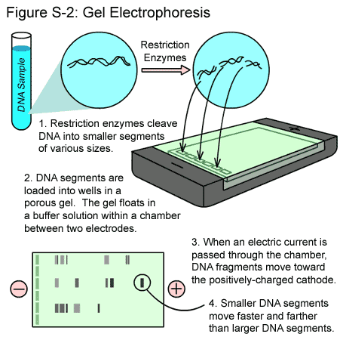

**(1)** According to the **BANDING PATTERN** to the right **DNA Fingerprint:**

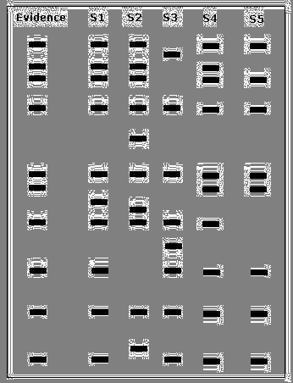 created by the process **DNA Gel Electrophoresis**, which

separates various size pieces of DNA called **restriction**

**fragment length polymorphisms** (*rflps*) that have been

created through the digesting (*cutting*) of DNA with

**restriction enzymes** according to **SIZE** and **CHARGE**

(*smaller rflps move faster and farther than larger ones*),

which suspect’s DNA was left at the crime scene? WHY?

________________________________________________

**________________________________________________**

**________________________________________________**

**________________________________________________**

**________________________________________________**

**________________________________________________**

**XI. GENETIC ENGINEERING / PLASMID MAPS**

[***http://sumanasinc.com/webcontent/animations/content/plasmidcloning.html***](http://sumanasinc.com/webcontent/animations/content/plasmidcloning.html)

**A.** Bacterial **plasmids** (*circular pieces of DNA found in bacteria/prokaryotes used as* ***vectors*)** range in size from 1,000 to 200,000 base pairs (*bp*), and are used extensively for genetic engineering / cloning purposes. Restriction enzymes are used to cut the plasmid DNA at specific locations creating **“sticky ends.”** These **“sticky ends”** are then joined together by the enzyme **DNA ligase** after the **gene of interest** linked to a marker gene (*usually a gene that makes the bacteria resistant to the antibiotic ampillicin for selection purposes*) are inserted into the plamid.

**(1)** The plasmid drawn below has restriction sites for the following restriction enzymes: **EcoR1**, **Sal1**, and **BamH1**. The distance in base pairs (*bp*) between restriction/cutting sites is listed between the sites.



**(a)** Which of the gel electrophoresis results below would be most similar to the one that

you would expect after cutting the cloning plasmid with the restriction enzyme **EcoR1**? ______

**(b)** Which of the gel electrophoresis results below would be most similar to the one that

you would expect after cutting the cloning plasmid with the restriction enzyme **Sal1**? ______

**(c)** Which of the gel electrophoresis results below would be most similar to the one that you would

 expect after cutting the cloning plasmid with all three restriction enzymes all at the same time? ______

**(2)** The diagram below shows a segment of DNA with a total length of 4,900 base pairs. The arrows indicate reaction sites for two restriction enzymes (enzyme X and enzyme Y).

**X**

**X**

**Y**

300

700

900

500

**a)** Describe the results you would expect *(number of bands*) from the electrophoretic separation of fragments from the following treatments of the DNA segment above. Assume that the digestions occurred under appropriate conditions and went to completion.

**I.** DNA digested with only enzyme X ______ bands

**II.** DNA digested with only enzyme Y ______ bands

**III.** DNA digested with enzyme X and enzyme Y combined ______ bands

**IV**. Undigested DNA ______ bands

**(3)** A bacterial plasmid is 100 kb in length. The plasmid DNA was digested to completion with two restriction enzymes in three separate treatments: **EcoRI**, **HaeIII**, and **EcoRI** + **HaeIII** (double digest). The fragments were then separated with electrophoresis, as shown:

**Results of Gel Electrophores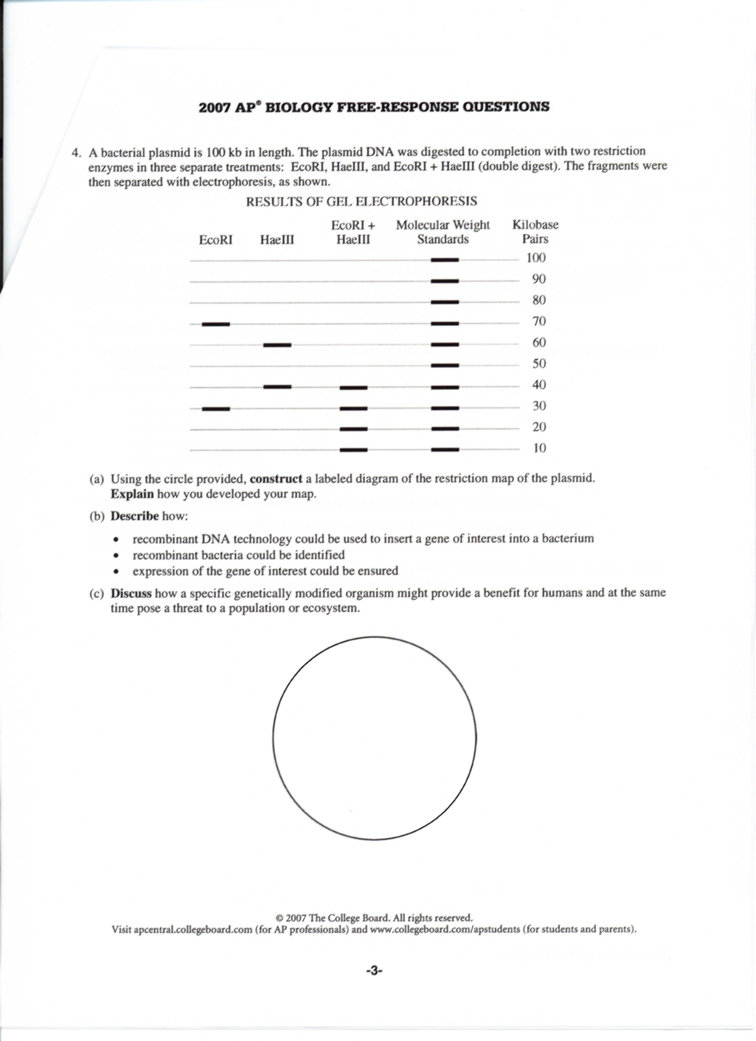 (1)** Using the circle provided, **construct** a labeled diagram of the restriction map of the plasmid.

**(2)** **Discuss** how a specific genetically modified organism might provide a benefit for humans and at the same time pose a threat to a population or ecosystem.

**XII. TEMPERATURE COEFFICIENT Q10**

The **Q10 temperature coefficient** is a measure of the *rate of change of a biological or chemical system as a consequence of increasing the* [*temperature*](http://en.wikipedia.org/wiki/Temperature) *by 10°C*. It is useful in studying cold blooded organisms because it expresses the temperature dependence of a biological process. There are many examples where the Q10 value is used, from the calculation of the [nerve conduction velocity](http://en.wikipedia.org/wiki/Nerve_conduction_velocity) to the calculation of muscle fiber contraction velocity. In fact, the Q10 value can be applied to [chemical reactions](http://en.wikipedia.org/wiki/Chemical_reaction) and physiological processes in most cold blood animal systems.

***The Q10 is calculated using the formula listed below, which is found on the AP Formula Sheet.***

**k =** is the Metabolic Rate

**t =** is the Temperature (oC or oK)

**Formula: Q10 =**

***Q10 is a unitless quantity as it is simply the factor by which a rate changes for every 10oC increase in body temperature.***

**Sample Problems:**

**(1)** Determine the Q10 value for the heart rate in *Daphnia*, the water flea.

*Round your answer to the nearest tenth.*

|  |  |
| --- | --- |
| **Temperature (Co)** | **Average Heart Rate**  (*beats per minute*) |
| 10 | 127 |
| 20 | 162 |

**(2)** Determine the Q10 value for the blood vessel contraction an earthworm.

*Round your answer to the nearest tenth.*

|  |  |
| --- | --- |
| **Temperature (Co)** | **Average Blood Vessel Contraction**  *(per minute)* |
| 16 | 16 |
| 21 | 19 |

**(3)** Determine the Q10 value for the breathing *rate of the dwarf* geckolizard.

*Round your answer to the nearest tenth.*

|  |  |
| --- | --- |
| **Temperature (Co)** | **Average Breathing Rate**  *(breaths per minute)* |
| 17 | 25 |
| 27 | 39 |

**XIII. PRIMARY PRODUCTIVITY CALCULATIONS**

Oxygen is necessary for the life processes of most organisms, including aquatic organisms. The abundance of available oxygen varies greatly between terrestrial and aquatic habitats. However, in both terrestrial and aquatic ecosystems, autotrophs like plants and green algae release oxygen gas as a byproduct of photosynthesis. The oxygen gas is then used by many organisms to create ATP through aerobic cellular respiration.

Approximately 21% of the atmosphere is composed of oxygen, whereas the *dissolved oxygen* (DO) concentration in water is only a fraction of 1%. *The concentration of DO in a body of water is often used as a benchmark indicator of water quality because it suggests the number of producers in the ecosystem and the activity levels of the producers and consumers.*

An ecosystem's **primary production** is the amount of light energy converted to chemical energy by autotrophs during a given time period. To measure the primary productivity of an aquatic ecosystem, one could attempt to measure the concentration of organic compounds produced by the autotrophs in a given time period. Since oxygen is a byproduct of photosynthesis, it is easier to use the concentration of DO as a measure of an aquatic ecosystem's primary productivity.

**Gross primary production** (**GPP**) is the total primary production by the autotrophs; it is the amount of light energy that autotrophs convert into chemical energy. **Net primary production** (**NPP**) is the amount of light energy that autotrophs convert to chemical energy minus the energy used by the autotrophs for cellular respiration (**R**). Net primary production is a very important measurement because it represents the amount of surplus organic material that will be available to consumers as food.

**Sample Problem:**

**1.** Use the data in the table below to determine the mg of Carbon fixed/L in each test tube.

*Round your answer to the nearest tenth.*

|  |  |  |  |  |
| --- | --- | --- | --- | --- |
| **Average Gross Primary Productivity of Duckweed in our Experiment** | | | | |
| **Test tube #** | **1** | **2** | **3** | **4** |
| **Dissolved Oxygen (mg O2/L)** | 0.95 | 0.325 | 0.0625 | -0.0375 |

**(a)** Test tube #1 **(c)** Test Tube #3

**(b)** Test Tube #2 **(d)** Test Tube #4