**­­­**

|  |  |  |
| --- | --- | --- |
| AP Biology  **Final**  **Exam**  **Review** | **North Salem University**  **MISSION**: *Engage students to continuously learn, question, define and solve problems through critical and creative thinking.*  Spring  2019 | |
| *This packet is designed to familiarize yourself with the location and proper use of the AP Biology equations and formulas you may encounter on the Grid-In Section of your AP exam.*  ***If you have any problems – please sign up for extra help after school.*** | | **Equations and**  **Formulas** |

|  |  |
| --- | --- |
| **Topic** | **Page** |
|  |  |
| Test Format | **3** |
| Gibbs Free Energy | **4** |
| Basic Statistics | **7** |
| Water Potential | **9** |
| Surface and Volume | **13** |
| Genetics and Probability | **13** |
| Chi-Square | **14** |
| Hardy-Weinberg | **15** |
| Graphing and Reaction Rates | **17** |
| Gel Electrophoresis | **19** |
| Plasmid Maps | **20** |
| Temperature Coefficient/ Q10 | **22** |
| Primary Productivity Calculations | **23** |
| Dilutions | **24** |
| pH | **25** |

**AP Biology Test Format:**

The AP Biology Exam is approximately 3 hours in length. There are two sections.

1. **Section I** is **90 minutes** and consists of **63 multiple-choice** questions and **6 grid-in** questions accounting for **50 percent** of the final score.
2. **Section II** is **90 minutes** and consists of **2 long free-response questions** **and 6 short free-response** **questions** accounting for **50 percent** of the final score. It begins with a 10-minute reading period to read the questions and plan your answers. The remaining 1 hour and 20 minutes is for writing. The 2 long free-response questions should require about 20 minutes each to answer. Questions 3 through 8 are short free-response questions and should require about 6 minutes each to answer. You are **NOT** expected to know the answers to **EVERY** question.

**Calculation Grid-In Tips:**

1. If a diagram is provided, analyze the diagram before you start calculating.
2. They won’t ask you for units in your answers on the calculation questions, but they may on the short / long response questions.
3. Don’t round your work until you get to the answer!
4. Read the directions carefully for each question you answer. The question will indicate whether you should round to the nearest whole number, tenth, hundredth, etc. If you round to a different place, your answer will be scored as INCORRECT!
5. With your four function calculator, there is no exponent function. You must use the “old school” method of multiplying a number by itself to square it.

**Example:** 23 = 2 x 2 x 2 = 8

1. You must be able to convert back and forth between scientific notation and whole numbers.

**Examples:**

5.1 x 103 = 5100 6.2 x 10-4 = 0.00062 442 = 4.42 x 102 0.008 = 8.0 x 10-3

**The Grid-in Chart**

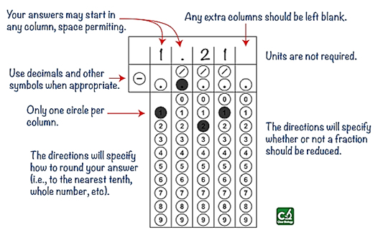

**I. FREE ENERGY**

**A.** The energy transformations of life are subject to **two laws of thermodynamics**:

**1.** The first, conservation of energy, states that energy cannot be created or destroyed.

**2.** The second states that when energy changes form, entropy (S), or the disorder of the universe, increases. Matter can become more ordered only if the surroundings become more disordered.

**B.** Organisms live at the expense of free energy.

**1.** A living system’s free energy is energy that can do work under cellular conditions.

Free energy (G) is related directly to total energy (H) and to entropy (S): ∆G = ∆H - T ∆S .

**(a)** ***Spontaneous*** changes involve a ***decrease*** in free energy (-∆G). In an exergonic (***spontaneous***) chemical reaction, the products have ***less*** free energy than the reactants (-∆G).

**(b)** ***Nonspontaneous*** changes require an input of energy (+∆G). In an endergonic ***(non- spontaneous***) reaction, the products have ***more*** free energy than the reactants. (+∆G)

*In cellular metabolism, exergonic reactions power endergonic reactions* ***(energy coupling****).*

*___________________________________ _______________________________*

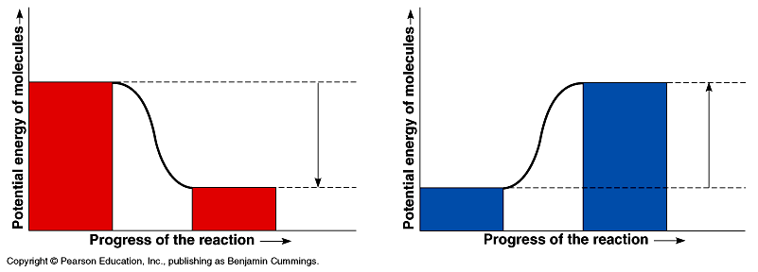

**1)** __________________________________ **1)** __________________________________

**2)** __________________________________ **2)** __________________________________

**Example**: ____________________________ **Example**: ____________________________

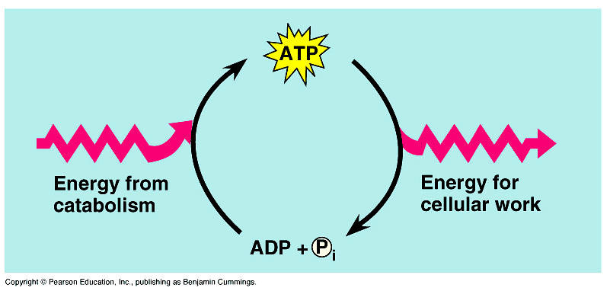**C. ATP powers cellular work by coupling exergonic reactions to endergonic reactions**

**1.** ATP is the cell’s energy shuttle. Release of its terminal phosphate group produces ADP, inorganic phosphate, and free energy.

**2.** ATP drives endergonic reactions by transfer of the phosphate to specific reactants, making them more reactive. In this way, cells can carry out work, such as movement and anabolism. Catabolic pathways drive the regeneration of ATP from ADP and phosphate.

**D. Catalyzed vs. Uncatalyzed Reactions**

1. **E**______________ are **C**________________ that **L**__________ the **A**__________________ energy

of a chemical reaction allowing them to proceed at a **T**__________ and **R**________ conducive for life.

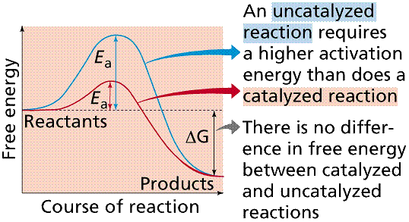

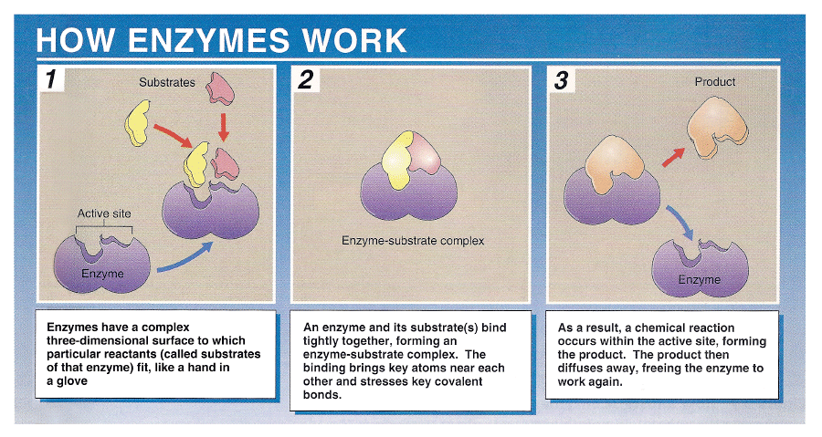**E. How Enzymes Work**

**F. Gibbs Free Energy Practice Problems**

**Temperature Conversions: K = °C + 273**

**http://images-mediawiki-sites.thefullwiki.org/03/3/7/0/1932191290094424.png Formula:**

**1**. Calculate the Gibbs *free energy change* (**ΔG**) for the following chemical reaction:

**ATP ADP + Pi**

The reaction occurs at **20 °C**, the *change in heat* (**ΔH**) = **19,070 cal**, and the *change in entropy*

(**ΔS**) = **90 cal/K.** *Give your answer to the nearest tenth.*

**-7,300 cal = -7.3 Kcal**

**2**. Calculate the *Gibbs free energy change* (**ΔG**) for the following chemical reaction:

**glutamate + NH3 glutamine + H2O**

The reaction occurs at **22 °C**, the *change in heat* (**ΔH**) = **4103 cal**, and the *change in entropy*

(**ΔS**) = **2.4 cal/K.** *Give your answer to the nearest tenth.*

**3395 cal = 3.4 Kcal**

**3.** Would either of the reactions above occur **spontaneously**? If so, which one(s) and why?

**Reaction #1 / -∆G**

**4.** Are either of the above reactions **endergonic**? If so, which one(s) and why?

**Reaction #2 / +∆G**

**II. BASIC STATISTICS**

**(1)** Your lab group collected the following data for the heights (***cm***) of their Wisconsin Fast Plants: **5.4 7.2 4.9 9.3 7.2 8.1 8.5 5.4 7.8 10.2**

**a)** Find the mean, median, mode and range for the data above. *Give your answer to the nearest whole number.*

**Mean**: **7.4** **Median: 7.5** **Mode**: **5.4 7.2** **Range**: **5.3**

**b)** Find the standard deviation by filling in the following table. **Standard Deviation:**

|  |  |  |  |  |  |
| --- | --- | --- | --- | --- | --- |
| **Heights (x)** | **Mean ()** |  |  |  |  |
|  |  |  |  | **1.75** |  |
|  |  |  |  |  |  |
|  |  |  |  |  |  |
|  |  |  |  |  |  |
|  |  |  |  |  |  |
|  |  |  |  | **What does this mean?** |  |
|  |  |  |  |  |  |
|  |  |  |  |  |  |
|  |  |  |  |  |  |
|  |  |  |  |  |  |
|  |  | 🡪 | **27.64** |  |  |

**Standard Normal Distribution or “The Bell Curve”**

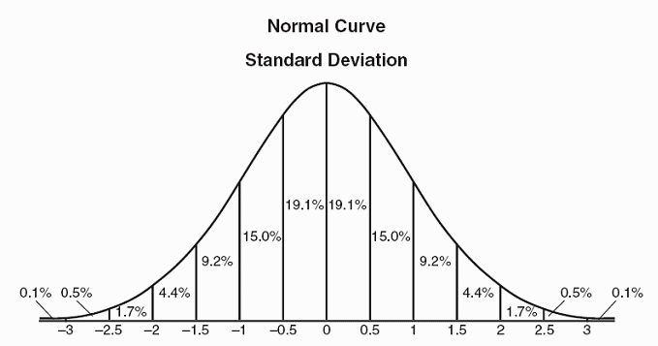For normally distributed data,

______ of data points lie between **±1** standard deviation of the mean, _____ of data points lie between **±2** standard deviations of the mean and **_____** of data points lie between **±3** standard deviation of the mean.

***Standard Deviations***

**(2)** A fertilized egg (zygote) undergoes 8 rounds of cleavage including cell partitioning. After the 8th round, half of the cells divide again while the remaining cells undergo **apoptosis** *(programmed cell death*). After this event those remaining cells undergo 2 more rounds of cleavage. *Round answer to the nearest whole number.*

How many cells are present after these events? **1024**

**(3)** During embryonic paw formation in Timon, a meerkat, there are initially 623 cells between the first 2 digits of the paw. Each of these cells and their subsequent daughter cells must undergo 3 rounds of cell division to provide enough cells for proper paw development. Next, differential gene expression initiates **apoptosis** causing the loss of 85% of the cells. *Round answer to the nearest whole number.*

How many cells remain after these events? **748**

**(4)** Use the diagram below to calculate the percentage of cells in each stage of the cell cycle.

*Round answer to nearest tenth.*

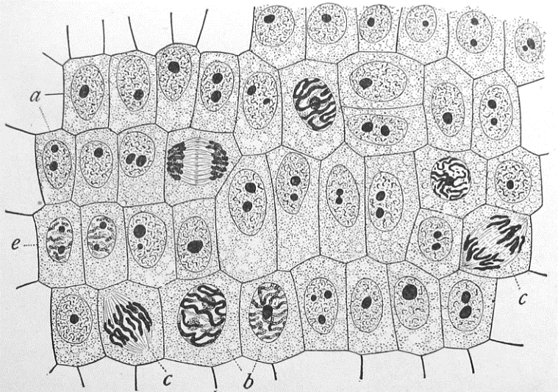

|  |  |
| --- | --- |
| **Stage** | **Percentage** |
| **Interphase** |  |
| **Prophase** |  |
| **Metaphase** |  |
| **Anaphase** |  |
| **Telophase** |  |

**III. WATER POTENTIAL**

**A.** Water potential is the free energy of water and will always move from an area of higher water potential to an area of lower water potential (*high free energy to low free energy*).

**B.** Water/Osmotic Potential is dependent on **pressure potential (P)** and **solute concentration (S)**.

## Water Potential = Pressure Potential + Solute Potential

** = P + S**

**Water basically moves from a higher water potential to a lower water potential.**

*(high free energy) (low free energy)*

**(1)** Water potential is measured in what units? ______________________________________________________

**(2)** What two factors determine water potential? (See the equation above) ________________________________

________________________________

**(3)** State which direction water will move regarding water potential.

_________________________________________________________________________________________

**(4)** Pure/distilled water has a water potential of **0 Bars**

**(5)** If water potential is **-2 bars** and solute potential is **-2 bars**, then pressure potential = **0 Bars**.

**(6)** If solute potential is **-3 bars** and water potential is **0 bars**, then the pressure potential = **3 Bars**.

**(7)** If water potential is **-9 bars** and pressure potential is **+4 bars**, then solute potential = **-13 Bars**.

**(8)** If a cell’s pressure potential is **3 bars** and it’s solute potentialis **-4.5 bars,** what is the resulting **water potential***Give your answer to the nearest tenth.*

**-1.5**

**(9)** If the cell from the previous question is placed into a beaker of sugar water with a solute potential of **-4.0 bars.**

In which direction will the net flow of water be and WHY?

**-1.0**

**(10)** The initial concentration of Side A and Side B are indicated on either side of the U-tube.

The membrane shown is permeable to sucrose and NaCl but NOT starch.

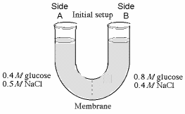

0.6M sucrose

1.2M starch

1.6M NaCl

1.5M sucrose

0.8M starch

0.4M NaCl

**a)** Initially, which side is hypertonic? **B** hypotonic? **A**

**c)** Please use the correct letters to fill in the blanks below. In order to reach equilibrium:

sucrose will move from side **A** to side **B**.

starch will move from side **---** to side **---.**

NaCl will move from side **B** to side **A**.

**d)** After this system reaches equilibrium: what is the molarity of each side? **A** = **2.85** **B** = **3.25**

Which side will lose water? **A**. How will you know? **Side B will rise.**

**(11)** Given the following scenarios, draw an arrow representing the movement of water across these semipermeable membranes.

**a) b) c)**

**ψ = 1.2 ψ = 3.2 ψ = 0 ψ = -2.3 ψ = -2.3 ψ = 0**

**Solute Potential of a Solution**

**S = -iCRT**

**i** = ionization constant (For sucrose this is 1)

**C** = osmolarity

**R** = pressure constant (0.0831 L bars/mole oK)

**T** = temperature in Kelvin (273 + oC)

**(12)** A cell is in equilibrium with its surroundings at 30oC. **Work Space:**

The molarity of the surrounding sucrose solution is 0.5M**.**

**a)** Calculate the solute potential of the surrounding solution.

*Give your answer to the nearest tenth.*

**-12.6 Bars**

**b)** What is the water potential of the surrounding solution?

**-12.6 Bars**

**c)** What is the water potential of the cytoplasm of the cell?

**-12.6 Bars**

**(13)** The value for water potential in root tissue was found to be -3.3 bars. If you take the root tissue and place it in

a 0.1M solution of sucrose at 20oC in a open beaker, what is the solute potential of the solution and in which direction will the net flow of water be.

**Solution Root**

**(14)** NaCl dissociates into 2 particles in water: Na+ and Cl-. If the solution in question 13 contained 0.1M NaCl instead of 0.1M sucrose, what is the solute potential of the solution and in which direction will the net flow of water be.

**-4.8 Bars Solution Root**

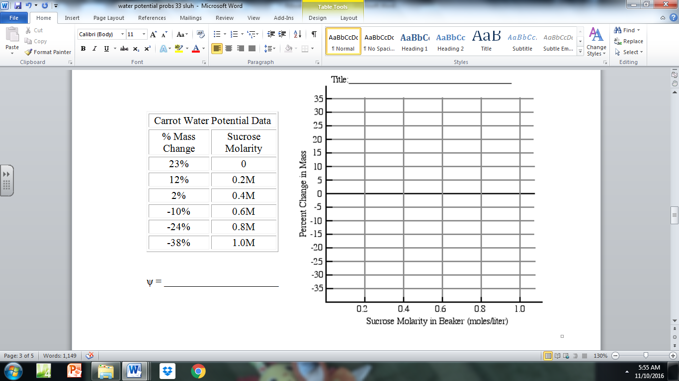**(15)** Graph the data in the data table below and use it to calculate the solute potential of carrots at 23oC.

**(16)** The dialysis bags pictured in the diagram below are impermeable to solutes, but permeable to water.

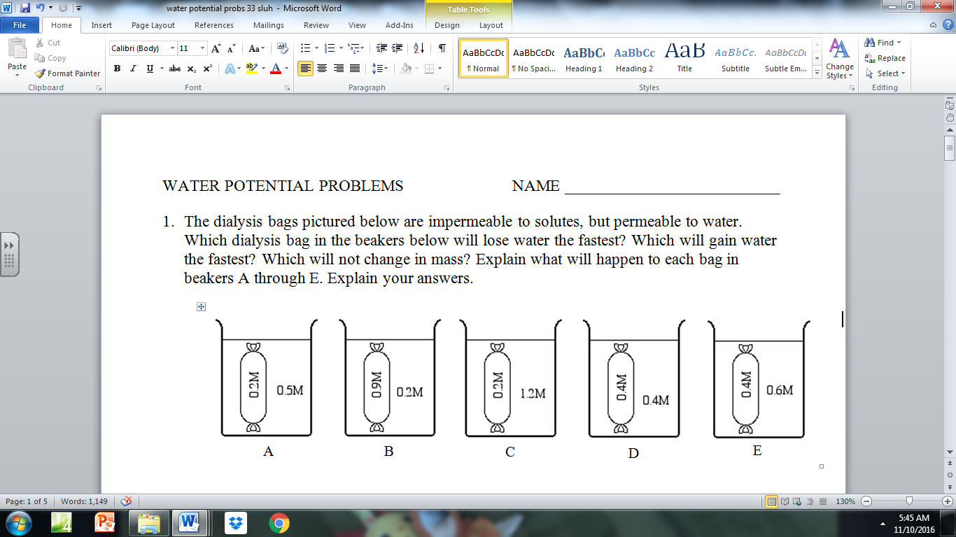

**a)** Which dialysis bag in the beakers below will lose the most water? **C**

**b)** Which will gain the most water? **B**

**c)** Which will not change in mass? **D**

**IV. SURFACE AREA AND VOULME**

**(1)** What is the SA/V for the cell to the right?

*Give your answer to the nearest hundredth.*

**314/523 = 0.60**

**(2)** Is it better for a cell to have a **HIGH** or **LOW** SA/V ratio? Explain.

**V. GENETICS / PROBABILITY**

## A. Rule of Addition

The rule of addition applies to the following situation. We have two events, and we want to know the probability that **either** event occurs.

**Example**: The chance of rolling a 1 or a 2 on a six-sided [die](http://en.wikipedia.org/wiki/Dice) is **1/3**.

The probability of rolling a 2, 5 or a 6 is **1/2**

## B. Rule of Multiplication

The rule of multiplication applies to the situation when we want to know the probability of the intersection of two events; that is, we want to know the probability that two events (Event A and Event B) **both** occur.

**Example**: If two coins are flipped the chance of both being heads is **1/4**.

The probability of rolling a snake eyes (2 twos) is **1/36.**

**(1)** What is the probability the parents shown below would create the genotypic offspring listed?

*Give your answer as a fraction.*

HhOoDdAaYy x HhooDdAayy

**a)** HhOoDdAaYy = ______

**b)** hhooDdAayy = ______

**VI. GENETICS / CHI-SQUARE**

Collected/Observed (O) data rarely conform exactly to prediction, so it is important to determine if the deviation (difference) between the expected (E) values (*based upon the hypothesis*) and the observed results is **SIGNIFICANT** enough to discredit the original hypothesis.

**Chi-Square Formula: Chi-Square Table**

|  |  |  |  |  |  |  |  |  |
| --- | --- | --- | --- | --- | --- | --- | --- | --- |
|  | **Degrees of Freedom** | | | | | | | |
| **p** | **1** | **2** | **3** | **4** | **5** | **6** | **7** | **8** |
| **0.05** | 3.84 | 5.99 | 7.82 | 9.49 | 11.07 | 12.59 | 14.07 | 15.51 |
| 0.01 | 6.64 | 9.32 | 11.34 | 13.28 | 15.09 | 16.81 | 18.48 | 20.09 |

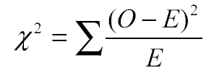

**Sample Problems:**

**(1)** In corn (*Zea mays*), purple kernels (P) are dominant to yellow kernels (p). Cobs from the offspring of a cross between a purple plant and yellow plant were used in a lab. A student counts **329** purple and **299** yellow kernels on one cob.

Calculate the chi-squared value for the null hypothesis that the purple parent was heterozygous for purple kernels*. Give your answer to the nearest tenth.*

**Expected Results:**

|  |  |
| --- | --- |
|  |  |
|  |  |

**1.4**

**(2)** In *Drosophila*, “bow-legged” is a mutation that is hypothesized to be X-linked recessive. A homozygous wild-type female was crossed with a bow-legged male. The F1 generation contained equal numbers of wild-type males and wild-type females. The F2 generation contained 30 wild-type males, 40 bow-legged males, 75 wild-type females, and 0 bow-legged females.

Calculate the chi-squared value for the null hypothesis that the “bow-legged” mutation is X-linked recessive.

*Give your answer to the nearest tenth.*

|  |  |
| --- | --- |
|  |  |
|  |  |

|  |  |
| --- | --- |
|  |  |
|  |  |

**1.6**

**VII. HARDY WEINBERG:**

*Population Genetics p2 + 2pq + q2 = 1*Hardy Weinberg Strategies:

**p =** frequency of the **dominant** allele in the population **1.** Figure out what you are given:  **q =** frequency of the **recessive** allele in the population allele **p/q** OR genotype: **p2 q2 2pq**

**(p + q = 1) 2.** Figure out what you are solving for.

**p2 =** percentage of **homozygous dominant** individuals **3.** Manipulate formulas to go from given to solving  
**q2 =** percentage of **homozygous recessive** individuals  **2pq =** percentage of **heterozygous** individuals

Hardy and Weinberg also argues that if five conditions are met, the population’s allele and genotype frequencies will remain constant from generation to generation. These conditions are as follows:

**1. The breeding population is large.** *The effect of chance on changes in allele frequencies is greatly reduced.*

**2. Mating is random.** *Individuals show no mating preference for a particular phenotype.*

**3. There is no mutation of the alleles.** *No alteration in the DNA sequences of alleles.*

**4. No differential migration occurs.** *No immigration or emigration.*

**5. There is no selection.** *All genotypes have an equal chance of surviving and reproducing.*

**Sample Problems:**

**(1)** In Mr. Collea’s AP Biology class at North Salem High School , _____ members of the class have a widow’s peak hairline (*one that comes to a point*). A widow’s peak hairline is controlled by a recessive allele (s). The dominant allele (S) for this trait produces a straight hairline. Determine the allelic frequencies (**p and q**) along with the number of individuals you would expect to have each of the possible three genotypes for this hairline trait?

|  |  |  |  |  |  |  |
| --- | --- | --- | --- | --- | --- | --- |
|  | **Phenotypes** | | | | **Allele Frequency Based**  **on the H-W Equation** | |
| **Straight Peak Hairline**  (p2 + 2pq) | | **Widow’s Peak Hairline**  (q2) | | **p** | **q** |
| **Class Population** | # | % | # | % |  |  |
|  |  |  |  |
| **North American Population** | 0.55 | | 0.45 | |  |  |

**a)** The frequency of the recessive allele **(q)** = __________. *Give your answer to the nearest tenth.*

**b)** The frequency of the dominant allele **(p)** = __________. *Give your answer to the nearest tenth.*

**c)** The frequency of homozygous dominant individuals **(p2)** = __________*. Give your answer as a percent.*

**d)** The frequency of heterozygous individuals **(2pq)** = __________. *Give your answer as a percent.*

**e)** The frequency of homozygous recessive individuals **(q2)** = __________. *Give your answer as a percent.*

**(2)** Utica Free Academy High School Class of 1986 (*of which Mr. Collea was the Vice President*) was made up of 90% right handed students. Being right handed (**R**) is the dominant trait over being left handed (**r**).

**a)** What is *p* and *q* for the population of Utica Free Academy High School students in 1986?

*Give your answer to the nearest hundredth*

**P = 0.684 q =0.316**

**b)** Find the percent of the student body in 1986 that are homozygous right handed, heterozygous right handed, and left handed. *Give your answer to the nearest whole number.*

**homozygous right handed = 47% heterozygous right = 43% left handed = 10%**

**c)** Fast forward to today at Utica Free Academy. We took a random sample of 100 students today and found that 18 of them were left handed. What are the new *p* and *q* values? How do they compare with the values from 1986?

**P = 0.576 q =0.424**

**d)** Come up with as many reasons as you can as to why this apparent change (*evolution*) could have occurred.

_________________________________________________________________________________

_________________________________________________________________________________

_________________________________________________________________________________

_________________________________________________________________________________

_________________________________________________________________________________

_________________________________________________________________________________

_________________________________________________________________________________

_________________________________________________________________________________

**IX. REACTION RATES**

**(1)** **Catalase** is an enzyme found in peroxisomes that facilitates the breakdown of hydrogen peroxide (H2O2), a toxic by-product of cellular respiration, into oxygen and water. An experiment was conducted to measure the reaction rate of catalase under ideal enzymatic conditions. Using the data collected and recorded below, properly create and label a line graph depicting the results of the experiment.

|  |  |  |  |
| --- | --- | --- | --- |
| **Time (seconds)** | **Initial H2O2 in beaker before catalase** | **Remaining H2O2 in beaker after catalase** | **Total H2O2broken down by catalase** |
| **10** | 5 mL | 4.5 mL | mL |
| **30** | 5 mL | 3.5 mL | mL |
| **60** | 5 mL | 2.0 mL | mL |
| **90** | 5 mL | 1.0 mL | mL |
| **120** | 5 mL | 0.5 mL | mL |
| **180** | 5 mL | 0.0 mL | mL |

Graph Title: __________________________________________________________________________________

|  |  |  |  |  |  |  |  |  |  |  |  |  |  |  |  |  |  |  |  |  |  |  |  |  |  |  |  |  |  |
| --- | --- | --- | --- | --- | --- | --- | --- | --- | --- | --- | --- | --- | --- | --- | --- | --- | --- | --- | --- | --- | --- | --- | --- | --- | --- | --- | --- | --- | --- |
|  |  |  |  |  |  |  |  |  |  |  |  |  |  |  |  |  |  |  |  |  |  |  |  |  |  |  |  |  |  |
|  |  |  |  |  |  |  |  |  |  |  |  |  |  |  |  |  |  |  |  |  |  |  |  |  |  |  |  |  |  |
|  |  |  |  |  |  |  |  |  |  |  |  |  |  |  |  |  |  |  |  |  |  |  |  |  |  |  |  |  |  |
|  |  |  |  |  |  |  |  |  |  |  |  |  |  |  |  |  |  |  |  |  |  |  |  |  |  |  |  |  |  |
|  |  |  |  |  |  |  |  |  |  |  |  |  |  |  |  |  |  |  |  |  |  |  |  |  |  |  |  |  |  |
|  |  |  |  |  |  |  |  |  |  |  |  |  |  |  |  |  |  |  |  |  |  |  |  |  |  |  |  |  |  |
|  |  |  |  |  |  |  |  |  |  |  |  |  |  |  |  |  |  |  |  |  |  |  |  |  |  |  |  |  |  |
|  |  |  |  |  |  |  |  |  |  |  |  |  |  |  |  |  |  |  |  |  |  |  |  |  |  |  |  |  |  |
|  |  |  |  |  |  |  |  |  |  |  |  |  |  |  |  |  |  |  |  |  |  |  |  |  |  |  |  |  |  |
|  |  |  |  |  |  |  |  |  |  |  |  |  |  |  |  |  |  |  |  |  |  |  |  |  |  |  |  |  |  |
|  |  |  |  |  |  |  |  |  |  |  |  |  |  |  |  |  |  |  |  |  |  |  |  |  |  |  |  |  |  |
|  |  |  |  |  |  |  |  |  |  |  |  |  |  |  |  |  |  |  |  |  |  |  |  |  |  |  |  |  |  |
|  |  |  |  |  |  |  |  |  |  |  |  |  |  |  |  |  |  |  |  |  |  |  |  |  |  |  |  |  |  |
|  |  |  |  |  |  |  |  |  |  |  |  |  |  |  |  |  |  |  |  |  |  |  |  |  |  |  |  |  |  |
|  |  |  |  |  |  |  |  |  |  |  |  |  |  |  |  |  |  |  |  |  |  |  |  |  |  |  |  |  |  |
|  |  |  |  |  |  |  |  |  |  |  |  |  |  |  |  |  |  |  |  |  |  |  |  |  |  |  |  |  |  |
|  |  |  |  |  |  |  |  |  |  |  |  |  |  |  |  |  |  |  |  |  |  |  |  |  |  |  |  |  |  |
|  |  |  |  |  |  |  |  |  |  |  |  |  |  |  |  |  |  |  |  |  |  |  |  |  |  |  |  |  |  |

What is the reaction rate for the catalase in this experiment between 30-90 seconds? ____________________

*(Label your reaction rate with the proper units!)*

**(2)** An experiment was conducted to measure the amount of oxygen used by crickets over time at two different temperatures. Create a double-line graph displaying these results.

|  |  |
| --- | --- |
| **Temp**  **(°C)** | **Time**  **(min)** |
| **O­2 used** |
| **22o C** | 0 | --- |
| 5 | 0.2 mL |
| 10 | 0.3 mL |
| 15 | 0.5 mL |
| 20 | 0.7 mL |
| **42o C** | 0 | --- |
| 5 | 0.8 mL |
| 10 | 1.5 mL |
| 15 | 2.2 mL |
| 20 | 3.0 mL |

Graph Title: __________________________________________________________________________________

|  |  |  |  |  |  |  |  |  |  |  |  |  |  |  |  |  |  |  |  |  |  |  |  |  |  |  |  |  |  |
| --- | --- | --- | --- | --- | --- | --- | --- | --- | --- | --- | --- | --- | --- | --- | --- | --- | --- | --- | --- | --- | --- | --- | --- | --- | --- | --- | --- | --- | --- |
|  |  |  |  |  |  |  |  |  |  |  |  |  |  |  |  |  |  |  |  |  |  |  |  |  |  |  |  |  |  |
|  |  |  |  |  |  |  |  |  |  |  |  |  |  |  |  |  |  |  |  |  |  |  |  |  |  |  |  |  |  |
|  |  |  |  |  |  |  |  |  |  |  |  |  |  |  |  |  |  |  |  |  |  |  |  |  |  |  |  |  |  |
|  |  |  |  |  |  |  |  |  |  |  |  |  |  |  |  |  |  |  |  |  |  |  |  |  |  |  |  |  |  |
|  |  |  |  |  |  |  |  |  |  |  |  |  |  |  |  |  |  |  |  |  |  |  |  |  |  |  |  |  |  |
|  |  |  |  |  |  |  |  |  |  |  |  |  |  |  |  |  |  |  |  |  |  |  |  |  |  |  |  |  |  |
|  |  |  |  |  |  |  |  |  |  |  |  |  |  |  |  |  |  |  |  |  |  |  |  |  |  |  |  |  |  |
|  |  |  |  |  |  |  |  |  |  |  |  |  |  |  |  |  |  |  |  |  |  |  |  |  |  |  |  |  |  |
|  |  |  |  |  |  |  |  |  |  |  |  |  |  |  |  |  |  |  |  |  |  |  |  |  |  |  |  |  |  |
|  |  |  |  |  |  |  |  |  |  |  |  |  |  |  |  |  |  |  |  |  |  |  |  |  |  |  |  |  |  |
|  |  |  |  |  |  |  |  |  |  |  |  |  |  |  |  |  |  |  |  |  |  |  |  |  |  |  |  |  |  |
|  |  |  |  |  |  |  |  |  |  |  |  |  |  |  |  |  |  |  |  |  |  |  |  |  |  |  |  |  |  |
|  |  |  |  |  |  |  |  |  |  |  |  |  |  |  |  |  |  |  |  |  |  |  |  |  |  |  |  |  |  |
|  |  |  |  |  |  |  |  |  |  |  |  |  |  |  |  |  |  |  |  |  |  |  |  |  |  |  |  |  |  |
|  |  |  |  |  |  |  |  |  |  |  |  |  |  |  |  |  |  |  |  |  |  |  |  |  |  |  |  |  |  |
|  |  |  |  |  |  |  |  |  |  |  |  |  |  |  |  |  |  |  |  |  |  |  |  |  |  |  |  |  |  |
|  |  |  |  |  |  |  |  |  |  |  |  |  |  |  |  |  |  |  |  |  |  |  |  |  |  |  |  |  |  |
|  |  |  |  |  |  |  |  |  |  |  |  |  |  |  |  |  |  |  |  |  |  |  |  |  |  |  |  |  |  |

What was the rate (*with proper units*) of oxygen consumption by the crickets **at 22o C**? _______________

**at 42o C**? _______________ **X. GEL ELECTROPHORESIS**

[*http://www.sumanasinc.com/webcontent/animations/content/gelelectrophoresis.html*](http://www.sumanasinc.com/webcontent/animations/content/gelelectrophoresis.html)

**DNA Gel Electrophoresis:**

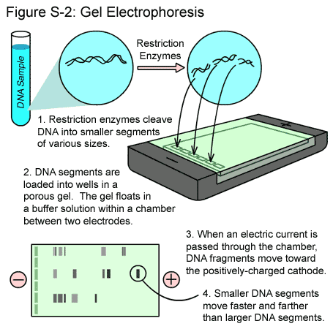

**(1)** According to the **BANDING PATTERN** to the right **DNA Fingerprint:**

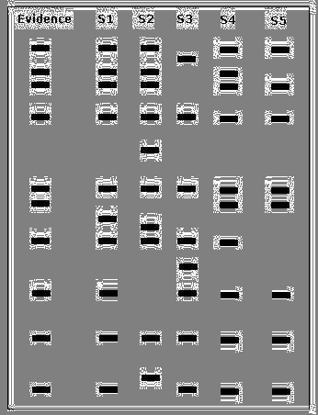 created by the process **DNA Gel Electrophoresis**, which

separates various size pieces of DNA called **restriction**

**fragment length polymorphisms** (*rflps*) that have been

created through the digesting (*cutting*) of DNA with

**restriction enzymes** according to **SIZE** and **CHARGE**

(*smaller rflps move faster and farther than larger ones*),

which suspect’s DNA was left at the crime scene? **WHY?**

________________________________________________

**________________________________________________**

**________________________________________________**

**________________________________________________**

**________________________________________________**

**________________________________________________**

**XI. GENETIC ENGINEERING / PLASMID MAPS**

[***http://sumanasinc.com/webcontent/animations/content/plasmidcloning.html***](http://sumanasinc.com/webcontent/animations/content/plasmidcloning.html)

**A.** Bacterial **plasmids** (*circular pieces of DNA found in bacteria/prokaryotes used as* ***vectors*)** range in size from 1,000 to 200,000 base pairs (*bp*), and are used extensively for genetic engineering / cloning purposes. Restriction enzymes are used to cut the plasmid DNA at specific locations creating **“sticky ends.”** These **“sticky ends”** are then joined together by the enzyme **DNA ligase** after the **gene of interest** linked to a marker gene (*usually a gene that makes the bacteria resistant to the antibiotic ampillicin for selection purposes*) are inserted into the plamid.

**(1)** The plasmid drawn below has restriction sites for the following restriction enzymes: **EcoR1**, **Sal1**, and **BamH1**. The distance in base pairs (*bp*) between restriction/cutting sites is listed between the sites.



**(a)** Which of the gel electrophoresis results below would be most similar to the one that

you would expect after cutting the cloning plasmid with the restriction enzyme **EcoR1**? **(b)**

**(b)** Which of the gel electrophoresis results below would be most similar to the one that

you would expect after cutting the cloning plasmid with the restriction enzyme **Sal1**? **(c)**

**(c)** Which of the gel electrophoresis results below would be most similar to the one that you would

 expect after cutting the cloning plasmid with all three restriction enzymes all at the same time? **(d)**

**(2)** The diagram below shows a segment of DNA with a total length of 4,900 base pairs. The arrows indicate reaction sites for two restriction enzymes (enzyme X and enzyme Y).

**X**

**X**

**Y**

300

700

900

500

**a)** Describe the results you would expect *(number of bands*) from the electrophoretic separation of fragments from the following treatments of the DNA segment above. Assume that the digestions occurred under appropriate conditions and went to completion.

**I.** DNA digested with only enzyme X **3**  bands

**II.** DNA digested with only enzyme Y **2**  bands

**III.** DNA digested with enzyme X and enzyme Y combined **4**  bands

**IV**. Undigested DNA **1** bands

**(3)** A bacterial plasmid is 100 kb in length. The plasmid DNA was digested to completion with two restriction enzymes in three separate treatments: **EcoRI**, **HaeIII**, and **EcoRI** + **HaeIII** (double digest). The fragments were then separated with electrophoresis, as shown:

**Results of Gel Electrophores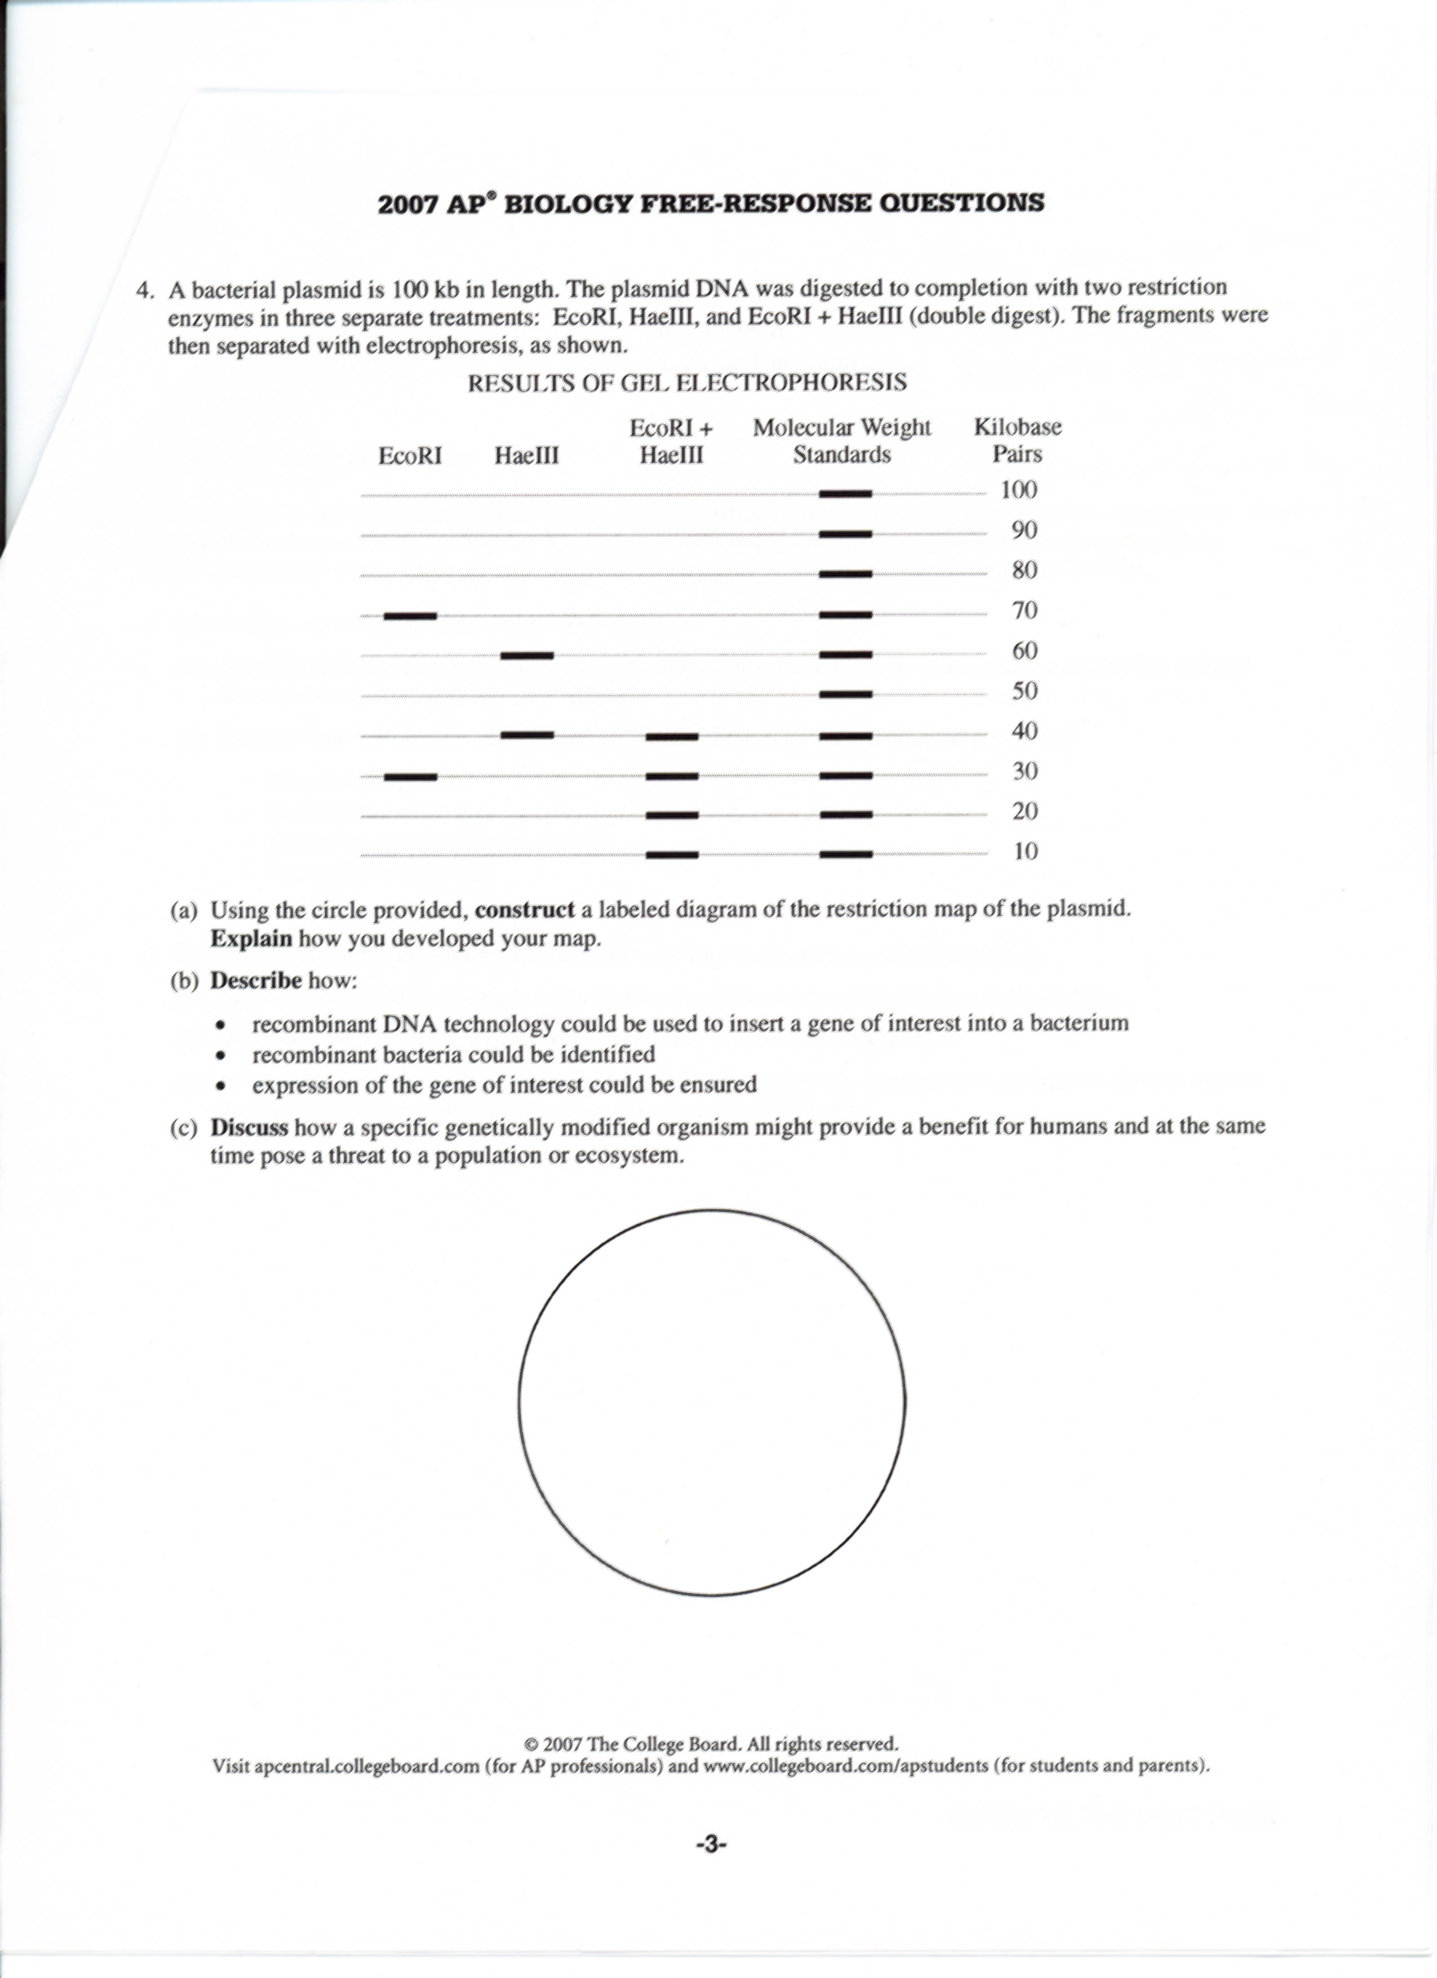 (1)** Using the circle provided, **construct** a labeled diagram of the restriction map of the plasmid.

**(2)** **Discuss** how a specific genetically modified organism might provide a benefit for humans and at the same time pose a threat to a population or ecosystem.

**XII. TEMPERATURE COEFFICIENT Q10**

The **Q10 temperature coefficient** is a measure of the *rate of change of a biological system as a consequence of increasing the* [*temperature*](http://en.wikipedia.org/wiki/Temperature) *by 10°C*. It is useful in studying cold blooded organisms because it expresses the temperature dependence of a biological process. There are many examples where the Q10 value is used, from the calculation of the [nerve conduction velocity](http://en.wikipedia.org/wiki/Nerve_conduction_velocity) to the calculation of muscle fiber contraction velocity. In fact, the Q10 value can be applied to [chemical reactions](http://en.wikipedia.org/wiki/Chemical_reaction) and physiological processes in most cold blood animal systems.

***The Q10 is calculated using the formula listed below, which is found on the AP Formula Sheet.***

**k =** is the Metabolic Rate

**t =** is the Temperature (oC or oK)

**Formula: Q10 =**

***Q10 is a unitless quantity as it is simply the factor by which a rate changes for every 10oC increase in body temperature.***

**Sample Problems:**

**(1)** Determine the Q10 value for the heart rate in *Daphnia*, the water flea.

*Round your answer to the nearest tenth.*

|  |  |
| --- | --- |
| **Temperature (Co)** | **Average Heart Rate**  (*beats per minute*) |
| 10 | 127 |
| 20 | 162 |

**1.3**

**(2)** Determine the Q10 value for the blood vessel contraction an earthworm.

*Round your answer to the nearest tenth.*

**1.4**

|  |  |
| --- | --- |
| **Temperature (Co)** | **Average Blood Vessel Contraction**  *(per minute)* |
| 16 | 16 |
| 21 | 19 |

**(3)** Determine the Q10 value for the breathing *rate of the dwarf* geckolizard.

*Round your answer to the nearest tenth.*

**1.6**

|  |  |
| --- | --- |
| **Temperature (Co)** | **Average Breathing Rate**  *(breaths per minute)* |
| 17 | 25 |
| 27 | 39 |

**XIII. PRIMARY PRODUCTIVITY CALCULATIONS**

The flow of energy through any ecosystem starts with the fixation of CO2 by plants and other autotrophic organisms. In this way the plant accumulates energy and this energy is called **gross** **primary production (GPP)**. The rate at which this energy accumulates is called **gross** **primary productivity**. However, plants must convert some of this energy (glucose 🡪ATP) during **respiration (R)** to stay alive and so is no longer available for the food web. The **difference** between what is accumulated (**GPP**) and what is available (*minus respiration*) for the food web is called

**net primary production (NPP)**.

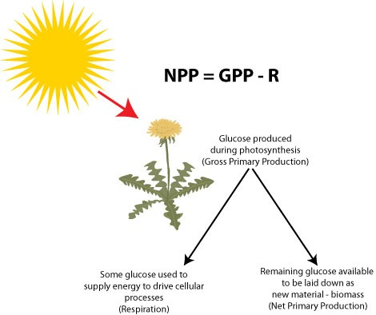To measure the **GPP** of any ecosystem one could attempt to measure the concentration of organic compounds (*glucose*) produced in a given time period.

For terrestrial ecosystems, this can be done by sequentially measuring change in the biomass over time.

Alternatively, the chemical formula for photosynthesis tells us that you can also measure O2 production or CO2 consumption.

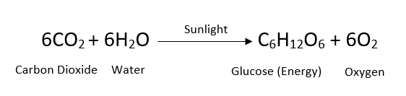

For aquatic ecosystem, it is easier to use the concentration of Dissolved Oxygen **(DO)** as a measure of the rate of photosynthesis and an ecosystem's **gross primary productivity** and then convert that value to mg carbon fixed/L using the Primary Productivity Calculation on the AP Formula Sheet.

**Sample Problems:**

**(1)** Use the data in the table below to determine the mg of carbon fixed/L in each test tube.

*Round your answer to the nearest hundredth.*

|  |  |  |  |  |
| --- | --- | --- | --- | --- |
| **Average Gross Primary Productivity of Duckweed in our Experiment** | | | | |
| **Test tube #** | **1** | **2** | **3** | **4** |
| **Dissolved Oxygen (mg O2/L)** | 0.95 | 0.325 | 0.0625 | -0.0375 |

**(a)** Test tube #1 **(c)** Test Tube #3

**0.36 0.02**

**(b)** Test Tube #2 **(d)** Test Tube #4

**0.12 - 0.01**

**(2)** The **net primary productivity** of a particular wetland ecosystem is found to be 8000 kcal/m2. If **respiration** by the aquatic producers is 12,000 kcal/m2 per year, what is the **gross primary productivity** for this ecosystem in kcal/m2 per year? *Round to the nearest whole number*.

**NPP = GPP – R**

**XIV. DILUTIONS** -Used to create a dilute solution from a concentrated stock solution

**Formula: CiVi = CfVf**

**i** = initial (starting)

**C** = concentration of solute

**f** = final (desired)

**V** = volume of solution

A simple dilution is one in which a unit volume

of a liquid material of interest (*1.0 M sucrose solution*) is combined or diluted with an

appropriate volume of a solvent (*distilled water*)

to achieve the desired concentration.

**(1)** Joe has a 2 g/L solution. He dilutes it and creates 3 L of a 1 g/L solution. How much of the original solution did he dilute? *Round to the nearest tenths*.

**C1V1 = C2V2**

**2V1 = 1(3)**

**V1 = 1.5 L**

**(2)** How much sucrose would you need to make 1.0 L of a 1.0 M (g/L) solution of sucrose (C12H22O11).

**C = 144**

**H = 22**

**O = 176**

**342g**

**(3)** You have a stock solution of 1.0 M sucrose in distilled water. You want to make 500 ml of 0.5 M sucrose solution. How much of the 1.0 M sucrose stock solution (Vi) will you need to dilute with distilled water in order to obtain 500 ml of a 0.5 M solution?

**C1V1 = C2V2**

**1V1 = 0.5(500mL)**

**V1 = 250mL**

**XV. pH** = -log[H+] - A measurement of the hydrogen ion concentration in a solution.

**The pH Scale**

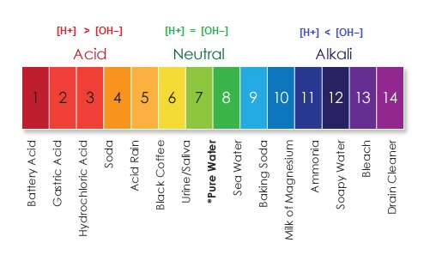

**(1)** What is the hydrogen ion concentration of a solution of pH 5?

**pH = - log [H+]**

**[H+] = 10-pH**

**[H+] = 10-pH**

**[H+] = 10-5.0**

**[H+] = 0.00001**

**(2)** What is the hydrogen ion concentration of a solution of pH 2?

**pH = - log [H+]**

**[H+] = 10-pH**

**[H+] = 10-pH**

**[H+] = 10-2.0**

**[H+] = 0.01**

**(3)** How much more acidic is a solution with a pH value of 2 compared to a solution with a pH value of 5?

**1,000**