Evolution: Possible Free-Response Questions

1. Describe the modern theory of biological evolution and discuss how it is supported by evidence from each of the following areas using specific examples from Neil Shubin’s Your Inner Fish:
(a) Fossil record
(b) Molecular biology
(c) Comparative anatomy
(d) Comparative embryology

2. On the archipelago of the Galapagos Islands, which most geologists believe to be of volcanic origin without ever having had any land connection with the west coast of South America, Darwin discovered a group of small finches. These birds have since been classified into more than a dozen species. These birds have differences, particularly in their adaptations for food-getting. It is believed that all these species are
descendants of a single species which migrated from the mainland. On the mainland there has never been more than a single species even though the rate of mutations is thought to be the same in both locations.

(a) Explain how each of the following could have played a role in the development of the many species of Galapagos finches:
- the bottleneck effect
- genetic drift
- reproductive isolation
- geographic isolation

(b) Explain why speciation has not occurred at the same rate on the mainland as it has on the islands?

3. Hardy-Weinberg

4. Phylogenic Tress

5. Discuss (IN DETAIL) three things Charles Darwin never knew.

6. Scientists recently have proposed a reorganization of the phylogenetic system of classification to include the Domain, a new taxonomic category higher (more inclusive) than the Kingdom category, as shown in the diagram below.

Universal Ancestor
Domain Bacteria Domain Archaea Domain Eukarya
(Eubacteria) (Archaebacteria) (Eukaryotes)
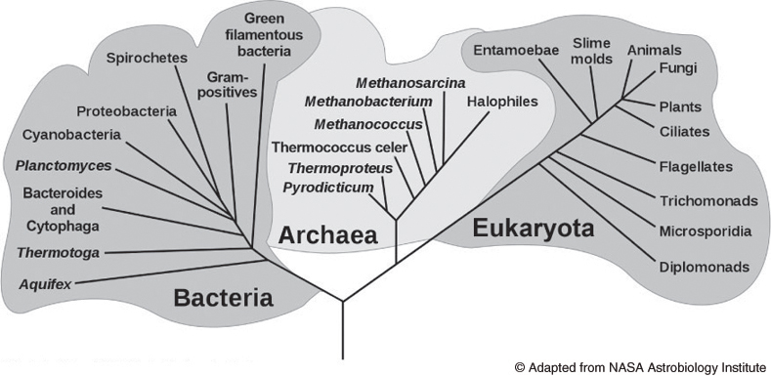
Universal Ancestor

(a) Compare and contrast the old five-kingdom classification scheme with the newer three-domain / four-kingdom scheme and describe how this classification scheme presents different conclusions about the relationships among living organisms than those presented by the older system.
(b) Describe three kinds of evidence that were used to develop the taxonomic scheme above, and
explain how this evidence was used.
(The evidence may be structural, physiological, molecular, and/or genetic.)

