Name _______________________________________ Date _________

AP Biology Mr. Collea

Part I. Thermoregulation and Heart Rate in Daphnia

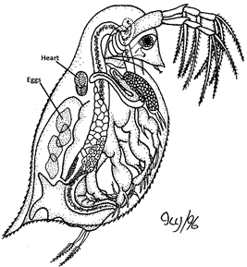
Homeostasis is the maintenance of a stable internal environment. One way organisms maintain homeostasis is by controlling their body temperature. In the Cellular Respiration lab, you experimented with peas and saw how the rate of oxygen consumption during cellular respiration varied with temperature. In that lab, you concluded (hopefully) the rate of oxygen consumption during cellular respiration increased with temperature.

In animals, an increase in cellular respiration triggers homeostatic mechanisms that increase both breathing and heart rate, resulting in more oxygen being available to cells and more carbon dioxide being removed from cells.

Thermoregulation is the maintenance of internal temperatures within a range that allows cells to function. It may involve both and adaptations. For example, humans thermoregulate by sweating or shivering (physiological) and snakes by basking on sunny rocks (behavioral).

In Part I of this lab, you will study the relationship between temperature and metabolic activity in an ectothermic animal. An ectotherm is an animal whose body temperature is much the same as its surroundings, such as a frog, a cricket, or a snake.

Because ectotherms' temperature remains close to that of their environment, they face special challenges in thermoregulation. Ectotherms exhibit a variety of behaviors that allow them to gain or lose heat. Examples include basking in the sun to warm up and burrowing in mud to cool down. Because metabolic rate increases with increasing temperature (Q₁₀), ectotherms do not become active until their body has absorbed heat. This accounts for the sluggish early morning behavior of many ectotherms such as snakes.

In this activity, you will be using a tiny crustacean called a Daphnia (related to shrimp) that has a clear outside skeleton (carapace) and jointed legs. Like other arthropods (jointed appendages), its heart is on its back and clearly visible through its carapace which makes it an ideal organism to study metabolic rate.

Because Daphnia are ectotherms (cold-blooded), their body temperature changes with the surrounding environment. Since chemical reactions are speeded up in warmer temps (increase kinetic energy causes more collisions between molecules), what would you predict/hypothesize the effect of temperature changes would be on their rate of metabolism (and heart rate) in Daphnia? State you hypothesis below in an IF…THEN format.

______________________________________________________________________________________

______________________________________________________________________________________

______________________________________________________________________________________

______________________________________________________________________________________
MATERIALS
Daphnia in culture liquid Transfer pipette cotton
A clean depression slide/coverslip Compound microscope
METHODS
1. Place a SMALL stand(s) of cotton in the center of your depression slide and using a clean pipette, carefully transfer a Daphnia and ONE drop of liquid onto a depression slide over the piece of cotton.
(Keep the drop small so that the Daphnia can’t swim out of your field of view.)
2. Place the slide under the microscope and focus on the Daphnia so that you can see the beating heart.

Keep the light for your microscope OFF as much as possible to avoid overheating your Daphnia!
3. Count the number of heart beats that occur in 10 seconds. Have your lab partner time 10 seconds for you as you count heartbeats. You want to make your measurements quickly, so that the Daphnia does not become stressed in the small volume of water.
4. Record the number of heart beats in the data table below. Multiply the number by 6 to get the number of beats per minute.
5. Take at least three separate heart rate measurements for each individual Daphnia and calculate the average of the three measurements.
6. When you have finished recording the heart rate in water at room temperature (the CONTROL), repeat the same procedure, however, this time you will place your Daphnia in the refrigerator for 1 minute to simulate a COLD environment and then in the oven for 1 minute to simulate a HOT environment.

7. Record the number of heart beats in the data table below. Multiply the number by 6 to get the number of beats per minute.
8. Take at least three separate heart rate measurements for each individual Daphnia in each environment and calculate the average of the three measurements.
 | Temperature (ºC)
 | Room (control) |  | Hot |  | Cold
Trial | 10 sec. | BPM (x6) | 10 sec. | BPM (x6) | 10 sec. | BPM (x6)
1
2
3
Average | ----- | 327 | ----- | 588 | ----- | 145

Table 1. Heart Rate of Daphnia at Various Temperatures

Part II. Q₁₀ Temperature Coefficient

The Q10 Temperature Coefficient is a measure of the rate of change of a biological or chemical system as a consequence of increasing the temperature by 10°C. It is useful in studying cold blooded organisms because it expresses the temperature dependence of a biological process. There are many examples where the Q10 value is used, from the calculation of the nerve conduction velocity to the calculation of muscle fiber contraction velocity. In fact, the Q10 value can be applied to chemical reactions and physiological processes in cold blood animal systems as well.

The Q10 is calculated using the formula listed below, which is also found on the AP Formula Sheet.
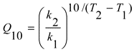
k = is the Metabolic Rate (R)
t = is the Temperature (ºC or ºK)

Formula:

Q10 is a unitless quantity as it is simply the factor by which a rate changes for every 10ºC increase in body temperature.

Bozeman Biology: Temperature Coefficient (Q10)

1. Define Q10:

2. How can you calculate a fish respiration rate?

3. Calculate his sample data. Round your answer to the nearest hundredth.
Temperature (Cº) | Respiration Rate  (operculum flaps per minute)

4. What is the range of most biological Q10 data and what does that mean?

5. Determine the Q₁₀ value for the heart rate in Daphnia, the water flea.
Round your answer to the nearest hundredth.
Temperature (Cº) | Average Heart Rate  (beats per minute)
20 | 212
30 | 353

Part III. Chemical Factors that Affect the Heart Rate of Daphnia

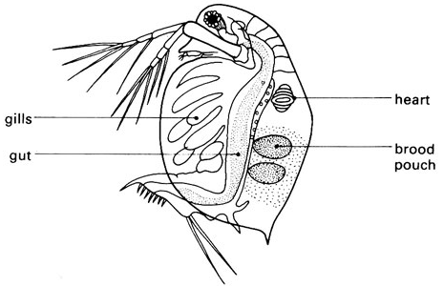
As discovered in Part I, the Daphnia (water flea) has a single, small heart that is easily visible when viewed with a compound light microscope under a low power. The heart rate (which can be up to 300 beats per minute) can be monitored and counted in different conditions – for example changing water temperature (Part I), or changing the type and concentration of chemicals added to the water as will be done in Part II of this activity. A change in Daphnia heart rate may not be a predictor of a similar change in human (or other vertebrates for that matter) heart rate under the same conditions, but the procedure provides
an interesting technique for investigating the effects
of different chemicals on a metabolic process.

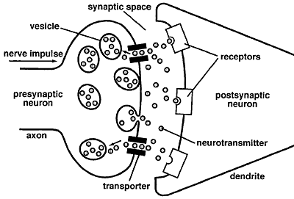
Chemicals which enter their bodies can also change their heart rate by interfering with the neurotransmitters (chemicals that nerves use to transmit nerve impulses from one neuron to another). The brain and body uses neurotransmitters to tell your heart to beat, your lungs to breathe, and your stomach to digest. They can also affect mood, sleep, concentration, weight, and can cause adverse symptoms when they are out of balance. Neurotransmitter levels can be depleted many ways. As a matter of fact, it is estimated that 86% of Americans have suboptimal neuro-transmitter levels. Stress, poor diet, neurotoxins, genetic predisposition, drugs (prescription and recreational), alcohol and caffeine usage can cause these levels to be out of optimal range.

There are two kinds of neurotransmitters – INHIBITORY and EXCITATORY. Excitatory neurotrans-mitters are not necessarily exciting – they are what stimulate the brain. Those that calm the brain and help create balance are called inhibitory. Inhibitory neurotransmitters balance mood and are easily depleted when the excitatory neurotransmitters are overactive. Some common neurotransmitters include acetylcholine, epinephrine, norepinephrine, dopamine, GABA and serotonin.

Chemicals that affect excitatory neurotransmitters are known as stimulants, whereas chemicals that affect inhibitory neurotransmitters are known as depressants. One of the most common stimulants is caffeine and one of the most common depressants in ethyl alcohol, both of which will be utilized in this activity.

METHODS

1. Repeat steps 1 – 5 from Part I except this time add ONE DROP of the 1% ethanol solution to the slide before adding the Daphnia. Turn the light OFF and wait 30 seconds.

When adding the Daphnia to the slide try to add as little water as possible.

2. Turn the light back on and count the number of heart beats for 10 seconds again, repeating at least 3. times. Multiply each count by 6 to get the heart rate per minute. Record in data in Table 2.
3. Carefully rinse the Daphnia into the “used” container, then repeat steps 1 and 2 with a new Daphnia using ONE DROP of 5% caffeine solution. Record in data in Table 2.

Table 2. Heart Rate of Daphnia Under the Influence of Various Chemicals

 | Chemicals
 | Depressant |  | Stimulants
 | Alcohol (ethanol) |  | Caffeine |  | Nicotine
Trial | 10 sec. | BPM (x6) | 10 sec. | BPM (x6) | 10 sec. | BPM (x6)
1
2
3
Average

Table 3. Heart Rate of Daphnia Under the Influence of Various Chemicals

 | Group
Trial | 1 | 2 | 3 | 4 | 5
1
2
3
Avg. | 224 | 148 | 146 | 208 | 232

Mouse Party

The simplified mechanisms of drug action presented in this activity are just a small part of the story. When drugs enter the body they elicit very complex effects in many different regions o
f the brain. Often they interact with many different types of neurotransmitters and may bind with a variety of receptors. For example, THC in marijuana can bind with cannabinoid receptors located on the presynaptic and/or postsynaptic cell in a synapse.
Where applicable, this activity primarily depicts how drugs interact with dopamine neurotransmitters because this website focuses on the brain's reward pathway. Mouse Party is designed to provide a small glimpse into the chemical
interactions at the synaptic level that cause the drug user to feel 'high'.

Diagram of a Synapse:
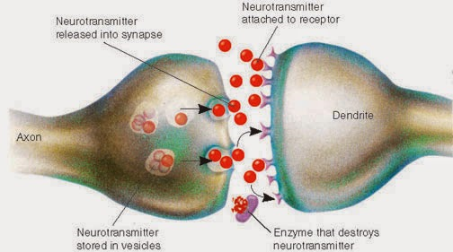

5. Fill in the chart below based upon the information presented in the Mouse Party animation
Drug | Neutransmitter(s) Involved (Inhibitory or Excitatory) | Action of Drug
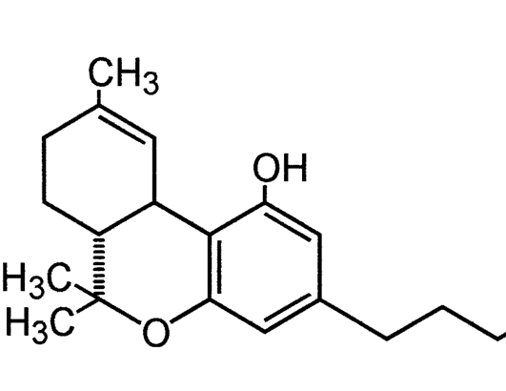
Marijuana
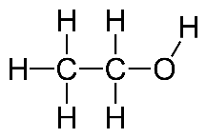
Alcohol
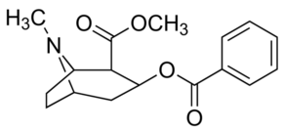
Cocaine
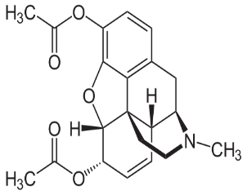
Heroin

Anatomy of Daphnia

