AP Biology  Interactive Student  Study  Guide | North Salem University  MISSION: Engage students to continuously learn, question, define and solve problems through critical and creative thinking.  Spring 2016
Homeostasis - Any self-regulating process by which biological systems tend to maintain stability while adjusting to conditions that are optimal for survival. If homeostasis is successful, life continues; if unsuccessful, disease or death ensues. The stability attained is actually a dynamic equilibrium in which continuous change occurs yet relatively uniform conditions prevail. Any system in dynamic equilibrium tends to reach a steady state, a balance that resists outside forces of change. When such a system is disturbed, built-in regulatory devices respond to the departures to establish a new balance; such a process is one of feedback control. All processes of integration and coordination of function, whether mediated by nervous and hormonal systems, are examples of homeostatic regulation. This unit will look at some of the homeostatic mechanisms achieved by the human body along with the organs and organ systems involved.  If you have any problems – please sign up for extra help after school. |  | Chapters : 40-49  Animal Form and Function.  HOMEOSTASIS

Homeostasis Guided Reading: Chapters 40 - 49

- Define Homeostasis.

- Any homeostatic control system has three functional components. Describe each of theses components below:
(a) receptor -

(b) control center -

(c) effector -

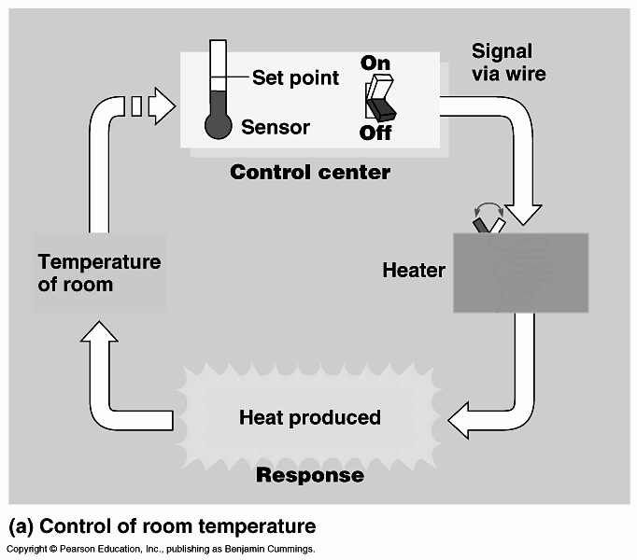
- Use the diagram to the right to help you explain the concept of negative feedback. (Figure 40.9)

- What is the difference between negative and positive feedback.

- What is an animal’s bioenergetics?

- Define metabolic rate.

- Animals have two basic bioenergetic “strategies”: endothermic and ectothermic. In the table below, describe each of these strategies being to sure include representative examples of each.

Strategy | Description | Examples
Endothermic
Ectothermic

- As mentioned in the table above, humans warm their bodies by heat generated by metabolism.
Label the diagram below which represents an overview of bioenergetics of an animal. (Figure 40.10)

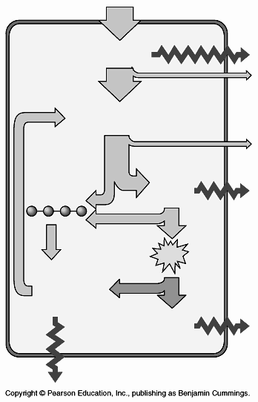

- As you can see from the previous diagram, animals must be able exchange chemicals with the environment and have specialized surfaces for exchanging certain chemicals with the surroundings. These exchange surfaces are usually internal (for multicellular organisms), but are connected to the environment via openings on the body surface. The exchange surfaces are finely branched or folded, giving them a very large surface area. Label the diagram below to see how the structure of digestive, respiratory and excretory systems allow for this vital function. (Figure 40.8)

Remember: Structure dictates function.

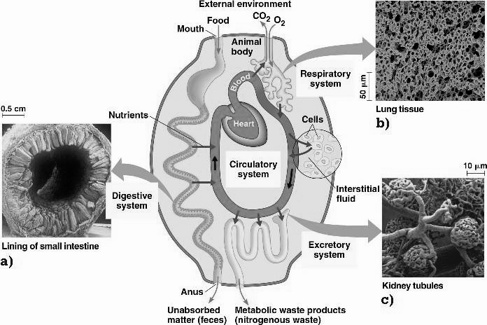

a) Label the diagram of the small intestine below and use it help you explain how its structure allows it to perform its function of absorbing nutrients from the food we eat. (Figure 41.19)

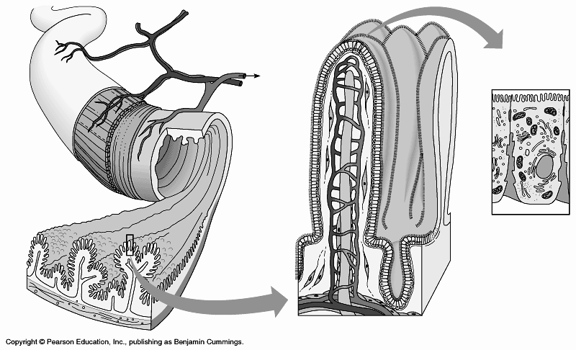

b) Label the diagram of the human respiratory surface (alveoli) below and use to help you explain how
its structure allows it to perform its function of gas exchange (oxygen diffusing INTO the blood and
carbon dioxide diffusion OUT of the blood). (Figure 42.23)

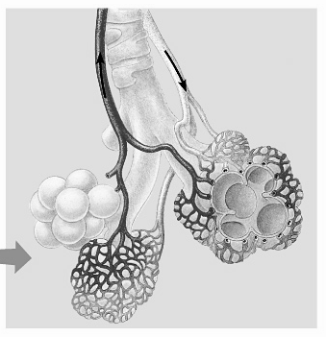
Characteristics of s Respiratory Surface:

1.

2.

3.

4.

c) Label the simplified diagram of the functional filtering unit of the kidney (nephron) below and use it to explain how its structure allows it to perform its function of filtering wastes from out of our blood. Be sure to define the four basic functions of the nephron. (Figure 44.17)
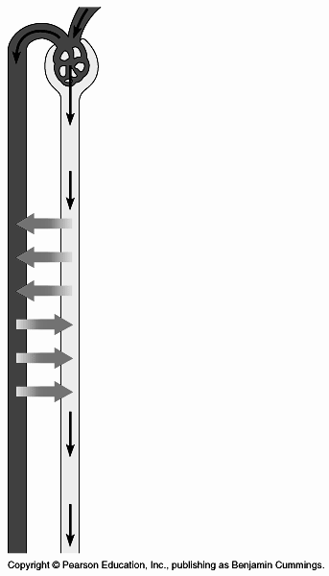

FILTRATION -

REABSORPTION -

SECRETION -
REREA

EXCRETION -

SSECRETION

The Human Excretory System
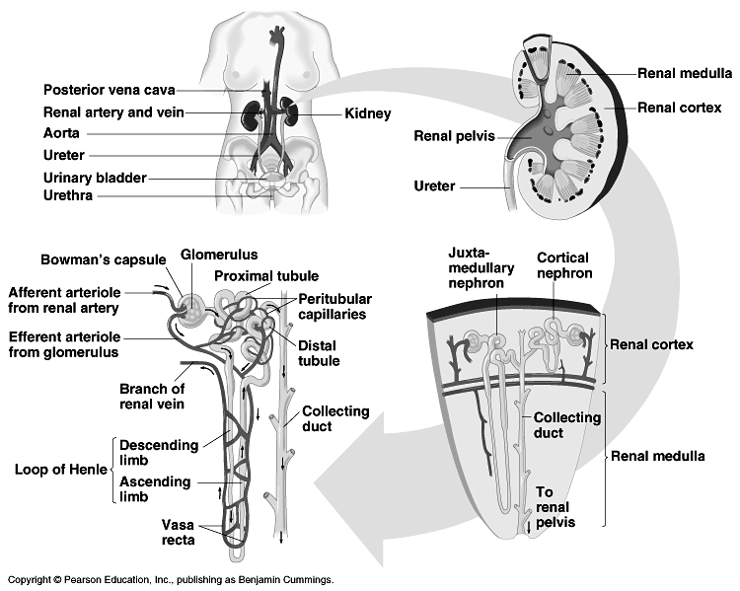

Guided Reading: Chapter 41

- Complete the diagram below concerning animal homeostasis and blood sugar regulation.
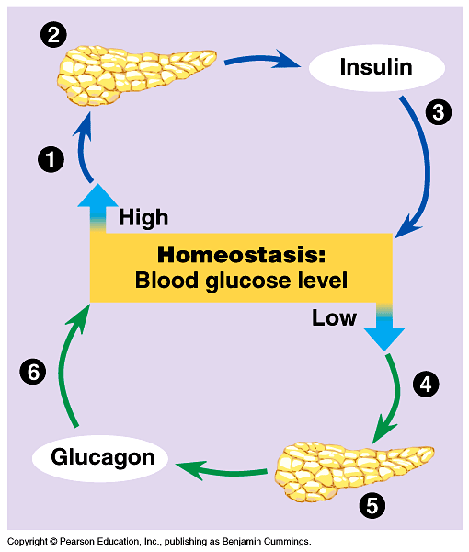
(Figure 41.1)

(1)

(2)

(3)

(4)

(5)

(6)

- Structural adaptations of digestive systems are often associated with diet.
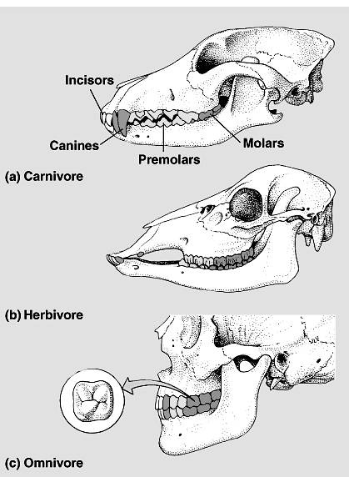
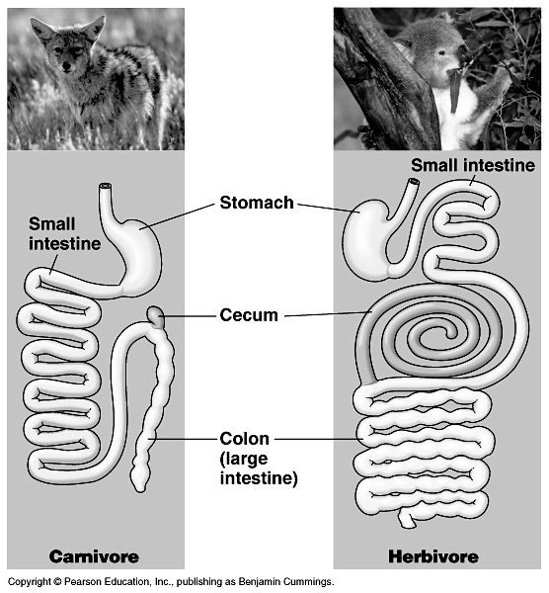
a) Use the diagram below to help you infer b) Use the diagram below to help you explain an organism’s diet based on its teeth? the general trends in the digestive tracts of herbivores and carnivores

(Figure 41.20) (Figure 41.21)
EXPLANATION: EXPLANATION:

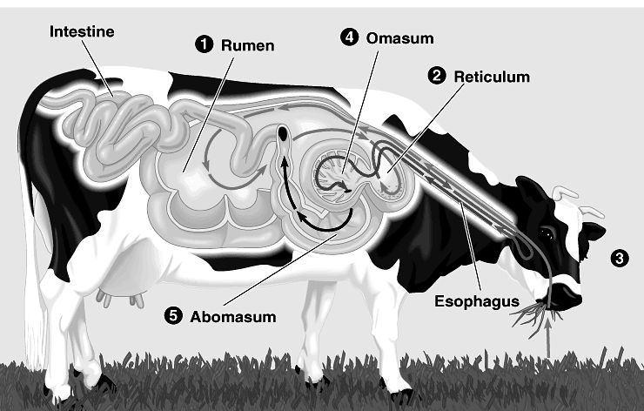
- Use the diagram to the right to help you explain how a ruminant’s (cow’s) digestive system is adapted to eating a diet rich in cellulose.

(Figure 41.22)

- Define symbiosis and describe how symbiotic interactions impact digestion?

Guided Reading: Chapter 42

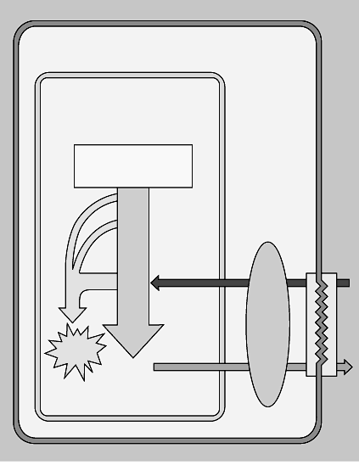
- Label the diagram to the right and use it to help you explain the role of gas exchange in bioenergetics.

(Figure 42.18)

- In the space below, create a flowchart showing the pathway a molecule of oxygen takes from the air until it is delivered by a red blood cell to the tissues.

- In the space below, create a flowchart showing the pathway a molecule of carbon dioxide takes from the cells until it is delivered by a red blood cell or plasma to the air.

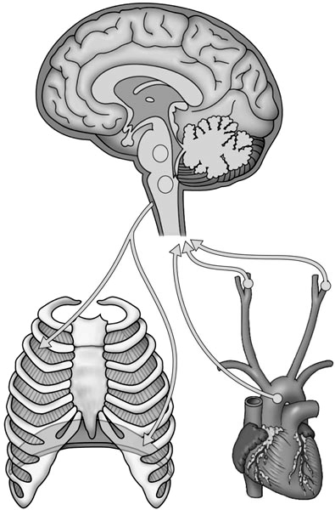
- Label the diagram below concerning the automatic control of breathing in humans.
a) List the three ways CO2 is transported in the blood.
(1)

(2)

(3)

b) What [gas] does the medulla regulate and what does it detect in order to do this?

(Figure 42.26)

- What is the adaptation of diving mammals that allow them to swim to great depths for very long periods of time?

Guided Reading: Chapter 43

- Fill in the chart below listing the various forms of nonspecific and specific defense mechanisms utilized by the body. (Figure 43.1)

Nonspecific Defense Mechanisms |  | Specific Defense Mechanisms (The Immune System)
First Line | Second Line | Third Line

- Briefly describe the functions of the four types of leukocytes (white blood cells).

(a) neutrophils –

(b) monocytes –

(c) eosinophils –

(d) basophils -

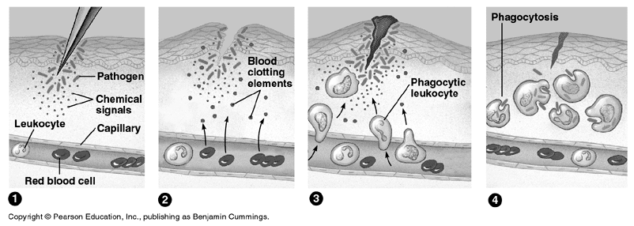
- Use the diagram below to help you explain the events that take place in a localized inflammatory response. (Figure 43.5)

- What role does histamine play in the inflammatory response?

- What role does chemokines play in the inflammatory response?

- Another symptomatic response to infection is fever. How does a moderate fever aid in the healing process?

- A variety of protein molecules function in nonspecific defense of the body. Describe the function of each of the antimicrobial proteins listed below.

(a) The Complement System –

(b) Interferon -

- Lymphocytes provide the specificity and diversity of the immune system. Briefly describe the two types of lymphocytes.

(a) B Lymphocytes (B Cells) –

(b) T Lymphocytes (T Cells) -

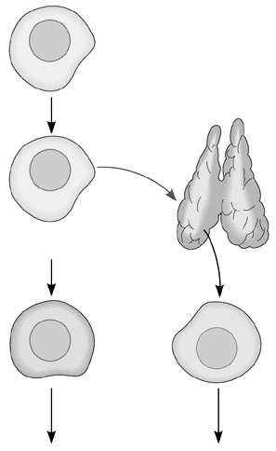
- Label the following diagram to the right relating to
the production and development of lymphocytes.
(Figure 43.8)

- What is the difference between antigens and antibodies?

- Remember, one of the many functions of the cell membrane is recognition. With that said, label the diagram below and use it to not only explain how B cells and T cells recognize specific antigens, but also to describe the process of clonal selection. (Figure 43.6)

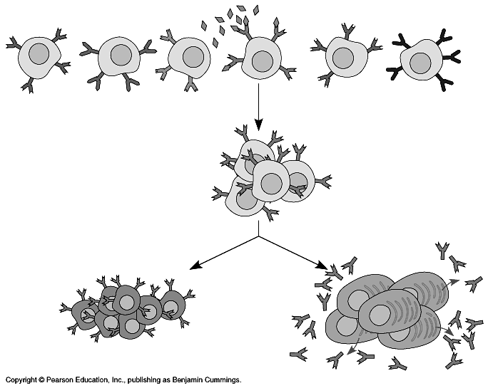

- Define the following terms related to specific immunity:

  - Humoral immune response -

  - Cell-mediated immune response -

  - Helper T cells –

  - Cytotoxic T cells -
- What is the Major Histocompatibility Complex (MHC) and what role does it plant in organ transplants?

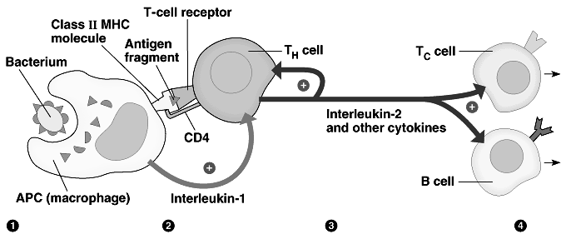
- Cell to Cell Communication is vital to the success of the immune system. Explain what is happening in the diagram below concerning the activation of Cytotoxic T (Tc) cells and B cells by Helper T cells. (Figure 43.11)

- What is the difference between active and passive immunity.

- Answer each of the following questions pertaining to AIDS.

(a) What does AIDS stand for?

(b) Name the retrovirus that causes AIDS.

(c) What are retroviruses?

(d) Specifically, what type of cells does the HIV virus effect?

Guided Reading: Chapter 44

- What is the Q10 effect?

- Use the diagram below to describe the thermostat function of the hypothalamus and the feedback mechanisms used in human thermoregulation. (Figure 44.10)

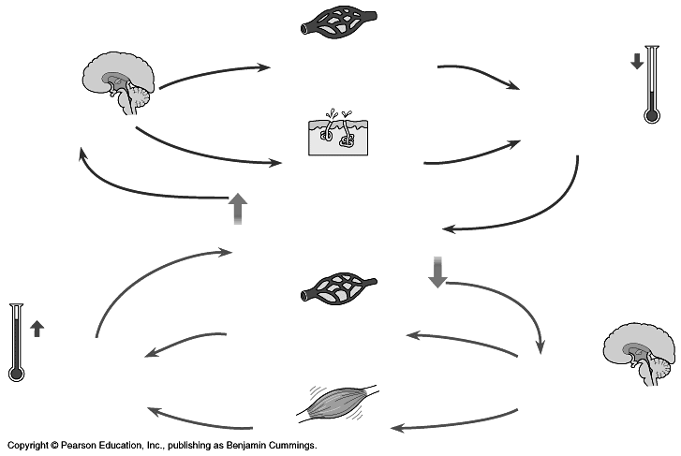

Homeostasis:
Body Temperature

- Define torpor and describe and give an example of long-tern torpor.

Guided Reading: Chapter 45

- Define the following terms:

(a) Hormones –

(b) Target Cells -

- What constitutes the endocrine system and what are its functions?

- What are endocrine glands?

- Review the basics of negative feedback by reviewing Question 3 and 4. (p.843).

- What is the basic difference between negative and positive feedback? (Activity 40F)

- Which type of feedback is more common in living systems?

- What is a signal transduction pathway?

- Label the diagrams below and use them to describe the differences between the two main mechanisms of chemical signaling of peptide (protein-based) and steroid (lipid-based) hormones.

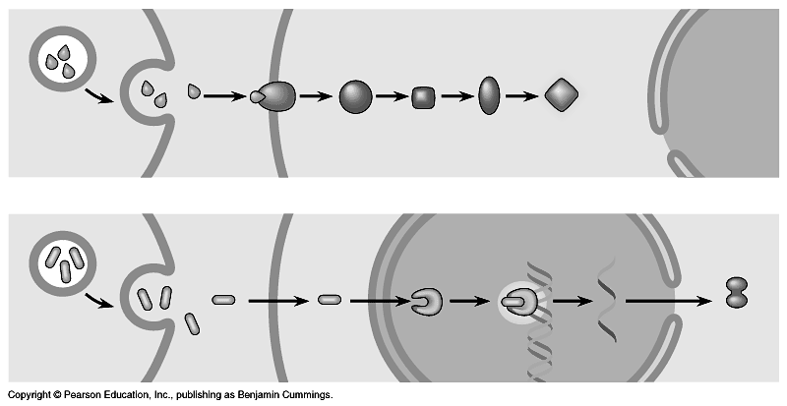
(a) Peptide Hormones: Receptor in Plasma Membrane. (Figure 45.3)

(b) Steroid Hormones: Receptor in Cell Nucleus. (Figure 45.3)

- Complete the diagram below concerning the hormonal control of calcium in the blood. (Figure 45.9)

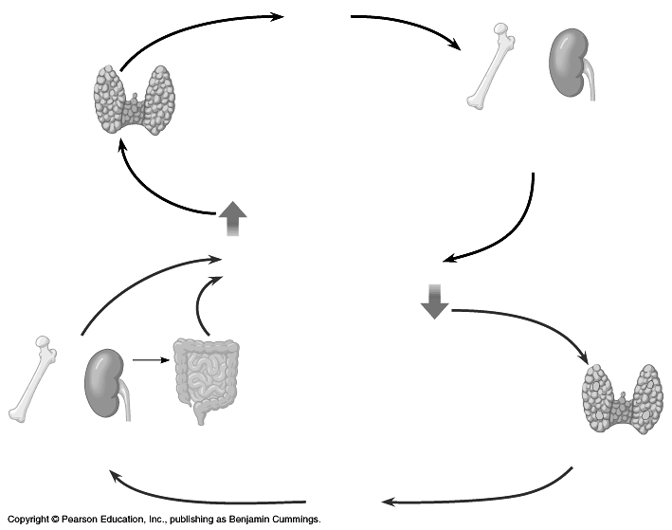
Homeostasis:
Blood Calcium Level

- REVIEW: Complete the diagram below concerning the hormonal control of glucose in the blood. (Figure 45.10)

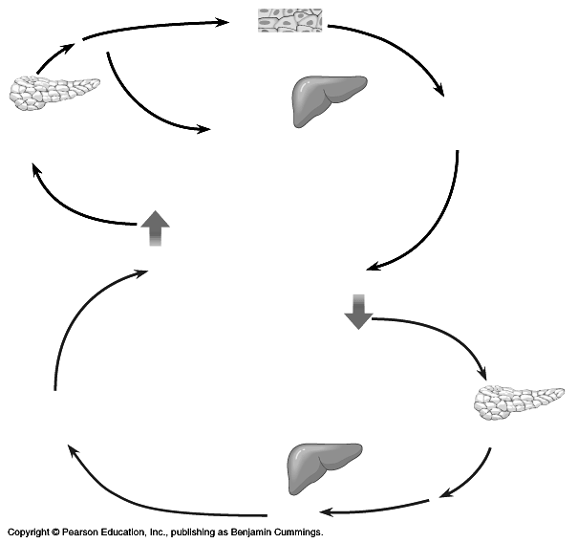

Homeostasis:
Blood Glucose Level

- What is the difference between Type I and Type II diabetes.

Guided Reading: Chapter 46

- Use the diagram below to list the four stages of the human female menstrual cycle.

(1) ________________________________ (3) ________________________________

(2) ________________________________ (4) ________________________________

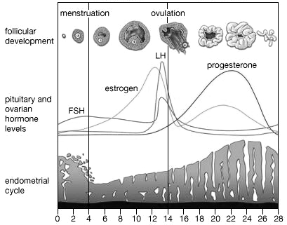
The Human Menstrual Cycle
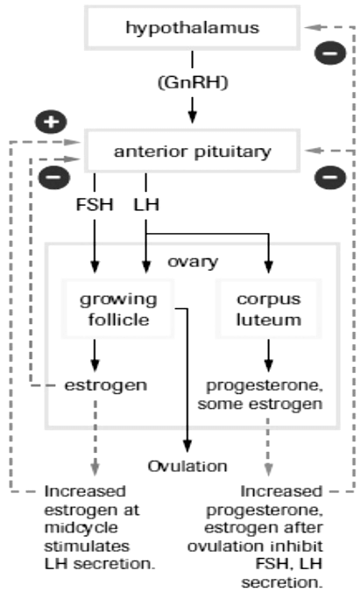
- Give one example of positive and two examples of negative feedback that is responsible for the incredible timing of events that take place that ready a women’s body for pregnancy once a month.

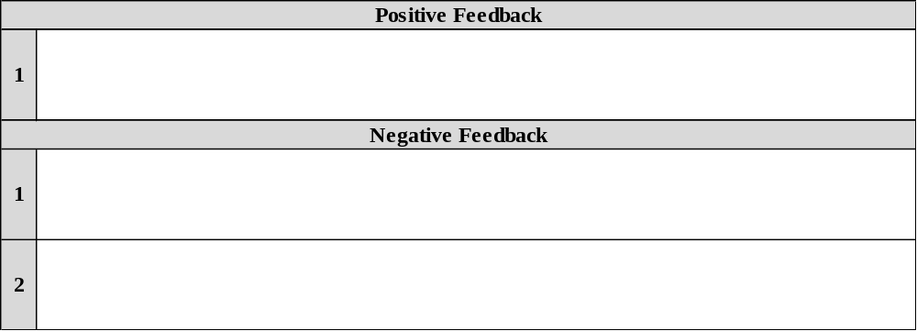
Guided Reading: Chapter 47

- The first MITOTIC cell divisions of the fertilized egg cell (zygote) results in an INCREASE in cell number and a DECREASE in cell size OR cleavage partitions the zygote into many smaller cells.
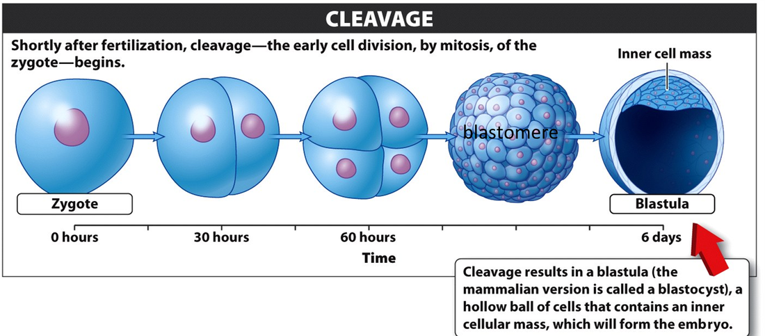
From a surface area to volume perspective, why is this necessary?

- What are embryonic stems cells and why are they center of much scientific research?

- Why is the experimentation of embryonic stem cells so controversial?

Guided Reading: Chapter 48

- Define the following terms:

(a) Sensory Receptors –

(b) Effector Cells –

- Label the diagram of the neuron below. (Figure 48.2)
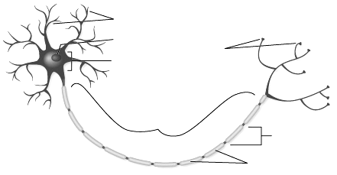

- Label the diagram below representing an overview of the human nervous system. (Figure 48.1)

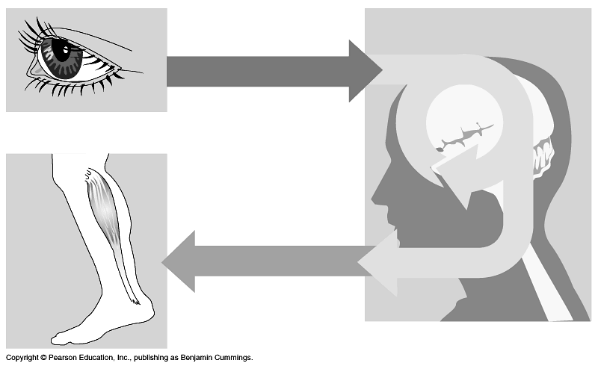

- Label the diagram below and use it to explain why myelin (remember Lorenzo’s Oil) is important in nerve conduction? (Figure 48.5)

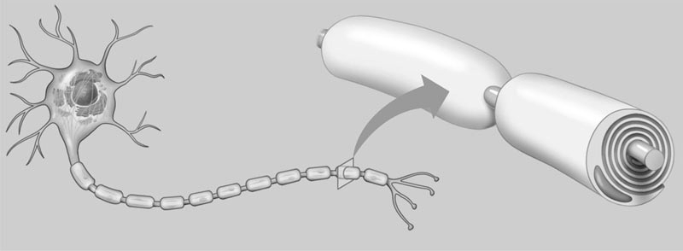

- Define the following terms related to the conduction of an electrochemical impulse along a neuron:

  - Polarized -

  - Membrane potential -

  - Resting potential -

  - Depolarization -

  - Action potential -

- How does the sodium-potassium pump maintain a membrane potential?
Hint: What gets pumped in and out?

- How does myelination and salutatory conduction affect the speed of an action potential?

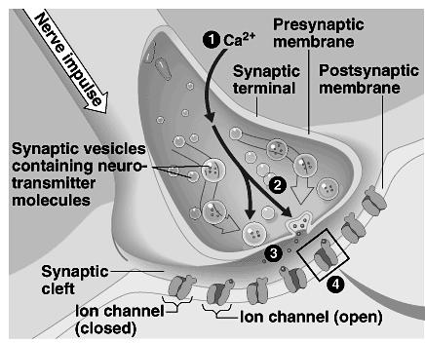
- Use the diagram below to describe the activity of a chemical synapse. (Figure 48.12

(1)

(2)

(3)

(4)

- What are neurotransmitters?

- Label the diagram below and use it to describe the activity of a neurotransmitters at chemical synapse. (Figure 48.12)

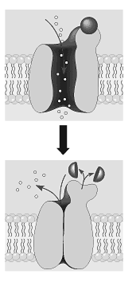

- Neurotransmitters are a special class of protein molecules that enable nerve cells to communicate with one another. One neurotransmitter can trigger a host of different responses depending on the receptors present on the postsynaptic cell. Some responses may be quick (a few milliseconds) others may take longer (due to the signal transduction pathway). In the table below, describe the major functions of each neurotransmitter.

Neurotansmitter | Function(s)
Acetylcholine
Epinepherine (Adrenaline)
Norepinepherine (Noradrenaline)
Dopamine
Serotonin

- Describe the major functions of the brain in the table located below the diagram. (Figure 48.20)

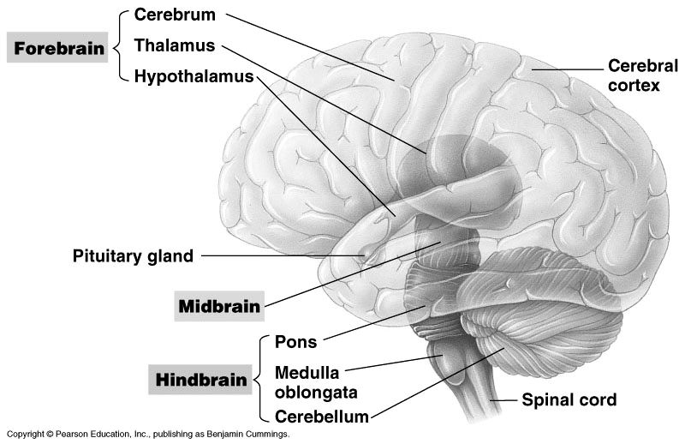

Homeostasis:
Body Temperature

Part of the Brain | Major Function(s)
Cerebrum
Thalmus
Hypothalmus
Cerebral Cortex
Cerebellum
Medulla oblongata
Pons

- Use the diagram below to help you describe the events involved in muscle contraction. (Figure 49.36)
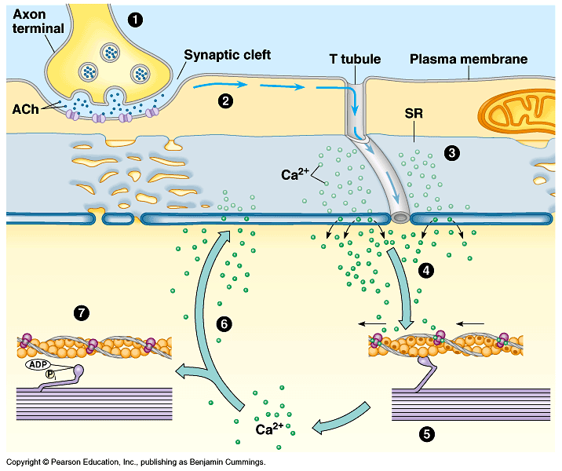

(1)

(2)

(3)

(4)

(5)

(6)

(7)

