Name ____________________________ Date __________
Regents Biology Mr. Collea / Ms. Sharpe

Making Connections

Background Information

Doing science is all about making connections. As they make observations, scientists are always looking for patterns and connections. For instance, doctors have observed that:
- pregnant women who smoke cigarettes have a higher incidence of low birth weight babies.
- pregnant women who drink alcohol have a higher incidence of having a child with learning disabilities.
- people who don’t exercise and consume a high fat/high sodium diet have a greater risk of developing and dying from heart disease.
- people who spend too much time in the sun have a higher incidence of skin cancer.

Each of these medical discoveries are a result of the patterns that can be observed and connections that can be made when studying people and their lifestyle choices.

Scientists look for patterns and connections in the natural world as well. For instance, scientists have observed that:
- every autumn in the Northeast leaves change colors. What’s the connection?
- plants grow better in the light than the dark. What’s the connection?

Discovering and explaining connections is one of the basic methods by which our knowledge of the world advances. It is what science is all about! Sometimes the connections are not what we expect or would predict, and sometimes we may have a hard time explaining them. Nevertheless, that is how science makes progress.

In this laboratory activity, you will draw on your prior knowledge of chewing gum to predict or hypothesize if there is a connection between gum chewing and the mass of gum. You will look for patterns and connections as you prepare to design and perform your own experiment to see if there is, indeed a connection between chewing and the mass of gum. The results of your experiment and the explanation for this connection will be included in the formal lab report you will write at the conclusion of this activity.

Since most scientific experiments are designed to prove a prediction or hypothesis right or wrong, let’s start by having you brainstorm as you make an educated guess or hypothesis as to what connection exists (if any) between chewing and the mass of gum.

When scientist make connections, they are really looking at what impact the independent variable has on the dependent variable of an experiment. Being able to identify these variables is a skill we will be working on throughout the year.

________________________

QUESTION: What affect does chewing have on the mass of gum?

________________________

(1) Based upon your prior knowledge of chewing food, explain what impact or effect the act of chewing has on the food in your mouth. (why?)
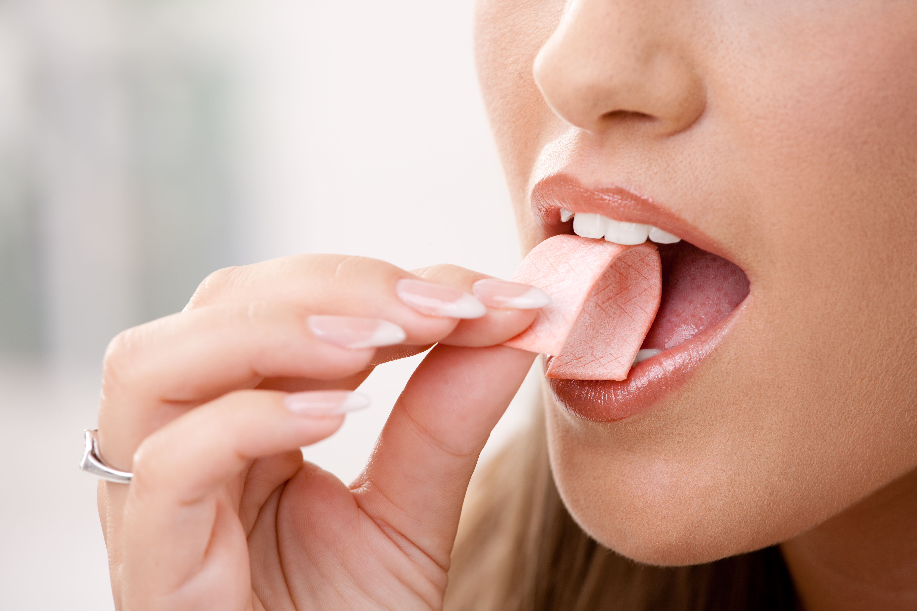
______________________________________

______________________________________

______________________________________

______________________________________

_____________________________________________

Terms/Concepts include:
These terms and concepts will be defined and explained in the Introduction section of your lab report.

_________________________________________________

_________________________________________________
_________________________________________________

(2) Use the information above to make a hypothesis as to how you predict chewing will affect the mass of gum.

________________________________________________________________________

________________________________________________________________________
Identifying Variables

Once you have made your prediction and stated your hypothesis, you will now attempt to
prove your hypothesis right (support) or wrong (refute) by designing and performing a
scientifically VALID, RELIABLE experiment.

Designing an experiment is all about creating a procedure or method to collect data to see
how the independent variable affects the depenedent variable. Measuring the dependent
variable is usually much easier than manipulating the independent variable as you will soon
find out.

Let’s go back and take a look at the aim, goal or purpose of this activity.

(3) How will you measure the dependent variable? ________________________________

________________________

QUESTION: What effect does chewing have on the mass of gum?

________________________

(4) How will you accurately measure or manipulate the independent variable? The answer
to this question will depend on whether your experiment is going to be scientifically valid or not.

List some of the variables or factors involved in the chewing process. (Refer to Question 1)

______________________________________

______________________________________

______________________________________

Keeping these variables the SAME or
CONSTANT is what a well designed
________________________ procedure or method is all about.
Let’s DO some science!
(Designing and performing a scientific experiment.)

Once you’ve identified as many controlled variables as you possibly can, you may now use them to begin to design a procedure or methodology to test your hypothesis.

EXPERIMENT

When designing and writing your procedure (methods), think of a recipe to make your
favorite food…one of mine is brownies.
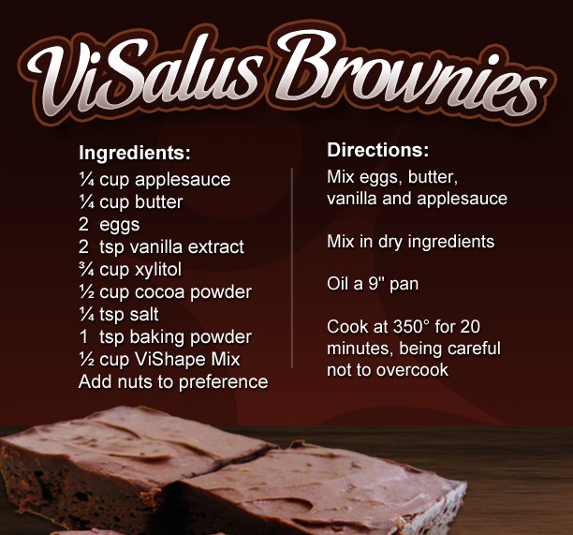

Materials Procedure
A list of the supplies needed to perform the experiment.
A description of the steps taken to perform the experiment.

A VALID, RELIABLE procedure is written in a manner so that if someone else were to use the same materials and follow your procedure, they would get VERY similar data and results.

In the space below, develop the methods you would for this gum chewing experiment:

Material:
Procedure:
Let’s collect some data!
Collecting, organizing and presenting data is what data tables and graphs are all about.
Their main purpose (especially graphs) is to make boring numbers more appealing to the eye.

It’s always a good idea to have your data tables constructed BEFORE you perform your
experiment so you have a place to write the information collected during the experiment.
Properly designed data tables should inform the teacher the main purpose of the experiment.

In most cases, the independent variable (that which I purposefully change) is in the left column, the
dependent variable (that which you measure) with the different trials is in the next columns, and the derived
or calculated column (often average) is on the far right or at the bottom.

Based upon the information above and your procedure, use a ruler and a pencil to construct a
data table you would you use for your experiment.

Title: ____________________________________________________________________

(The effects of _______________ on ______________________________.)
Independent Variable Dependent Variable

Let’s graph some data!

Title: ____________________________________________________________________

Dependent
Variable

Independent Variable
I. Title: Does chewing affect the mass of gum?

II. Abstract:

III. Introduction (Background Information):

Terms/Concepts: _____________________________________________________________________

____________________________________________________________________

Hypothesis: _________________________________________________________________________

_________________________________________________________________________

Dependent Variable: _________________________________________________________________

Independent Variable: _________________________________________________________________

Controlled Variables: _________________________________________________________________

IV. Methods / Procedure:

V. Results / Data:

Data Table: Graph:

VI. Discussion / Analysis:

VII. Conclusions:

