Name _____________________________________ Date ___________
Honors Biology Mr. Collea
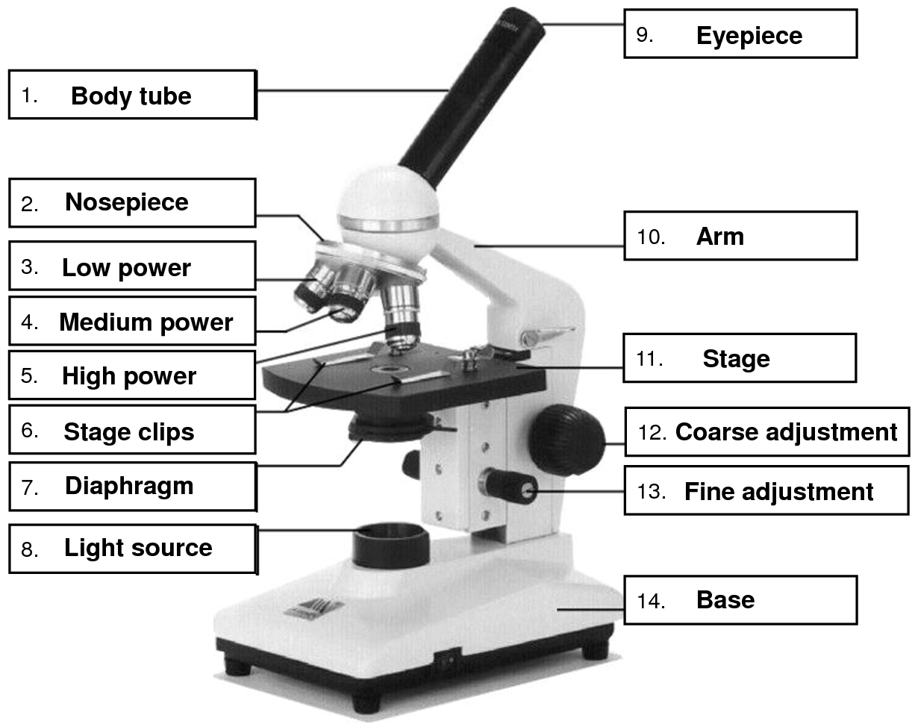
Light
Fine Adjustment
Coarse Adjustment
Stage
Arm
Eyepiece (10x)
Diaphragm
Stage Clips
High Power (40x)
Low Power (10x)
Scanning Power (4x)
Nose Piece
Body Tube
Base

