Name ___________________________________ Date ____________
Honors Biology Mr. Collea
Microscopy Lab

Background Information

"Micro" refers to tiny, "scope" refers to view or look at. Microscopes are tools used to enlarge images of small objects so as they can be studied. The compound light microscope is an instrument containing two lenses and a variety of knobs to resolve (focus) the image. Because it uses more than one lens, it is sometimes called the compound microscope in addition to being referred to as being a light microscope.

In this lab, you will:

___ label the parts of a compound light microscope.

___ demonstrate the proper procedures used in correctly carrying and storing a compound light microscope.

___ determine the total magnification of the microscope under scanning, low and high power.

___ prepare a wet mount slide with and without stain.

___ describe changes in the field of view and available light when going from low to high power.

___ describe how to increase the amount of light when switching from low to high power.

___ describe the proper procedure for focusing under scanning, low and high power.

___ explain why objects must be focused and centered in the field of view before switching from low to high

power.

___ state the advantages of using biological stains in the slide making process.

___ describe the proper procedure for adding stain to a slide that has already been made.

___ state the structural differences between plant and animal cells as seen under a microscope.

Figure 1. A Simple Compound Light Microscope
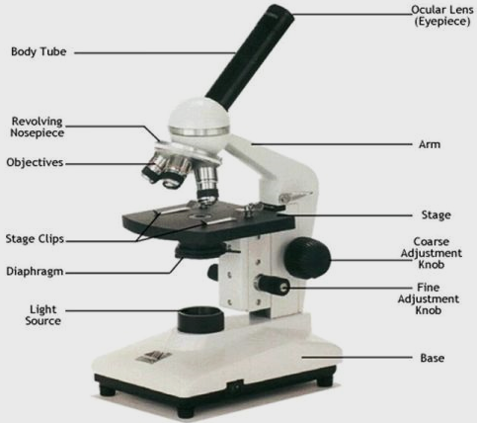

Before we begin, let’s review the parts of a simple compound microscope.
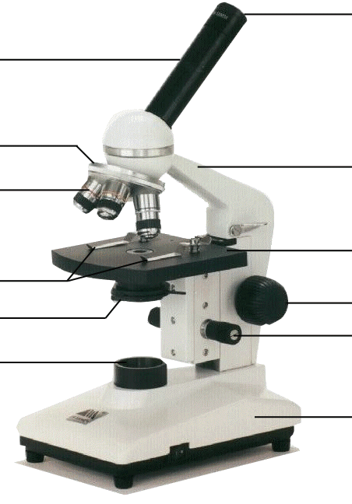

Microscope Do's and Don'ts
1. Always carry a microscope with both hands, one grasping the arm and the other under the base.
2. Never store the microscope under high power - always switch to low power before removing a slide.
3. All of our compound microscopes are parfocal, meaning that the objects remain in focus as you change
from one objective lens to another. Examine your specimen first using the scanning power (4x); then
low power objective (10x); then use the high power objective (40x). Because the objectives are parfocal,
you need to use only the fine adjustment knob to fine tune your image.
Never use the coarse adjustment under HIGH power.
4. Before switching magnification, always remember to…
FOCUS…CENTER…then SWITCH

Part I. Determining Total Magnification

To calculate the total magnification of a microscope is really quite simple. To get the total magnification take the power of the objective lense (4X, 10X, 40x) and multiply by the power of the eyepiece, usually 10X.

Table 1. Total Magnification
Objective | Color | Magnification | Eyepiece | Total Magnification
Scanning
Low
High

Part II. Make a Wet Mount Slide of the Letter “e”

* * * Always make sure the slide and coverslip are clean * * *

Figure 2. The Letter “e”

1. With your scissors cut out a SMALL, LOWERCASE

letter “e” from the newspaper.

2. Place a drop of water on the slide.

3. Place the letter “e” on the glass slide so as to look like Figure 2.

4. SLOWLY drag the coverslip until it touches the drop of water and then CAREFULLY lower the cover slip at a 45º angle to prevent the formation of air bubbles.

Figure 3. How to Make a Wet Mount Slide.
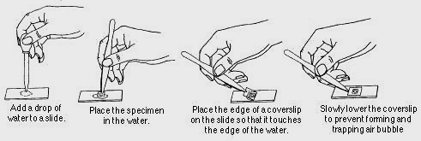

5. Turn on the microscope and place the slide on the stage;

making sure the "e" is facing the normal reading position

(see Figure 2). Use the course adjustment and focus the

letter “e” under scanning power.

Draw what you see in the space to the right.

6. Describe what you see through the eyepiece and what you see on the stage.

____________________________________________________________ 40x

7. Looking through the eyepiece, move the Looking through the eyepiece, move the

slide to the RIGHT. slide to the UP.

What direction does the image move? What direction does the image move?

_________________________________ _________________________________

Looking through the eyepiece, move the Looking through the eyepiece, move the

slide to the LEFT. slide to the DOWN.

What direction does the image move? What direction does the image move?

_________________________________ _________________________________

8. Re-center the slide and switch to low power.

Draw what you see in the space to the right.

Before switching magnification, always remember to…
FOCUS…CENTER…then SWITCH

100x

9. Re-center the slide and switch to high power.

Draw what you see in the space to the right.

Before switching magnification, always remember to…
FOCUS…CENTER…then SWITCH
NEVER use the Coarse Adjustment!
Adjust the diaphragm as needed.

400x

10. Remove and clean (and dry) the slide and cover slip.

Part III. Observing Animal and Plant Cells

Materials: clean slide(s) and coverslip(s) methylene blue (animal cell stain)
flat toothpick onion tissue
epithelial (cheek) cell iodine (plant cell stain)

Figure 4. How to Make a Wet Mount Cheek Cell Slide

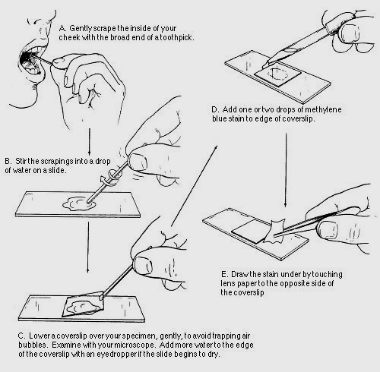
1. Place a drop of water on a CLEAN slide.
2. Use the blunt end of the toothpick to (gently) rub the back inside of your cheek. (A)
3. Stir the cheek cell scrapings into the water on the slide. (B)
4. Place a cover slip at an angle so that it touches the drop. Slowly lower the raised end of the cover slip at a 45º angle. Check for and remove any excess water. (C)
5. Observe the cells under scanning power.
FOCUS – CENTER – SWITCH to low power.
6. Draw AND label what you see.
7. FOCUS – CENTER – SWITCH to high power.
8. Draw AND label what you see.

Figure 5. The Wicking Technique
Used to add stain to an already made slide.
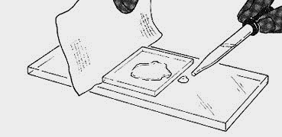
9. Add one or two drops of METHELENE BLUE to one edge of the coverslip.
10. Wick the stain under the coverslip by touching a paper towel to the opposite edge of the coverslip.

(HINT: Tilting the slide may help too.)
11. Observe the cells under scanning power.
FOCUS – CENTER – SWITCH to low power.
12. Draw AND label ONE skin cell.
13. FOCUS – CENTER – SWITCH to high power.
14. Draw AND label ONE skin cell.

15. Repeat the same procedure except this time use and Onion and Iodine to stain. See Figure 6.
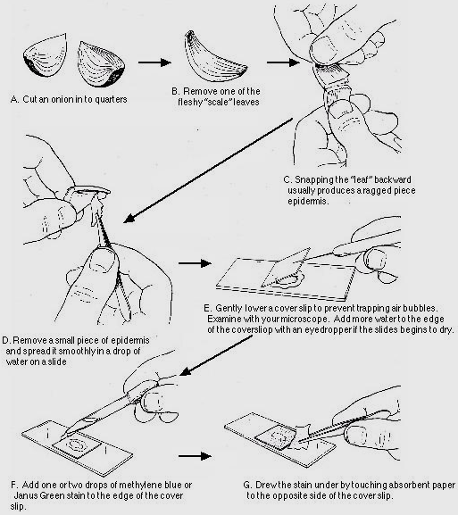
Figure 6. How to Make a Wet Mount Onion Cell Slide

Prepare a Microscope for Storage

1. Store microscopes with the scanning OR low objective in place. NEVER HIGH!
2. Rack the stage all the way down using the coarse adjustment.
3. Wrap cord neatly around the base or around the holder.
4. Carefully place the microscope back in its designated spot in the microscope cabinet.
Figure 7. Animal Cell Structure

Figure 8. Plant Cell Structure
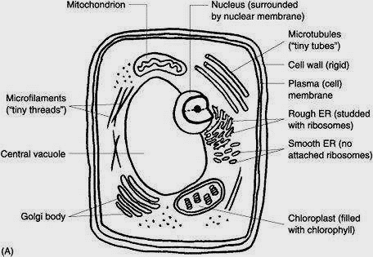

Name ___________________________________ Date ____________
Honors Biology Mr. Collea

Microscopy Lab

Summary Sheet

1. Briefly describe how to properly carry a microscope.

(a) _________________________________________________________________________________

(b) _________________________________________________________________________________

(c) _________________________________________________________________________________

2. Briefly describe how to properly prepare a microscope for storage.

(a) _________________________________________________________________________________

(b) _________________________________________________________________________________

(c) _________________________________________________________________________________

(d) _________________________________________________________________________________

3. Before switching magnification, what should you always remember to do?

_____________________________________________________________________________________

_____________________________________________________________________________________

4. Briefly explain why it is important to lower the cover slip at a 45º angle when making a slide?

_________________________________________

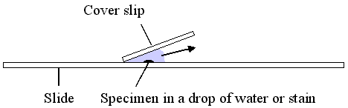
_________________________________________

_________________________________________
5. Explain why the specimen must be centered in the field of view on low power before going to high power.

_____________________________________________________________________________________

_____________________________________________________________________________________

6. A microscope has a 20X ocular (eyepiece) and two objectives of 10X and 43X respectively.

a) Calculate the low power magnification of this microscope. Show your formula and all work.

b) Calculate the high power magnification of this microscope. Show your formula and all work.

7. Describe the changes in the amount of available light when going from low to high power.

_____________________________________________________________________________________

_____________________________________________________________________________________

8. Explain what the microscope user may have to do to fix the problem incurred in question # 7.

_____________________________________________________________________________________

_____________________________________________________________________________________

9. How does the procedure for focusing the microscope differ under high power as opposed to low power?

_____________________________________________________________________________________

_____________________________________________________________________________________

10. How does the procedure for focusing the microscope differ under high power as opposed to low power?

_____________________________________________________________________________________

_____________________________________________________________________________________

Animal Cell Observations:
You should be able to see, draw, color and label the cell membrane, cytoplasm, nucleus and mitochondria.
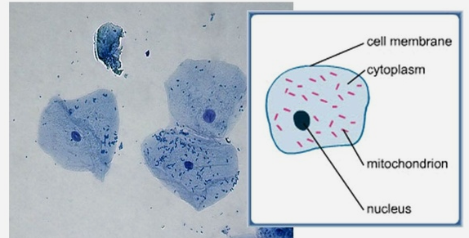

Unstained Cheek Cell Unstained Cheek Cell

100x 400x

Stained Cheek Cell Stained Cheek Cell

100x 400x

Plant Cell Observations:
You should be able to see, draw, color and label the cell wall, cytoplasm, nucleus and nucleolus.

Unstained Onion Cell Unstained Onion Cell

100x 400x

Stained Onion Cell Stained Onion Cell

100x 400x

