Name ____________________________ Date ___________
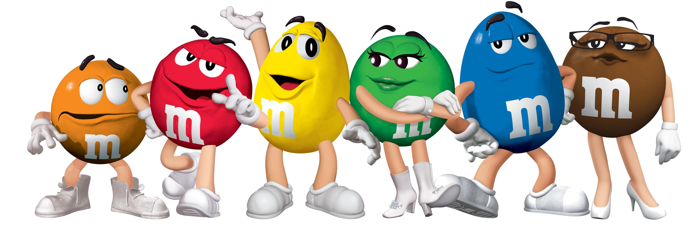
AP Biology Mr. Collea
Statistics and Probability: Colors in M&M’s

Background Information:
Consider a trait that exhibits the pattern of simple dominance. If we were to cross two heterozygous
individuals (i.e., Aa x Aa), then we would expect a 3:1 ratio of dominant to recessive phenotypes in the
offspring. But what if we actually did this cross and did not get the expected 3:1 ratio? The difference from the expected ratio could be due to random chance or some type of sampling error. But it is also possible that the difference from the expected ratio is due to the fact that our original expectation was incorrect (i.e., the trait does not actually exhibit the pattern of simple dominance).

How can we determine which of these is the most likely cause of the difference between our expectation
and our actual observation?

We can conduct a Chi-Square (χ2) analysis!

When starting a Chi-Square analysis, we must first identify the null hypothesis. A null hypothesis is a
prediction that something is not present, that a treatment will have no effect, or that there is no SIGNIFICANT difference between what is expected and what is observed. Another way of saying this is the hypothesis that an observed pattern of data and an expected pattern are effectively the same, differing only by chance, not because they are truly different.

The null hypothesis is for a Chi-Square analysis is ALWAYS the same:
There is NO significant difference between the observed and expected results
OR
Any difference between the observed and expected data is due to CHANCE.

The goal of the Chi-Square analysis is to ACCEPT or REJECT this null hypothesis.

Once we have calculated a value for the Chi-Square, we will compare it to a table of critical values. If the
calculated Chi-Square value is smaller than the critical value, we ACCEPT our null hypothesis because our data is consistent with what we would expect - any slight difference is due to chance. If the calculated Chi- Square is larger than the critical value, we REJECT our null hypothesis because our data is too different from what was expected to explain the differences by chance - there must be some other explanation so guess what…you learned something!

This investigation will let you practice using the Chi-Square test with a “population” of familiar objects,
M&M® candies. Later on, we will use this same method to analyze the results of fruit fly crosses (FRQ).

Objectives:
After completing the investigation you should be able to:
• write and test a null hypothesis that pertains to this investigation.
• determine the degrees of freedom for an investigation(s).
• calculate the χ2 value from observed data and expected data.
• determine if the Chi-Square value exceeds the critical value and if the null hypothesis is accepted or rejected.
• explain the importance of large sample sizes when conducting statistical analysis of any kind.

Problem:
Have you ever wondered why the package of M&Ms you just bought never seems to have enough of your
favorite color? Why do you always seem to get the package of mostly brown M&Ms? What’s going on at the Mars Company? Is the number of the different colors of M&Ms in a package really different from one package to the next? Or, does the Mars Company do something to insure that each package gets the correct number of each color?

Here is some information from the M&M website:

Table 1: Expected % of color in M&Ms

% Color | Milk Chocolate
Brown | 13%
Blue | 24%
Orange | 20%
Green | 16%
Red | 13%
Yellow | 14%

Degrees of Freedom = _______________

CHI-SQUARE TABLE
 | Degrees of Freedom
p | 1 | 2 | 3 | 4 | 5 | 6 | 7 | 8
0.05 | 3.84 | 5.99 | 7.82 | 9.49 | 11.07 | 12.59 | 14.07 | 15.51
0.01 | 6.64 | 9.32 | 11.34 | 13.28 | 15.09 | 16.81 | 18.48 | 20.09

One way that we could determine if the Mars Company is true to its word is to sample a package of M&Ms and do a type of statistical test known as a “goodness of fit” test. This type of statistical test allows us to determine if any differences between our observed measurements (counts of colors from our M&M sample) and our expected (what the M&M website claims) are simply due to chance or some other reason (i.e. the Mars Company’s sorters are not putting the correct number of M&M’s in each package). The goodness of fit test we will be using is called a Chi-Square (χ2) Analysis.
Table 2: Individual Data for Color Percentages: Small Bag

Color | 1 | Exp.
Brown |  | 13
Blue |  | 24
Orange |  | 20
Green |  | 16
Red |  | 13
Yellow |  | 14

Table 3: Chi-Square Analysis of Individual Data: Small Bag

Color | obs | exp | obs - exp | (obs - exp)2 | (obs - exp)² exp
Brown |  | 13
Blue |  | 24
Orange |  | 20
Green |  | 16
Red |  | 13
Yellow |  | 14
 |  |  |  | X² Total
 |  |  | Degrees of Freedom

Work Space:
(Round your answers to the nearest whole number)

Conclusion: __________________________________________________________________________

_____________________________________________________________________________________

_____________________________________________________________________________________
Color | 1 | 2 | 3 | 4 | 5 | 6 | 7 | 8 | 9 | 10 | Obs. | Exp.
Brown |  |  |  |  |  |  |  |  |  |  |  | 13
Blue |  |  |  |  |  |  |  |  |  |  |  | 24
Orange |  |  |  |  |  |  |  |  |  |  |  | 20
Green |  |  |  |  |  |  |  |  |  |  |  | 16
Red |  |  |  |  |  |  |  |  |  |  |  | 13
Yellow |  |  |  |  |  |  |  |  |  |  |  | 14
Table 4: Class Data for Color Percentages: Small Bag

Table 5: Chi-Square Analysis of Class Data: Small Bag

Color | obs | exp | obs - exp | (obs - exp)2 | (obs - exp)² exp
Brown |  | 13
Blue |  | 24
Orange |  | 20
Green |  | 16
Red |  | 13
Yellow |  | 14
 |  |  |  | X² Total
 |  |  | Degrees of Freedom

Work Space:
(Round your answers to the nearest whole number)

Conclusion: __________________________________________________________________________

_____________________________________________________________________________________

_____________________________________________________________________________________
Table 6: Individual Data for Color Percentages: Large Bag
Color | 1 | Exp.
Brown |  | 13
Blue |  | 24
Orange |  | 20
Green |  | 16
Red |  | 13
Yellow |  | 14

Table 7: Chi-Square Analysis of Individual Data: Large Bag
Color | obs | exp | obs - exp | (obs - exp)2 | (obs - exp)² exp
Brown |  | 13
Blue |  | 24
Orange |  | 20
Green |  | 16
Red |  | 13
Yellow |  | 14
 |  |  |  | X² Total
 |  |  | Degrees of Freedom

Work Space:
(Round your answers to the nearest whole number)

Conclusion: __________________________________________________________________________

_____________________________________________________________________________________

_____________________________________________________________________________________
Color | 1 | 2 | 3 | 4 | 5 | 6 | 7 | 8 | 9 | 10 | Obs. | Exp.
Brown |  |  |  |  |  |  |  |  |  |  |  | 13
Blue |  |  |  |  |  |  |  |  |  |  |  | 24
Orange |  |  |  |  |  |  |  |  |  |  |  | 20
Green |  |  |  |  |  |  |  |  |  |  |  | 16
Red |  |  |  |  |  |  |  |  |  |  |  | 13
Yellow |  |  |  |  |  |  |  |  |  |  |  | 14
Table 8: Class Data for Color Percentages: Large Bag

Table 9: Chi-Square Analysis of Class Data: Large Bag
Color | obs | exp | obs - exp | (obs - exp)2 | (obs - exp)² exp
Brown |  | 13
Blue |  | 24
Orange |  | 20
Green |  | 16
Red |  | 13
Yellow |  | 14
 |  |  |  | X² Total
 |  |  | Degrees of Freedom

Work Space:
(Round your answers to the nearest whole number)

Conclusion: __________________________________________________________________________

_____________________________________________________________________________________

_____________________________________________________________________________________

Special Note:

The probability decreases as the Chi-Square value increases. Therefore, the lower the Chi- Square value, the higher the probability that the difference between the observed results and the expected results is due to chance alone and you ACCEPT the null hypothesis. Usually, a scientist is hoping to find a low Chi-Square value (ACCEPT H_{o}) because it means there is a high probability that the deviation from the expected results is due to chance alone. This tells the scientist that the proposed explanation is likely to be correct.
If, however, the Chi-Square value is high (REJECT H_{o}), it means that there is a low probability that the deviation is due to chance alone. This tells the scientist that the explanation is probably incorrect and that the true reason for the deviation is something other than chance alone. At that point you have some explaining to do and it may be back to the drawing board!

Questions

1. We begin by stating the null hypothesis. Remember, the null hypothesis for a Chi-Square analysis is always the same. What is the null hypothesis for this activity?

Null Hypothesis: _______________________________________________________________________
_____________________________________________________________________________________
_____________________________________________________________________________________

2. What is the number of degrees of freedom? ________
(n - 1)

3. Remember that the Chi-Square value is a measure of the difference between the observed and expected numbers. We are using it to test whether the observed and expected numbers are close enough to accept the null hypothesis (that chance alone can explain the difference) or so far apart that the null hypothesis must be rejected and there must be more at play here. Based upon the results of this activity, what are your OVERALL conclusions:

Small Bag – Individual Results: Accept the null hypothesis Reject the null hypothesis

Small Bag – Class Results: Accept the null hypothesis Reject the null hypothesis

Large Bag – Individual Results: Accept the null hypothesis Reject the null hypothesis

Large Bag – Class Results: Accept the null hypothesis Reject the null hypothesis

4. What is the purpose of collecting data from the entire class instead of just looking at individual results?

_________________________________________________________________________________
_________________________________________________________________________________
_________________________________________________________________________________
_________________________________________________________________________________
_________________________________________________________________________________
_________________________________________________________________________________
_________________________________________________________________________________

