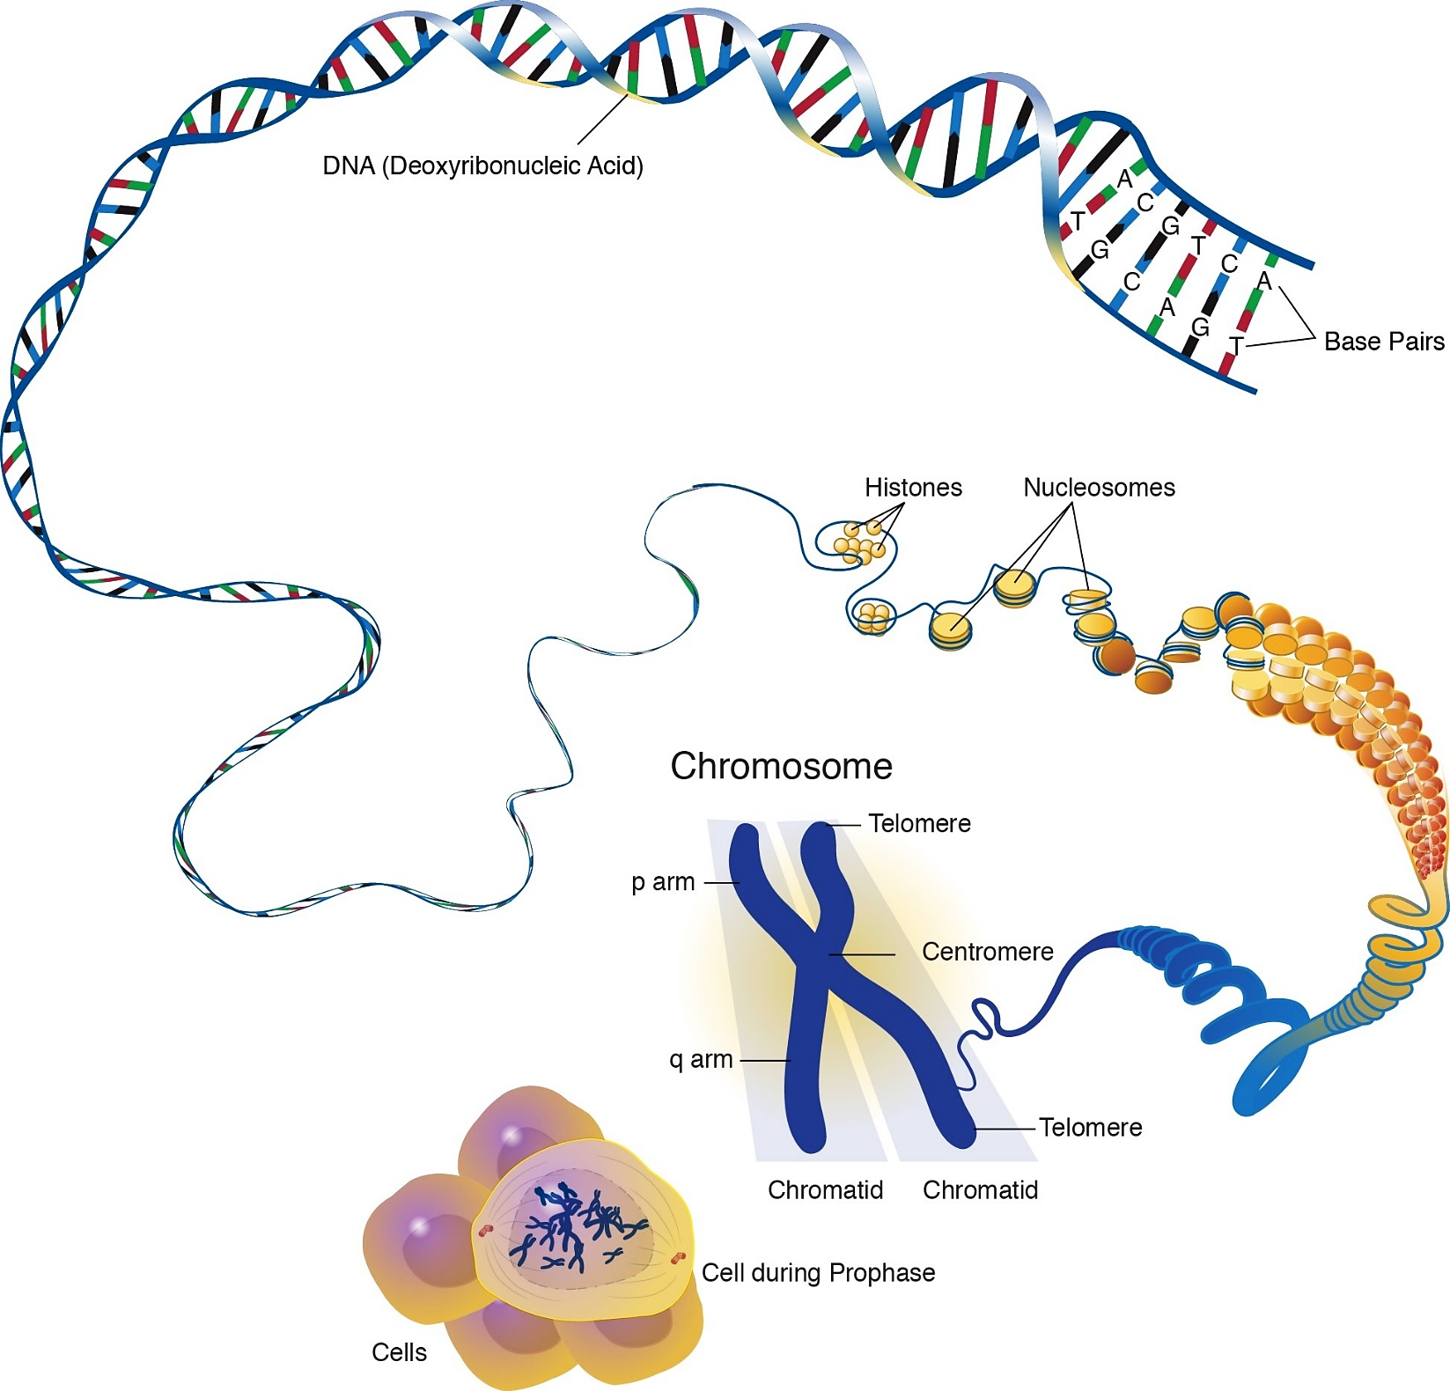
Organization of DNA in the Nucleus

