Name ___________________________ Date _______
Photosynthesis Lab AP Biology

Photosynthesis Lab
(Measuring the rate of the light-dependent reaction using the rising leaf-disc method)

Abstract:
Purpose: To measure, record, calculate and compare the rate of the light-dependent reactions of
photosynthesis (under various conditions).

Introduction: Word Bank:
autotroph/autotrophic nutrition photosynthesis light/photons
chloroplast/chlorophyll/NADP thylakoid/grana guard cells
light-dependent reaction chemiosmosis photophosphorylation
leaf / stomates spongy mesophyll palisade mesophyll

Methods:
Procedure: Think about a factor (independent variable) you would like to test in this experiment.
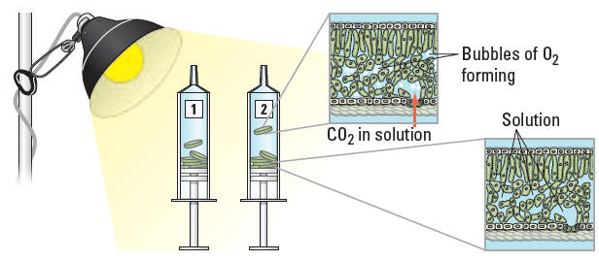

Data/Results: Create a data table(s) to organize your observations and graph(s) to present your results.

Discussion:

Post-Lab Questions: Possible questions to follow.

