Name ___________________________ Date _______
Photosynthesis Lab AP Biology

The Effects of Temperature and Wavelength (λ) on the Rate of Photosynthesis
(Measuring the rate of photosynthesis using the rising leaf-disc method)

Abstract:
Purpose: To measure, record, calculate and compare the rate of photosynthesis at various temperatures.

Introduction: Word Bank:
autotroph/autotrophic nutrition photosynthesis light/photons
chloroplast/chlorophyll/NADP thylakoid/grana guard cells
light-dependent reaction chemiosmosis photophosphorylation
leaf / stomates spongy mesophyll palisade mesophyll
enzymes temperature/avg. kinetic energy denaturation
light / color / wavelength Photosystem I and II action spectrum
absorption spectrum

Methods:
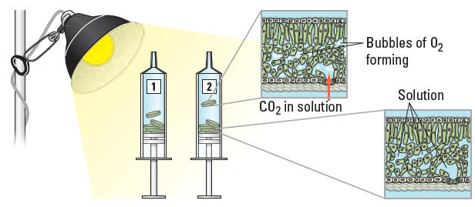

Data/Results:

Table 1. Time for Leaf Discs to Rise in Cold Temperatures ( ____ºC)

 | Time for Leaf Discs to Rise (min)
Group | #1 | #2 | #3 | #4 | #5
1
2
3
4
5
6
Avg.

Table 2. Time for Leaf Discs to Rise at Room Temperatures ( ____ºC)

 | Time for Leaf Discs to Rise (min)
Group | #1 | #2 | #3 | #4 | #5
1
2
3
4
5
6
Avg.

Table 3. Time for Leaf Discs to Rise in Warm Temperatures ( ____ºC)

 | Time for Leaf Discs to Rise (min)
Group | #1 | #2 | #3 | #4 | #5
1
2
3
4
5
6
Avg.

Table 4. Time for Leaf Discs to Rise at Various Temperatures

 | Avg. Time for Leaf Discs to Rise (min)
Temp. | #1 | #2 | #3 | #4 | #5 | Avg.
Cold (2ºC)
Room Temp (22ºC)
Warm (32ºC)

Table 5. Time for Leaf Discs to Rise under Various Colors (λ)
 | Avg. Time for Leaf Discs to Rise (min)
Color | #1 | #2 | #3 | #4 | #5 | Avg.
White
Blue
Green
Red

Possible Graph(s):
