Name ______________________________ Date ___________
Polypeptides and Water Mr. Collea

Polypeptides and Water: Protein Folding

Background Information

FIGURE 1. Condensation / dehydration synthesis reaction responsible for the formation of proteins and peptide bonds.

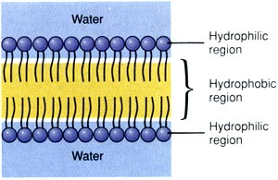
The simulation in this activity represents an amino acid (polypeptide) chain. Certain properties are used to characterize amino acids. For example, some amino acids are attracted to water (hydrophilic), while some amino acids are repelled by water (hydrophobic). This attraction and repulsion has to do with hydrogen bonds. Amino acids that are electrically charged (positive or negative), and amino acids that are polar (regions of partial charge), are hydrophilic. Amino acids that are non-polar, meaning they have a balanced electrical charge, do not form hydrogen bonds with water and disrupt existing hydrogen bonds between water molecules. As a result, non-polar molecules are driven to re-arrange themselves to minimize the amount of their surface area that comes into contact with water. Non-polar amino acids are hydrophobic. You may recall (prior knowledge) how the non-polar, hydrophobic lipid tails of the phospholipid bilayer of plasma membranes behave in the same fashion.
FIGURE 2. Phospholipid Bilayer

Four Levels of Protein Structure

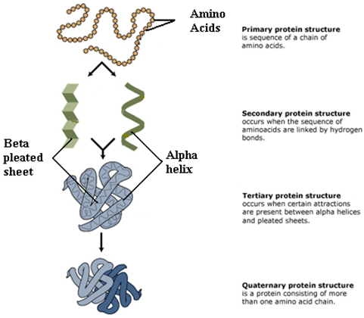

Activity 1
Follow the steps below and answer the question that follow.
- Place your mouse over one green and on yellow amino acid to determine if its hydrophobic or hydrophyllic:

Green = ____________________________ Yellow = ____________________________

- Choose “hydrophobicity” as the color scheme.
- Select “water” as the solvent type.
- Click “play”
- Observe how the polypeptide reacts.

1. How does this polypeptide behave in an aqueous (water) environment?

____________________________________________________________________________________

____________________________________________________________________________________

____________________________________________________________________________________

____________________________________________________________________________________

2. How do hydrophobic (yellow) and hydrophilic (green) amino acids behave differently?

____________________________________________________________________________________

____________________________________________________________________________________

____________________________________________________________________________________

____________________________________________________________________________________

Activity 2
Follow the steps below and answer the question that follow.
- Click “generate random protein” to reset the polypeptide
- Select “oil” as the solvent type.
- Click “play”
- Observe how the polypeptide reacts.

3. How do the amino acids arrange differently when the polypeptide is allowed to fold in oil?

____________________________________________________________________________________

____________________________________________________________________________________

____________________________________________________________________________________

____________________________________________________________________________________
Activity 3
Many molecular interactions influence how polypeptides conform (fold) into their final shape. You have observed how water and oil influence conformation. Now you will view how the polypeptide behaves if in a vacuum. This will allow you to see how intramolecular interactions between amino acids influence protein conformation. Follow the steps below and answer the question that follow.
- Click “generate random protein” to reset the polypeptide.
- Select “charge” as the amino acid color scheme.
- Choose “vacuum” as the solvent type (this will eliminate hydrophobic and hydrophilic interactions)
- Click “All hydrophilic” to include only charged and polar amino acids in your polypeptide (positively charged amino acids are blue, negatively charged amino acids are red, and polar amino acids are gray)
- Click “play” and observe how the polypeptide behaves.
- After a few moments, click “All hydrophilic” again to re-arrange the amino acids.
- Continue to observe how the amino acids react toward one another.

4. What pattern of interaction do you observe between the amino acids?
Keep in mind that adjacent amino acids are connected by strong covalent peptide bonds. Consider the interactions that occur between amino acids that do not share a peptide bond.

____________________________________________________________________________________

____________________________________________________________________________________

____________________________________________________________________________________

____________________________________________________________________________________

____________________________________________________________________________________

Intermolecular Forces in Proteins

