**Population Growth**

**Formulas:**

**Rate Population Growth Exponential Growth Logistic Growth**

dY/dt dN/dt = B – D  

**dY** = amount of change **N** = population size

**t** = time **K** = carrying capacity

**B** = birth rate **rmax** = maximum per capita growth rate of population

**D** = death rate

 =  =  = **population growth rate**

Population growth rate **dN/dt** is the *change in the population size* (**N**) over some *time* (**t**) interval.

**Population Growth Rate (dN/dt) = birth rate (B) – death rate (D)**

**Birth rate** (**B**) is the proportion of individuals born in a population (*over a period of time*).

**Example**: if there are 5 births among 10 individuals,

B = 5/10 = **0.5**

**Death rate (D)** is the proportion of individuals dying in a population (*over a period of time*).

**Example**: if 4 of 10 individuals die,

D = 4/10 = **0.4**

Thus, **dN/dt = B – D**

**dN/dt = 0.5 – 0.4**

**dN/dt =** **0.1**

Change in population can be calculated by multiplying the growth rate (**dN/dt**) by the original population size (**N**)

**Change in Population =** (**dN/dt**) **N**

In this example, change in population = (**dN/dt**) **N**  = **0.1(10)** = 1,

so the population has increased by one individual in that time period.

To determine the *size of the population at the end of the time period*,

add the population size (**N**) to the change in the population

= **N +** (**dN/dt**) **N**

= 10 + (0.1)10

= 10 + 1

= **11**

**19.** There are **252** deer in a population. There is no net immigration or emigration. If **47** deer die and **32** deer are born in one month, what is the population size at the end of the month?

*Round your answer to the nearest whole number.*

***237 deer***

**20.** In a population of **600** squirrels, the *birth rate* **(B)** in a particular period is .**06** and the *death rate* **(D)** is **0.12**.

**a)** What is the *growth rate* of the population (B – D)? *Round your answer to the nearest hundredth.*

***-0.6***

**b)** What is the actual number of squirrels that were born during this particular period?

*Round your answer to the nearest whole number.*

***36 births***

**c)** What is the actual number of squirrels that died during this period?

*Round your answer to the nearest whole number.*

***72 deaths***

**21.** In a population of **750** fish, **25** die on a particular day while **12** were born.

**a)** What is the *death rate* **(D)** for the day? *Round your answer to the nearest hundredth.*

***0.033***

**b)** What is the *birth rate* **(B)** for the day? *Round your answer to the nearest hundredth.*

***0.016***

**c)** What is the *growth rate* of the population (B – D)? *Round your answer to the nearest hundredth.*

***-0.017***

**22.** In a population of **125** foxes, **10** die on a particular day and **22** were born on that day.

**a)** What is the *death rate* **(D)** for the day? *Round your answer to the nearest hundredth.*

***0.08***

**b)** What is the *birth rate* **(B)** for the day? *Round your answer to the nearest hundredth.*

***0.18***

**c)** What is the *growth rate* of the population (B – D)? *Round your answer to the nearest hundredth.*

***0.10***

**23.** The doubling time of a population of plants is **12** years. Assuming that the initial population is **300** and that the rate of increase remains constant, how large will the population be in **36** years?

*Round your answer to the nearest whole number.*

***2400***

**24.** If **300** robins are found in a 20 hectare plot, what’s the density in robins/hectare in that plot?

*Round your answer to the nearest whole number.*

***15 robins/hectare***

**25.** If **3400** maple trees are counted on a 3km x 4km rectangular piece of land, what is the density of the maple trees per square kilometer (km)? *Round your answer to the nearest tenth.*

***283.3 maple trees/km2***

**26.** You and your friends have monitored two populations of wild lupine for one entire reproductive cycle (June – Year 1 to June – Year 2). By carefully mapping, tagging and taking a census of the plants throughout this period, you obtain the data listed in the table below.

|  |  |  |
| --- | --- | --- |
| **Parameter** | **Population A** | **Population B** |
| **Initial # of plants** | 500 | 300 |
| **# of new seedlings established** | 100 | 30 |
| **# of initial plants that die** | 20 | 100 |

**(a)** Calculate the following parameters for each population. *Round your answer to the nearest hundredth.*

|  |  |  |
| --- | --- | --- |
| **Parameter** | **Population A** | **Population B** |
| Birth Rate **(B)** | **0.2** | **0.1** |
| Death Rate **(D)** | **0.04** | **0.33** |
| Population Growth Rate **(B - D)** | **0.16** | **-0.23** |

(**b)** Given the intitial population size of population A and assuming that the population is experiencing growth at the growth rate [*calculated above*], what will the number of plants be in each of the next 3 years. (Use the intial population size as time 0.) *Round your answer to the nearest whole number.*

|  |  |  |
| --- | --- | --- |
| **Time (year)** | **Population** | **Work Space** |
| 0 | **500** | **80** |
| 1 | **580** | **93** |
| 2 | **673** | **108** |
| 3 | **781** | **125** |

**(c)** Given the intitial population size of population B and assuming that the population is experiencing growth at the growth rate [*calculated above*], what will the number of plants be in each of the next 3 years. (Use the intial population size as time 0.) *Round your answer to the nearest whole number.*

|  |  |  |
| --- | --- | --- |
| **Time (year)** | **Population** | **Work Space** |
| 0 | **300** | **-69** |
| 1 | **231** | **-53** |
| 2 | **178** | **-41** |
| 3 | **137** | **32** |

**27.** In a population of **600** squirrels, the *birth rate* **(B)** in a particular period is .**06** and the *death rate* **(D)** is **0.12**.

**a)** What is the *growth rate* of the population (B – D)? *Round your answer to the nearest hundredth.*

**b)** What is the actual number of squirrels that were born during this particular period?

*Round your answer to the nearest whole number.*

**c)** What is the actual number of squirrels that died during this period?

*Round your answer to the nearest whole number.*

**28.** In a population of **750** fish, **25** die on a particular day while **12** were born.

**a)** What is the *death rate* **(D)** for the day? *Round your answer to the nearest hundredth.*

**b)** What is the *birth rate* **(B)** for the day? *Round your answer to the nearest hundredth.*

**c)** What is the *growth rate* of the population (B – D)? *Round your answer to the nearest hundredth.*

**29.** In a population of **125** foxes, **10** die on a particular day and **22** were born on that day.

**a)** What is the *death rate* **(D)** for the day? *Round your answer to the nearest hundredth.*

**b)** What is the *birth rate* **(B)** for the day? *Round your answer to the nearest hundredth.*

**c)** What is the *growth rate* of the population (B – D)? *Round your answer to the nearest hundredth.*

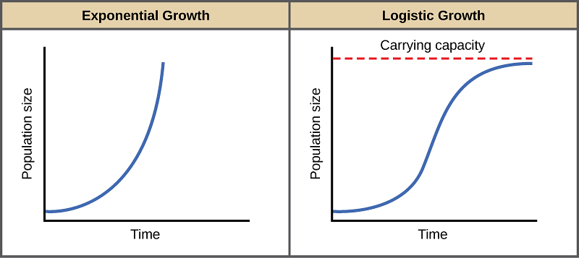**Exponential growth** is continuous population growth in an environment where resources are unlimited; it is **density-independent growth**.

Most density-independent factors are **abiotic**, or nonliving, and include:

_________________________ _________________________

_________________________ _________________________



**Formula**:

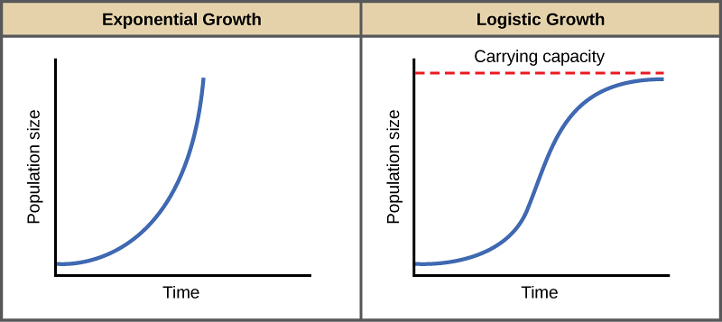

**Logistic growth** is continuous population growth in an environment

where resources are limited; it is **density-dependent growth.**

Most density-dependent factors(*a limiting factor that depends on*

*population size*) are mainly **biotic**, or living, and include:

_________________________ _________________________

_________________________ _________________________

 **Formula**:

**Exponential vs Logistic Growth**

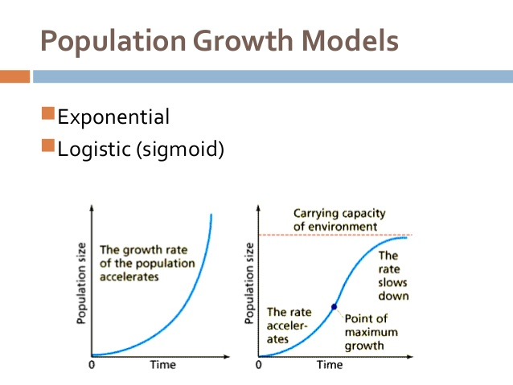

**30.** A certain population **A** is experiencing **exponential growth**.

Population size = **50**

Births = **10**

Death = **4**

**a)** Calculate the individual growth rate (rmax). This is also known as *the maximum per capita growth rate of a population rate*.

**rmax = 0.12**

**b)** Calculate the population growth rate.

**(0.12)(50) = 6**

**31.** A certain population **B** is experiencing **logistic growth**.

Population size = **50**

Use the same growth rate as in the previous question.

rmax = **0.12**

Carrying capacity (**K**) = **400**

**a)** Calculate the population growth rate.

**5.25**

**b)** Given that the individual growth rates (rmax) of the populations above were equal, explain why

the population growth rates were different between population A and B.

**32.** The following population, C, has **no limits** on food resources or space.

Population size = **500**

Births = **240**

Deaths = **170**

**a)** Calculate the growth rate (rmax).

**rmax = 0.14**

**b)** How many individuals will be in the population at the start of the second generation?

**(0.14)(500) = 70 + 500 = 570**

**c)** How many individuals will be in the population at the start of the third generation?

**(0.14)(570) = 80 + 570 = 650**

**33.** Now consider population D, in which food resources are **limited**.

Population size = **500**

Use the same growth rate as in the previous question.

rmax = **0.14**

Carrying Capacity **(K)** = 1,000

**a)** How many individuals will be in the population at the start of the second generation?

**535**

**b)** How many individuals will be in the population at the start of the third generation?

**570**

**34.** There are **300** falcons living in a certain forest at the beginning of 2013.

The population is under carrying capacity. If the maximum per capita

growth rate **(rmax) = 0.1** falcons/year, predict the population size of the

falcon population each year for the next four years.

*Round your answer to the nearest whole number.*

|  |  |  |  |
| --- | --- | --- | --- |
| **2014** | **2015** | **2016** | **2017** |
| **300 x 0.1 = 30**  **300 + 30 = 330** | **330 x 0.1 = 33**  **330 + 33 = 363** | **363 x 0.1 = 36**  **363 + 36 = 399** | **399 x 0.1 = 40**  **399 + 40 = 439** |

 **(a)** Using the information from above, fill in the table below and construct the graph.

|  |  |
| --- | --- |
| **Year** | **Population Size** |
| **2013** | **300** |
| **2014** | **330** |
| **2015** | **363** |
| **2016** | **399** |
| **2017** | **439** |

**(b)** Find the **average rate of change** *(slope)* for the falcon population from 2013 to 2018.

*Round your answer to the nearest tenth.*

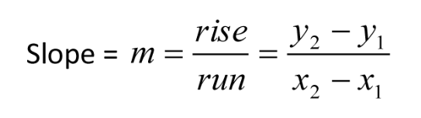 **36.6**

**35.** Utica, NY had a population of **49,000** in the year 2013. The infrastructure of the city allows for a carrying capacity of **60,000** people. rmax = **0.9** for Utica.

**(a)** Is the current population above or below the carrying capacity? _________________________

**(b)** Will the population increase or decrease in the next year? _________________________

**(c)** What will be the population growthfor 2013? **8070.3**

*Round your answer to the nearest whole number.*



**Formula:**

**(d)** What will the population size be at the start of 2014?

**49,000 + 8070 = 57,070**

|  |  |  |
| --- | --- | --- |
| **Year** | **Population size** | **Population growth** |
| **2013** | **49,000** | **8070** |
| **2014** | **57,070** | **2508** |
| **2015** | **59,578** | **377** |
| **2016** | **59,955** | **40** |
| **2017** | **59,995** | **4** |

 **(e)** Fill in the data table and construct a graph.

**(f)** What happened to the population size over the years? _________________________

**(g)** What happened to the population growth over the years? _________________________

**(h)** Explain your answer from f and g using what you know about carrying capacity.

__________________________________________________________________________________

__________________________________________________________________________________

__________________________________________________________________________________

**36.** Fill in the following chart to calculate the population growth rates for a population of rats in an urban area. The starting population is **450** individuals and the rmax is equal to **0.15**. The population has reached its carrying capacity of **1000** rats and is experiencing logistic growth.

|  |  |  |  |  |  |
| --- | --- | --- | --- | --- | --- |
| **Generation** | **N** | **rmax** | **rmax N** | **(K-N)/K** | **final dN/dt** |
| **1** | **450** | **0.15** | **67.5** | **0.55** | **37.13** |
| **2** | **487** | **0.15** | **73.1** | **0.51** | **37.28** |
| **3** | **524** | **0.15** | **78.6** | **0.48** | **37.73** |
| **4** | **562** | **0.15** | **84.3** | **0.44** | **37.09** |
| **5** | **599** | **0.15** | **89.9** | **0.40** | **36.00** |

**(a)** In which of the generations (1-5) does the birth rate exceed the death rate? ___________

**(b)** Does this population reach zero growth rate at any point in generations 1-5? (Y, N) ________

**(c)** Explain why the growth rate begins to decrease after generation 3.

_______________________________________________________________________________________

_______________________________________________________________________________________

_______________________________________________________________________________________

_______________________________________________________________________________________

_______________________________________________________________________________________

****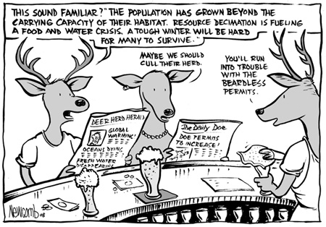**37.** Base your answers to the following questions on the graph and cartoon below.

**(a)** What type of growth curve is exhibited by the deer? _____________________________

**(b)** What type of organism (*r or K selected*) is displayed in the graph above? _________________________

**(c)** After reaching carrying capacity, in which year was the deer population the lowest? __________

**(d)** Give two possible reasons for this population decrease after it had reached its carrying capacity.

___________________________________________________________________________________

**(e)** In approximately which year did the deer population exceed its carrying capacity? ________

**(f)** Give two possible reasons why the population exceeded its carrying capacity.

__________________________________________________________________________________

**38.** Use the graph to the right to calculate the **lag time** (*in* *months*) between the change

in the densities of prey and

the predator populations

_______________________