Possible Behavior Free Response Questions

1. Seeds that are randomly positioned when planted in a pot of soil placed on a window sill produce seedlings with downward growing roots and upward growing shoots (stems). Above ground, the shoots are oriented toward light.
Describe the biochemical and physiological mechanisms that occur to produce the responses listed below and explain how each response is beneficial to the plant.
a. the downward growth of the roots
b. the upward growth of the shoots
c. the bending of the shoots toward the light

2. Define photoperiodism. Describe three examples of photoperiodism in plants and explain how each example gives the
plant an evolutionary advantage.

3. Individual organisms make short-term adjustments to temporary environmental changes in temperature, moisture and light. For each environmental factor, describe the biochemical and/or physiological mechanisms by which animals and plants adjust to changes in that factor.

4. The activities of organisms change at regular time intervals. These changes are called biological rhythms. The graph below
depicts the activity cycle over a 48-hour period for a fictional group of mammals called pointy-eared bombats found on an
isolated island in the temperate zone.
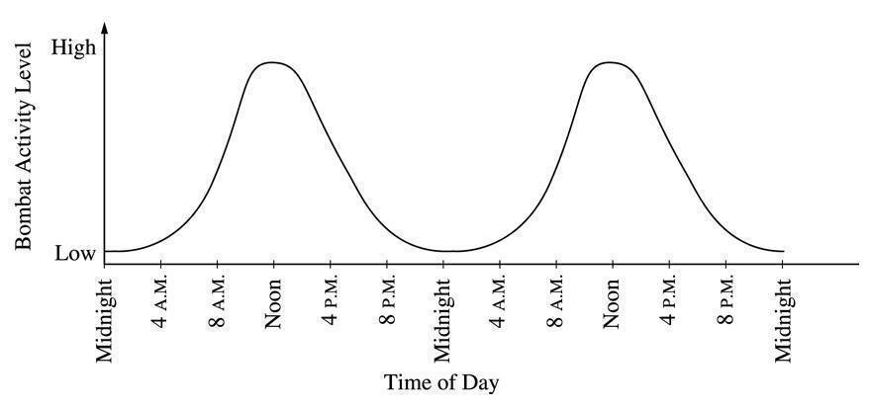

(a) Describe the cycle of activity for the bombast in terms of circadian rhythms.

(b) Propose a hypothesis regarding the effect of light on the cycle of activity in bombats. Describe a controlled experiment that could be performed to test this hypothesis along with a data table containing the results from your

experiment that support your hypothesis.

(c) Discuss how each of the following factors might affect the behavior of the bombats to result in this pattern of activity.
* temperature
* food availability
* presence of predators
* social behavior

