­­­Name ______________________________ Date __________

AP Biology Mr. Collea

***Part I. Water Molecule Building Activity***

*(Prior Knowledge)*

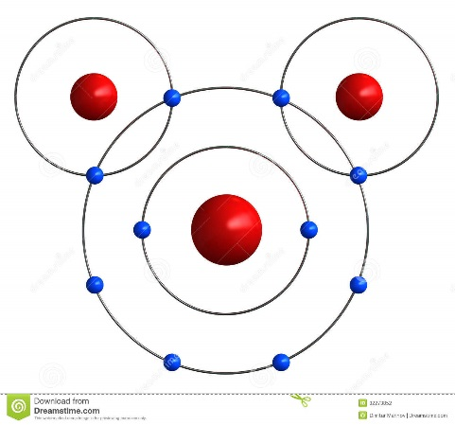*IMAGINE TRYING TO live in a world dominated by* ***dihydrogen oxide,*** *a compound that has no taste or smell and is so variable in its properties that it is generally benign but at other times swiftly lethal. Depending on its state, it can scald you or freeze you. In the presence of certain organic molecules it can form carbonic acids so nasty that they can strip the leaves from trees and eat the faces off statuary. In bulk, when agitated, it can strike with a fury that no human edifice could withstand. Even for those who have learned to live with it, it is an often murderous substance.* ***We call it water****.*

**Figure 1.** Molecular Structure of Water

**Background Information**

Water is a compound essential to all living things. The average human body is 70% water by volume. Without water, cells would have difficulty maintaining their shape and chemical messengers and vital nutrients could not travel around the body. Water is the medium in which the business of life is conducted. Water is formed when one oxygen atom forms a single covalent bond with two separate hydrogen atoms. This arrangement gives oxygen the two electrons it needs to fill its outer shell and allows both hydrogen atoms to receive the single electrons they need for their outer shells. The oxygen and hydrogen atoms share electrons but they don’t exactly share evenly. **(Figure 1)** Oxygen has eight protons in its nucleus and each hydrogen atom has only one. Because oxygen’s nucleus has so many more protons, the pull it has on the orbiting electrons is much greater that the pull exerted by the much smaller hydrogen nuclei. As a result the electrons spend a greater amount of their time on the oxygen side of the water molecule. This creates a region of slightly negative charge on the oxygen side of water and a region of slightly positive charge on the hydrogen side of water. A molecule with an uneven distribution of charge is known as a **polar molecule**. The polar nature of water allows it to demonstrate some unique properties that will be investigated in the next part of this activity.

**Procedure:**

Using the Water Molecule Model Building Cut-Outs page:

**1.** Color the oxygen atoms of each water molecule red.

**2.** Indicate the relative charge of each side of the water molecules by placing pluses and minuses on the

correct sides.

**3.** Cut out 5 of the water molecules.

**4.** Model a water droplet by gluing the water molecules in an arrangement similar to **Figure 2** in the space provided on the next page.

**5.** Indicate the hydrogen bonds between each water molecule by drawing three black circles as seen in

**Figure 2**.

**6.** Cut out the sodium (NA+) and chlorine (Cl-) ions and the remaining water molecules as they will be used as you investigate the properties of water.

***Model of a Water Droplet***

***Part II. Properties of Water***

**Activity Overview:**

There is no doubt that water is vital to living organisms. Besides being the most plentiful chemical compound on the Earth’s surface, water makes up roughly 50-95% of the composition of living cells, depending on their function and nutrient content. As a chemical compound, water possesses some unique physical and chemical properties that make it an ideal compound for life. In this part of the lab, you will explore a few of water’s properties by performing some simple activities that illustrate water’s importance to life.

**Objectives:**

**(1)** Describe the structure and geometry of a water molecule, and explain what properties emerge as a result of this structure.

**(2)**  Explain the relationship between the polar nature of water and its ability to form hydrogen bonds.

**(3)**  List four characteristics of water that are emergent properties resulting from hydrogen bonding.

**(4)**  Describe the biological significance of the cohesiveness of water.

**(5)** Describe how water contributes to the fitness of the environment to support life.

**Materials:**

Water Ethanol Glass microscope slide Piece of wax paper

Salt Sponge Plastic Shot Glasses Fan

Pipets Sugar Balloon Lipid/Oil

Penny Dish soap 400 mL beaker Chromatography Paper

**SAFETY**

**Alcohol is flammable and toxic. Keep away from sources of heat. Do not ingest!**

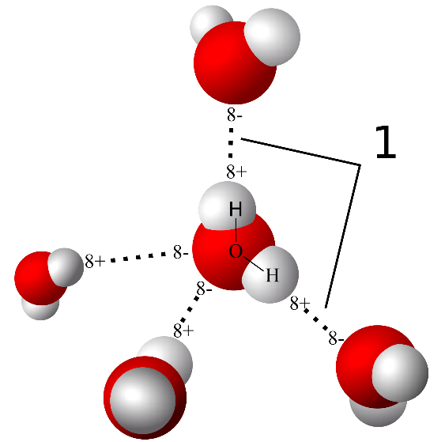**Part 1. WATER IS POLAR**

Water has both a positive and a negative charge on its molecular structure. This is due to the unpaired electrons of the oxygen atom hanging out in its outer valence shell. There is a slightly positive charge on the ends where the hydrogen atoms are. This unequal sharing of electrons causes the water molecule to be **polar**. This enables it to dissolve many things, mainly ionic compounds such a salts. Water dissolves sodium chloride (*table salt*) by causing the sodium (Na+) and Chlorine (Cl-) ions to pull away or disassociate from one another. The water molecules form a **hydration sphere** around each ion. The negative side of the water molecule will orientate toward the positive sodium ions and the positive side of the water molecule will orientate toward the negative chlorine ions. If the water evaporates, the sodium and chlorine ions will come together again to form salt crystals. **Figure 2:** Hydrogen Bonding

**Activity 1A: Hydration Spheres Model**

**1.** Cut out the sodium (NA+) and chlorine (Cl-) ions and the remaining water molecules.

**2.** Create hydration spheres around the ions by pasting the Na+, Cl-, and water molecules in an arrangement as described above.

***Hydration Spheres Model***

However, contrary to popular belief, water is not a universal solvent, as it is unable to dissolve **nonpolar** molecules such as lipids and some proteins thus making them very difficult to enter cells. The polarity water is also critical to the formation of cell membranes, which are composed of phospholipids and proteins and will be discussed in Chapter 8.

**Activity 1B: “Universal” Solvent**

**1.** Fill a plastic shot glass 2/3 full of water.

Fill a second with the same amount of ethanol.

**2.** Using a balance, mass out 0.5 grams of salt and

place this into the glass of water and swirl it around. Record your results in the data table to the right.

**3.** Repeat step 2, except place the salt into the shot glass containing ethanol.

**4.** Repeat this experiment with 0.5 grams of sugar.

Record your results in the data table to the right.

**5.** Clean up your work area and shot glasses.

**Table 1. Dissolving Results**



In what liquid(s) do the salt and sugar dissolve and why?

_____________________________________________________________________________________

_____________________________________________________________________________________

_____________________________________________________________________________________

_____________________________________________________________________________________

_____________________________________________________________________________________

**Activity 1C: Adhesion, Cohesion and Surface Tension**

*Adhesion* is the ability of water to stick to others substances. For example, water can stick to the side of a swimming pool. *Cohesion* is the ability of water molecules to stick to themselves (H-bonds). Cohesion causes the surface of the water to have tension and tests can be done to measure the relative tension of different aqueous solutions. In this portion of the lab, you will examine these three properties and later apply them to the concept of capillary action.

**1.** Obtain three pennies, 3 pipettes, a beaker of distilled water, salt water and soapy water.

**2.** Use your pipette to drop tap water onto a penny, one drop at a time. Count how many drops you can add before any water spills over the edge. Record the number of drops in the data table below. Repeat this 4 more times and find the average number of drops of distilled water a penny will hold. Be sure to completely dry your penny between each trial. Repeat with your solution of salt water and then with soapy water.

**Table 2. Drop Results**

|  |  |  |  |
| --- | --- | --- | --- |
|  | **Number of Drops on a Penny** | | |
| **Trial** | **Distilled Water** | **Salt Water** | **Soapy Water** |
| **1** |  |  |  |
| **2** |  |  |  |
| **3** |  |  |  |
| **4** |  |  |  |
| **5** |  |  |  |
| **Avg.** |  |  |  |

Is there a difference in the total number of drops that can fit on a penny for each liquid? __________

Is this difference **SIGNIFICANT**? ________________________________________________________

Which liquid had more cohesion? How do you know?

*Give an explanation for your results in terms of hydrogen bonds.*

**_____________________________________________________________________________________**

**_____________________________________________________________________________________**

**_____________________________________________________________________________________**

**_________________________________________________________________________**

**_________________________________________________________________________**

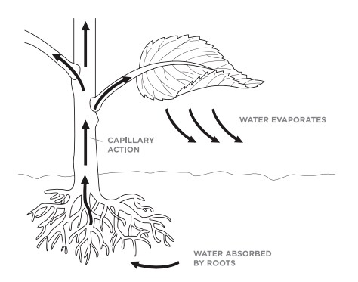**Activity 1D: Capillary Action, Adhesion and Cohesion**

Water has the ability to stick onto things (adhesion) and stick to itself (cohesion). These two properties together allow water to defy gravity and climb up tubes of small diameter. This is called capillary action and is responsible for the transpirational pull observed in plants.

**1.** Obtain a stalk of celery that has been soaking in water. Holding the celery stalk under water, use a razor blade to make a new horizontal cut on the far end of the celery (*away from the leaves*). Watch what happens.

Use the diagram above to help you explain how these properties could be applicable to living things.

**_____________________________________________________________________________________**

**_____________________________________________________________________________________**

**_____________________________________________________________________________________**

**_________________________________________________________________________**

**_________________________________________________________________________**

**Activity 1E: Heat of Vaporization**

For such a small molecule, water has a very high specific heat. This means it takes a lot of energy to raise the temperature of water. Another important property is the range of temperature for which water remains a liquid. The Heat of Vaporization is the quantity of heat that must be absorbed if a certain quantity of liquid is vaporized at a constant temperature. The heat of vaporization of water is **2260 J/g**. This means that to change water from a liquid into a gas, the water itself must absorb **2260 J** of energy. As a comparison, the alcohol we have been using in this lab has a heat of vaporization of **124 J/g**. This property of water is important because many organisms use evaporative cooling; or the evaporation of water, in order to cool themselves off when they are hot. This is why sweating is a great way to cool down on a hot day.

|  |  |  |
| --- | --- | --- |
| **Trial** | **Water** | **Alcohol** |
| **1** |  |  |
| **2** |  |  |
| **3** |  |  |
| **Avg.** |  |  |

**1.** Get an alcohol swab and rub it on the inside of your **Table 3. Evaporation Time** (*seconds*)

forearm.

**2.** Place your moistened arm in front of a fan, and

time how long it takes for the alcohol to completely

evaporate so that your arm is dry. Repeat 3 times

and record your data in the table at right.

**3.** Repeat this activity with a wet sponge. Record

your data in the data chart at right. Repeat each of

these 3 times and record your data in the table to

the right.

Is there a difference in the evaporation time of water and alcohol? __________

Is this difference **SIGNIFICANT**? ________________________________________________________

Using the data you collected above, which liquid evaporates faster and why?

_____________________________________________________________________________________

_____________________________________________________________________________________

_____________________________________________________________________________________

_____________________________________________________________________________________

_____________________________________________________________________________________

_____________________________________________________________________________________

***Water Molecule Building Activity***

(Cut- Outs)