Name ___________________________________ Date ____________
AP Biology Mr. Collea

Organism Respiration

Objectives: Identify and explain the effect of germination or non-germination on cell respiration.
Identify and explain the effect on temperature on cell respiration.
Explain how a respirometer can be used to determine a respiration rate.
Calculate a respiration rate given a graph.

Background Information:

Cellular respiration is the release of energy from organic compounds by metabolic, chemical oxidation within each cell. Note the equation below for the complete oxidation of glucose. Oxygen is required for this process.
C6H12O6 + 6O2 6CO2 + 6H2O + 36 ATP

In this experiment, the relative volume of oxygen consumed by germinating and non-germinating (dry) peas
at two different temperatures will be measured. A device called a respirometer will be constructed to measure the oxygen consumed. The carbon dioxide produced during cellular respiration of the peas will be removed in the presence of potassium hydroxide and will form solid potassium carbonate:

CO2 + 2KOH K2CO3 + H2O

Since the CO2 is being removed, the change in the volume of gas in the respirometer will be directly related to the amount of oxygen consumed. A number of physical laws relating to gases are important to the understanding of how the respirometer works. The laws are summarized in the general gas law that states:

PV = nRT

where P is the pressure of the gas, V is the volume, n is the number of molecules of the gas, R is the gas constant, and T is the temperature. This law implies the following concepts:
If the temperature and pressure are kept constant, then the volume of the gas is directly
proportional to the number of molecules of the gas.
If the temperature and volume remain constant, then the pressure of the gas changes in direct
proportion to the number of molecules of gas present.
If the number of gas molecules and the temperature remain constant, then the pressure is inversely
proportional to the volume.
If the temperature changes and the number of gas molecules is kept constant, then either
the pressure or volume (or both) will change in direct proportion to the temperature.

It is also important to remember that gases and fluids flow from regions of high pressure to regions of low pressure. The amount of oxygen consumed will be measured over time.

Materials: Six respirometers will be required and should be set up as follows:

Respirometer | Temperature | Contents
1 | 25°C | Germinating Seeds
2 | 25°C | Dry Seeds + Beads
3 | 25°C | Beads
4 | 10°C | Germinating Seeds
5 | 10°C | Dry Seeds + Beads
6 | 10°C | Beads

Methods:

__ 1. Both a room temperature bath and a 10°C bath should be set up immediately to allow time for the
temperature of each to adjust. Add ice to attain 10°C.

__2. Obtain a 100 mL graduated cylinder and fill it with 50 mL of water.

__3. Drop in ____ germinating peas and determine the amount of water that was displaced.
This will be equal to the volume of the peas.

__4. Record the volume of ____ germinating peas below. Then remove these peas and place them on a paper towel. They will be used in Respirometer #1 and #4..

Pea Volume _______ mL Pea Volume _______ mL

__5. Refill the graduated cylinder with 50 mL of water. Drop ____ dried (non-germinating) peas into
the graduated cylinder and add enough glass beads to attain a volume equivalent to the expanded germinating peas. Remove and place on a paper towel. They will be used in Respirometer #2.

__6. Repeat procedure step 5, but this time, fill the cylinder with glass beads alone until the designated volume is reached. These will be used in Respirometer #3.

__7. Repeat steps 2-6 to prepare a second set of germinating peas, dry peas plus beads, and beads for use in respirometers #4, 5, and 6 in a different temperature.

SAFTEY GLASSES MUST BE WORN WHEN HANDLING KOH. POTASSIUM HYDROXIDE IS A CAUSTIC BASE. REPORT ALL SPILLS TO THE INSTRUCTOR.
IF SPILLED ON SKIN, FLUSH WITH LARGE QUANTITIES OF WATER.

__8. To assemble the six respirometers, obtain six vials, each with an attached stopper and pipette.
Place a small piece of cotton in the bottom of each vial and, using a dropper, moisten the cotton
with 1 mL 15% KOH. Make sure that the respirometer vials are dry on the inside.
BE CAREFUL NOT TO GET KOH ON THE INSIDE OF THE RESPIROMETER!
Pace a small wad of nonabsorbent cotton (glass wool) on top of the KOH-soaked absorbent cotton.
It is important that the amounts of cotton and KOH be the same for each respirometer. (See Figure 1)

__9. Place each set of germinating peas, dry peas + beads, and beads in vials 1, 2, 3 respectively, and vials 4, 5, 6, respectively.

__10. Both a room temperature (approximately 25°C) and a 10°C water bath should be set up.

__11. A sling of masking tape is attached to hold the pipettes out of the water during a 7 minute equilibrium period.

__12. Vials 1, 2, and 3 should rest in the room temperature bath. Vials 4, 5, and 6 should rest in the 10°C water bath. They should be weighted down to prevent them from floating. (See Figure 2)
Figure 1

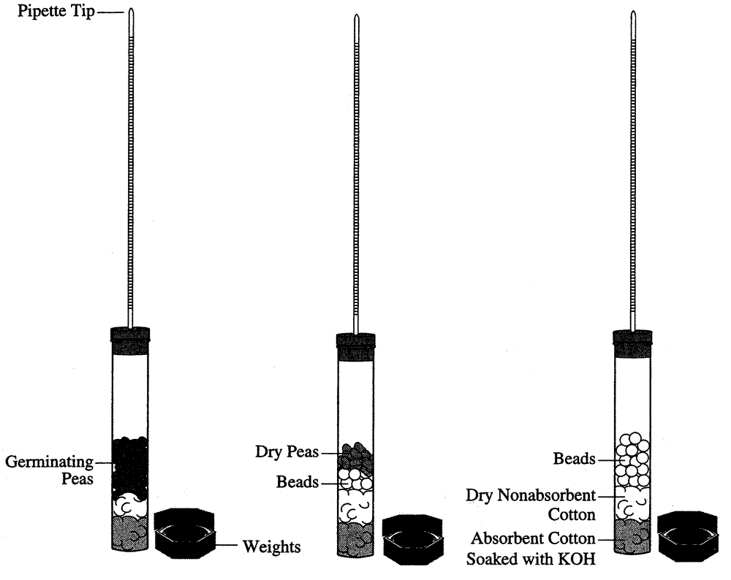

Figure 2

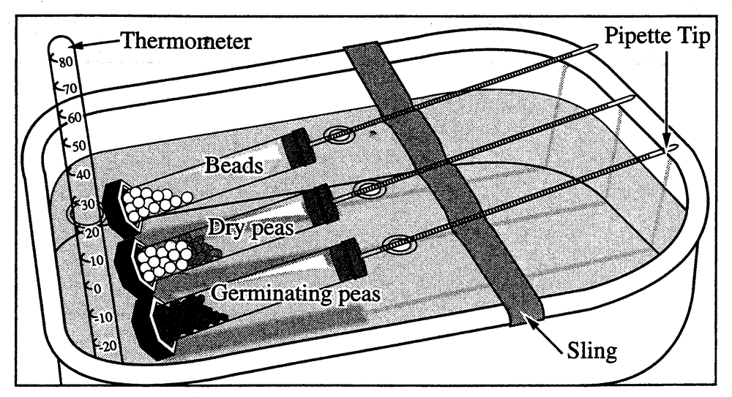

__13. After the equilibrium period of 7 minutes, immerse all 6 respirometers entirely in their respective baths. Work swiftly, checking for leaks. Arrange them so that the pipettes can be read through the water without having to manipulate them by hand.

__14. Allow 3 more minutes to equilibrate then record to the nearest 0.01 mL the initial position of water in each pipette. This will be t = 0.

__15. Every 5 minutes for 20 minutes take readings of the water’s position in each pipette and record in Table 1.

__16. From the slope of the four lines on the graph, determine the rate of O2 consumption of germinating and dry peas during the experiments at room temperature and at 10°C. Recall that rate = ∆y/∆x . Record the rates in Data Table 2.

Data Table 2

Condition | Show Calculations Here | Rate  (mL O2/minute)
Germinating Peas @ 10°C
Germinating Peas @ 25°C
Dry Peas @ 10°C
Dry Peas @ 25°C

Graph of the corrected difference column for the germinating peas and dry peas only. This graph should have all 4 lines—2 at 10°C, and 2 at 25°C. Remember, we are measuring the rate of oxygen consumption.

Conclusion Questions:

1. Identify the hypotheses being tested in this activity?

_______________________________________________________________________________________
_______________________________________________________________________________________
_______________________________________________________________________________________
_______________________________________________________________________________________

2. Identify the control group(s) in this activity.

_______________________________________________________________________________________
_______________________________________________________________________________________
_______________________________________________________________________________________
_______________________________________________________________________________________

3. This activity uses a number of controls. Identify at least three of the controls and describe the purpose of each of these controls.

_______________________________________________________________________________________
_______________________________________________________________________________________
_______________________________________________________________________________________
_______________________________________________________________________________________
_______________________________________________________________________________________
_______________________________________________________________________________________

4. Why is it necessary to correct the reading from the peas with the reading from the beads.

_______________________________________________________________________________________
_______________________________________________________________________________________
_______________________________________________________________________________________
_______________________________________________________________________________________

5. What is the purpose of KOH in this experiment?

_______________________________________________________________________________________
_______________________________________________________________________________________
_______________________________________________________________________________________

6. Why did the vial have to be completely sealed around the stopper?

_______________________________________________________________________________________
_______________________________________________________________________________________
_______________________________________________________________________________________
_______________________________________________________________________________________

7. Explain why water moved into the respirometers’ pipettes?

_______________________________________________________________________________________
_______________________________________________________________________________________
_______________________________________________________________________________________
_______________________________________________________________________________________
_______________________________________________________________________________________

8. If you used the same experimental design to compare the rates of respiration of a 25g reptile and a 25g mammal at 10°C, what results would you expect? Explain your reasoning.

_______________________________________________________________________________________
_______________________________________________________________________________________
_______________________________________________________________________________________
_______________________________________________________________________________________
_______________________________________________________________________________________
_______________________________________________________________________________________
_______________________________________________________________________________________
_______________________________________________________________________________________

9. If respiration in a small mammal were studies at both 10°C and 25°C, what results would you predict?
Explain your reasoning.

_______________________________________________________________________________________
_______________________________________________________________________________________
_______________________________________________________________________________________
_______________________________________________________________________________________
_______________________________________________________________________________________

10. Explain the effects of germination (vesus nongermination) on pea seed respiration.

_______________________________________________________________________________________
_______________________________________________________________________________________
_______________________________________________________________________________________
_______________________________________________________________________________________
_______________________________________________________________________________________

11. Where does a germinating pea seed get the glucose it needs for respirations?

_______________________________________________________________________________________
_______________________________________________________________________________________
_______________________________________________________________________________________
_______________________________________________________________________________________
_______________________________________________________________________________________

12. Describe the process of germination for pea seeds. What purpose does water SPECIFICALLY serve?

_______________________________________________________________________________________
_______________________________________________________________________________________
_______________________________________________________________________________________
_______________________________________________________________________________________
_______________________________________________________________________________________
_______________________________________________________________________________________
_______________________________________________________________________________________
_______________________________________________________________________________________
_______________________________________________________________________________________
_______________________________________________________________________________________
_______________________________________________________________________________________
_______________________________________________________________________________________
_______________________________________________________________________________________
_______________________________________________________________________________________
_______________________________________________________________________________________

Measurement of Oxygen Consumption by Soaked and Dry Pea Seeds at Room Temperature and 10°C Using Volumetric Methods
Temp (°C ) | Time (min) | Beads Alone |  | Germinating Peas |  |  | Dry Peas and Beads
 |  | Reading at time X | Diff.* | Reading at time X | Diff.* | Corrected Diff. | Reading at time X | Diff.* | Corrected Diff.
25°C | 0
25°C | 5
25°C | 10
25°C | 15
25°C | 20
10°C | 0
10°C | 5
10°C | 10
10°C | 15
10°C | 20
* Difference = (initial reading time 0) - (reading at time X)
* Corrected Difference = (initial pea seed reading at time 0 - pea seed reading at time X) - (initial bead reading at time 0 - bead reading at time X)
Data Table

Measurement of Oxygen Consumption by Soaked and Dry Pea Seeds at Room Temperature and 10°C Using Volumetric Methods
Temp (°C ) | Time (min) | Beads Alone |  | Germinating Peas |  |  | Dry Peas and Beads
 |  | Reading at time X | Diff.* | Reading at time X | Diff.* | Corrected Diff.  | Reading at time X | Diff.* | Corrected Diff. 
25°C | 0 | 0.93 |  | 0.91 |  |  | 0.92
25°C | 5 | 0.91 |  | 0.84 |  |  | 0.89
25°C | 10 | 0.90 |  | 0.77 |  |  | 0.87
25°C | 15 | 0.90 |  | 0.71 |  |  | 0.87
25°C | 20 | 0.90 |  | 0.64 |  |  | 0.85
10°C | 0 | 0.95 |  | 0.92 |  |  | 0.91
10°C | 5 | 0.94 |  | 0.88 |  |  | 0.90
10°C | 10 | 0.92 |  | 0.85 |  |  | 0.87
10°C | 15 | 0.93 |  | 0.83 |  |  | 0.85
10°C | 20 | 0.93 |  | 0.80 |  |  | 0.85
* Difference = (initial reading time 0) - (reading at time X)
 Corrected Difference = (initial pea seed reading at time 0 - pea seed reading at time X) - (initial bead reading at time 0 - bead reading at time X)
Sample Data:

