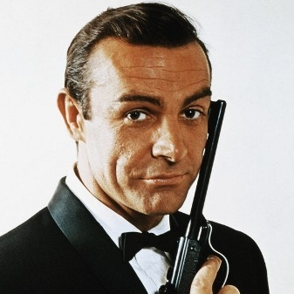
Sean Connery as the original James Bond. Sean Connery as Dr. Campbell.
