Name _______________________________ Date ______________

AP Biology Mr. Collea

**Why are cells so small?**

*(Why does cleavage of the fertilized egg/zygote increase the number of cells and not the size/volume?)*

**Introduction**

Why are cells so small? Think about this: even though a whale is much larger than a human and a human is much larger than a tulip, their cells are all roughly the same size. Whales don’t have larger cells than humans, just more of them. There is a very specific reason why cells are the size they are. Anytime this cell interacts with its environment, it does so at its membrane. The more membrane a cell has, the more exchange it can perform with its environment. (*This exchange can include activities such as obtaining nutrients or getting rid of wastes*.) We refer to the amount of surface that an object has as its **surface area** (**SA**). Once materials get inside the cell, they move via diffusion. **Diffusion** is the random movement of particles that results in their dispersion in the cytoplasm. A drop of food coloring in a beaker of water will diffuse until the entire beaker is the same color. This type of movement occurs inside cells as a way of dispersing molecules. Diffusion works best over short distances. Imagine how long it would take food coloring molecules to diffuse in a water glass vs. in a swimming pool. Because the water glass has less **volume** (**V**), diffusion is more efficient. Cells try to **maximize their surface area** (*more cell membrane* *to improve exchange*) and **minimize their volume** (*less cytoplasm or stuff to make diffusion more efficient*). A basketball-sized cell would have lots of surface area (good), but also lots of volume (bad). Think about how long it would take molecules to diffuse from the outer portion of the ball to the center. A ping-pong ball or a marble would be better choices. When we discuss the interplay of these two quantities, we use the ratio of surface area to volume (abbreviated SA/V). Ideal cells have large SA values, but small V values.

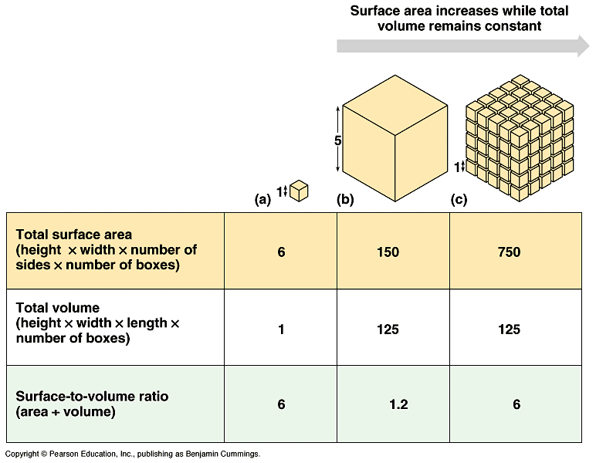

|  |  |  |  |
| --- | --- | --- | --- |
| **Table 1.** | **(a)** | **(b)** | **(c)** |
| **Total Surface Area** (width x height x # of sides x # of boxes) |  |  |  |
| **Total Volume**  (length x width x height x # of boxes) |  |  |  |
| **Surface Area to Volume Ratio** (surface area ÷ volume) |  |  |  |

**Part I. Calculating Volume and Surface Area.**

*Calculate the following measurements using the formulas located on your AP Biology questions and Formula Sheet*

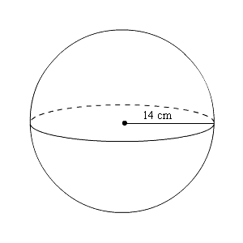

**1.** Determine the volume of the sphere to the right.

**2.** Determine the surface area of the same sphere.

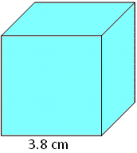

**3.** Determine the volume of the cube to the right.

**4.** Determine the surface area of the same cube?

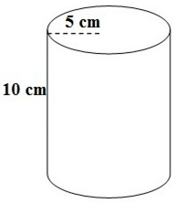

**5.** Determine the volume of the column to the right?

**6.** Determine the surface area of the same column?

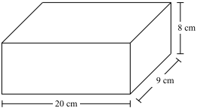**7.** Determine the volume of the rectangular solid to the right.

**Part II. Surface Area : Volume in Sea Urchin Embryos**

**Methods**

**1.** Look at the photos of the cells on p.5. These are very young embryos from sea urchins, marine organisms that you may have seen in nature documentaries or possibly while on vacation snorkeling along a rocky coastline.

These photos were taken over a span of 105 minutes,

beginning immediately after fertilization (Panel 1). The fertilized egg then divided once (Panel 3) to produce a two cell embryo (Panel 4), and then again (Panel 5) to produce a 4-cell embryo (Panel 6). Eventually, hundreds of **MITOTIC** divisions would result in a tiny sea urchin larva that would settle to the sea bed and grow into the mature urchin to the right.

Embryonic cells such as these are convenient to use as models for cell size because they are nearly perfect spheres. You will use these cells to determine SA/V ratios.

**2.** **Measure the diameter of the cells.**

There is a scale bar printed below the photo of the cells. It works just like a scale bar on a map. The scale bar on the photos tells you that a distance of about 4 cm (the length of the line) equals 0.1mm which equals 100 μm in the photos. The symbol μ is pronounced “micro”; a μm is a micrometer, one- millionth of a meter or one-thousandth of a millimeter (1mm = 1000*u*m). Measure the diameter of the cells in Panels 1, 4, and 6 in μm, using the scale bar as a guide. The diameter is simply the distance from one end of the cell to the opposite end. In Panels 4 and 6, just measure one cell; we’ll assume they’re all nearly perfect spheres and roughly the same size. Record these diameters in **Table 2**.

**Table 2.**

|  |  |  |  |  |  |
| --- | --- | --- | --- | --- | --- |
| **Panel** | **Diameter** (*u*m) | **Radius** (*u*m) | **SA:**(*u*m2) | **V** (*u*m3) | **SA/V** |
| **1** |  |  |  |  |  |
| **4** |  |  |  |  |  |
| **6** |  |  |  |  |  |

**3. Determining the radius of the cells.**

When we use geometry to describe spheres, we tend to use the radius of the sphere rather than the diameter. The radius is defined as the distance from the center of the sphere to the edge. This can be figured out easily by simply dividing the diameter in half. Divide the diameters in half, and record these values in the **Table 2**.

**4. Determining surface area.**

Surface area (SA) can be calculated using the formula:  **SA = 4 π r2**

Since π ≅ 3.14, this can be simplified to:

SA = 12.56 x (radius)2

Calculate the surface area (SA) for each of your three cells and record the values in **Table 2**.

**Panel 1: Panel 4: Panel 6:**

**5. Determining volume**

Volume (V) can be calculated using the formula: **V = 4/3π r3**

This can also be simplified to:

V = 4.19 x (radius)3

Calculate the volume (V) for each of your three cells and record the values in **Table 2**.

**Panel 1: Panel 4: Panel 6:**

**6. Determining SA/V ratios**

Once you have determined the SA and V, it’s relatively easy to figure out the ratio.

Simply divide SA by the V. Record the SA/V ratios in **Table 2**.

**Panel 1: Panel 4: Panel 6:**

**Sea Urchin Embryo Photos**

**1.0 mm = 1000 *u*m**

**Fertilization and Development of a Human Embryo**

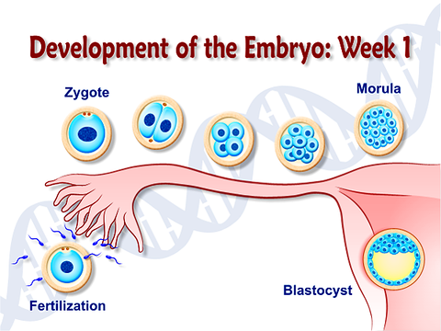

**Post Lab Questions**

**1.** Which panel shows cells with the highest SA/V ratio? _______

**2.** Which panel shows cells with the lowest SA/V ratio? _______

**3.** What happens to the SA/V ratios of these embryonic cells over time (from 0-105 min)?

**4.** What happened to the surface area as the size increased?

**5.** What happened to the volume as the size increased?

**6.** What happened to the surface area to volume ratio as the size increased?

**7.** Do you think large cells and small cells carry out diffusion and osmosis at the same rate?

Why or why not?

**8.** If a cell has a high concentration of something, say, waste, that it wants to get rid of, which do you

predict will be able to get rid of the waste sooner – a smaller cell or a large one? Why?

**9.** Consider a mouse and an elephant. If both were left in the cold overnight, which would be in more danger of freezing to death? Why?

**Part III. Robert Hooke Award for Cell Design**



*Robert Hooke*

*July 28, 1635 – March 3, 1703*

Your team will be given a block of the agar that you must design into your own cell to maximize volume & mass, but minimize diffusion time.

**RULES:**

1. No donut-like holes through the agar cell - cell membranes cannot sustain that shape.
2. Model cell will be placed in 50 mL of vinegar.
3. No poking, prodding, touching tray containing agar cell in solution.

1. Teacher will mass the “cell” at the start of race - cell must not break when handled.

***Disqualification if cell breaks upon massing or transferring from tray to tray.***

1. Teacher determines when 100% diffusion takes place.

1. **Winner** = highest ratio of **mass divided by time**.