**Testing for the presence of glucose using**

**the chemical *indicator* Benedicts Solution.**

**Procedure:**

**(1)** Place 5mL (*one dropper full*) of the solution to be tested into a clean test tube.

**(2)** Add approximately10 drops of the glucose indicator called Benedicts Solution.

**(3)** Carefully place the test tube into a hot water bath.

**(4)** Keep an eye on the test tube to see if the solution changes color.

**\* Wear googles and NEVER point a heated test tube at your face! \***

(**+**) Positive Results = if the solution changes color = glucose **IS** present

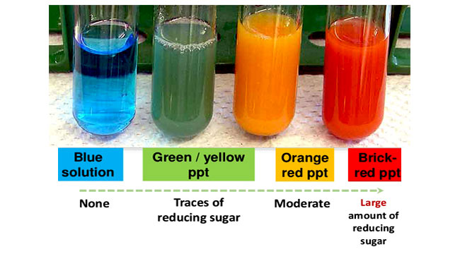(-) Negative Results = if the solution doesn’t changes color = glucose is **NOT** present