Living Yeast with Congo Red
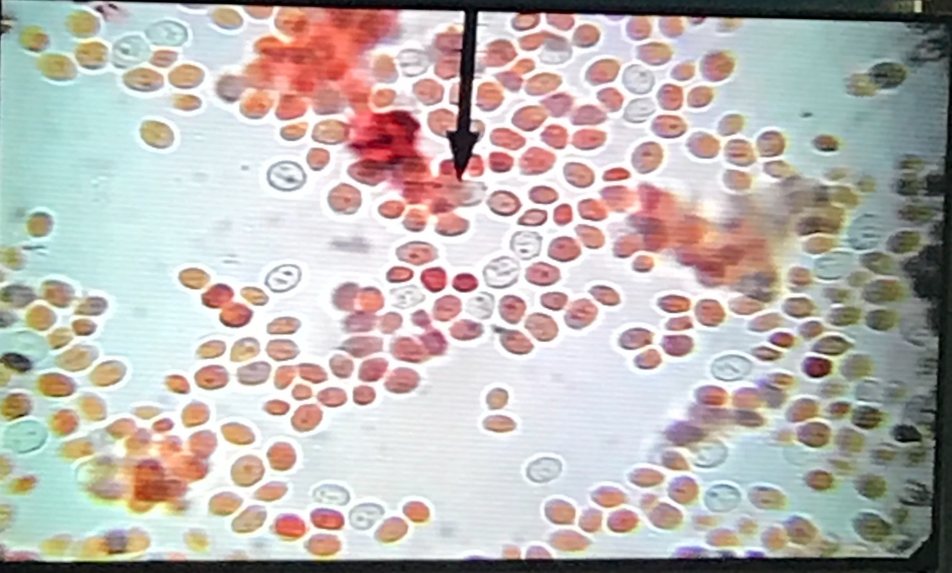

Percentage of Cell with Congo Red =

Boiled Yeast with Congo Red
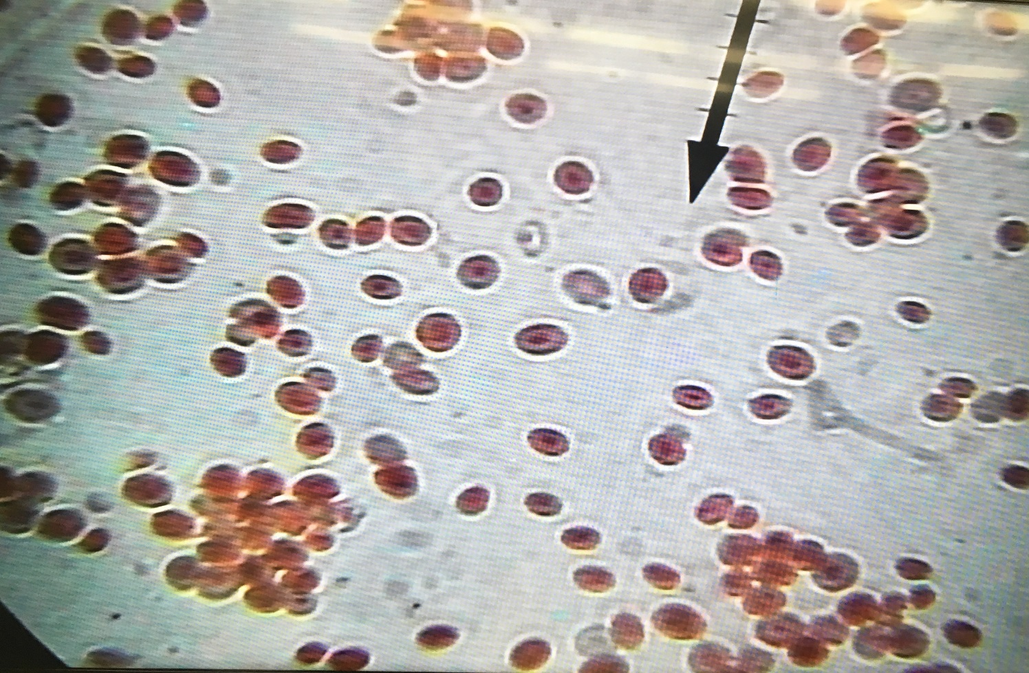

Percentage of Cell with Congo Red =

