Name ___________________________________ Date ____________
Honors Biology Mr. Collea

Advanced Microscopy

Background Information

Biology involves the study, prediction, and analysis of real-world phenomena as related to living things.
To communicate data accurately, we must set specific standards for our basic measurements. The science community has standardized on what is known as the Système International (SI), which defines seven baseline measurements and their standard units, forming the foundation of what is called the metric system of measurement. The base unit of weight is the gram. The base unit of volume is the liter. The basic unit of length in the metric system, the meter, is roughly equivalent to the U.S. yard and will be utilized in various parts of this lab.

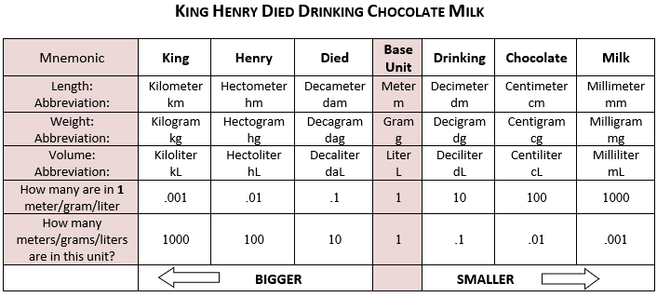

For smaller measurements, the meter (m) is divided up into 100 parts, known as centimeters (cm), each centimeter divided up into 10 millimeters (mm), each millimeter is divided into 1000 micrometers/microns (um) and each micrometer is divided into 1000 nanometers (nm). For larger measurements, the meter is grouped into larger units of 1000 meters, known as a kilometer (Km). The length of a baseball bat is approximately one meter, the radius of a U.S. quarter is approximately a centimeter, the diameter of the metal in a wire paperclip is roughly one millimeter and the width of the DNA molecule is about 2 nanometers.

Metric Prefixes
Prefix: | Symbol: | Magnitude: | Meaning (multiply by):
tera- | T | 10¹² | 1 000 000 000 000
giga- | G | 10⁹ | 1 000 000 000
mega- | M | 10⁶ | 1 000 000
kilo- | k | 10³ | 1000
hecto- | h | 10² | 100
deka- | da | 10 | 10
- | m g L sec | - | -
deci- | d | 10⁻¹ | 0.1
centi- | c | 10⁻² | 0.01
milli- | m | 10⁻³ | 0.001
micro- | µ | 10⁻⁶ | 0.000 001
nano- | n | 10⁻⁹ | 0.000 000 001
pico- | p | 10⁻¹² | 0.000 000 000 001

Metric Conversions
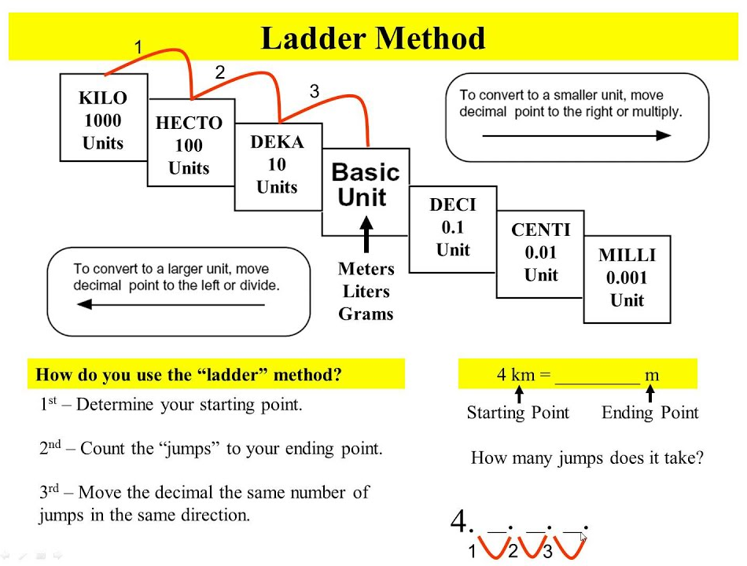

Try these conversions,

1) 2000 mg = ___________ g 2) 5 L = ___________ mL 3) 16 cm = ___________ mm

4) 14 km = ___________ m 5) 198 g = ___________ kg 6) 2500 m = _________ km

7) 48 cm = _________ m 8) 75 mL = ___________ L 9) 65 g = _________ mg

10) 5.6 kg = _________ g 11) 50 cm = ___________ m 12) 6.3 cm = _________ mm

13) 8 mm = _________ cm 14) 5.6 m = ___________ cm 15) 120 mg = _________ g

In reality, on your NYS Regents Exam you’ll only be expected to convert from mm um

16) 1 mm = ___________ um 17) 1 um = ___________ mm 18) 1.5 mm = ___________ um

19) 500 um = ___________ mm 20) 500 um = _________ mm 21) 3.5 mm = ___________ um

22) 1 mm = _________________ nm 22) 1 m = _______________________ nm

23) The diagram to the right represents two cells next to a measuring
device under the low-power objective of a compound light microscope. What is the approximate length of one of the cells?
(1) 100 um (2) 500 um (3) 100 um (4) 1500 um

24) What is the approximate length of each of the cell’s nuclei?
(1) 100 um (2) 500 um (3) 100 um (4) 1500 um

25) What is the diameter of the field of view?
(1) 200 um (2) 400 um (3) 800 um (4) 1600 um

Part I. Observing Depth of Field

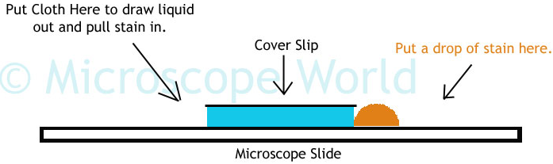

The depth of field refers to resolution in the longitudinal plane (or more simply put, the depth or distance that exists between the slide and the coverslip). Depth of field decreases as magnification increases.

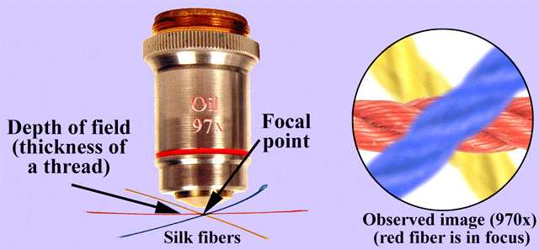
Consider three threads crisscrossed on a microscope slide. At lower magnification, it is usually possible to get all three threads in focus at the same time, but at higher magnifications, when one of the thread is in focus, the other threads will be blurry and vice versa. This is also the case when looking at tissues from plants or animals that are two or more cell layers deep (cells in one layer will be in focus a higher magnification, while those in other layers are blurry).

1. Examine the prepared slide of colored thread to see if you can all three threads in focus at the same time under Scanning, Low and then High Power.

2. Prepare a wet mount slide of 2 strands of hair (from 2 different people) crisscrossed to see if you can get both strands of hair in focus at the same time under Scanning, Low and then High Power.

3. When finished, complete questions 1, 2 and 3 on the Summary Sheet.

Troubleshooting
Occasionally you may have trouble with working your microscope.
Here are some common problems and solutions.

1. Image is too dark!
Adjust the diaphragm, make sure your light is on.

2. There's a spot in my viewing field, even when I move the slide the spot stays in the same place!
Your lens is dirty. Use lens paper, and only lens paper to carefully clean the objective and ocular
lens. The ocular lens can be removed to clean the inside.

3. I can't see anything under high power!
Remember the steps, if you can't focus under scanning and then low power, you won't be able to
focus anything under high power.
FOCUS…CENTER…then SWITCH

4. Only half of my viewing field is lit, it looks like there's a half-moon in there!
You probably don't have your objective fully clicked into place on the nosepiece.
Part II. Calculating the Diameter of the Field of View
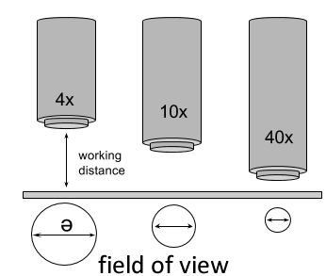

Field of view refers to how much of a specimen is visible

at any given time in the lateral plane. Or more simply put,

it is the diameter of the circle of light visible when looking through

a microscope. As seen in the diagram to the right, the field of view is also inversely proportional to the magnification (as the magnification increases, the field of view decreases). Another way to understand this

is to consider that when a specimen is magnified, the microscope is zooming in on it and, consequently, seeing less of it.

You see MORE of LESS.

100x 400x

Methods:
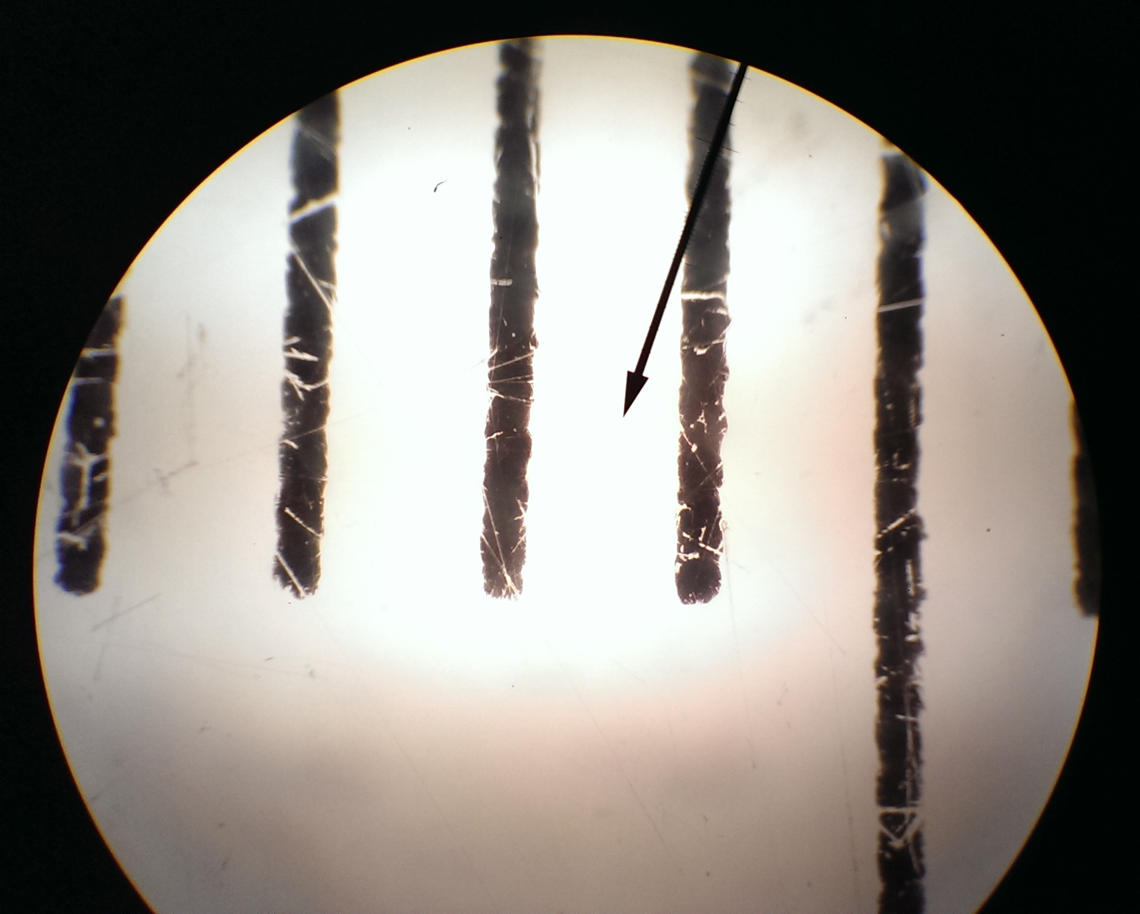
1. Use a clear ruler with a cm/mm scale to measure the diameter of
your field of view at scanning (40x). Record your data in Table 1.

2. Repeat the process on low power (100x). Record your measurement in Table 1. Convert millimeters (mm) to microns (um) for both the scanning and low power. Remember: 1mm = 1000um
You can at this point use these measurements to estimate the size of any specimen
in your viewing field that you can see with low or scanning power.

3. Repeat the process on high power (400x). What do you notice? Record your measurement here
______________________

4. As you see, measurements on High Power can be a bit more complicated. If you try to use the clear ruler technique, you’ll find that you cannot see the individual ruler marks because as magnification increases, the field of view decreases. This is where maths (algebra) comes in, the values you estimated in steps 1 and 2 above can be used to solve a ratio to determine the size of your field of view on high power.
=
Low Power Magnification High Power Field of View
High Power Magnification Low Power Field of View

solving for High Power Magnification you get the formula …

x
=
High Power Field of View
Low Power Magnification
High Power Magnification
Low Power Field of View
Table 1.

Objective | Magnification | Ocular | Total Magnification | Diameter of Field of View
Scanning |  |  |  | _______ mm ___________ um
Low |  |  |  | _______ mm ___________ um
High |  |  |  | _______ mm ___________ um

Formula:
x
=
High Power Field of View
Low Power Magnification
High Power Magnification
Low Power Field of View

Objective | Diameter of Field of View Calculations
High

Part III. Estimating the Size of Specimens

Once you have an estimate of your high power field of view,
Actual Size = Field of View
Number of cells that fit across
any specimen you are viewing under high power can be
estimated based on that and the following formula to the right.
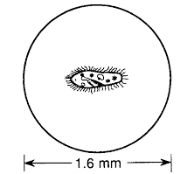

1. Using the formula above, estimate the size of the paramecium to
the right

_______ mm ___________ um

2. View, draw and estimate the sizes of each of the following:
a) the width of human hair
b) a paramecium
c) the height of the perched owl on a dollar bill

3. Start your Pond Water Scavenger Hunt!!!

Part IV. Biodiversity in a Drop of Pond Water

Size (um) | Organism
 | Cyclops
 | Water Shrimp
Daphnia
(Water Flea)
 | Amoeba
 | Volvox
 | Spirogyra
 | Oscillatoria
 | Rotifer
 | Tartigrade (Waterbear)
 | Planaria
 | Euglena
 | Nematode
 | Diatom
 | Pediastrm
 | Vorticella
 | Stentor
 | Micrasterius
 | Closterium
 | Colpidium
 | Phacus
 | Paramecium
 | Hydra
 | Pandorina

Name ___________________________________ Date ____________
Honors Biology Mr. Collea

Advanced Microscopy Lab

Summary Sheet

1. What is the simple definition for Depth of Field?

_____________________________________________________________________________________

_____________________________________________________________________________________

2. Draw what the crisscrossed threads look like under Scanning, Low and High Power.

40x 100x 400x

3. Draw what the crisscrossed hairs look like under Scanning, Low and High Power.

40x 100x 400x
4. Were you able to get all three strands of colored thread in focus under –

(a) Scanning Power YES or NO (b) High Power YES or NO

5. Were you able to get both strands of hair in focus under –

(a) Scanning Power YES or NO (b) High Power YES or NO

6. What is the simple definition for Field of View?

_____________________________________________________________________________________

_____________________________________________________________________________________

7. Draw what the clear plastic ruler looks like under Scanning, Low and High Power.

40x 100x 400x

8. Draw what a single strand of human hair looks like under Scanning, Low and High Power.

40x 100x 400x

9. Draw what a single paramecium looks like under Scanning, Low and High Power.

40x 100x 400x

10. Draw what the perched owl on a dollar bill looks like under Scanning and Low Power.

40x 100x

Actual Size = Field of View
Number of cells that fit across
11. Fill in the data table below.

Specimen | Estimated Size
Hair | _______ mm ___________ um
Perched Owl | _______ mm ___________ um
Paramecium | _______ mm ___________ um

