Base your answers to question 9 – 11 on the diagram below which shows
various finches found on the Galapagos Islands and on your knowledge of biology.

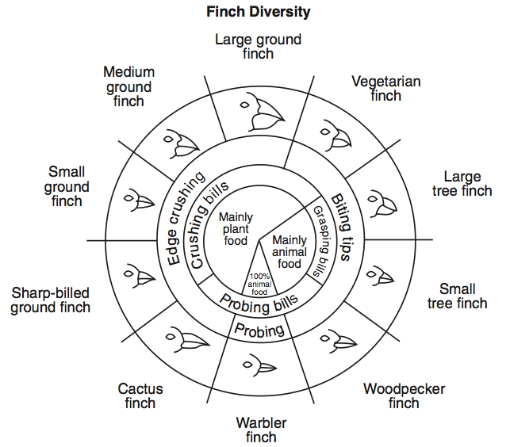

9. Predict which species of finch would be most likely to survive if the weather on the Galapagos Islands gradually changed and the seeds available to the finches became larger with heavier coverings. Explain.

_________________________________________________________________________________

_________________________________________________________________________________

_________________________________________________________________________________

_________________________________________________________________________________

10. One island is populated by two species-Ground Finches and Small Tree Finches.
a. What two types of food would you expect to be available on this island? Explain.

_________________________________________________________________________________________

_________________________________________________________________________________________

_________________________________________________________________________________________

b. Would you expect the two species to compete for food on this island? Explain.

_________________________________________________________________________________________

_________________________________________________________________________________________

_________________________________________________________________________________________

c. How might the two native finch populations be affected if several dozen Sharp-billed Ground Finches were to migrate to the island and survive? Explain.

_________________________________________________________________________________________

_________________________________________________________________________________________

_________________________________________________________________________________________

11. Explain how an island could support large populations of both Large Ground Finches and Small Ground Finches? Explain.

_________________________________________________________________________________________

_________________________________________________________________________________________

_________________________________________________________________________________________

12. What was acting as the selecting agent in this activity?

_________________________________________________________________________________________

_________________________________________________________________________________________

