Chapter 26: The Stuff of Life

Directions: Read Ch.26 from the book A Short History of Nearly
Everything by Bill Bryson and then answer the questions below.

Analogy 1: DNA is an instruction manual for the body.

Analogy 2: The human genome is a parts list of what we are made of which says nothing about how we work.

Statement to Consider 1: “There are two yards of DNA coiled inside each nucleus of your cells.”

Statement to Consider 2: “We are all uncannily alike. You share 99.9 % of the same genes with any other human being.”

1. What are the odds against you being here?
2. Bryson states, “In the most literal and fundamental sense we are all family.”
What does he mean by this statement?
3. What makes us a species?
4. What is the human genome?
Why does Bryson say there no such thing as a human genome?
5. Why does DNA exist?
6. How much DNA is contained in a human being?
7. Why does Bryson say DNA is “a molecule that is not itself alive and for the most part doesn’t do anything at all”?
8. DNA is one of the “most non-reactive, chemically inert molecules in the living world”.
Why does Bryson say this?
9. Why did scientists think DNA was “too simple” to be important to life?
What does the principle of Occam's razor state? GOOGLE IT!
10. How is DNA like Morse code?
11. What function does RNA serve?
12. What did Thomas Morgan Hunt discover?
13. What are the advantages of working with fruit flies for genetic studies?
14. What did Oswald Avery’s experiments prove?
15. Who is Linus Pauling and what did his structure of DNA look like?
16. What did Maurice Wilkins spend much of the WWII doing?
17. What assumption did Watson and crick make?
18. Which scientists had the best X-ray crystallography images of DNA?
Why was this scientist not forthcoming with her findings?
19. Why was the discovery of the structure of DNA mostly overlooked?
20. Why did Rosalind Franklin not receive a Nobel Prize?
21. What percentage of your DNA is “meaningless non-coding DNA?”
22. What is a gene?
23. How are genes like keys on a piano?
24. What is guano?
25. Describe the shape (structure) of DNA.
26. Briefly describe DNA replication.
27. What is a “Snip?”
28. Why is the balance between accuracy and errors in DNA replication a fine one?
29. How are “all organisms are in some sense slaves to their genes?”
30. Briefly describe the experiments that took place in Germany and Switzerland involving mice and fruit flies.
31. What are Hox genes?
32. What does the statement, “it is not the number of genes you have, but what you do with them” mean?
33. Why were the results of the Human Genome Project both a surprise and a disappointment?
34. Why is cracking the human genome only the beginning?
35. What is the “human proteome”?
36. What is required for a protein to function properly?
37. Why does Bryson include the most profound true statement there is: “All life is one.”
Why do you think he feels this is so important? Do you agree?

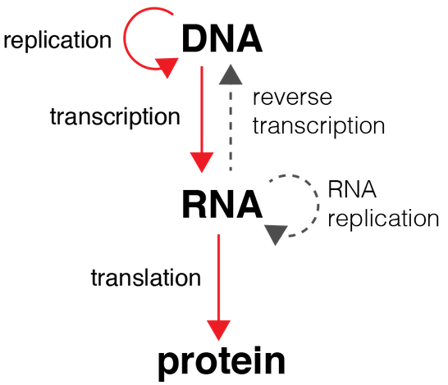
Central Dogma of Biology

