­­­Name ______________________________ Date __________

AP Biology Mr. Collea

***Diffusion and Osmosis***

**Objectives:** **(1)** Describe the physical mechanisms of diffusion and osmosis.

**(2)** Describe how molar concentration affects the process of diffusion.

**(3)** Predict cell outcomes when changing the concentration of solute in a solution in which the “cell” is suspended.

**(4)** Determine the molar concentration of sucrose in a plant cell.

**(5)** Observe plasmolysis in red onion cells.

**Background Information:**

Many aspects of the life of a cell depend on the fact that atoms and molecules are constantly in motion (the concept of kinetic energy). This kinetic energy results in molecules bumping into and rebounding off each other and moving in new directions. One result of this molecular motion is the process of diffusion.

**Diffusion** is the random movement of molecules from an area of higher concentration to an area of lower concentration. **Osmosis** is a special case of diffusion. It is the diffusion of water through a selectively permeable membrane from a region of higher water potential to a region of lower water potential until equilibrium is reached. Water potential is the measure of free energy of water in a solution.

Water potential is the free energy of water, water will always move from an area of higher water potential to an area of lower water potential (high free energy to low free energy). Water potential has 2 components: **osmotic potential** - which is dependent on solute concentration and **pressure potential** - which results from the exertion of pressure either positive or negative on a solution. This can be reviewed on pages 751-752 in your textbook.

## Water Potential = Pressure Potential + Osmotic Potential

**w = p + **

The water potential of pure water in a beaker at STP is 0 because both osmotic and pressure potentials are 0. The addition of a solute to water lowers the osmotic potential (makes **w** more negative and, therefore, lowers the water potential). When dealing with plant cells like those found in a potato, osmotic potential of a cell is lowered as a result of more solute dissolved in its cytoplasm. When placed in a pure water situation, the cells are now hypertonic to the environment. The water potential in the beaker is higher than in the cell. Water will diffuse into the cell until the pressure potential equalizes. As a result, the cell will swell. Conversely, if solute is added to the water of the beaker so that the water potential is higher in the cell than the beaker, the cell is said to be hypotonic to its surroundings and water will diffuse out of the cell until the pressures are equal. As a result, the cell will shrink (*plasmolysis*). Water basically moves from a higher water potential to a lower one.

**Activity Overview:**

In Part I of this lab, you will work with a cell model using dialysis tubing to represent your cell. You will fill dialysis tubing with distilled water and immerse them in known concentrations of sucrose solutions, calculate and graph the % change in mass in each dialysis tube and explain the changes in the tubes in terms of water potential. In Part II of this lab, you will be working with a real cell system - potato cells. You will immerse cores of potato in different molar concentrations of sucrose to determine the water potential of potato cells. Part III is a review of the Plasmolysis Lab from Honors Biology in which we will surround red onion cells with a 15% salt solution and observe them under a compound light microscope and explain the changes in the plant cells in terms of water potential.

**Methods:**

**Materials:**

**Part I. Dialysis Tubing Part II. Potato Cores Part III. Plasmolysis**

400mL Beaker / Plastic Cup Small Petri Dish Glass Slide / Cover slip

Dialysis Tubing 2/3 Potato Cores Red Onion Specimen

Twisty Ties / String Sucrose Solution 15% NaCl solution

Paper Towels Paper Towels Paper Towels

Digital Scale Forceps Microscope

Digital Scale

**Part I: Procedure**

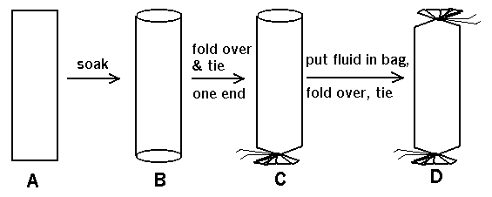**(1)** How to tie and fill the dialysis tube.

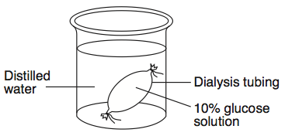**(2)** Place dialysis tube in known sucrose concentrations

**Hypothesis:** Predict what YOU think will happen to the mass of your dialysis tube and WHY.

_____________________________________________________________________________________

_____________________________________________________________________________________

_____________________________________________________________________________________

**Data and Results: Table 1.** Dialysis Tubes Results

|  |  |  |  |  |
| --- | --- | --- | --- | --- |
| **Beaker / Cup** | **Initial Mass (g)** | **Final Mass (g)** | **Mass Difference** | **% Change in Mass\*** |
| **0.0M sucrose**  (Distilled Water) |  |  |  |  |
| **0.2M sucrose** |  |  |  |  |
| **0.4M sucrose** |  |  |  |  |
| **0.6M sucrose** |  |  |  |  |
| **0.8M sucrose** |  |  |  |  |
| **1.0M sucrose** |  |  |  |  |

|  |  |  |
| --- | --- | --- |
| *Percent Change in Mass = | (Final Mass) – (Initial Mass) | X 100 |
| Initial Mass |

**Graph 1.** Percent Change in Dialysis Tubes at Different Molarities of Sucrose

|  |  |  |  |  |  |  |  |  |  |  |  |  |  |  |  |  |  |  |  |  |  |  |  |  |  |  |  |  |  |
| --- | --- | --- | --- | --- | --- | --- | --- | --- | --- | --- | --- | --- | --- | --- | --- | --- | --- | --- | --- | --- | --- | --- | --- | --- | --- | --- | --- | --- | --- |
|  |  |  |  |  |  |  |  |  |  |  |  |  |  |  |  |  |  |  |  |  |  |  |  |  |  |  |  |  |  |
|  |  |  |  |  |  |  |  |  |  |  |  |  |  |  |  |  |  |  |  |  |  |  |  |  |  |  |  |  |  |
|  |  |  |  |  |  |  |  |  |  |  |  |  |  |  |  |  |  |  |  |  |  |  |  |  |  |  |  |  |  |
|  |  |  |  |  |  |  |  |  |  |  |  |  |  |  |  |  |  |  |  |  |  |  |  |  |  |  |  |  |  |
|  |  |  |  |  |  |  |  |  |  |  |  |  |  |  |  |  |  |  |  |  |  |  |  |  |  |  |  |  |  |
|  |  |  |  |  |  |  |  |  |  |  |  |  |  |  |  |  |  |  |  |  |  |  |  |  |  |  |  |  |  |
|  |  |  |  |  |  |  |  |  |  |  |  |  |  |  |  |  |  |  |  |  |  |  |  |  |  |  |  |  |  |
|  |  |  |  |  |  |  |  |  |  |  |  |  |  |  |  |  |  |  |  |  |  |  |  |  |  |  |  |  |  |
|  |  |  |  |  |  |  |  |  |  |  |  |  |  |  |  |  |  |  |  |  |  |  |  |  |  |  |  |  |  |
|  |  |  |  |  |  |  |  |  |  |  |  |  |  |  |  |  |  |  |  |  |  |  |  |  |  |  |  |  |  |
|  |  |  |  |  |  |  |  |  |  |  |  |  |  |  |  |  |  |  |  |  |  |  |  |  |  |  |  |  |  |
|  |  |  |  |  |  |  |  |  |  |  |  |  |  |  |  |  |  |  |  |  |  |  |  |  |  |  |  |  |  |
|  |  |  |  |  |  |  |  |  |  |  |  |  |  |  |  |  |  |  |  |  |  |  |  |  |  |  |  |  |  |
|  |  |  |  |  |  |  |  |  |  |  |  |  |  |  |  |  |  |  |  |  |  |  |  |  |  |  |  |  |  |
|  |  |  |  |  |  |  |  |  |  |  |  |  |  |  |  |  |  |  |  |  |  |  |  |  |  |  |  |  |  |
|  |  |  |  |  |  |  |  |  |  |  |  |  |  |  |  |  |  |  |  |  |  |  |  |  |  |  |  |  |  |
|  |  |  |  |  |  |  |  |  |  |  |  |  |  |  |  |  |  |  |  |  |  |  |  |  |  |  |  |  |  |
|  |  |  |  |  |  |  |  |  |  |  |  |  |  |  |  |  |  |  |  |  |  |  |  |  |  |  |  |  |  |

**Part II: Procedure**

__1. Using a cork borer, Mr. Collea will provide you with 2/3 potato cylinders for each Petri dish.

__2. CAREFULLY blot the potato cylinders on a paper towel to dry using the forceps to **ALWAYS**

handle the specimens. Be sure to be **consistent in your potato cylinder drying methods**.

__3. Place the potato cylinders immediately into the small Petri dish and cover to avoid evaporation.

__4. Quickly determine the total mass of all potato cylinders together using the digital scale and record data in **Table 2**. *Remember to always use forceps in handling your specimens and to*

***IMMEDIATELY*** *place the covers back* *on the Petri dish when finished to prevent evaporation.*

__5. After you have massed all of your potato core specimens, place them in their designated location in

the biology lab where they will be submerged in an unknown sucrose solution and left to stand

overnight.

__6. The next day, CAREFULLY carry your Petri dishes back to your lab table, CAREFULLY remove

the potato cores from one of the solution using forceps, blot and dry them gently on paper towel **using the same method from yesterday** and determine their combined mass. Do the same for your other two Petri dishes and record your data on **Table 2**.

__7. Calculate the percent change in mass for each and record results in **Table 2**.

__8. Graph the class data for the percent change in mass on Graph 2.

**Data and Results:**

**Table 2.** Potato Core Results: Individual Data

|  |  |  |  |  |
| --- | --- | --- | --- | --- |
| **Petri Dish** | **Initial Mass (g)** | **Final Mass (g)** | **Mass Difference** | **% Change in Mass\*** |
| **A** |  |  |  |  |
| **B** |  |  |  |  |
| **C** |  |  |  |  |
| **D** |  |  |  |  |
| **E** |  |  |  |  |
| **F** |  |  |  |  |

|  |  |  |
| --- | --- | --- |
| *Percent Change in Mass = | (Final Mass) – (Initial Mass) | X 100 |
| Initial Mass |

**Table 3.** Potato Core Results: Class Data

|  |  |  |  |  |  |  |
| --- | --- | --- | --- | --- | --- | --- |
|  | **A** | **B** | **C** | **D** | **E** | **F** |
| **Group 1** |  |  |  |  |  |  |
| **Group 2** |  |  |  |  |  |  |
| **Group 3** |  |  |  |  |  |  |
| **Group 4** |  |  |  |  |  |  |
| **Group 5** |  |  |  |  |  |  |
| **Group 6** |  |  |  |  |  |  |
| **Avg.** |  |  |  |  |  |  |
|  | **A** | **B** | **C** | **D** | **E** | **F** |
| **Molarity** |  |  |  |  |  |  |

**Graph 2.** Percent Change in Mass of Potato Cores at Different Molarities of Sucrose

**Molar Concentration of the Potato Cores = ____________*M***

**Part III.** Plasmolysis in Red Onions

**Red Onion Cells in Distilled Water Red OnionCells in 15% Salt Solution**

**Conclusion Questions:**

**Using the formula below, calculate the solute potential and water potential for each of the lab set ups.**

*Remember* ***ESA****!*

**Water Potential: = P + S**

**Solute Potential : ψs = -iCRT**

i = Ionization constant

C = Molar concentration

R = Pressure Constant (R = 0.0831 liter bars/mole oK)

T = Temperature (oK) (273 + oC of solution)

**1.** Calculate the solute potential **and** water potential **3.** Calculate the solute potential **and** water potential

of a 0.0 M sugar solution at 22 oC. of a 0.6 M sugar solution at 22 oC.

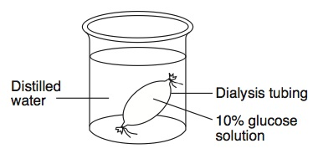

**2.** Calculate the solute potential **and** water potential **4.** Calculate the solute potential **and** water potential

of a 0.2 M sugar solution at 22 oC. of a 0.8 M sugar solution at 22 oC.



**5.** What are the functions of the cell membrane?

__________________________________________________________________________________

__________________________________________________________________________________

__________________________________________________________________________________

**6.** The cell membrane is often described as a bilayer. Explain this term. What two layers make up the

cell membrane?

__________________________________________________________________________________

__________________________________________________________________________________

__________________________________________________________________________________

**7.** Where are proteins found in the cell membrane?

__________________________________________________________________________________

__________________________________________________________________________________

__________________________________________________________________________________

**8.** Explain why the cell membrane is described as a Fluid Mosaic Model.

__________________________________________________________________________________

__________________________________________________________________________________

__________________________________________________________________________________

__________________________________________________________________________________

**9.** Give an example of a molecule that is unable to pass through the cell membrane.

Explain why.

__________________________________________________________________________________

__________________________________________________________________________________

__________________________________________________________________________________

__________________________________________________________________________________

**10.** Explain the function of a transport protein and give an example of how a transport protein is used

in a specific cell in the body.

__________________________________________________________________________________

__________________________________________________________________________________

__________________________________________________________________________________

**11.** Explain the similarities and difference between active transport and facilitated diffusion and give

an example of each.

__________________________________________________________________________________

__________________________________________________________________________________

__________________________________________________________________________________

__________________________________________________________________________________

**12.** Some of the proteins on the surface of the cell are known as receptor proteins because they receive

*messages* from outside the cell. Draw a diagram to show a receptor protein and the signal molecule it receives. (*Remember the importance of shape in biology.)*

**13.** What is one possible message that one cell might send to another cell?

__________________________________________________________________________________

__________________________________________________________________________________

**14.** What is the function of cholesterol in the cell membrane?

__________________________________________________________________________________

__________________________________________________________________________________

**15.** Which dialysis tube from Part I had the greatest increase in mass?

_________________________________________________________________________________

**16.** Explain, in terms of **water potential**, why this result occurred.

_________________________________________________________________________________

_________________________________________________________________________________

_________________________________________________________________________________

_________________________________________________________________________________

_________________________________________________________________________________

_________________________________________________________________________________

**17.** Which dialysis tube from Part I had the smallest increase in mass?

_________________________________________________________________________________

**18.** Explain, in terms of **water potential**, why this result occurred.

_________________________________________________________________________________

_________________________________________________________________________________

_________________________________________________________________________________

_________________________________________________________________________________

**19.** Summarize, in terms of water potential, the process of osmosis.

_________________________________________________________________________________

_________________________________________________________________________________

_________________________________________________________________________________

_________________________________________________________________________________

_________________________________________________________________________________

**20.** What is plasmolysis?

_________________________________________________________________________________

_________________________________________________________________________________

_________________________________________________________________________________

_________________________________________________________________________________

**21.** Explain the changes observed in the red onion cells using the terms, *water potential*, *hypertonic*

and *hypotonic*.

_________________________________________________________________________________

_________________________________________________________________________________

_________________________________________________________________________________

_________________________________________________________________________________

_________________________________________________________________________________

_________________________________________________________________________________

_________________________________________________________________________________

_________________________________________________________________________________

**2.** In the winter, icy roads are often salted to remove the ice and make them less slippery. Grasses

and other herbaceous plants often die near the side of these roads. What causes this to happen?

_________________________________________________________________________________

_________________________________________________________________________________

_________________________________________________________________________________

_________________________________________________________________________________

**23.** When a person is given fluid intravenously (an I.V.) in the hospital, the fluid is typically a saline

solution isotonic to human body tissues. Explain why this is necessary.

_________________________________________________________________________________

_________________________________________________________________________________

_________________________________________________________________________________

_________________________________________________________________________________

_________________________________________________________________________________

**24.** What if the unthinkable happened at the hospital! A patient was given an I.V. bag with distilled

water in it rather than saline solution. Describe what would happen to their red blood cells and

explain why this would occur.

_________________________________________________________________________________

_________________________________________________________________________________

_________________________________________________________________________________

_________________________________________________________________________________

_________________________________________________________________________________

**25.** Many freshwater one-celled organisms, like Paramecium, have contractile vacuoles. These

structures collect and pump out excess water that accumulates in the cell. Explain, in terms of

water potential, why these organisms needs such a structure.

_________________________________________________________________________________

_________________________________________________________________________________

_________________________________________________________________________________

_________________________________________________________________________________

_________________________________________________________________________________

**26.** Popcorn sold at movie theaters is very salty, causing people to become thirsty and to buy soft

drinks...cha ching. Explain why salty popcorn causes this thirst.

_________________________________________________________________________________

_________________________________________________________________________________

_________________________________________________________________________________

_________________________________________________________________________________

**27.** Explain why soft-bodied invertebrates, like slugs, die when you pour salt on them.

_________________________________________________________________________________

_________________________________________________________________________________

_________________________________________________________________________________

_________________________________________________________________________________

**28.** Label the diagram of the plasma membrane below.

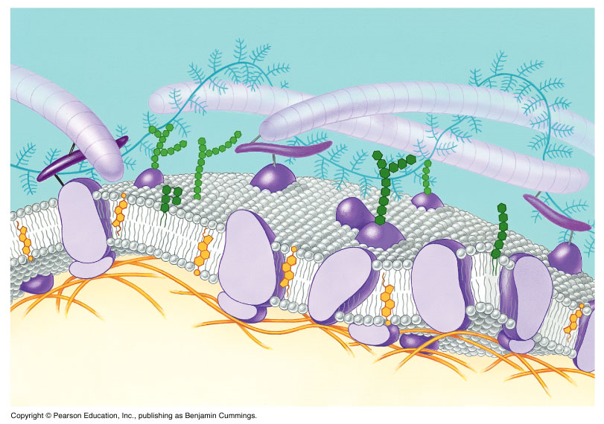

|  |  |
| --- | --- |
| **Sucrose Molarity** | **% Change in Mass** |
| 0.0M | 20% |
| 0.2M | 10% |
| 0.4M | -3% |
| 0.6M | -17% |
| 0.8M | -25% |
| 1.0M | -30% |

**29.** Zucchini cores placed in sucrose solutions at 27°C resulted in the following percent changes after 24 hours:

Graph the results below:

Title: ________________________________________________________________________________

|  |  |  |  |  |  |  |  |  |  |  |  |  |  |  |  |  |  |  |  |  |  |  |  |  |  |  |  |  |  |
| --- | --- | --- | --- | --- | --- | --- | --- | --- | --- | --- | --- | --- | --- | --- | --- | --- | --- | --- | --- | --- | --- | --- | --- | --- | --- | --- | --- | --- | --- |
|  |  |  |  |  |  |  |  |  |  |  |  |  |  |  |  |  |  |  |  |  |  |  |  |  |  |  |  |  |  |
|  |  |  |  |  |  |  |  |  |  |  |  |  |  |  |  |  |  |  |  |  |  |  |  |  |  |  |  |  |  |
|  |  |  |  |  |  |  |  |  |  |  |  |  |  |  |  |  |  |  |  |  |  |  |  |  |  |  |  |  |  |
|  |  |  |  |  |  |  |  |  |  |  |  |  |  |  |  |  |  |  |  |  |  |  |  |  |  |  |  |  |  |
|  |  |  |  |  |  |  |  |  |  |  |  |  |  |  |  |  |  |  |  |  |  |  |  |  |  |  |  |  |  |
|  |  |  |  |  |  |  |  |  |  |  |  |  |  |  |  |  |  |  |  |  |  |  |  |  |  |  |  |  |  |
|  |  |  |  |  |  |  |  |  |  |  |  |  |  |  |  |  |  |  |  |  |  |  |  |  |  |  |  |  |  |
|  |  |  |  |  |  |  |  |  |  |  |  |  |  |  |  |  |  |  |  |  |  |  |  |  |  |  |  |  |  |
|  |  |  |  |  |  |  |  |  |  |  |  |  |  |  |  |  |  |  |  |  |  |  |  |  |  |  |  |  |  |
|  |  |  |  |  |  |  |  |  |  |  |  |  |  |  |  |  |  |  |  |  |  |  |  |  |  |  |  |  |  |
|  |  |  |  |  |  |  |  |  |  |  |  |  |  |  |  |  |  |  |  |  |  |  |  |  |  |  |  |  |  |
|  |  |  |  |  |  |  |  |  |  |  |  |  |  |  |  |  |  |  |  |  |  |  |  |  |  |  |  |  |  |
|  |  |  |  |  |  |  |  |  |  |  |  |  |  |  |  |  |  |  |  |  |  |  |  |  |  |  |  |  |  |
|  |  |  |  |  |  |  |  |  |  |  |  |  |  |  |  |  |  |  |  |  |  |  |  |  |  |  |  |  |  |
|  |  |  |  |  |  |  |  |  |  |  |  |  |  |  |  |  |  |  |  |  |  |  |  |  |  |  |  |  |  |
|  |  |  |  |  |  |  |  |  |  |  |  |  |  |  |  |  |  |  |  |  |  |  |  |  |  |  |  |  |  |
|  |  |  |  |  |  |  |  |  |  |  |  |  |  |  |  |  |  |  |  |  |  |  |  |  |  |  |  |  |  |
|  |  |  |  |  |  |  |  |  |  |  |  |  |  |  |  |  |  |  |  |  |  |  |  |  |  |  |  |  |  |

**30.** From the graph, determine the sucrose molar concentration equivalent to the molarity of the zucchini cells.

_______________________________

**31.** Why did you calculate percent (%) change in mass of the potato cores rather than use the

change in mass directly?

___________________________________________________________________________

___________________________________________________________________________

___________________________________________________________________________

**32.** If a potato is allowed to dehydrate by sitting in the open air, would the water potential of the potato

increase or decrease? Why?

___________________________________________________________________________

___________________________________________________________________________

___________________________________________________________________________

___________________________________________________________________________

___________________________________________________________________________

**33.** If a plant cell has a lower water potential than its surrounding environment, is the cell hypertonic

(in terms of solute concentration) or hypotonic to its environment?

Will the cell gain water or lose water? Explain your response.

___________________________________________________________________________

___________________________________________________________________________

___________________________________________________________________________

___________________________________________________________________________

___________________________________________________________________________

**34.** How could the lab techniques used in this activity be applied to determine which apples,

Macintosh or Delicious are sweeter?

I will offer this as **extra credit** if you and one partner decide to carry it out from scratch and test two types of apples. It would require a mini-lab write up, which I will explain to you if you decide to do it. I will act as an advisor but will not do anything for you…