Name ___________________________________ Date ____________
AP Biology Mr. Collea

Advanced Microscopy Lab

Background Information

"Micro" refers to tiny, "scope" refers to view or look at. Microscopes are tools used to enlarge images of small objects so as they can be studied. The compound light microscope is an instrument containing two lenses and a variety of knobs to resolve (focus) the image. Because it uses more than one lens, it is sometimes called the compound microscope in addition to being referred to as being a light microscope.

Before we begin, let’s review the parts of a simple compound microscope.
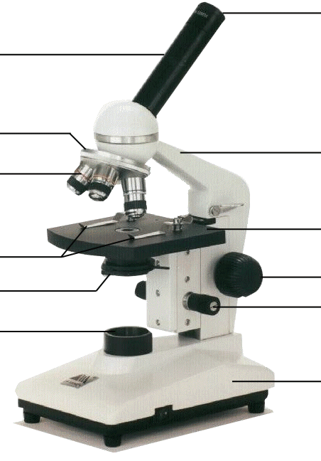

Microscope Do's and Don'ts
1. Always carry a microscope with both hands, one grasping the arm and the other under the base.
2. Never store the microscope under high power - always switch to low power before removing a slide.
3. All of our compound microscopes are parfocal, meaning that the objects remain in focus as you change
from one objective lens to another. Examine your specimen first using the scanning power (4x); then
low power objective (10x); then use the high power objective (40x). Because the objectives are parfocal,
you need to use only the fine adjustment knob to fine tune your image.
Never use the coarse adjustment under HIGH power.
4. Before switching magnification, always remember to…
FOCUS…CENTER…then SWITCH

Part I. Determining Total Magnification

To calculate the total magnification of a microscope is really quite simple. To get the total magnification take the power of the objective lens (4x, 10x, 40x and 100x) and multiply by the power of the eyepiece (10x).

Table 1. Total Magnification
Objective | Color | Magnification | Eyepiece | Total Magnification
Scanning
Low
High
Oil
Immersion

Part II. Make a Wet Mount Slide
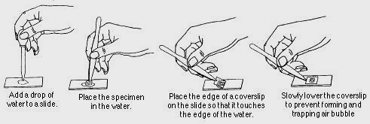

Part III. Observing Depth of Field

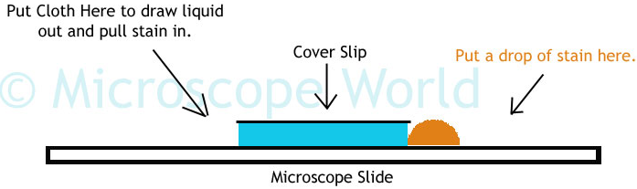

The depth of field refers to resolution in the longitudinal plane (or more simply put, the depth or distance that exists between the slide and the coverslip). Depth of field decreases as magnification increases.

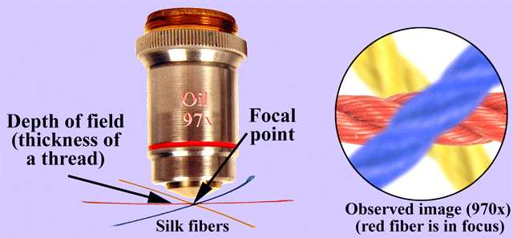
Consider three threads crisscrossed on a microscope slide. At lower magnification, it is usually possible to get all three threads in focus at the same time, but at higher magnifications, when one of the thread is in focus, the other threads will be blurry and vice versa. This is also the case when looking at tissues from plants or animals that are two or more cell layers deep (cells in one layer will be in focus a higher magnification, while those in other layers are blurry).

1. Examine the prepared slide of colored thread to see if you can all three threads in focus at the same time under Scanning, Low and then High Power.

2. Prepare a wet mount slide of 2 strands of hair (from 2 different people) crisscrossed to see if you can get both strands of hair in focus at the same time under Scanning, Low and then High Power.

3. When finished, complete questions 1, 2 and 3 on the Summary Sheet.

Troubleshooting
Occasionally you may have trouble with working your microscope.
Here are some common problems and solutions.

1. Image is too dark!
Adjust the diaphragm, make sure your light is on.

2. There's a spot in my viewing field, even when I move the slide the spot stays in the same place!
Your lens is dirty. Use lens paper, and only lens paper to carefully clean the objective and ocular
lens. The ocular lens can be removed to clean the inside.

3. I can't see anything under high power!
Remember the steps, if you can't focus under scanning and then low power, you won't be able to
focus anything under high power.
FOCUS…CENTER…then SWITCH

4. Only half of my viewing field is lit, it looks like there's a half-moon in there!
You probably don't have your objective fully clicked into place on the nosepiece.
Part IV. Calculating the Diameter of the Field of View
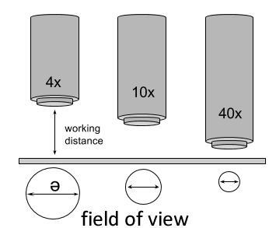

Field of view refers to how much of a specimen is visible

at any given time in the lateral plane. Or more simply put,

it is the diameter of the circle of light visible when looking through

a microscope. As seen in the diagram to the right, the field of view is also inversely proportional to the magnification (as the magnification increases, the field of view decreases). Another way to understand this

is to consider that when a specimen is magnified, the microscope is zooming in on it and, consequently, seeing less of it.

You see MORE of LESS.

100x 400x

Methods:
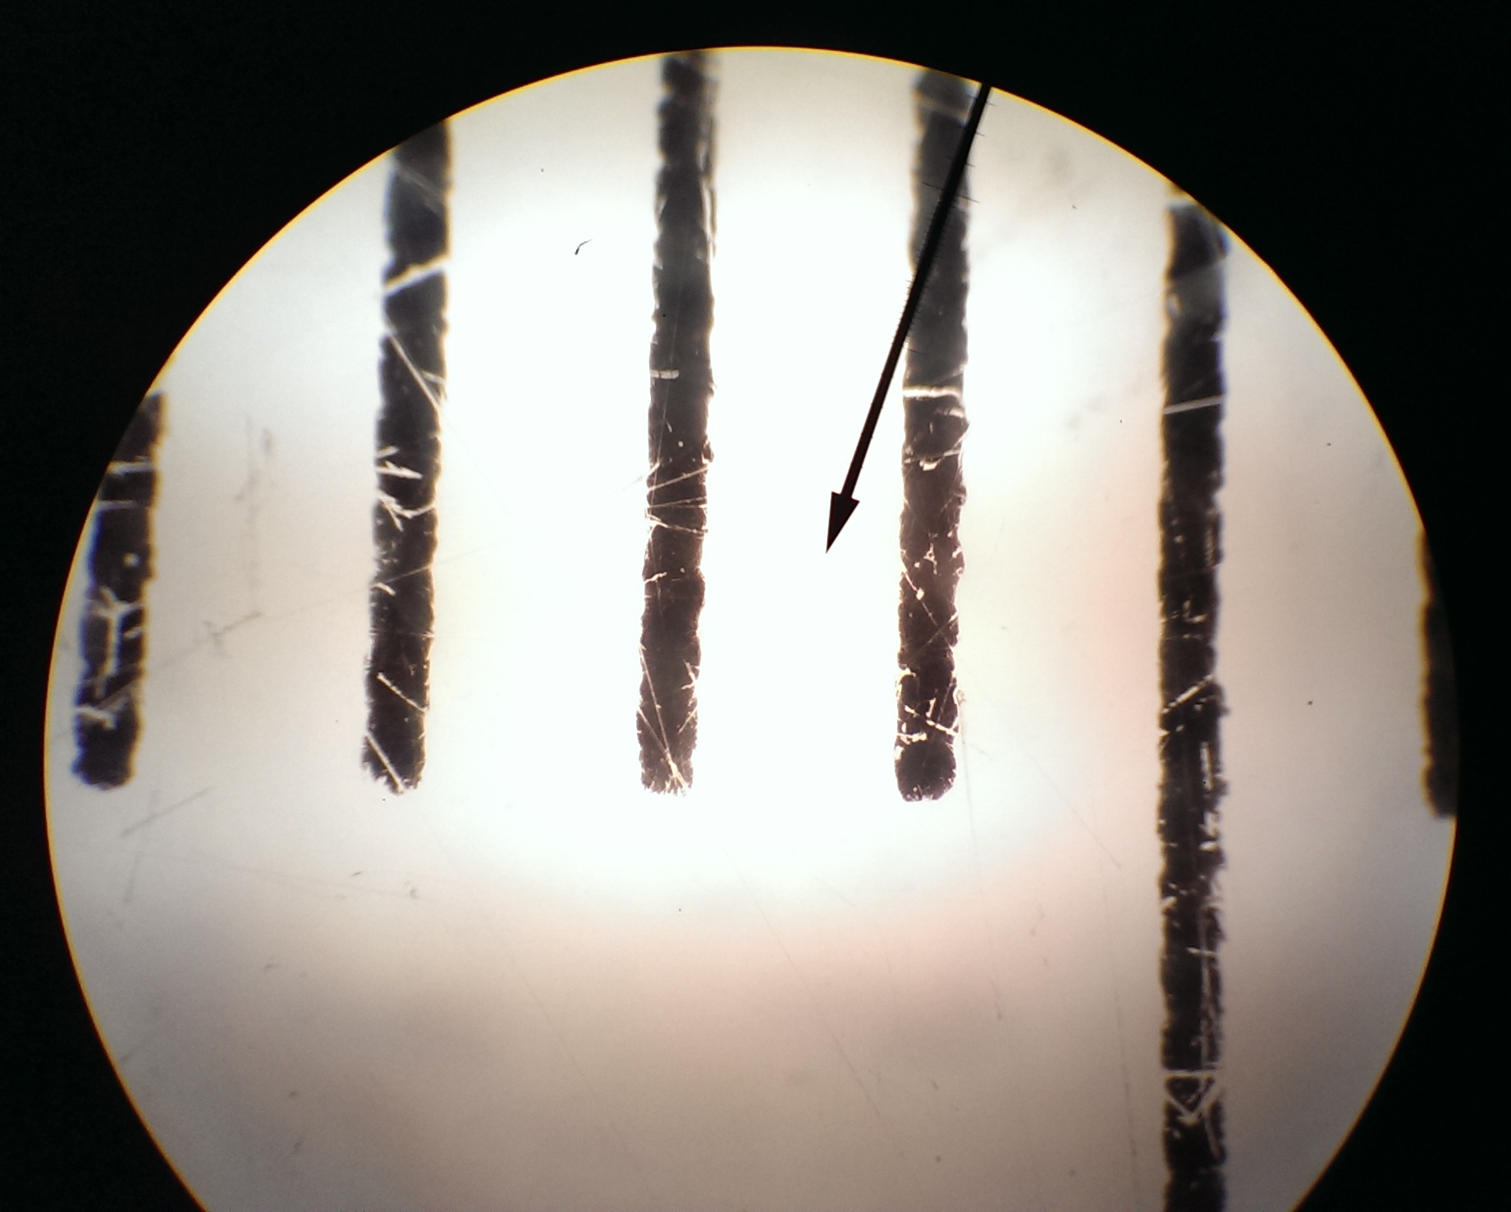
1. Use a clear ruler with a cm/mm scale to measure the diameter of
your field of view at scanning (40x). Record your data in Table 1.

2. Repeat the process on low power (100x). Record your measurement in Table 1. Convert millimeters (mm) to microns (um) for both the scanning and low power. Remember: 1mm = 1000um
You can at this point use these measurements to estimate the size of any specimen
in your viewing field that you can see with low or scanning power.

3. Repeat the process on high power (400x). What do you notice? Record your measurement here
______________________

4. As you see, measurements on High Power can be a bit more complicated. If you try to use the clear ruler technique, you’ll find that you cannot see the individual ruler marks because as magnification increases, the field of view decreases. This is where maths (algebra) comes in, the values you estimated in steps 1 and 2 above can be used to solve a ratio to determine the size of your field of view on high power.
=
Low Power Magnification High Power Field of View
High Power Magnification Low Power Field of View

solving for High Power Magnification you get the formula …

x
=
High Power Magnification
High Field of View
Low Power Field of View
Low Power Magnification
Table 1.

Objective | Magnification | Ocular | Total Magnification | Diameter of Field of View
Scanning |  |  |  | _______ mm ___________ um
Low |  |  |  | _______ mm ___________ um
High |  |  |  | _______ mm ___________ um

Formula:
x
=
High Power Magnification
Low Power Field of View
High Power Field of View
Low Power Magnification

Objective | Diameter of Field of View Calculations
High

Part V. Estimating the Size of Specimens

Once you have an estimate of your high power field of view,
Actual Size = Field of View
Number of cells that fit across
any specimen you are viewing under high power can be
estimated based on that and the following formula to the right.
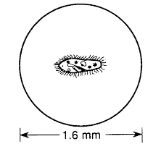

1. Using the formula above, estimate the size of the paramecium to
the right

_______ mm ___________ um

2. View, draw and estimate the sizes of each of the following:
a) the width of human hair
b) a paramecium
c) the height of the perched owl on a dollar bill

Part VI. Observing Eukaryotic Animal Cells

Safety Precautions:
(1) Remember to FOCUS and CENTER specimen before changing objective lenses.
(2) Focus very carefully with the 40x objective over the stained specimen on the slide.
* Once focused, do not alter focus for the next three steps! *
(3) Rotate turret/nosepiece half way so that the 40x and 100x objectives straddle specimen.
(4) Apply a small drop of oil directly on the slide over the specimen.
(5) CAREFULLY Rotate 100x objective into the immersion oil .
a) Never use an oil immersion lens without the oil.
b) Never get oil on any other lens.
c) Clean up all oil when finished.

Methods:

__1. Prepare a stained slide of epithelial cells using methylene blue.

__2. Focus the specimen on scanning power (4x – red).

__3. Rotate nosepiece to 10x objective – focus and center the specimen.

__4. Rotate nosepiece to 40x objective – focus (using the fine adjustment only), center, draw and label
what you see.

__5. Locate desired portion of specimen (nucleus) in the center of the field. Refocus very carefully so that
the specimen is focused as sharply as possible. (Do not alter focus for the following steps.)

__6. Partially rotate the nosepiece so that 40x and 100x objectives straddle the specimen.

__7. Place a small drop of oil on the slide in the center of the lighted area.
(Take care not to dribble on the stage.)

__8. Rotate the nosepiece so that the 100x oil immersion objective touches the oil and clicks into place.

__9. Focus using the fine adjustment only. Hopefully, the specimen will come into focus easily. Do not
change focus dramatically. If you still have trouble, move the slide slightly left and right, looking for
movement in the visual field, and focus on the object which moved. Draw and label what you see.

Never go back to the 10x or 40x objectives after you have applied oil to the
specimen since oil can ruin the lower power objectives. [The 4x objective can
be used because it is high enough to be above the oil.]

__10. Clean up! When you have finished, wipe the 100x oil immersion objective carefully with lens paper
to remove all oil. Wipe oil from the slide thoroughly with a Kimwipe. Clean stage should any oil
have spilled on it.

How to Make a Wet Mount Cheek Cell Slide
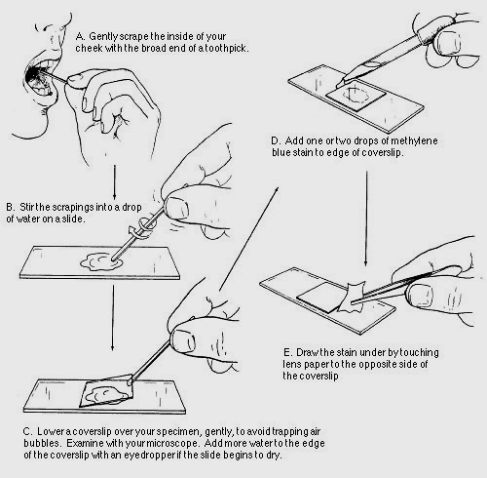

.

Prepare a Microscope for Storage

1. Store microscopes with the scanning OR low objective in place. NEVER HIGH!
2. Rack the stage all the way down using the coarse adjustment.
3. Wrap cord neatly around the base or around the holder.
4. Carefully place the microscope back in its designated spot in the microscope cabinet.

Part VII. Observing Eukaryotic Plant Cells

Safety Precautions:
(1) Remember to FOCUS and CENTER specimen before changing objective lenses.

Methods:

__1. Prepare a stained slide of red onion skin using only water.

__2. Focus the specimen on scanning power (4x – red).

__3. Rotate nosepiece to 10x objective – focus and center the specimen.

__4. Rotate nosepiece to 40x objective – focus (using the fine adjustment only), center, draw and label
what you see.

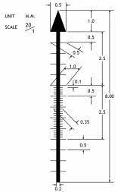

Part VIII. Biodiversity in a Drop of Pond Water

Size (um) | Organism
 | Cyclops
 | Water Shrimp
Daphnia
(Water Flea)
 | Amoeba
 | Volvox
 | Spirogyra
 | Oscillatoria
 | Rotifer
 | Tartigrade (Waterbear)
 | Planaria
 | Euglena
 | Nematode
 | Diatom
 | Pediastrm
 | Vorticella
 | Stentor
 | Micrasterius
 | Closterium
 | Colpidium
 | Phacus
 | Paramecium
 | Hydra
 | Pandorina

Name ___________________________________ Date ____________
AP Biology Mr. Collea

Advanced Microscopy Lab

Post-Lab Questions

1. Briefly describe how to properly carry a microscope.

(a) _________________________________________________________________________________

(b) _________________________________________________________________________________

(c) _________________________________________________________________________________

2. Briefly describe how to properly prepare a microscope for storage.

(a) _________________________________________________________________________________

(b) _________________________________________________________________________________

(c) _________________________________________________________________________________

(d) _________________________________________________________________________________

3. Before switching magnification, what should you always remember to do?

_____________________________________________________________________________________

_____________________________________________________________________________________

4. Briefly explain why it is important to lower the cover slip at a 45º angle when making a slide?

_________________________________________

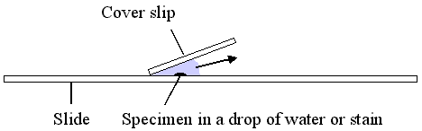
_________________________________________

_________________________________________
5. Explain why the specimen must be centered in the field of view on low power before going to high power.

_____________________________________________________________________________________

_____________________________________________________________________________________

6. A microscope has a 20x ocular (eyepiece) and two objectives of 10x and 43x respectively.

a) Calculate the low power magnification of this microscope.

b) Calculate the high power magnification of this microscope.

7. Describe the changes in the amount of available light when going from low to high power.

_____________________________________________________________________________________

_____________________________________________________________________________________

8. Explain what the microscope user may have to do to fix the problem incurred in question # 7.

_____________________________________________________________________________________

_____________________________________________________________________________________

9. How does the procedure for focusing the microscope differ under high power as opposed to low power?

_____________________________________________________________________________________

_____________________________________________________________________________________

_____________________________________________________________________________________

10. What is the simple definition for Depth of Field?

_____________________________________________________________________________________

_____________________________________________________________________________________

11. Draw what the crisscrossed threads look like under Scanning, Low and High Power.

40x 100x 400x

12. Draw what the crisscrossed hairs look like under Scanning, Low and High Power.

40x 100x 400x

13. Were you able to get all three strands of colored thread in focus under –

(a) Scanning Power YES or NO (b) High Power YES or NO

14. Were you able to get both strands of hair in focus under –

(a) Scanning Power YES or NO (b) High Power YES or NO
15. What is the simple definition for Field of View?

_____________________________________________________________________________________

_____________________________________________________________________________________

16. Draw what the clear plastic ruler looks like under Scanning, Low and High Power.

40x 100x 400x

17. Draw what a single strand of human hair looks like under Scanning, Low and High Power.

40x 100x 400x

18. Draw what a single paramecium looks like under Scanning, Low and High Power.

40x 100x 400x

19. Draw what the perched owl on a dollar bill looks like under Scanning and Low Power.

40x 100x

Actual Size = Field of View
Number of cells that fit across
20. Fill in the data table below.

Specimen | Estimated Size
Hair | _______ mm ___________ um
Perched Owl | _______ mm ___________ um
Paramecium | _______ mm ___________ um
Cheek Cell | _______ mm ___________ um

21. Draw what a single cheek cell looks like under 100x, 400x and 1000x.

100x 400x 1000x

22. Draw what a single red onion cell looks like under 400x.

400x

