Mouse Party

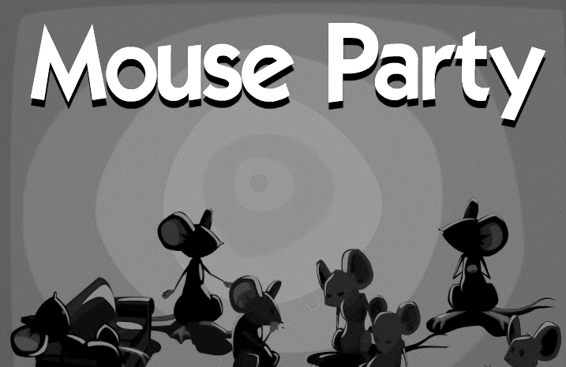
The simplified mechanisms of drug action presented in this activity are just a small part of the story. When drugs enter the body they elicit very complex effects in many different regions o
f the brain. Often they interact with many different types of neurotransmitters and may bind with a variety of receptors. For example, THC in marijuana can bind with cannabinoid receptors located on the presynaptic and/or postsynaptic cell in a synapse.
Where applicable, this activity primarily depicts how drugs interact with dopamine neurotransmitters because this website focuses on the brain's reward pathway. Mouse Party is designed to provide a small glimpse into the chemical
interactions at the synaptic level that cause the drug user to feel 'high'.

Diagram of a Synapse:
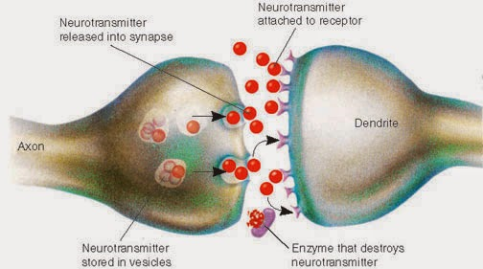

5. Fill in the chart below based upon the information presented in the Mouse Party animation
Drug | Neutransmitter(s) Involved (Inhibitory or Excitatory) | Action of Drug
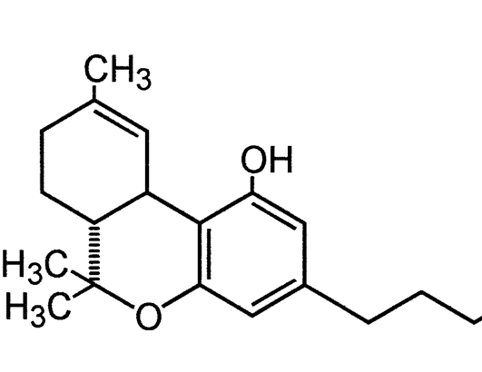
Marijuana
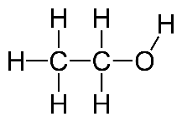
Alcohol
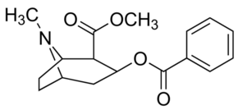
Cocaine
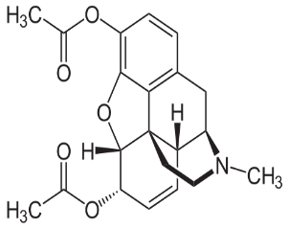
Heroin

