Name _______________________________ Date ______________

Biology Mr. Collea

**Why are cells so small?**

*(Why does cleavage of the fertilized egg/zygote increase the number of cells and not the size/volume?)*

**Introduction**

Why are cells so small? Think about this: even though a whale is much larger than a human and a human is much larger than a tulip, their cells are all roughly the same size. Whales don’t have larger cells than humans, just more of them. There is a very specific reason why cells are the size they are. Anytime this cell interacts with its environment, it does so at its membrane. The more membrane a cell has, the more exchange it can perform with its environment. (*This exchange can include activities such as obtaining nutrients or getting rid of wastes*.) We refer to the amount of surface that an object has as its **surface area** (**SA**). Once materials get inside the cell, they move via diffusion. **Diffusion** is the random movement of particles that results in their dispersion in the cytoplasm. A drop of food coloring in a beaker of water will diffuse until the entire beaker is the same color. This type of movement occurs inside cells as a way of dispersing molecules. Diffusion works best over short distances. Imagine how long it would take food coloring molecules to diffuse in a water glass vs. in a swimming pool. Because the water glass has less **volume** (**V**), diffusion is more efficient. Cells try to **maximize their surface area** (*in order to improve exchange*) and **minimize their volume** (*to make diffusion more efficient*). A basketball-sized cell would have lots of surface area (good), but also lots of volume (bad). Think about how long it would take molecules to diffuse from the outer portion of the ball to the center. A ping-pong ball or a marble would be better choices. When we discuss the interplay of these two quantities, we use the ratio of surface area to volume (abbreviated SA/V). Ideal cells have large SA values, but small V values.

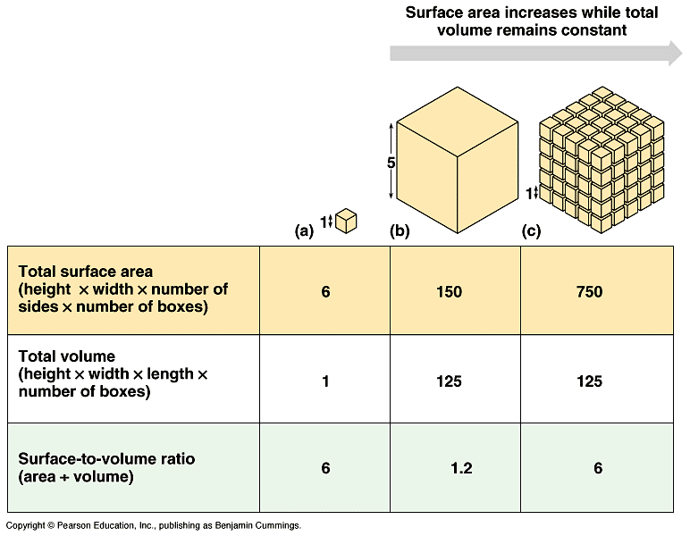

|  |  |  |  |
| --- | --- | --- | --- |
| **Table 1.** | **(a)** | **(b)** | **(c)** |
| **Total Surface Area** (width x height x # of sides x # of boxes) |  |  |  |
| **Total Volume**  (length x width x height x # of boxes) |  |  |  |
| **Surface Area to Volume Ratio** (surface area ÷ volume) |  |  |  |

**Part I. Calculating Volume and Surface Area.**

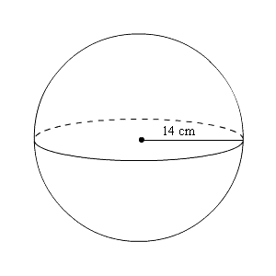**1.** Determine the volume of the sphere to the right.

**(*Remember: E S A*)**

**2.** Determine the surface area of the same sphere.

**(*Remember: E S A*)**

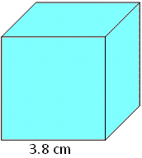

**3.** Determine the volume of the cube to the right.

**(*Remember: E S A*)**

**4.** Determine the surface area of the same cube?

**(*Remember: E S A*)**

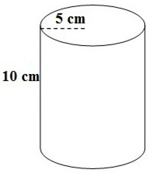

**5.** Determine the volume of the column to the right?

**(*Remember: E S A*)**

**5.** Determine the surface area of the same column?

**(*Remember: E S A*)**

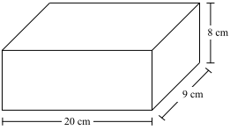**6.** Determine the volume of the block to the right.

**(*Remember: E S A*)**

**7.** Explain in words how to find the surface area of the

same block. Use your explanation to create a formula

and then use the dimensions to calculate its surface area.

**(*Remember: E S A*)**

**Part II. Measuring and Calculating Volume and Surface Area.**

**Table 2. Volume and Surface Area of a Sphere**



**Table 3. Volume and Surface Area of a Cube**



**Table 4. Volume and Surface Area of a Column / Cylinder**



**Part III. Surface Area : Volume in Sea Urchin Embryos**

In this activity, you will make measurements of cells to determine Surface Area to Volume Ratio (SA). (*The cells are located on p. 7.)*

**Methods**

**1.** Look at the photos of the cells on p.7. These are very young embryos from sea urchins, marine organisms that you may have seen in nature documentaries or possibly while on vacation along a rocky coastline.

These photos were taken over a span of 105 minutes,

beginning immediately after fertilization (Panel 1). The fertilized egg then divided once (Panel 3) to produce a two cell embryo (Panel 4), and then again (Panel 5) to produce a 4-cell embryo (Panel 6). Eventually, hundreds of **MITOTIC** divisions would result in a tiny sea urchin larva that would settle to the sea bed and grow into the mature urchin to the right.

Embryonic cells such as these are convenient to use as models for cell size because they are nearly perfect spheres. You will use these cells to determine SA/V ratios.

**2.** **Measure the diameter of the cells.**

There is a scale bar printed below the photo of the cells. It works just like a scale bar on a map. The scale bar on the photos tells you that a distance of about 4 cm (the length of the line) equals 100 μm in the photos. As learn in our previous lab, the symbol μ is pronounced “micro”; a μm is a micrometer, one-millionth of a meter. Measure the diameter of the cells in Panels 1, 4, and 6 in μm, using the scale bar as a guide. The diameter is simply the distance from one end of the cell to the opposite end. In Panels 4 and 6, just measure one cell; we’ll assume they are roughly the same size.

If a cell is more oval-shaped than spherical, measure along the longer axis.

Record these diameters in **Table 5**.

**Table 5.**

|  |  |  |  |  |  |
| --- | --- | --- | --- | --- | --- |
| **Panel** | **Diameter (*u*m)** | **Radius (*u*m)** | **(SA)** | **V** | **SA/V** |
| **1** |  |  |  |  |  |
| **4** |  |  |  |  |  |
| **6** |  |  |  |  |  |

**3. Determining the radius of the cells.**

We will assume that these cells are perfect spheres. When we use geometry to describe spheres, we tend to use the radius of the sphere rather than the diameter. The radius is defined as the distance from the center of the sphere to the edge. This can be figured out easily by simply dividing the diameter in half. Divide the diameters in half, and record these values in the **Table 5**.

|  |  |
| --- | --- |
| **Panel** | **Work Space** |
| **1** |  |
| **4** |  |
| **6** |  |

**4. Determining surface area.** Surface area (SA) can be calculated using the formula:

SA = 4π(radius)2

Since π ≅ 3.14, this can be simplified to:

SA = 12.56 x (radius)2

Calculate the SA for each of your three cells and record the values in **Table 1**.

|  |  |
| --- | --- |
| **Panel** | **Work Space** |
| **1** |  |
| **4** |  |
| **6** |  |

**5. Determining volume**

Volume (V) can be calculated using the formula:

V = 4/3π(radius)3

This can also be simplified to:

V = 4.19 x (radius)3

Calculate the V for each of your three cells and

|  |  |
| --- | --- |
| **Panel** | **Work Space** |
| **1** |  |
| **4** |  |
| **6** |  |

record the values in **Table 1**.

**6. Determining SA/V ratios** Once you have determined the SA and V, it’s

relatively easy to figure out the ratio.

Simply divide SA by the V.

Record the SA/V ratios in **Table 1**.

**Sea Urchin Embryo Photos**

**Fertilization and Development of a Human Embryo**

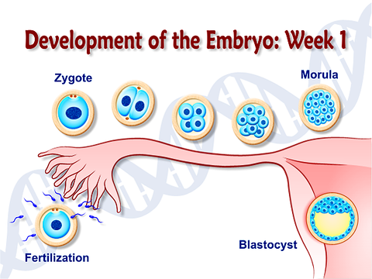

**Post Lab Questions**

**1.** Which panel shows cells with the highest SA/V ratio? _______

**2.** Which panel shows cells with the lowest SA/V ratio? _______

**3.** What happens to the SA/V ratios of these embryonic cells over time (from 0-105 min)?

**4.** What happened to the surface area as the size increased?

**5.** What happened to the volume as the size increased?

**6.** What happened to the surface area to volume ratio as the size increased?

**7.** Do you think large cells and small cells carry out diffusion and osmosis at the same rate?

Why or why not?

**8.** If a cell has a high concentration of something, say, waste, that it wants to get rid of, which do you

predict will be able to get rid of the waste sooner – a smaller cell or a large one? Why?

**9.** Consider a mouse and an elephant. If both were left in the cold overnight, which would be in more danger of freezing to death? Why?

**Part IV. Investigating Surface Area and Volume Using Model Cells**

**Introduction**

The previous activities helped to answer the question of why are most cells, no matter what the size of the organism, microscopic in size? What happens when a cell grows larger and what causes it to divide?

These questions can be answered because of a process called **diffusion**. Diffusion is a major transport mechanism for moving substances into and out of the cell. Diffusion occurs **passively** (*meaning that it does not require energy*) through the cell membrane. Therefore, if cells were too large, they could not efficiently absorb materials or excrete wastes through the process of diffusion. If a cell doubled in size, it would require more nutrients and would have to excrete more waste. Otherwise, the lack of nutrients and build up of wastes would upset the **homeostasis** of the cell and ultimately lead to cell death by starvation or poisoning. This investigation will allow you to observe the changing relationship of surface area-to-volume for a growing cell. In order to investigate this relationship we will be using agar blocks as models of cells. These blocks are pink because they contain a biological indicator called phenolphthalein and have soaked in a sodium hydroxide (NaOH) solution . Phenolphthalein is a biological indicator that reacts with a basic solution such as sodium hydroxide (NaOH). The phenolphthalein will turn pink when mixed with NaOH. The NaOH has diffused into the agar cubes containing phenolphthalein giving them their pink color. When placed in an acidic solution of vinegar (acetic acid), these same cubes will change color again. But will the vinegar diffuse at an equal rate for each cube?

**Materials:** (per lab group)

phenolphthalein agar cubes 100 ml of 0.5% acetic acid (vinegar)

250 ml beaker ruler

plastic knife plastic spoon stop watch / smart phone

**Methods:**

1. Pick up 2 agar cubes (one small and one large).

*Think of the cubes as large models of microscopic cells.*

1. Using the plastic spoon, carefully place the cubes in the beaker and pour in enough vinegar to cover them.
2. Allow the setup to stand for the next 10 minutes. During this time be sure to occasionally swirl the vinegar solution but be careful not to scratch or cut the surface of the cubes.

1. While you are waiting for results, answer the questions 1, 2, 3, 6, 7, 8 and 9.

- - - - - - - - - - - - - - - - - - - - - - - - - - - - - - - - - - - - - - - - - - - - - - - - - - - - - - - - - - - - - - - - - - - - - - - - -

1. At the end of 10 minutes, take your beaker to the sink. Carefully pour off the vinegar solution and rinse the agar cubes with water. Using plastic spoons, remove the agar cubes from the beaker, place them on a paper towel and blot them dry.
2. Using a plastic knife, cut the cubes in half and examine and compare their inside appearance. Using the mm ruler, measure the depth of the colored zones for each cube and record your data in Table 3. Sketch each cube to show the color changes on Table 4.
3. After you have made your observations and recorded your data, be sure to clean up your lab area and properly dispose of your agar cubes.

**Data/Results:**

**Table 6.**

|  |  |  |  |  |
| --- | --- | --- | --- | --- |
| **"Cell"** | **Side Length** | **Surface Area (SA)** | **Volume (V)** | **Surface Area:Volume Ratio (SA / V)** |
| **1** |  |  |  |  |
| **2** |  |  |  |  |

**Work Space:**

**Table 7.**

|  |  |
| --- | --- |
| **"Cell" 1 Sketch** | **"Cell" 2 Sketch** |
|  |  |
| **Depth of Color Change:__________** | **Depth of Color Change:__________** |

**1.** If the pink color represents wastes found inside the cell, which of your 2 model cells do you think would be most efficient at getting rid of it? Explain.

_________________________________________________________________________________ _________________________________________________________________________________ _________________________________________________________________________________

_________________________________________________________________________________

**2.** Which model cell do you think will do the best job of moving food into the cell? Explain.

_________________________________________________________________________________ _________________________________________________________________________________ _________________________________________________________________________________ _________________________________________________________________________________

**3.** Name and describe the process by which food and wastes move into and out of cells.

_________________________________________________________________________________ _________________________________________________________________________________ _________________________________________________________________________________ _________________________________________________________________________________

**4.** Name the cell organelle responsible for the movement of materials in and out of a cell.

__________________________________________________________________________________

**5.** Draw and label a diagram of the fluid mosaic model of the cell membrane in the space below.

**6.** Calculate the total surface area of each of your 2 model cells and record your results in Table 6.

**7.** Which model cell has the greatest surface area? _________________

**8.** Calculate the volume of each of your 2 model cells and record your results in Table 6.

**9.** Do these calculations change your answer to questions 1 and 2? Why or why not?

_________________________________________________________________________________ _________________________________________________________________________________

**10.** Anything that the cell takes in, like oxygen and food, or lets out, such as carbon dioxide, must go through the cell membrane. Which geometric calculation best represents how much cell membrane the models have?

_________________________________________________________________________________

**11.** What similarities did you notice when you measured the colored zone of each cube?

_________________________________________________________________________________ _________________________________________________________________________________ _________________________________________________________________________________

**12.** As the cell grows larger, will it need more or less cell membrane to survive? ___________________

**13.** How do your observations and calculations relate to the questions of why cells are usually very small?

_________________________________________________________________________________ _________________________________________________________________________________ _________________________________________________________________________________

**Part V. Robert Hooke Award for Cell Design**

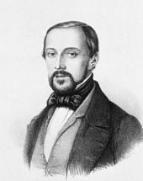

*Robert Hooke*

*July 28, 1635 – March 3, 1703*

Your team will be given a block of the agar that you must design into your own cell to maximize volume & mass, but minimize diffusion time.

**RULES:**

1. No donut-like holes through the agar cell - cell membranes cannot sustain that shape.
2. Model cell will be placed in 50 mL of vinegar.
3. No poking, prodding, touching tray containing agar cell in solution.

1. Teacher will mass the “cell” at the start of race - cell must not break when handled.

***Disqualification if cell breaks upon massing or transferring from tray to tray.***

1. Teacher determines when 100% diffusion takes place.

1. **Winner** = highest ratio of **mass divided by time**.