AP Biology  Practice  Questions | North Salem University  MISSION: Engage students to continuously learn, question, define and solve problems through critical and creative thinking.  Fall  2019
Water Potential can be described as a measure of how freely water molecules can move in a particular environment or system. It is measured in kilopascals (kPa) and is represented by the Greek letter Psi (Ψ). Water potential is never positive but has a maximum value of zero, which is that of pure water at atmospheric pressure.  If you have any problems – please sign up for extra help after school |  | Water  Potential

Bozeman Biology: Water Potential
1. Give the definition of water potential.

2. What does water potential allow us to figure out?

3. What is the “unit” for water potential?
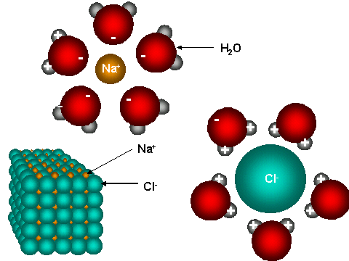

4. Use the diagram to the right to help you explain how
water (a polar molecule) orientation changes when NaCl
is added to it?

5. What is the water potential of pure water?

6. Which way does water move?

7. Summarize, using water potential, why salt causes water to leave a slug.

8. Label the diagram of the tree below and use it to explain why water moves from the roots to the tips of the treetops.

9. Write out and describe the water potential equation.

10. Solute potential is a factor of osmosis, what is pressure potential a factor of?

11. Why is pressure potential often a positive number?

12. Write out and explain each part of the solute potential equation:

13. Why is i (the ionization constant) a value of 2 for NaCl and a value of 1 for sucrose?

14. How does increasing temperature affect solute potential?

15. Show the steps (Equation – Substitute – Answer) to work out his sample problem below.

WATER POTENTIAL

A. Water potential is the free energy of water, water will always move from an area of higher water potential to an area of lower water potential (high free energy to low free energy).

B. Water/Osmotic Potential is dependent on pressure potential (Ψ_{P}) and solute concentration (Ψ_{S}).

Water Potential = Pressure Potential + Solute Potential
Ψ = Ψ_{P} + Ψ_{S}

* Water basically moves from a higher (+) water potential to a lower (-) water potential. *
(high free energy) (low free energy)

* The addition of solutes REDUCES water potential to a NEGATIVE water potential. *

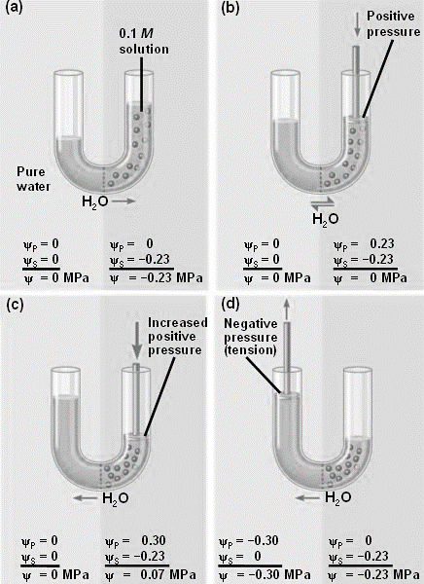
* Water potential values allow us to predict the direction of the flow of water. *
(This can be reviewed on pages 751-752 in your textbook.)
Sample Water Potential Problems:

(1) The initial concentration of Side A and Side B are indicated on either side of the U-tube.
The membrane shown is permeable to sucrose and NaCl but NOT starch.
0.6M sucrose
1.2M starch
1.6M NaCl
1.5M sucrose
0.8M starch
0.4M NaCl

a) Initially, which side is hypertonic? _______

b) Initially, which side is hypotonic? _______

c) Please use the correct letters to fill in the blanks below. In order to reach equilibrium:

sucrose will move from side ______ to side ______. starch will move from side ______ to side ______.

NaCl will move from side ______ to side ______.

d) After this system reaches equilibrium: what is the molarity of each side? A = _______ B = _______

Which side will lose water? _______. How will you know?

Remember: Water Potential = Pressure Potential + Solute Potential
Ψ = Ψ_{P} + Ψ_{S}
Equation – Substitution - Answer

(2) If a cell’s Ψ_{P} = 3 bars and it’s Ψ_{S}= -4.5 bars, what is the resulting Ψ? Work Space:
Give your answer to the nearest tenth.

(3) If the cell from the previous question is placed into a beaker Work Space:
of sugar water with Ψ_{S}= -4.5 bars.
In which direction will the net flow of water be and WHY?

Sample Solute Potential Problems:

ψs = -iCRT

i = Ionization constant
C = Molar concentration
R = Pressure Constant (R = 0.0831 liter bars/mole ºK)
T = Temperature (ºK) (273 + ºC of solution)

Reminders:
Units of water potential, pressure potential and solute potential are typically bars, megapascals or kilopascals. When solving the problems below, use the same units as the prompt. If there are no units in the prompt, your units for water potential will be bars because the R constant in your Appendix B is 0.0831 liters bars/moles K. (For problems in megapascals, R is 0.00831 liters megapascals /moles K. R in this case is 10 times smaller because 1 MPa = 10 bars.)

1. An open beaker has been determined to be 0.2 M. Calculate the solute potential at 22ºC. Remember ESA!

2. Calculate the solute potential of a 1.5 M sugar solution in a dialysis tube sitting in distilled water at 22 ºC.

3. Calculate the water potential for this same experiment.

4. Water potential values are useful because they allow us to predict the direction of the flow of water.
Suppose that a student calculates the water potential of a solution inside piece of dialysis tubing to be -6.25 bars
and the water potential of a solution surround the piece of dialysis tubing to be -3.25 bars.
In which direction will the water flow?

